Exploring teacher and learner perceptions of artificial intelligence chatbots for English conversation practice: A mixed-methods study in Saudi English-as-a-foreign-language classrooms

***Abdullah Alshayban***

***ORCID:***[*https://orcid.org/0000-0002-3620-1977*](https://orcid.org/0000-0002-3620-1977)

*Department of English Language and Literature, Qassim University, Qassim 52571, Saudi Arabia*

ashieban@qu.edu.sa

**Abstract**

With the increasing integration of artificial intelligence (AI) in language education, chatbots are gaining attention for their potential to support English conversation practice in English as a Foreign Language (EFL) settings. In this study, I investigated the perceptions of Saudi university students and EFL teachers regarding the use of AI chatbots for enhancing speaking skills. I adopted a convergent mixed-methods design involving 226 learners and 62 teachers from Saudi higher education institutions. I collected data using two adapted and structured questionnaires, which consisted of demographic questions, Likert-scale items across five dimensions (motivation, fluency, confidence, helpfulness, and risk), and three open-ended questions per group. I analyzed the quantitative data using descriptive statistics and non-parametric tests and the qualitative data thematically. Findings indicate that learners view chatbots as helpful, motivating tools that enhance their confidence and speaking fluency. Teachers, however, expressed greater concerns regarding misinformation, pedagogical control, and student overreliance on technology. I found no significant relationship between teaching experience and risk perception, highlighting that skepticism may stem from broader institutional or pedagogical concerns rather than experience alone. This study highlights the need for balanced AI integration that supports learner autonomy while addressing teacher apprehensions. It contributes to the literature on AI-enhanced language learning by providing practical recommendations for EFL educators and policy stakeholders in underexplored regional contexts.

**Keywords**:artificial intelligence chatbots; English as a foreign language; learning motivation; teacher perception; technology acceptance model; computer-assisted language learning

**1. Introduction**

Artificial intelligence (AI) has rapidly transformed educational landscapes, reshaping how learners engage with language and how educators design instruction. AI-driven chatbots such as ChatGPT, Replika, and Bing Chat have introduced new dimensions of interactivity and personalization into second language learning (Amirkhani and Hosseini 2025; Nguyen 2023). They are important tools that provide learners with the opportunity to speak in real time and help them become more autonomous, and in low-stakes environments, they also help lower the affective filter (Çelik and Gürsoy 2020; Siyan et al. 2024). In addition, international research has emphasized the potential role of chatbots in promoting speaking fluency, vocabulary retention, and learners’ confidence (Jeon 2024; Kang and Sung 2024; Qiao and Zhao 2023).

Traditionally, in many contexts where teachers teach English as a foreign language (EFL), especially in places such as Saudi Arabia, they focus on reading and grammar (Al Husaini and Qutub 2025), which does not necessarily develop communicative competence. This stark difference has created opportunities for AI tools to address the imbalance by simulating spoken interaction with uniform, non-evaluative feedback (Wiboolyasarin et al. 2025; Yoo et al. 2025). Nonetheless, students’ excitement does not always align with their teachers’ concerns about misinformation, dependence, and loss of pedagogical control (Nguyen 2023; Wu et al. 2025; Zainuddin 2024). Such rising frictions between innovation and instructional integrity call for complementary research on the perceptions of AI chatbots by learners and teachers alike to inform language education practices that are balanced and effective.

To enhance interactivity and encouragement, AI chatbots offer a new alternative that engages learners without the pressure of a high-stakes context, thereby ensuring learner agency in repeatable environments where learners can seek conversational scaffolding to improve their learning (Jeon 2024). To date, anecdotal benefits have been reported by Ballıdağ and Aydın (2025), including enhanced speaking confidence, reduced anxiety, and increased lexical diversity. Recent empirical evidence supports these outcomes, particularly when chatbots incorporate contextual feedback (Ballıdağ and Aydın 2025; Kang and Sung 2024). However, the challenges of engagement, relevance of content, and alignment of pedagogy are still present (Chien et al. 2022; Wu et al. 2025).

For Saudi EFL learners, whose speaking opportunities are limited, chatbots could fill crucial gaps in oral practice. However, robust evidence on their actual value in developing spontaneous conversation remains limited.

Research on digital language education has progressed from foundational models of technology-enhanced instruction (Levy, 1997; Warschauer, 1996) to more interactive tools such as AI-powered chatbots. These conversational agents represent a new frontier in language learning, offering real-time interaction, language modeling, and learner feedback (Godwin-Jones 2023). Empirical studies have confirmed their benefits in enhancing learner engagement, speaking fluency, and vocabulary acquisition (Apriani 2024; Huang, Hew and Fryer 2022; Qiao and Zhao 2023). Moreover, researchers have demonstrated that chatbot use reduces learner anxiety and increases motivation, particularly through emotionally responsive interactions (Çelik and Gürsoy 2020; Jeon 2024; Siyan et al. 2024).

While student-focused findings are largely positive, teacher-focused studies raise concerns. Educators report difficulties in ensuring pedagogical alignment, depth of feedback, and managing student dependence on AI tools (Yoo et al. 2025; Zainuddin 2024). Evaluations of ChatGPT integration in China and Korea emphasize the importance of institutional readiness and teacher training (Lee 2024; Nguyen 2023). Despite growing interest, notable gaps remain, particularly in Arabic-speaking contexts, where limited research exists on the integration of spoken chatbots. Few researchers have concurrently analyzed both teacher and learner perspectives about AI-mediated conversation practice.

**1.1 Identified research gaps**

A review of the literature reveals three core deficiencies: (a) a scarcity of mixed-methods studies that triangulate quantitative outcomes with qualitative insights (Creswell and Plano Clark 2018); (b) insufficient focus on oral fluency and conversation-specific chatbot use, particularly outside writing tasks (Alyami, Alotaibi, & Khan, 2025); and (c) a lack of empirical research within Saudi EFL contexts on dual stakeholder perspectives. Addressing these gaps is critical for designing pedagogically sound, culturally relevant AI integrations.

**1.2 Study purpose and significance**

The purpose of this study is to explore and compare the perceptions of Saudi EFL learners and teachers regarding the use of AI chatbots for English conversation practice. By combining quantitative survey results with qualitative insights, the research provides a well-rounded understanding of both user groups’ experiences, expectations, and concerns. This study is significant for three reasons. First, it contributes to the growing body of research in AI-assisted language learning, particularly in the area of speaking skills, which the literature often underrepresents. Second, it addresses a notable research gap by offering perspectives from both learners and teachers within the Saudi educational context, where AI tools are increasingly present but not yet fully integrated. Third, the findings have practical value for educators and policymakers aiming to implement chatbots more effectively in EFL classrooms. By identifying perceived benefits, challenges, and suggestions for classroom use, the study supports responsible and pedagogically aligned integration of AI technologies in language education.

**1.3 Research objectives**

The study has four objectives:

1. To explore Saudi EFL learners’ perceptions of AI chatbots as tools for improving conversational English skills.
2. To examine English teachers’ attitudes toward AI chatbots’ pedagogical value and limitations in language education.
3. To identify the perceived benefits, challenges, and risks associated with using AI chatbots for English conversation practice.
4. To develop practical recommendations for the effective integration of AI chatbots into Saudi EFL classrooms based on user perceptions and experiences.

**1.4 Research questions**

Corresponding to these objectives, I seek to address the following questions:

1. What are Saudi EFL learners’ perceptions of AI chatbots as tools for improving conversational English skills, and to what extent do they view them as effective in practice?
2. What are English teachers’ attitudes toward AI chatbots’ pedagogical value and limitations, and how consistently do teachers share these attitudes across the teaching community?
3. What are the most perceived benefits, challenges, and risks of chatbot-based conversational practice, and do Saudi EFL learners and teachers frequently report them?
4. What recommendations can be made for the effective integration of AI chatbots into Saudi EFL classrooms, and how are these linked to both teachers’ and learners’ perceptions and experiences?

**2. Literature review**

In this literature review, I explore the role of AI-powered chatbots in English conversation practice, with a focus on their application in the EFL context. As educational technologies evolve, conversational AI tools have emerged as both promising and contested resources within computer-assisted language learning (CALL). I have structured this section thematically, discussing the rise of AI chatbots, their pedagogical benefits for speaking fluency, their impact on learner confidence, teacher perspectives on integration, and the broader technological, emotional, and contextual dimensions, especially in under-researched Saudi EFL classrooms.

**2.1** **The rise of AI chatbots in language education**

The development of AI chatbots in CALL has shifted dramatically from early rule-based systems to today’s large language models (LLMs), such as ChatGPT, Replika, and Bing AI. Initially, common educational chatbots were primarily limited to conventional grammar exercises or predetermined responses (Huang et al. 2022). However, LLM-powered systems now offer interactive, open-ended dialogue with human-like fluency, making them increasingly viable for spoken language support (Jeon 2024).

The literature reflects a growing emphasis on leveraging chatbots beyond writing correction or vocabulary drilling. Jeon (2024) reported that EFL learners, especially young users, experience increased interaction quality through chatbots that mimic real conversation. Similarly, Kang and Sung (2024) emphasized that modern tools, such as ELSA Speak and ChatGPT, can support informal spoken practice outside class hours.

Recent studies highlight the shift from written AI tools to conversational agents, enabling students to engage in asynchronous and low-pressure speaking sessions (Ballıdağ and Aydın 2025). This trend aligns with the CALL field’s broader movement toward adaptive, context-aware, and learner-driven systems (Wiboolyasarin et al. 2025). However, despite these technological advancements, empirical evaluations of conversational AI in classroom contexts, especially for speaking practice, remain limited, particularly in non-Western regions.

**2.2 Pedagogical benefits for speaking fluency and engagement**

Several studies have identified chatbot use as a facilitator for improving speaking fluency, vocabulary development, and motivation. In their mixed-methods study, Amirkhani and Hosseini (2025) found that EFL learners using chatbots demonstrated improved vocabulary retention and sentence formation accuracy. Similarly, Wu et al. (2025) observed significant improvements in learners’ speaking performance and a reduction in anxiety when chatbots were embedded in “think–pair–share” tasks.

From a pedagogical standpoint, chatbots provide students with frequent, low-stakes speaking opportunities, thereby encouraging autonomy in practice (Çelik and Gürsoy 2020). This aligns with self-determined learning models, where learners actively seek practice opportunities without teacher intervention. Chatbots also enable repetitive dialogue, supporting vocabulary recycling and increasing output fluency (Alyami, Alotaibi, & Khan, 2025; Apriani et al. 2024).

Furthermore, students perceive chatbots as useful practice partners that reduce cognitive pressure during live speech, enhancing their overall engagement (Al Husaini and Qutub 2025). These tools can function as virtual conversation partners, particularly helpful in under-resourced or exam-oriented learning environments where classroom speaking time is limited (Qiao and Zhao 2023).

**2.3 Anxiety reduction and learner perceptions**

Reducing language anxiety is a critical factor in improving speaking outcomes. Chatbots’ nonjudgmental, private, and repetitive nature has been shown to lower affective filters in speaking tasks. In a survey of EFL learners, Çelik and Gürsoy (2020) found that participants reported increased speaking confidence when participating in tech-mediated environments with peer or teacher-led conversations.

Learners who used AI chatbots had considerably lower visible speaking anxiety levels than those who practiced with their peers (Ballıdağ and Aydın 2025). The observed decrease in anxiety levels was attributed to the comfortable, nonjudgmental environment that conversational bots provided.

Further, Qiao and Zhao (2023) found in their research that chatbot use enhances self-regulation because students can regulate the speed and difficulty of the conversation themselves. Students also reported positive perceptions of chatbot assistance, and many felt more confident speaking in real-life situations (Al Husaini and Qutub 2025). Nonetheless, other students reported that online chatbots repeated themselves, gave irrelevant answers, or lacked comprehension of nuanced questions (Safar and Anggraheni 2024), motivating the redesign of AI interfaces.

**2.4 Teacher perceptions and integration strategies**

In contrast, teachers’ perceptions of AI chatbots appeared to be more conservative. Teaching professionals acknowledged the potential of these tools to support out-of-class language practice, although they raised concerns about over-reliance, information validity, and misalignment with pedagogical goals. Zainuddin (2024) revealed that Saudi EFL teachers welcomed the use of chatbots but proposed implementation-guided use, especially for formative assessment tasks. Yoo et al. (2025) found that although teachers considered the potential uses of pedagogical chatbots intriguing, they were also concerned with a loss of control over the instruction. Likewise, Nguyen (2023) reported that teachers expressed concerns about the depth of chatbot feedback and its ability to scaffold language learning.

Nevertheless, several researchers have proposed practical ways to integrate chatbots into the curriculum. For instance, Amirkhani and Hosseini (2025) suggested embedding chatbot prompts into classroom role-plays, fluency warm-ups, and reflective journals. Teachers also require structured training on AI tools and need administrative support to ensure alignment with curriculum objectives (Wiboolyasarin et al. 2025; Zainuddin 2024).

**2.5 Emergent generative AI tools in EFL settings**

The launch of ChatGPT in late 2022 marked a turning point in public and academic awareness of AI in education. Unlike task-specific chatbots such as Duolingo or ELSA Speak, LLMs offer broader language understanding and real-time adaptability. However, generative AI systems also introduce challenges, including hallucinations, inconsistent responses, and bias, which can hinder the reliability of learning (Huang et al. 2022; Siyan et al. 2024). Alyami, Alotaibi, & Khan, (2025) and Al Husaini and Qutub (2025) highlighted rising interest in Saudi and broader Asian contexts in using ChatGPT-like tools for English writing and conversation support. However, educators have noted that while learners are enthusiastic, many lack the AI literacy required to use such tools critically and responsibly (Nguyen 2023; Yoo et al. 2025).

Thus, while the proliferation of generative AI tools increases accessibility to spoken English practice, their pedagogical use requires careful design and moderation, especially in linguistically and culturally diverse classrooms.

**2.6 Empathy, emotional intelligence, and technological design**

Recent studies indicate that learners increasingly value emotional responsiveness and empathy in chatbot interactions. Siyan et al. (2024) emphasized the importance of designing chatbots that can respond adaptively and empathetically, especially when learners show frustration or confusion.

Huang et al. (2022) discussed the concept of “rapport-building” in chatbot conversations, where perceived emotional intelligence fosters greater learner engagement. In EFL contexts, especially where speaking anxiety is high, emotionally aware systems can enhance user comfort and persistence. Still, few researchers have explored affective responses in chatbot-supported speaking practice. While vocabulary and fluency outcomes are commonly assessed, emotional interaction remains under-theorized (Safar and Anggraheni 2024). This gap suggests the need to explore how chatbots might mirror human-like encouragement or culturally sensitive responses, particularly in conservative contexts such as Saudi Arabia.

**2.7 Integration challenges and teacher-focused development**

Despite the enthusiasm, several barriers inhibit effective chatbot use in EFL education. Common obstacles include the lack of access, minimal teacher training, weak policy support, and limited curricular alignment (Nguyen 2023; Wiboolyasarin et al. 2025). Teachers face challenges in assessing chatbot-generated output, maintaining student engagement, and ensuring appropriate use. Ethical concerns, plagiarism, misinformation, and misuse also complicate the adoption of AI in language education (Yoo et al. 2025; Zainuddin 2024). As a result, educators have called for more structured training programs, clear pedagogical frameworks, and alignment with national language standards.

Studies suggest that successful integration requires not only technical support but also institutional guidance and professional development. The lack of ready-made AI pedagogical models hinders many educators from experimenting with chatbot tools, especially in high-stakes or examination-focused systems (Nguyen 2023).

**2.8 Specific gaps in Saudi EFL research**

There is a visible underrepresentation of Gulf and Saudi EFL contexts in AI-assisted language learning literature. Most chatbot-related studies originate from East Asia or Europe, with limited attention to the experiences of Middle Eastern learners and teachers (Al Husaini and Qutub 2025; Alyami, Alotaibi, & Khan, 2025). Moreover, few researchers have simultaneously examined both student and teacher perspectives. While learners’ motivation and anxiety are widely studied, teachers’ readiness and instructional strategies remain relatively unexplored. Similarly, mixed methods designs that triangulate survey results with open-ended insights are rare (Ballıdağ and Aydın 2025).

Given the rapid adoption of AI in Saudi education policies, there is a pressing need to evaluate EFL classroom readiness for chatbot-supported speaking practice, from both pedagogical and affective perspectives. This gap justifies the present study, in which I aim to investigate dual-user perceptions through a mixed-methods lens and contribute to the growing field of AI-assisted language learning.

**2.9 Theoretical underpinnings: Adoption, motivation, and cognitive response**

In this study, I employed an integrative theoretical framework incorporating the technology acceptance model (TAM—Davis 1989), self-determination theory (SDT—Deci and Ryan 2013), technology threat avoidance theory (TTAT—Liang and Xue 2009), and communicative competence theory (CCT—Canale and Swain 1980).

TAM provides insight into teachers and learners’ perceptions of chatbot usefulness, emphasizing perceived pedagogical value as central to adoption intentions (Huang et al. 2022; Venkatesh and Bala 2008). Complementarily, SDT addresses learner motivation through autonomy, competence, and relatedness, factors that are enhanced by chatbot interactions, which promote self-paced practice, effective language acquisition, and emotional engagement (Qiao and Zhao 2023; Siyan et al. 2024).

TTAT also provides a theoretical perspective for interpreting teachers’ concerns about the adoption of chatbots by focusing on subjective assessments of the potential drawbacks of using a chatbot, such as the dissemination of misinformation and data privacy (Liang and Xue 2009; Nguyen 2023). Last, CCT contextualizes gains in fluency and confidence, interpreting conversations with chatbots as a space with low performance anxiety in which one can harness strategic language and overall communicative effectiveness (Çelik and Gürsoy 2020; Wu et al. 2025).

By combining these theories, I can place this study’s quantitative and qualitative findings within established frameworks. The present multi-theoretical framework offers analytically holistic clarity of the study’s variables and enhances conceptual lenses to interpret variables such as chatbot usefulness, motivation, risk perception, fluency, and learner confidence as they pertain to the Saudi EFL context.

**3. Language classrooms methodology**

**3.1 Research design**

In this study, I employed a convergent mixed-methods design, which enabled the simultaneous collection and analysis of both quantitative and qualitative data within a single phase of the study. Such an approach is appropriate not only for quantifying patterns in beliefs about AI chatbots among teachers and learners but also for eliciting motivation and hesitation as well as context-specific interpretations that are likely to be lost in numbers (Creswell and Plano Clark 2018).

**3.2 Participants and sampling**

The sample consisted of 226 Saudi EFL learners and 62 English language teachers in undergraduate universities across Saudi Arabia. I used a convenience sampling method and sent invitations to participants through institutional mailing lists, WhatsApp groups, and learning management system (LMS) platforms.

**3.3 Data collection instruments**

To investigate perceptions toward AI-driven chatbots in EFL speaking practice, I administered a structured questionnaire to learners and a separate questionnaire to teachers. I used and adapted the instruments, partially based on Widianingtyas et al. (2023), to fit the context of Saudi EFL and the study’s theory, which is grounded in TAM and SDT (Kang and Sung 2024; Yoo et al. 2025).

Each questionnaire consisted of three sections: (a) demographic information, (b) closed-ended items using a 5-point Likert scale (1 = *strongly disagree* to 5 = *strongly agree*), and (c) three open-ended questions designed to collect qualitative insights. The dual-format (quantitative and qualitative) design enabled a comprehensive understanding of user perceptions and supported the study’s convergent mixed-methods approach. The instrument underwent peer review and minor pilot testing with ten learners and three teachers to ensure clarity and contextual appropriateness (Wu et al. 2025).

**3.4 Procedure**

I invited participants via institutional channels and provided them with a Google Form link. The form included an introduction, study purpose, consent statement, and estimated completion time. Data collection took place over three weeks in March 2025. I followed all ethical protocols and gave participants the option to withdraw at any time. I collected no personally identifiable information.

**3.5 Data analysis**

I analyzed quantitative data using IBM SPSS Statistics software (version 28). I used descriptive statistics (mean, SD) to summarize participant responses and inferential tests such as the Mann–Whitney U test, Kruskal–Wallis, and Spearman’s correlation coefficient to test group differences and relationships between constructs (Amirkhani and Hosseini 2025; Safar and Anggraheni 2024).

I analyzed qualitative data from open-ended responses using Braun and Clarke’s (2006) thematic analysis. I derived codes inductively and grouped them under themes aligned with learning motivation, engagement, and perceived limitations.

**3.6 Ethical considerations**

I adhered to ethical research protocols by obtaining informed consent digitally in advance and ensuring anonymity and confidentiality. Because I collected no sensitive data and the study posed minimal risk, participating institutions deemed formal ethical approval unnecessary.

**3.7 Trustworthiness and validity**

I achieved triangulation by combining quantitative data with qualitative narratives. Peer review and pilot testing enhanced content validity, while the dual-format analysis supported dependability and credibility (Creswell and Plano Clark 2018).

**4. Data analysis**

In this section, I present an analysis of the data collected through both quantitative and qualitative methods, structured to address the study’s four research objectives. I divided it into two subsections. In the first, I detail statistical findings from surveys using SPSS Statistics software, while in the second, I explore thematic insights derived from open-ended responses. This dual approach ensures a well-rounded understanding of learner and teacher perceptions regarding AI chatbot use in EFL classrooms.

**4.1 Quantitative analysis**

I conducted descriptive statistics to summarize demographic characteristics and chatbot usage patterns among the study’s 288 participants (226 students and 62 teachers). As shown in Table 1, the gender distribution was nearly balanced across both groups, with 53.5% of students and 54.8% of teachers identifying as men. In terms of age, most students were between 20 and 29 years old (61.1%), while most teachers fell within the 40–59 age range (75.8%), highlighting a notable generational diversity between the user groups. All participants reported 100% prior usage of AI chatbots, confirming familiarity with the technology across both cohorts. Usage frequency showed divergence; 63.7% of students reported weekly usage, compared to only 16.1% of teachers. Conversely, 61.3% of teachers used chatbots occasionally. Measures of central tendency reflected this variance, with the mean usage frequency lower for teachers (M = 3.06) compared to students (M = 2.39). These differences suggest higher integration and comfort levels among learners.

**Table 1.** Descriptive statistics of respondents

| **Variable** | **Students (*n* = 226)** | **Teachers (*n* = 62)** |
| --- | --- | --- |
| **Gender** |  |  |
| Male | 53.5% (*n* = 121) | 54.8% (*n* = 34) |
| Female | 46.5% (*n* = 105) | 45.2% (*n* = 28) |
| **Age Group** |  |  |
| Less than 20 | 38.5% (*n* = 87) | – |
| 20–29 | 61.1% (*n* = 138) | – |
| 30–39 | 0.4% (*n* = 1) | 12.9% (*n* = 8) |
| 40–59 | – | 75.8% (*n* = 47) |
| 50 and above | – | 11.3% (*n* = 7) |
| **AI Chatbot Usage** |  |  |
| Yes | 100% (*n* = 226) | 100% (*n* = 62) |
| **Usage Frequency** |  |  |
| Daily | 0.9% (*n* = 2) | – |
| Weekly | 63.7% (*n* = 144) | 16.1% (*n* = 10) |
| Occasionally | 31.4% (*n* = 71) | 61.3% (*n* = 38) |
| Rarely | 4.0% (*n* = 9) | 22.6% (*n* = 14) |
| **Mean Frequency Score** | 2.39 | 3.06 |
| **Standard Deviation** | 0.58 | 0.62 |

**4.2 Inferential statistics by objective**

**4.2.1 Research Objective 1: Student perceptions toward AI chatbots for English conversation**

In this section, I address Objective 1 and Hypotheses 1 and 1a. Two hypotheses that guided the analysis are:

* **H1**: Students hold significantly positive perceptions toward AI chatbots.
* **H1a**: There is a significant positive correlation between chatbot perception and perceived speaking improvement.

To assess this, I computed composite variables of students’ perception and speaking. Following that, I conducted a one-sample *t* test and Spearman’s correlation coefficient.

**Table 2.** One-sample T test for student perception toward chatbots

| **Variable** | **N** | **Mean** | **SD** | ***t* value** | **Df** | **Sig. (2-tailed)** | **95% CI of Mean Difference** |
| --- | --- | --- | --- | --- | --- | --- | --- |
| Perception Mean | 226 | 4.36 | 0.28 | 71.95 | 225 | < .001 | [1.33, 1.40] |
|  |  |  |  |  |  |  |  |

The results indicate a significantly positive perception among students toward AI chatbots (M = 4.36, SD = 0.28), *t* (225) = 71.95, *p* < .001, as depicted in Table 2. This confirms H1, showing that students generally view chatbots favorably. To understand the magnitude of this effect, I calculated Cohen’s *d* and Hedges’ *g*.

**Table 3.** Effect size for one-sample T test

| **Statistic** | **Value** | **95% CI (Lower, Upper)** |
| --- | --- | --- |
| Cohen’s *d* | 4.79 | [4.32, 5.25] |
| Hedges’s Correction | 4.77 | [4.31, 5.23] |

The effect size is exceptionally large (Cohen’s *d* = 4.79), reinforcing that student perceptions are not only statistically significant but also practically meaningful. I conducted Spearman’s correlation coefficient to examine the association between chatbot perception and speaking improvement (Table 3).

**Table 4.** Spearman correlation between chatbot perception and speaking improvement

| **Variables** | **1** | **2** |
| --- | --- | --- |
| 1. perception mean | 1.00 | .689** |
| 2. speaking mean | .689** | 1.00 |

The Spearman’s coefficient (rs = .689, *p* < .001) indicates a strong and statistically significant positive correlation between perception and perceived improvement in speaking, thus supporting H1a(Table 4). These findings suggest that Saudi EFL learners overwhelmingly perceive AI chatbots as effective and supportive tools for English conversation practice. Students not only viewed the chatbot experience positively, but those with higher perception scores were also more likely to report gains in speaking confidence and performance. Moreover, I formulated a bar graph to support Objective 1 visually. By plotting the mean scores of five key learning dimensions, fluency, confidence, vocabulary, helpfulness, and motivation, Figure 1 highlights which aspects learners found chatbot use most positively influenced.

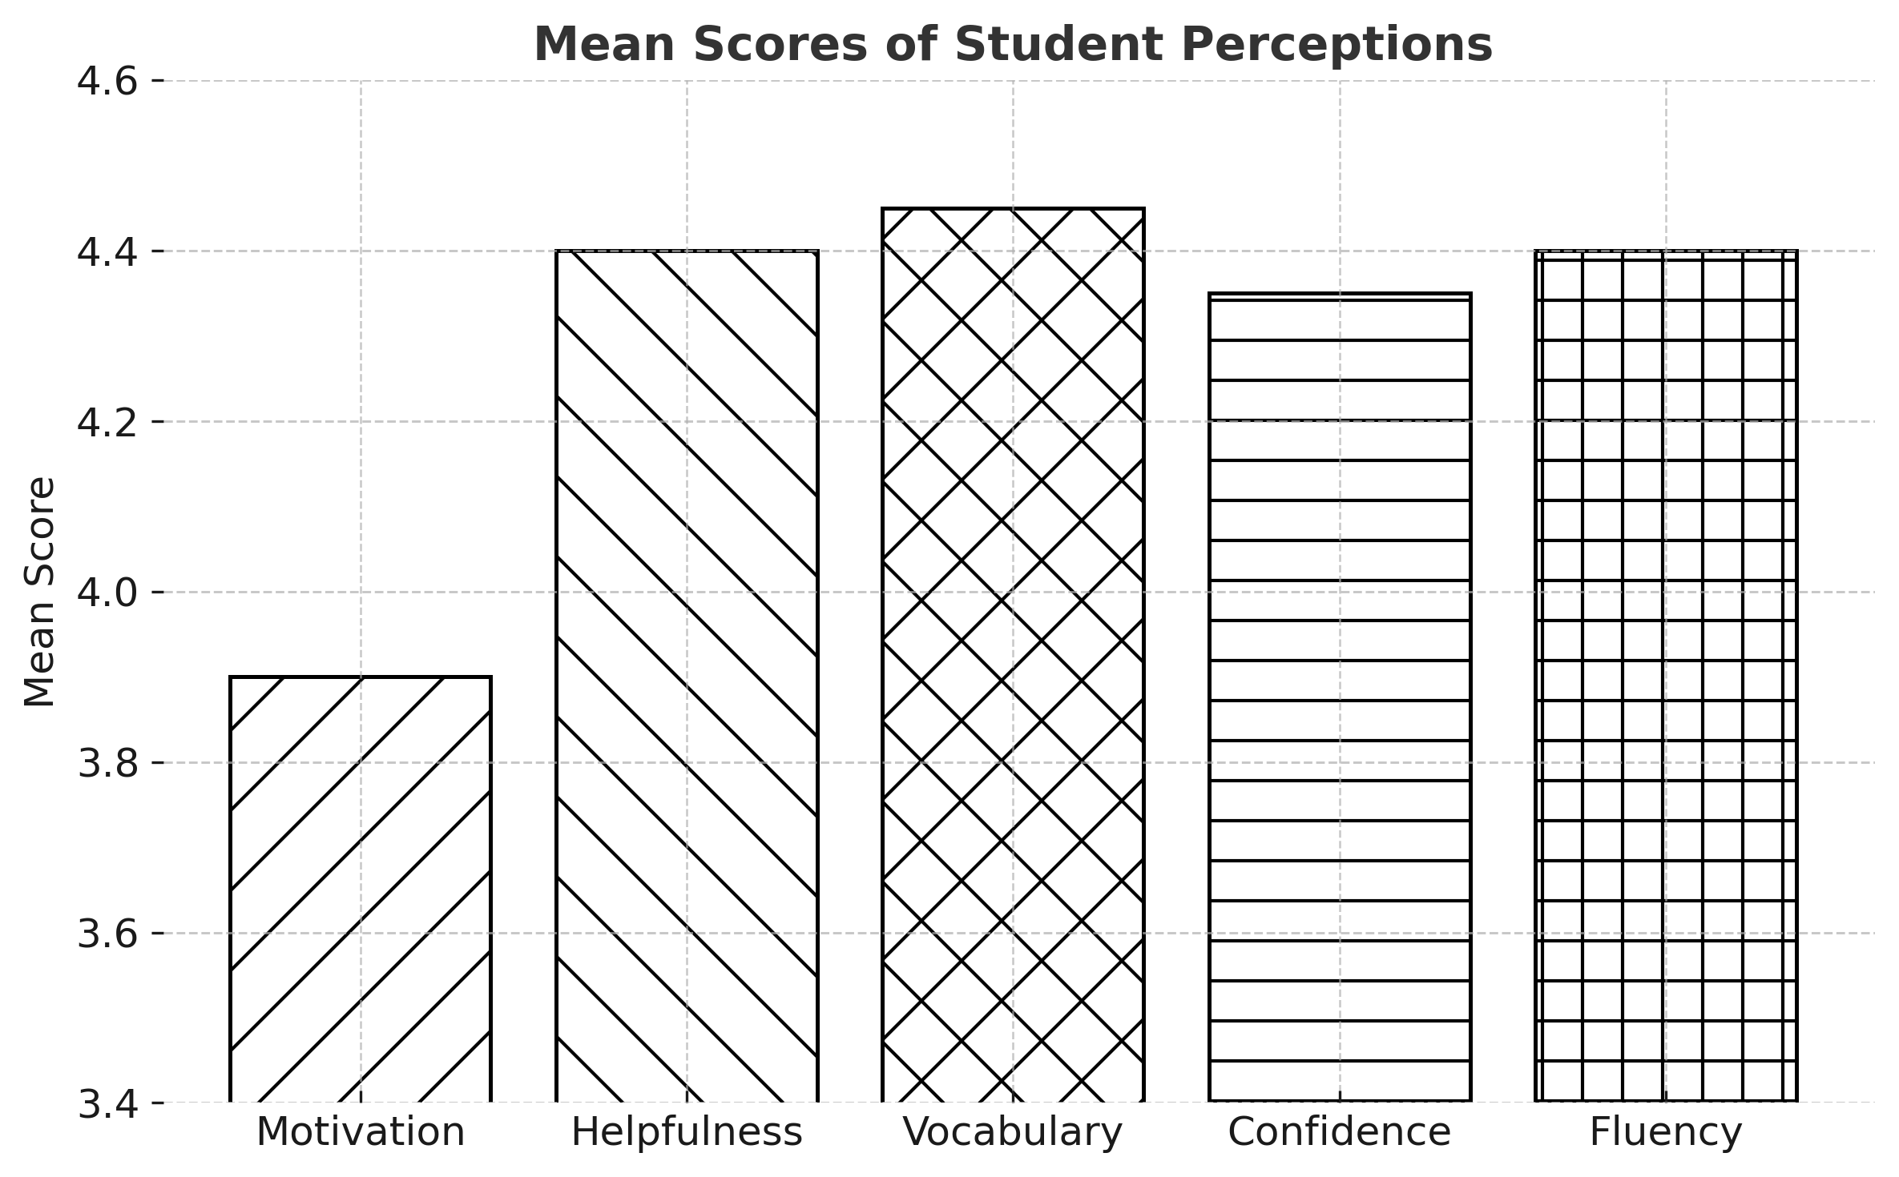

**Figure 1.** Mean scores of student perceptions toward AI chatbots across key language learning dimensions

**4.2.2. Research Objective 2: Teacher perceptions and limitations toward AI chatbot integration.**

In this section, I address Objective 2 and further test Hypotheses 2 and 2a. To test H2, I conducted a one-sample *t* test on the computed variable teacher perception, which aggregated responses from items evaluating teachers’ perceived pedagogical value of chatbots.

**Table 5.** One-sample T test for teachers’ perceptions toward chatbots

| **Variable** | **Mean** | **T** | **df** | **Sig. (2-tailed)** | **Mean Diff.** | **95% CI (Lower–Upper)** |
| --- | --- | --- | --- | --- | --- | --- |
| Teacher perception | 4.08 | 31.70 | 61 | < .001 | 1.078 | 1.01–1.15 |

According to the results shown in Table 5, the mean value of 4.08, coupled with a statistically significant result (*p* < .001), supports H2. Teachers showed favorable attitudes toward chatbots’ potential to enhance language learning.

**Table 6.** Effect size of teacher perceptions

| **Metric** | **Value** | **95% CI (Lower–Upper)** |
| --- | --- | --- |
| Cohen’s *d* | 4.03 | 3.27–4.78 |
| Hedges’s *g* | 3.98 | 3.23–4.72 |

Cohen’s *d* and Hedges’ *g* indicate a very large effect size as shown in Table 6, confirming that the deviation from neutrality is not only statistically significant but is practically meaningful. To test H2a, I used Spearman’s correlation coefficient to explore the relationship between teacher limitation (perceived limitations in using AI) and experience. I used statement 10, “My teaching experience influences how I perceive AI tools,” as a proxy for experience because it directly reflects the respondent’s self-assessed influence of their teaching tenure on their AI-related attitudes, aligning with H2a’s conceptual focus. Table 7 shows the test results.

**Table 7.** Spearman’s correlation between experience and perceived limitations

| **Variables** | **Ρ** | **Sig. (2-tailed)** | **N** |
| --- | --- | --- | --- |
| Experience × Limitations | −0.182 | 0.158 | 62 |

I found no significant correlation between teaching experience and perceived limitations of AI chatbot usage (*p* = .158). The weak, negative, and nonsignificant correlation (ρ = −0.182, *p* = 0.158) suggests that the number of years a teacher has taught does not have a strong influence on perceived limitations, thus not supporting H2a. Teachers demonstrate a statistically and practically significant positive perception toward chatbot integration, supporting the notion that the teaching cohort recognizes pedagogical value. However, teaching experience does not appear to influence perceived limitations, indicating that challenges may stem more from institutional support or platform design rather than individual experience. I created a boxplot (Figure 2) to explore the relationship visually between teachers’ perceived teaching experience influence and their views on AI chatbots’ limitations. Figure 2 shows slight variation in perceived chatbot limitations across teacher experience levels; however, I found no significant association. This suggests that teachers’ perceptions of AI limitations remain relatively stable, regardless of their self-reported teaching experience, and thus does not support H2a.

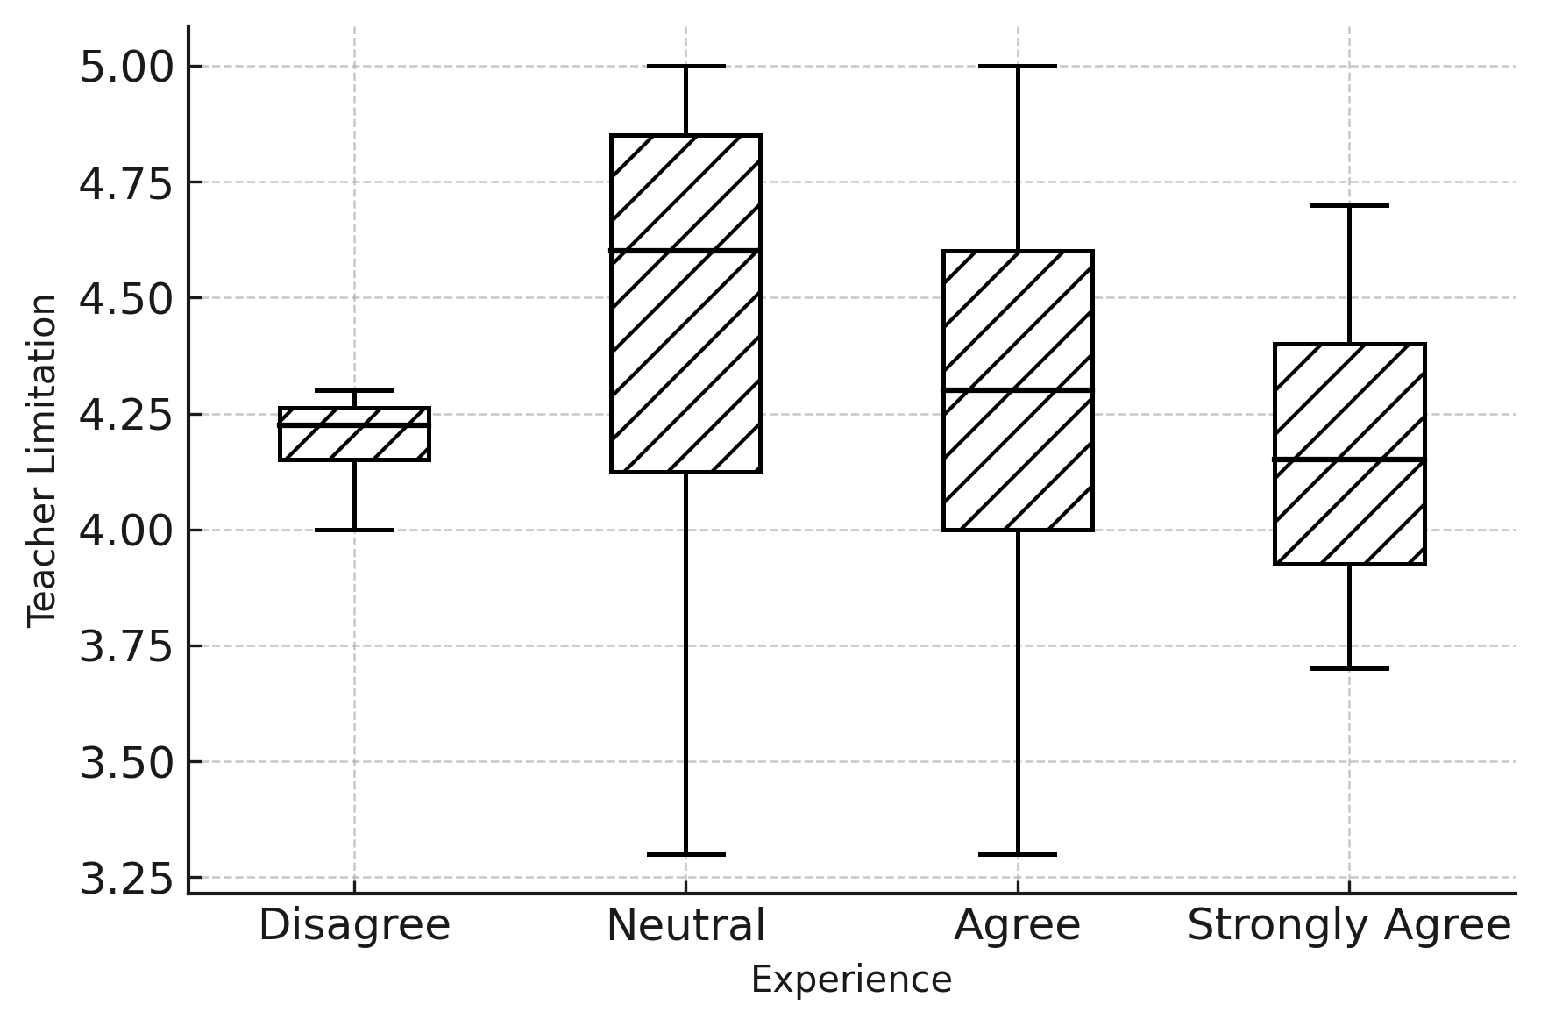

**Figure 2.** Boxplot indicating slight variation in perceived chatbot limitations across teacher experience levels

**4.2.3. Research Objective 3: Perceived benefits, challenges, and risks associated with using AI chatbots for English conversation practice.**

In the third objective, I aimed to scrutinize and compare how learners and teachers perceive the benefits, challenges, and risks of using AI chatbots in English conversation practice. These acumens are critical for understanding how different stakeholder groups receive such technologies and for informing implementation strategies in Saudi EFL classrooms. To address this objective, I first used descriptive statistics (depicted in Tables 8 and 8a) to assess perception trends within each group, followed by a Mann–Whitney U test to evaluate differences in perceived risk between students and teachers.

**Table 8a.** Descriptive statistics—Teachers (N = 62)

| **Variable** | **Minimum** | **Maximum** | **Mean** | **Std. Deviation** |
| --- | --- | --- | --- | --- |
| Benefits | 3.50 | 4.75 | 4.2540 | 0.26968 |
| Challenges | 3.00 | 5.00 | 4.1694 | 0.49542 |
| Risks | 4.00 | 5.00 | 4.5000 | 0.32643 |

**Table 8b.** Descriptive statistics—Students (N = 226)

| **Variable** | **Minimum** | **Maximum** | **Mean** | **Std. Deviation** |
| --- | --- | --- | --- | --- |
| Benefits | 3.43 | 5.00 | 4.3824 | 0.26894 |
| Challenges | 1.00 | 5.00 | 3.7942 | 0.95378 |
| Risks | 1.00 | 5.00 | 3.7743 | 1.00109 |

The results depict that both students and teachers acknowledged high benefits, with students rating them slightly higher (M = 4.38) than teachers did (M = 4.25). However, teachers reported higher perceived risks (M = 4.50) compared to students (M = 3.77). Similarly, teachers perceived more challenges (M = 4.17) than students did (M = 3.79), suggesting that educators are more cautious or critical in their assessment of AI chatbot use.

**4.3 Mann–Whitney U test: Group comparison on perceived risk**

To test H3 and H3a, I conducted a Mann–Whitney U test to examine whether a statistically significant difference exists between students’ and teachers’ perceptions of risk associated with using AI chatbots for English conversation practice. I chose this non-parametric test due to the ordinal nature of the Likert-scale data and the unequal sample sizes between the two groups. Tables 9 and 9a show the perceived risk scores between students and teachers.

**Table 9.** Ranks of risk scores by group

| **Group** | **N** | **Mean Rank** | **Sum of Ranks** |
| --- | --- | --- | --- |
| Students | 226 | 129.56 | 29,281.50 |
| Teachers | 62 | 198.94 | 12,334.50 |

**Table 9a.** Mann–Whitney U test results

| **Test Statistic** | **Value** |
| --- | --- |
| Mann–Whitney U | 3630.500 |
| Wilcoxon W | 29281.500 |
| Z | −6.082 |
| Asymp. Sig. (2-tailed) | < 0.001 |

According to the values depicted in Tables 9 and 9a, a statistically significant difference exists in the perceived risk scores between students and teachers (U = 3630.5, Z = −6.082, p < .001), indicating that the two groups did not share the same level of concern regarding the use of AI chatbots. Specifically, the mean rank for teachers (198.94) was substantially higher than that for students (129.56), suggesting that teachers consistently rated risk-related items more negatively. This finding provides strong support for Hypothesis 3 (H3), confirming that a significant perceptual gap exists. Moreover, Hypothesis 3a (H3a) is also validated because teachers indeed reported higher levels of perceived risk than students did. I formulated a boxplot (Figure 3) to compare the perceived risks of AI chatbot use in EFL education between the two user groups. The boxplot visualizes the distribution of risk perception scores (on a 5-point Likert scale) for students and teachers participating in the study. The results suggest that while students expressed mixed feelings about potential risks (some even downplaying them), teachers tended to perceive AI chatbots as riskier, possibly due to concerns around misinformation, over-reliance, or pedagogical control. This highlights the importance of addressing teacher concerns in the effective integration of AI tools into language classrooms.

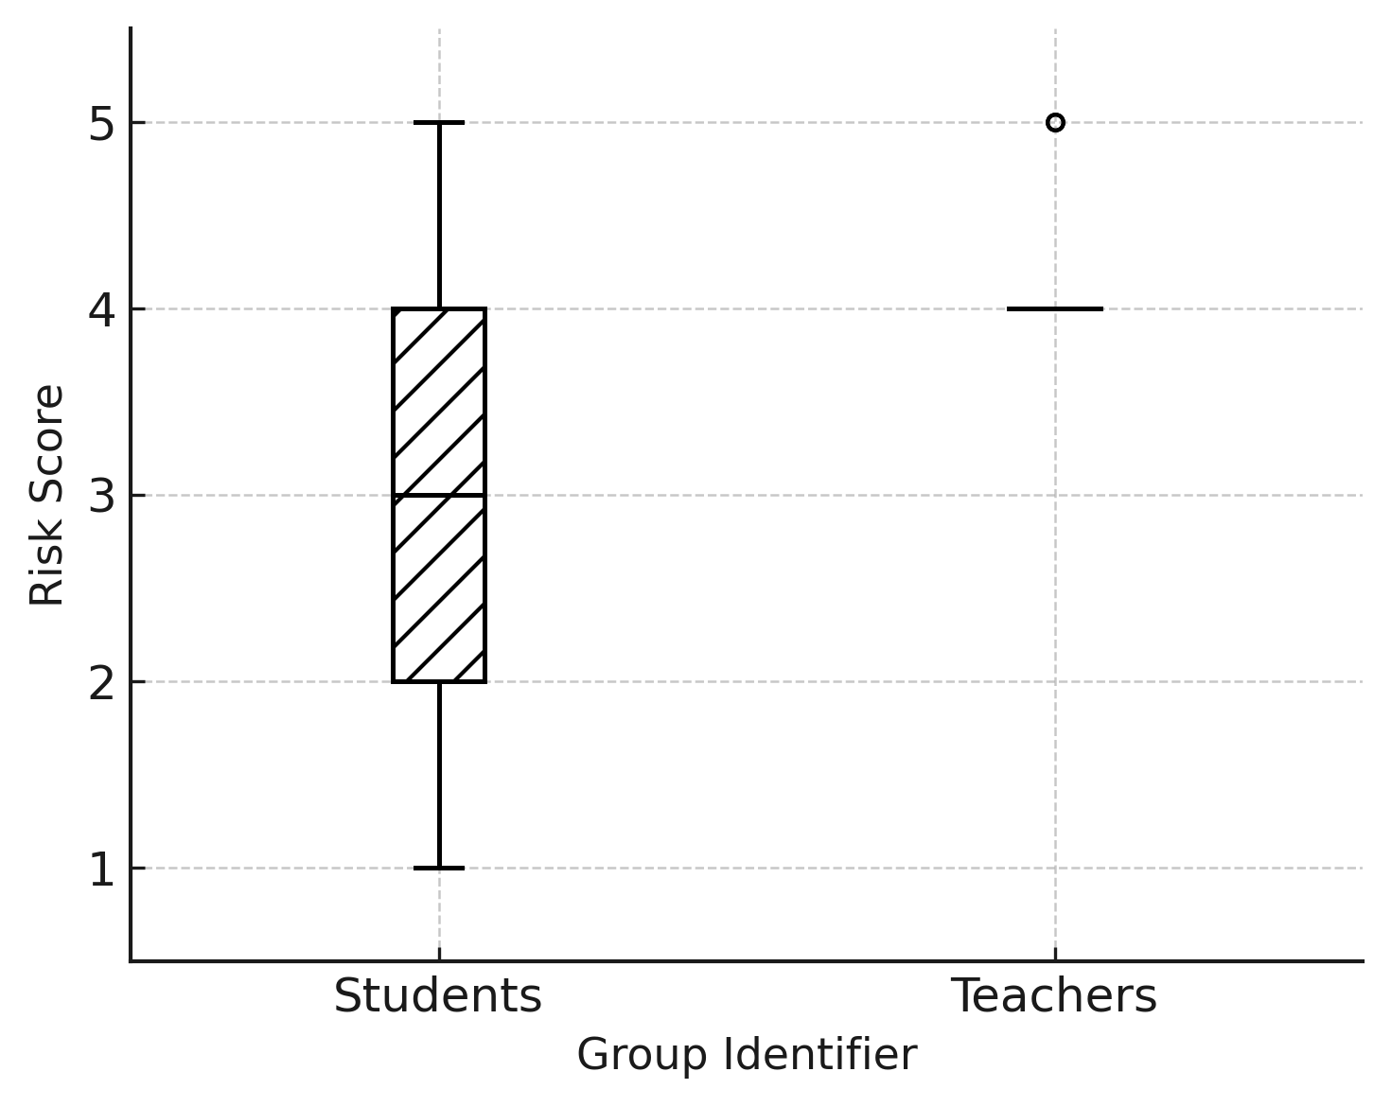

**Figure 3.** Group-wise comparison of risk perception toward AI chatbots among students and teachers

**4.4 Qualitative analysis: Exploring perceived benefits, challenges, and suggestions for chatbot integration**

In this section, I address Objective 4: “To identify the perceived benefits, challenges, and recommendations related to AI chatbot use in English conversation practice.” The qualitative analysis complements the quantitative data results for Objectives 1–3 by providing a richer understanding of students’ and teachers’ experiences. It grounds nuanced perceptions, contextual challenges, and practical recommendations, and as such, guides more contextualized, learner-centric recommendations for the targeted deployment of AI chatbots in English language classrooms.

**4.5 Thematic analysis method**

I evaluated the qualitative responses—226 from students and 62 from teachers—through an inductive thematic analysis process. I initially employed open coding to identify patterns of ideas, keywords, and phrases within the responses. I then grouped the codes thematically into categories showing major trends across groups of participants. I used thematic analysis to derive themes directly from the data, without imposing preexisting categories, so that the real perspectives could emerge. I generated the students’ and teachers’ maps separately to show where their perceptions differed and where they were the same. This approach enabled an experience-based interpretation of perceptions, barriers, and suggestions regarding the use of AI chatbots in EFL settings.

**4.6 Key themes from learners’ responses**

Based on thematic analysis of the qualitative responses from 226 learners, I identified four main themes that represent different but interconnected experiences of using AI chatbots for English conversation practice. An inductive coding process clustered students’ perceptions into themes centered on emotional comfort, technological limitations, fluency enhancement, and pedagogical recommendations. Table 10 shows excerpts of student responses relevant to themes.

**Theme 1: Improvements in Fluency and Vocabulary.** Many learners highlighted that AI chatbots aided them with vocabulary retention as well as fluency in spontaneous dialogue. Several found reduced barriers in forming sentences and applying novel vocabulary in proper contexts, and many pointed out how the chatbots’ casual backdrop enhanced their language experience.

**Theme 2: Confidence and Anxiety Reduction.** Chatbots offered an emotionally safe space that enabled students to participate without worrying about peer judgment. This created a risk-free environment and was a much larger participatory space, particularly for those who suffered from speaking anxiety.

**Theme 3: Challenges with Understanding and Relevance.** While there were positive outcomes, some learners noted downsides, including chatbots’ repetitive, irrelevant responses. They viewed these limitations as obstacles to authentic language practice and at times made the interaction unnatural or unable to simulate real-life contexts.

**Theme 4: Suggestions for Effective Use.** Students suggested improvements, such as a recommendation for teachers to incorporate chatbot activities into regular lessons. Several emphasized that feedback from a teacher in conjunction with AI usage may be important in making the chatbot experience more pedagogically effective. To support these findings, Table 10 shows representative quotes from students that align with each of the themes.

**Table 10.** Students’ quotes in accordance with themes



**4.7 Key themes from teachers’ responses**

Thematic analysis of the 62 teachers’ open-ended answers revealed three major themes related to practical issues and pedagogical issues of using AI chatbots in English language teaching and learning. The themes identified through inductive thematic coding provided empirical grounding for the study’s second and fourth research objectives. Table 11 shows excerpts of teacher responses relevant to these themes.

**Theme 1: Perceived Pedagogical Value.** Many teachers recognized the potential of AI chatbots to support speaking fluency, learner autonomy, and classroom engagement. They described the tools as effective supplements for oral practice, especially for shy or underperforming students. This perception aligns with Hypothesis 1 (positive teacher perception) and Hypothesis 2 (acknowledging pedagogical utility).

**Theme 2: Observed Risks and Limitations.** While teachers recognized some benefits to using these chatbots, they also raised a range of issues. Most notable were students’ overdependence on chatbots, the superficial nature of chatbot responses, and the possibility of misinterpreting tone or nuance in learners’ AI responses. These responses lend further support for the quantitative findings under Objective 3, especially with respect to perceived risks.

**Theme 3: Recommended Practices for Integration.** Teachers shared meaningful strategies for integrating chatbots pedagogically. Recommendations included matching chatbots with role-play activities, implementing chatbots out of class, making reflective journals, and helping students examine chatbot errors. These proposals coincide with the focus in Objective 4, which is the application of those practices in the actual classroom. Table 11 provides examples of selected quotes from teachers to illustrate these themes.

**Table 11.** Teachers’ quotes in accordance with themes



**4.8 Synthesis and triangulation of findings**

In this section, I combine the quantitative and qualitative results to provide a holistic view of AI chatbot use in English language education. Learners’ qualitative reflections demonstrated enhanced fluency, greater vocabulary retention, and increased confidence, thus solidifying perception scores that were not only statistically significant but also positively correlated in *t* tests (Objective 1—my hypotheses H1 and H1a). Learners mentioned being able to “speak without fear,” which manifestly validates the chatbots’ potential to prepare learners for spoken English. Teachers’ narrative responses regarding Objective 2 were reflected in the descriptive and correlational results**.** They acknowledged some pedagogical advantages but expressed concerns regarding certain limitations, especially with respect to providing feedback that offers depth and tone interpretation. This knowledge resonates with the experience-related patterns in the quantitative data, thus reinforcing H2 and H2a.

The Mann–Whitney U results for Objective 3 indicated that students’ and teachers’ risk perception differed, with teachers being more risk-averse. This is inconsistent with the qualitative feedback about risks such as overdependence, technical inaccuracy, and relevance of content. Finally, both datasets fulfilled Objective 4. Teachers promoted structured integration, and students recommended contextual improvements with feedback mechanisms. Collectively, these cross-validated findings provided compelling and actionable guidance for the responsible, ethical, and pedagogical use of AI chatbots in the classroom.

**5. Final Reflection**

The triangulation of quantitative and qualitative data in the analysis section offers a comprehensive insight into AI chatbot integration in Saudi EFL classrooms. While learners perceived chatbots positively regarding fluency and confidence, teachers recommended a cautious and guided implementation of these innovative sources. The results confirm all three hypotheses, specifically answer the four research objectives, and provide database recommendations for pedagogy-based, context-sensitive chatbot use in future English language instruction.

In this section, I interpret and contextualize this study’s findings within existing literature and theoretical frameworks, and I discuss the implications of key results for EFL practice.

**5.1 Interpretation of key findings**

Learners were generally appreciative of AI chatbots, with the results strongly supporting all hypotheses regarding the chatbots’ utility in enhancing fluency, vocabulary, and overall confidence. This is consistent with previous literature that has highlighted AI’s role in reducing anxiety and supporting learner autonomy (Çelik and Gürsoy 2020). However, teachers were more cautious, believing that the risks of using a chatbot were greater. The negligible correlation I found between teaching experience and perceived limitations (Hypothesis 2a)—although unexpected—indicates an alternative possibility that institutional and cultural factors, rather than individual teacher experience, drive teacher caution (Nguyen 2023). The gulf between the students’ eagerness and their teachers’ hesitance points to a fundamental pedagogical void. While both learners and teachers are interested in autonomous, non-evaluative learning interactions, teachers seem to prefer deeper, more contextualized learning, perhaps due to issues of chatbot accuracy and pedagogical effectiveness. Such dichotomous views, however, highlight the challenges of integrating AI tools effectively into Saudi EFL classrooms.

**5.2 Integration with existing literature**

This study provides further evidence and extends previous research on the integration of AI chatbots in CALL and language education settings. Similar results, indicating positive perceptions toward the effectiveness of chatbots in helping learners with their fluency, vocabulary, and confidence levels, align closely with previous research. In a similar vein, Kang and Sung (2024), Qiao and Zhao (2023), and Jeon (2024) found significant gains in learners’ speaking performance with the use of AI-mediated speaking interactions. In addition, learners’ increased motivation and lowered anxiety levels align with previous researchers, such as Çelik and Gürsoy (2020), who noted that chatbot interactions provide low anxiety and higher willingness to communicate.

Conversely, teachers held tentative views on chatbot integration, primarily expressing concerns regarding misinformation, shallow feedback, and risk of learners over-relying on chatbots. Teachers’ hesitancy regarding chatbot limitations, however, is also reflected in studies by Nguyen (2023) and Zainuddin (2024) that echoed this similar caution. Notably, the present study provides little evidence to support the notion that teaching experience shapes perceptions of chatbot limitations, which is contrary to previous findings in the literature (Jeon 2024; Nguyen 2023). The unanticipated outcome suggests that teachers’ cautious approach might stem more from broader institutional, pedagogical, or cultural factors than from individual experience alone.

Furthermore, unlike most studies focused on learners (e.g., Amirkhani and Hosseini 2025; Huang et al. 2022), my study contributes to the literature by investigating both learner and teacher perspectives. In particular, results on chatbot-enabled learner autonomy and emotional engagement represent a significant elaboration of earlier findings by Siyan et al. (2024) and Wiboolyasarin et al. (2025), which highlight the most important facets related to learner acceptance. At the same time, teachers’ concerns about chatbots’ limited empathy and responsiveness correspond closely to the results of Yoo et al. (2025) that highlight the importance of adequate training and explicit guidelines in pedagogical integration.

Finally, this study addresses the research gap identified by Al Husaini and Qutub (2025), who called for more research on the use of AI chatbots in the context of Saudi Arabian education, which has received relatively little attention. Methodologically, I used this study to add to the already growing AI-in-EFL literature by employing a mixed-methods approach and emphasizing the need for a simultaneous focus on learner interest in the use of AI technology and teacher concerns respecting such uses (Apriani et al. 2024; Safar and Anggraheni 2024). Together, these insights offer a detailed, multifaceted perspective necessary for achieving the potential of integrating AI chatbots into language education.

My findings align with the theories that informed the research. I explored the encouragement that learners received on chatbot usefulness and helpfulness because it closely aligns with TAM, in which researchers have shown that perceived usefulness has a strong effect on technology adoption (Davis, 1989; Huang et al. 2022). In the same vein, the increase in learner motivation and learner autonomy also supports SDT, which confirms that satisfaction of learners’ needs for autonomy, competence, and relatedness facilitates intrinsic motivation (Deci and Ryan 2013; Qiao and Zhao 2023). The prominent caution reflected by teachers’ expressed risk perceptions aligns well with TTAT because a perceived technological threat triggers avoidance behavior (Liang and Xue 2009; Nguyen 2023). Such theoretical connections provide a strong lens through which to interpret the attitudes and behaviors observed, adding conceptual consistency to the study. Aggregated, they provide empirical support for the multi-framework perspective focused on AI chatbot integration in EFL education.

**5.3 Pedagogical implications**

The results provide important implications for EFL teachers, curriculum developers, and policymakers who might incorporate AI chatbots into language learning. Chatbots have been beneficial for fluency, vocabulary, or even learner independence, especially in warm-up or follow-up tasks, due to students’ motivation and positive attitudes. Nevertheless, teachers raised alarms about reliability and teaching design, indicating the need for balanced adoption. Curriculum developers will need to offer explicit training and guidelines on how to integrate these tools into classroom practices, while policymakers must ensure the ethical use and privacy of student data. Professional development and clear strategies for bridging gaps are required to support effective, context-appropriate chatbot adoption in Saudi EFL classrooms, ensuring that they work in synergy with, not in derogation of, human instruction.

**6. Conclusion**

**6.1 Final reflections**

In this study, I investigated the perceptions of Saudi EFL teachers and learners regarding the use of AI chatbots for practicing conversational English by employing a convergent mixed-methods design. Findings showed that both groups had positive attitudes toward chatbots as a tool for developing speaking fluency, vocabulary, and boosting confidence. Chatbots offered a low-anxiety, autonomous practice environment that learners found beneficial, especially when they perceived chatbots as helpful motivators. Teachers also recognized these benefits, but their responses were more cautious; they noted possible risks, including misinformation, lack of context, and other factors (e.g., pedagogical suitability). Statistical analyses indicated that teachers and learners differed significantly in their perceptions of risk, while perception of risk with respect to limits revealed that the teacher’s experience has not been significantly correlated. Qualitative insights complemented these findings, emphasizing the spectrum of perceptions within each group and the challenges inherent to the implementation of AI in education.

**6.2 Implications of study**

The results provide a range of new implications for the theory and practice of language education. Theoretically, the study validates the applicability of TAM, SDT, and TTAT frameworks in explaining educational stakeholder acceptance of educational AI. From a practical standpoint, learner attitudes toward chatbots were positive, demonstrating promising potential for implementing these tools as additional practice in speaking activities. However, the fact that teachers expressed a cautious perception indicates that carefully crafted and pedagogically sound strategies for integrating digital technologies are necessary, along with professional development programs to ensure teachers have the skills and self-confidence to integrate these digital technologies effectively. Balancing behavior in this way suggests that the implementation of AI chatbots can only be successful when both the learner’s motivation and the teacher’s concerns are addressed.

**6.3 Recommendations**

Drawing on these insights, I can offer several recommendations concerning what constitutes a truly effective chatbot. Educational institutions need to adopt a hybrid approach where chatbots act as complementary tools together with teacher-led instruction. This would help overcome the limitations identified and respond to teachers’ fears, by allowing them to keep the pedagogical reins. Alongside this, workshops that specifically emphasize the ethical use of chatbots in the classroom are necessary to prepare teachers. To address the communicative needs of language learners better, chatbot developers need to build on the responsiveness, cultural adaptability, and emotional engagement abilities of chatbots. Finally, legislators need to develop specific regulations on how to use AI in Saudi EFL contexts ethically and effectively.

**6.4 Limitations and Future Directions**

Despite its contributions, the study has some limitations. The cross-sectional design limited insights into long-term impacts of chatbots and the behavioral changes that result. The reliance on self-reported data could introduce response biases, and the findings might not generalize beyond Saudi tertiary educational contexts. Future research should include longitudinal studies assessing actual chatbot use over time, intervention-based experiments examining specific pedagogical outcomes, and comparative studies across diverse cultural contexts. Further exploration of affective dimensions, such as emotional engagement and empathy in chatbot interactions, would also significantly enhance the understanding of AI’s potential in language education.

**Data (if relevant)**

To ensure broad dissemination of results, the authors are invited to state briefly the availability of their data (if accessible; cf. Instructions for Contributors).

**Acknowledgements (if relevant)**

Acknowledge, if necessary, financial support or external contributions (e.g. colleagues).

Author contributions (if relevant)

List, if necessary, the contributions of each author in this article.

Ethical statement and competing interests (required)

All papers should be accompanied by a short (50-80 words) statement referring to any external validation of the experiment design, volunteer status of participants, anonymity, competing interests, etc., in accordance with practices in their country. If no competing interests exist, the declaration should also include the following statement “The author(s) declare(s) no competing interests.”

**References**

Haifa Fayez Al Husaini & Huda Qutub. 2025. Exploring the use of AI writing assistant for foreign language learners: A mixed-methods study in the Saudi EFL context. *English Language Teaching* 18(6): 14–30. <https://doi.org/10.5539/elt.v18n6p14> (accessed 10 July 2025)

Abeer Alyami, Sara Alotaibi, & Waheeda Khan. 2025. Saudi EFL learners’ perceptions of using Artificial Intelligence and its impact on their writing skills. *Arab World English Journal* 16(1). <https://ssrn.com/abstract=5203107> (accessed 10 July 2025).

Zahra Amirkhani & Ali Hosseini**.** 2025. Exploring AI chatbot affordances in EFL higher education: Impacts on language proficiency, usability, engagement, and perceived effectiveness. *International Journal of Multicultural and Multireligious Understanding* 12(3): 683–696. <https://www.researchgate.net/publication/390549390> (accessed 12 July 2025).

Esti Apriani, Luisa Cardoso, Ahmed J. Obaid, Endang Wijayanti, Fitri Esmianti & Dewi Supardan. 2024. Impact of AI-powered chatbots on EFL students’ writing skills, self-efficacy, and self-regulation: A mixed methods study. *Global Educational Research Review* 1(2): 57–72. <https://journal.myresearch.id/gerr/article/view/8> (accessed 12 July 2025).

Mehmet Ballıdağ & Selami Aydin. 2025. A comparison of the effects of AI-based chatbots and peer interactions on speaking anxiety among EFL learners. *Foreign Language Annals* 3(2): 224–238. <https://doi.org/10.1002/fer3.70005> (accessed 08 July 2025).

Virginia Braun & Victoria Clarke. 2006. Using thematic analysis in psychology. *Qualitative Research in Psychology* 3(2): 77–101. https://doi.org/10.1191/1478088706qp063oa (accessed 09 July 2025).

Michael Canale & Merrill Swain. 1980. Theoretical bases of communicative approaches to second language teaching and testing. *Applied Linguistics* 1: 1–47. <https://doi.org/10.1093/applin/I.1.1> (accessed 08 July 2025).

Serpil Çelik & Esra Gürsoy. 2020. Exploring EFL learners’ speaking anxiety and confidence in technology-enhanced environments. *Language Learning in Higher Education* 10(1): 61–82. <https://doi.org/10.1515/cercles-2020-0005> (accessed 12 July 2025).

Yu-Ching Chien, Ting-Ting Wu, Chia-Hung Lai & Yeuh-Min Huang. 2022. Investigation of the influence of artificial intelligence markup language-based LINE Chatbot in contextual English learning. *Frontiers in Psychology* 13: 785752. <https://www.frontiersin.org/articles/10.3389/fpsyg.2022.785752> (accessed 10 July 2025).

John W. Creswell & Vicki L. Plano Clark. 2018. *Designing and conducting mixed methods research* (3rd ed.). Thousand Oaks, CA: Sage Publications. <https://toc.library.ethz.ch/objects/pdf/z01_978-1-4129-7517-9_01.pdf> (accessed 10 July 2025).

Fred D. Davis. 1989. Perceived usefulness, perceived ease of use, and user acceptance of information technology. *MIS Quarterly* 13(3): 319–340.

<https://www.jstor.org/stable/249008> (accessed 08 July 2025).

Edward L. Deci & Richard M. Ryan. 2013. *Intrinsic motivation and self-determination in human behavior*. New York: Springer.

<https://books.google.com.pk/books?id=M3CpBgAAQBAJ> (accessed 12 July 2025).

Richard Godwin-Jones. 2023. Emerging spaces for language learning: AI bots, ambient intelligence, and the metaverse. *Language Learning & Technology* 27(2): 6–27. <https://scholarspace.manoa.hawaii.edu/bitstream/10125/73450/1/godwin-jones.pdf> (accessed 12 July 2025).

Weijiao Huang, Khe Foon Hew & Leuk K. Fryer. 2022. Chatbots for language learning—Are they really useful? A systematic review of chatbot-supported language learning. *Journal of Computer Assisted Learning* 38(1): 237–257. <https://onlinelibrary.wiley.com/doi/abs/10.1111/jcal.12610> (accessed 10 July 2025).

Jaeho Jeon. 2024. Exploring AI chatbot affordances in the EFL classroom: Young learners’ experiences and perspectives. *Computer Assisted Language Learning* 37(1–2): 1–26. <https://doi.org/10.1080/09588221.2023.2238736> (accessed 10 July 2025).

Sooyeon Kang & Min-Chang Sung. 2024. EFL students’ self-directed conversation practice with AI chatbot. *Language Learning & Technology* 28(1): 1–19. <https://hdl.handle.net/10125/73600> (accessed 12 July 2025).

Hee-Kyung Lee. 2024. Perceptions, integration, and learning needs of ChatGPT among EFL teachers. *Korea TESOL Journal* 20(1): 3–19. <https://koreatesol.org> (accessed 07 July 2025).

Michael Levy. 1997. *Computer-assisted language learning: Context and conceptualization*. Oxford: Oxford University Press. <https://books.google.com.pk/books?id=RRGgrjteVjUC> (accessed 10 July 2025).

Huigang Liang & Yajiong Xue. 2009. Avoidance of information technology threats: A theoretical perspective. *MIS Quarterly* 33(1): 1–90. <https://www.jstor.org/stable/20650279> (accessed 12 July 2025).

Nguyen Thi Chi. 2023. University teachers’ perceptions of using ChatGPT in language teaching. *PAIC Proceedings of the AsiaCALL International Conference* 4: 116–128. <https://doi.org/10.54855/paic.2349> (accessed 08 July 2025).

Hongling Qiao & Aruna Zhao. 2023. Artificial intelligence-based language learning: Illuminating the impact on speaking skills and self-regulation in Chinese EFL context. *Frontiers in Psychology* 14: 1255594. <https://doi.org/10.3389/fpsyg.2023.1255594> (accessed 11 July 2025).

Muh. Safar & Dinni Anggraheni. 2024. Language learning through AI chatbots: Effectiveness and cognitive load analysis. *Journal of Social Science Utilizing Technology* 2(3): 430–445. <https://journal.ypidathu.or.id/index.php/jssut/article/view/1346> (accessed 12 July 2025).

Li Siyan, Teresa Shao, Zhou Yu & Julia Hirschberg. 2024. Using adaptive empathetic responses for teaching English. *arXiv*. <https://arxiv.org/abs/2404.13764> (accessed 13 July 2025).

Viswanath Venkatesh & Hilol Bala. 2008. Technology acceptance model 3 and a research agenda on interventions. *Decision Sciences* 39(2): 273–315. <https://onlinelibrary.wiley.com/doi/abs/10.1111/j.1540-5915.2008.00192.x> (accessed 06 July 2025).

Mark Warschauer. 1996. Computer-assisted language learning: An introduction. In Fotos, Sharlene (ed.), *Multimedia language teaching*, 3–20. Taipei: Logos International. <https://www.ict4lt.org/en/warschauer.html> (accessed 08 July 2025).

Watcharapol Wiboolyasarin, Kanokpan Wiboolyasarin, Phornrat Tiranant, Nattawatt Jinowat & Poomipat Boonyakitanont. 2025. AI-driven chatbots in second language education: A systematic review of their efficacy and pedagogical implications. *Ampersand* 14: 100224. <https://www.researchgate.net/publication/391762415> (accessed 10 July 2025).

Nugraheni Widianingtyas, Thomas Wahyu Prabowo Mukti & Ronald Maraden Parlindungan Silalahi. 2023. ChatGPT in language education: Perceptions of teachers—A beneficial tool or potential threat? *Voices of English Language Education Society* 7(2): 279–290. <https://e-journal.hamzanwadi.ac.id/index.php/veles/article/view/20326> (accessed 08 July 2025).

Ting-Ting Wu, Intan Permata Hapsari & Yeuh-Min Huang. 2025. Effects of incorporating AI chatbots into think-pair-share activities on EFL speaking anxiety, language enjoyment, and speaking performance. *Computer Assisted Language Learning*: 1–39. <https://www.tandfonline.com/doi/abs/10.1080/09588221.2025.2478271> (accessed 12 July 2025).

Minju Yoo, Hyoungwook Jin, Juho Kim. 2025. How do teachers create pedagogical chatbots? *arXiv*. <https://doi.org/10.48550/arXiv.2503.00967> (accessed 10 July 2025).

Muhammad Zainuddin. 2024. Teachers’ perceptions of AI tools in enhancing student engagement. *Research Studies in English Language Teaching and Learning* 2(6): 367–380. <https://doi.org/10.62583/rseltl.v2i6.64> (accessed 12 July 2025).