Reflections on Language and Literature: Exploring the Folklore of Foreign Professionals through an English Proficiency Course
Vedera M¹,Gundagani L²
^{1,2}Department of Materials Development, Testing, and Evaluation,School of ELE,Central University,Tarnaka,Rangareddy District,India.
Email: bbsuma.prof@gmail.com
Abstract:
Language and thinking, the closely connected models have often resulted in identifying the capacity of one's self through the mastery of one's language (Kelly, 1996:11). Language plays an important role in bridging cultural gaps and enabling global conversations. English language provides a comprehensive analysis of the world around us. Discourse Analysis allows us to examine the language for constructing social identities, and cultural norms. Similarly, literature provides a language model and fosters language development. It not only helps to improve English language proficiency to express emotions, expand vocabulary and understand cultural competence but also engages in a deeper portrayal of interpretation, creative and critical thinking. English Language and literature constructs and negotiates cultural, gender, class, and social identities. A blend of language development with the literary interpretations of various genres infused with technology-enabled instruction, collaborative and interactive approaches have not only resulted in sharing language competency but also raised cultural awareness among the participants belonging to developing nations working in different capacities as auditors, doctors, diplomats, engineers, ministers, and members of parliament, lawyers, pilots, police officers, teachers, scientists, secretaries, and journalists. This blended approach has given positive motivation and resulted in expressing the cultural identities of the participants in music, places, songs, dances, and customary practices at the Internal Training Program (ITP) through the Progress to Proficiency English Course conducted at the English and Foreign Languages University. The classroom activity to improve the presentation skills among the participants created a memorable experience in comprehending the folklore of various countries of Africa, South Asia, South East Asia, Central Asia, and Latin America. The present research focused on the presentation abilities using PPT slides by sharing the folklore in customary narratives, religious beliefs, and conventional approaches of some developing nations.

Key Words: Language, Literature, Communicative Proficiency, Folklore, Folkloric Schedule, Developing Countries, Internal Training Program (ITP).

1. Introduction:
The primary objective of the International Training Programme (ITP) offered at EFLU is to make the participant progress from basic to proficient levels in English. It has three levels: Basic, Intermediate and Advanced levels. The Ministry of External Affairs, Government of India, funds the program through ITEC scholarships to developing countries in Africa, South Asia, South East Asia, Central Asia, and Latin America for enhancing LSRW skills, grammar, and vocabulary development. Each course runs for 12 weeks.
The present research focused on 22 participants who belonged to B1 and B2 levels as per the Common European Framework of Reference (CEFR) framework.
2. Objectives of Speaking Skills:
The main learning objective was to improve speaking skills among the participants. The learning environment in the classroom considered the activities to improve their speaking skills such as short introductions; describing places, and people; giving directions; role plays; group discussions, and presentations. The specific learning objectives were to make the participant
- interact and introduce themselves in a semi-formal conversation
- use descriptive language to talk about people, places, and objects
- take part in conversations and role-play scenarios and familiarize them with simple to advanced workplace situations such as ordering food, booking appointments, analyzing reports, and conducting meetings
- deliver presentations using multimedia facilities.
All the participants met one another for the first time. The participants actively engaged in their professional careers working at different administrative levels. They had never visited the places of the co-participants earlier. However, experiencing their language identities, cultural differences and traditional routines resulted in not just improving their language proficiency but also carried a long-lasting impression of different customs, and long-established conventions. The interactive, collaborative classroom speaking activities exposed them to the historical, standard, and classic folklore of various countries. As the participants progressed from the self-introduction stage to delivering presentations towards the end of the training program, they shared the folklore using PowerPoint presentations.
A majority of the participants have not delivered any presentations using multimedia technologies. According to the multimedia principle, verbal explanations with non-verbal knowledge representations improve the comprehensive level of the learners. (Mayer 2001). The research provided the participants with the multi modal learning environment to create effective PowerPoint presentations.. Hence a visually appealing environment infused with smart classroom facilities engaged the participants to deliver multimodal presentations.

3. Literature Review:
Taylor, Eric K. (2006), recommends the following methods for improving speaking skills through folktales:
- allow the learners to share folktales
- make them write and check for grammatical errors
- ask them to read the folktales
- permit them to revisit, revise, and expand the written folktales
- let them comprehend the vocabulary used in the written folktales and practice it
- allow them to retell the folktales
- call the students and ask them to share the corrections
- discuss the moral value of the folktales. (Taylor, Eric K. 2006)

Mantra, et al, (2019) observed improvement in the learner's motivation levels and speaking skills while using folktale-based instruction in the English classroom. William John Thomas used the term "folklore" in 1846. Initially meant for "oral peasant tales," it has emerged over time as a major branch of study to understand communities, people, languages, behaviors, and society. The folklore is a rich humanistic and creative approach towards understanding the legendary and customary narratives; expressing religious customs, proverbs, rituals, and mythological beliefs; exchanging traditional and folk songs, music, and tales; and realizing the ethnic groups, their identities, lifestyles, foods, recipes, popular destinations, and many more.
According to Kirshenblatt-Gimblett, folklore is "the study of a particular mode of cultural production." Laurence Gomme in his work 'Folklore as an Historical Science' written in 1908 defined folklore as "a reconstruction of prehistoric periods of human civilizations, traditions, and beliefs."
The Finnish historical-geographical methodology reassembles the history of folklore by conducting unbiased and clear investigations of each segment, transcending cultural and linguistic limitations.
The comparative folklorist of the Finnish school followed an organized approach to recording tales from different places and times with substantial evidence rather than depending on the descriptive details, mood, and style of presentation. This study, rather, excerpted the folklore of different countries through descriptive narratives. The research, while not influenced by presentation style, utilized multimodal assets as a presentation technique to codify the cultural and historical descriptions of the participants. Barfield and Uzarski (2009) who were in English teaching programs as foreign languages (EFL) developed curricula by integrating indigenous culture, by taking folktales mostly from the United Kingdom, United States, and Australia. They believe learning English is more relevant to local learners. The familiarity of the folklore material used in the classroom provides a comprehensive understanding to the learner with much faster and easier communication in English.
Guthrie (2013), a researcher from Ontario, Canada who teaches English in secondary schools reported that teaching English acquires local knowledge. The study revealed that the children gained knowledge of local culture through English education leading to practical sessions about students' life learning, self-experiential, self-reflective, and self-evaluation learning.
The academic folklorists currently employ the term, folklore as a ‘cultural register’— on par with the linguistic one; one among a range of possibilities freely available to members of a cultural cohort for cognition, practice, and communication. This means that folklore is observed anywhere and among everyone irrespective of their working status, or their locality – be it a city or a village, a businessperson or a ‘boor’.

4. Research Method:
In this study, the research focused on the classroom performance of the participants while delivering PowerPoint presentations. The process followed a semi-structured interview. The research design was exploratory as the participants belonged to different cultural, social, and educational backgrounds coming from countries in Africa, Central Asia, Latin America South Asia, and Southeast Asia. The questions were open-ended and conversational to build trust and rapport and encourage honest and detailed responses. The survey considered qualitative analysis which provided interesting facts. Out of 22 participants, 3 participants expressed that they are familiar with PPT presentations. The research introduced PPT presentations using Google PPT slides or Microsoft Office PPT slides. The research appraised content creation, use of discourse markers, aspects of coherence and cohesion, PPT generation, and multimedia materials such as YouTube videos, shorts, and mini-lectures, to enhance their presentations. After the classroom inputs, the participants went to a digital laboratory for hands-on experience. The activity raised enthusiasm among the participants.

5. Literature through Language: Sharing the Folklore
The participants did not have any acquaintance with the other participants before attending the ITP program. They have negligible knowledge of the folklore of other participants' countries. This activity has resulted in sharing the rich cultural and traditional folklore of different developing nations. Here are some engaging and interesting glimpses from their presentations:
a. The Cultural City of Siby
The presentation about Mali engrossed the attention of the participants. It described the beauty of Siby, the warmth of the Siby people, and the benevolent nature of welcoming the tourists. As shown in Figure A, the presentation covered The Arch of Kamandjan, a natural structure, and a protective wall for Siby people. Siby people have historical links with the Mandinka people (the Mandinka or Malinke people, represent the largest subgroup of the Mandé people, one of the largest ethno-linguistic groups in Africa with about 11 million people).
The epic story intrigued the audience with the legendary story of converting the rock into an arch with the sword of Siby king, Kamandjan. In 2018, they submitted the Arch to UNESCO under 'The Mandé Historic Sites and Cultural Landscapes'. The presenter listed the important tourist destinations such as Djendjeni Waterfalls, and Danda Waterfalls.

b. The Chin Nation in Myanmar
The presentation covered the three main prominent features of the Chin nation in Myanmar. It started with a general description of 135 ethnic groups and 8 major national ethnic races. Then, it focused on Hornbills, the faithful birds representing the symbol of the Chin People. The Chin Traditional Bamboo Dance, characterized by the sharp sound of men clapping bamboo placed horizontally at each end of the stage as shown through a YouTube video (https://www.youtube.com/watch?v=VAd5bnfVaoY) and mostly performed on moonlit nights engrossed the attention of the audience. The sound of the bamboo hitting each other sets the rhythm for the dance. The dancers perform a variety of steps, sometimes imitating bird movements or tree swaying. The rich cultural representations of ethnic races and the traditional dances of the Chin nation reveal an energizing and reviving side of the Myanmar people.

c. Mozambique, the land of Pearls
Mozambique, the Land of Pearls has Bazaruto archipelago, the largest marine reserve in Africa. The interesting facts about’ The Dugongs’, also known as sea cows, listed in the critically endangered zone created an emotional connection during the presentation. The audience discovered the Bazaruto Archipelago Important Marine Mammal Area (IMMA), has created a reserve of 16,280 square km for the conservation of these sea cows. The presentation described the entire itinerary and travel plan for Mozambique. The details about traveling costs, accommodation, and food items, especially the popular seafood helped the participants gather information about their travel plans during the Q & A session.

d. Comoros, the Perfume Islands
The presentation briefed about Comoros, the Perfume Islands. The visitors noticed the most spoken languages Arabic, a blend of Swahili, and also the influence of the French language during their visit to Comoros Islands. The presentation introduced Madama, the national food of Comoros; and Cassavaas shown in Figure B, the staple food known as Tapioca. The other popular dishes such as Langouste a la Vanille (lobster with vanilla), Mkatra Foutra (fried bread), Pilaou (spiced rice), and unique ingredients like Vanilla, cloves, and coconut represented a unique cooking style. The presentation highlighted the traditional drumming during festivals and marriage celebrations. It was worth noticing that they preserved their rich tradition of folk tales.

e. Bagan, the land of temples
The presentation mentioned the necessity of conserving and preserving the historical sites which are the archaeological reserves in Bagan. It also briefed different eras-the Ancient era beginning in 2 A.D.; the Golden era during the 9th century with Bagan as the capital city for its historical brilliance and ancient civilization, and the Decline and Destruction representing Bagan’s destruction during the 13th century.

As shown in Figure C, Bagan, the land of Temples portrays 2,000 Buddist temples built with many-tiered towers and Pagodas. The presentation covered famous festivals such as the Ananda Pagoda Festival, meant for worshiping Budda; and the Thingyan Water Festival meant for splashing water on each other. The audience explored the deep-rooted spiritual heritage, cultural beliefs, historical monuments, and ongoing conservation projects. The presentation ended by showing the economic impact of Bagan in the form of tourism covering $100M revenue per annum, employment opportunities with 20k jobs, and new infrastructural developments with 50 new hotels. The presentation concluded by extending a warm invitation to the participants with a concluding remark 'Bagan being designated as a UNESCO World Heritage Site in 2019 is a must-see place'.

f. Vietnamese celebrations
Celebrations and festivals represent Vietnamese folklore. TẾT is the short form of TẾT NGUYÊN ĐÁN or Vietnamese Lunar New Year. The celebrations happen according to the Lunar calendar every day between the end of January and early February. The festival celebrations are similar to the Indian way of celebrations in most festivals like cleaning and decorating the house, buying new clothes, and visiting friends, near and dear ones. The festival celebration gains spiritual attention by visiting a Pagoda, the temple to offer prayers to the Almighty; eat, drink, and sing. Playing cards is one of the entertainment games during the celebrations. One interesting fact is the Vietnamese visit the graves of their ancestors to pay homage to the departed souls. Another interesting fact is the Vietnamese people share ‘Lucky money cards’, a symbolic representation of receiving lucky money. The major food items such as boiled chicken, fried spring rolls, Candied fruits, Five-fruit trays, and melon seeds are customary during such celebrations. The cultural representation of serving Vietnamese square or cylindrical sticky rice cake (Bánh chưng/ Bánh Tét), and Vietnamese braised pork with eggs in coconut juice represents the typical food habits of Vietnamese people. The presentation also covered the customary practice of singing Vietnamese folk songs. The presentation concluded by mentioning the ‘Southeast Asia record of flying 2024 drones’ on the celebration day.

g. CONGO, Voluntary pigmentation
The facts about voluntary pigmentation in Congo gained attention from the audience. Voluntary pigmentation is an individual's initiative to lighten his/ her natural color. This is a well-known practice in Black Africa and is common with black people residing in some parts of Europe and the United States.
As shown in Figure D, the presentation revealed the shocking reasons for voluntary pigmentation, the most common way to avoid inferiority complexes. Most women tend to use chemicals to save their marriage. The presenter said, "Women are afraid that their men will leave them if they do not look beautiful. Divorces happen if the women cannot please men. Men also desire to look handsome but end up with cutaneous burns." Men and women commonly practice voluntary pigmentation leading to demarcation and tingling of the body. Such customary practices also resulted in fatal consequences leading to skin cancer, diabetes, arterial hypertension, and kidney complications. The presentation revealed the facts about beliefs on beauty, cosmetic world influences, and self-identity crises in many individuals.
h. The Kayan Ring, Myanmar women:
The Kayan women, also known as 'Giraffe women' hail from Myanmar. They belong to the Kayan Lahwi tribe and wear brass rings around their necks. This is a typical traditional identity mostly volunteered at the age of five by the young girls from Kayan. The Kyan rings cause major health risks. Since the rings are only half an inch thick, they pull the neck and make the head float above a pedestal of golden chains. The weights of these rings press the collarbone down, while the vertebrae of the spine shrink. The coils affect the back and shoulders. Since the medical facilities are poor, many consume betel nuts, though addictive to get rid of pain.
As shown in Figure E, the female necks are long and slender signifying beauty, grace, and respect. The civil conflict between Karenni and the Burmese government resulted in the Kayan people leaving Myanmar and moving to the northern Thailand hill region. The Thai government placed them in secured villages and they have been a subject of tourism since then. However, the tribe lacks common facilities such as water, electricity, health care, and education. The community also lacks contemporary commodities such as computers and cell phones.
The presentation revealed that the Giraffe women become a source of income as many tourists approximately forty thousand tourists visit to see them each year and take photographs for $8-16 each. The tribe takes this opportunity to sell their artisan crafts.
6. Major Findings:
All the presentations left valuable insights into the folklore of the participants hailing from Africa, South Asia, South East Asia, Central Asia, and Latin America. The activity has led to fostering global citizenship and promoting cross-cultural awareness. The review and feedback shared by the participants revealed the quantitative and qualitative data with unbiased and honest facts.
a. Scores
The researcher tabulated the scores obtained by the participants according to the assessment criteria shown in Table 1. The study did not disclose the names of the participants to maintain confidentiality. One participant scored below 10 marks. The feedback indicated as 'poorly researched with inaccurate and disorganized information with no proper introduction, body, and conclusion; poor visuals with a confusing design; disruptive presentation with poor eye contact, lack of clarity and weak delivery'. Cosequently, following the assessment rubric, 9 participants received 'Good'; 7 received 'Fairly Good', and 5 received 'Excellent' remarks.

b. Recognizing the cultural and traditional values of the co-participants
Likewise, open-ended questionnaires led to deciphering insightful information through a qualitative approach. All the participants unanimously expressed their interest and enthusiasm in discovering the customary, conventional, and diverse lifestyles and living conditions of the participants. The study presents some excerpts.

Participant 1
I love the way ‘Lucky money cards’ distributed in the class after the presentation. The invitation is so special to me. I will remember this throughout my life. Visiting Vietnam is one of my tourist destinations now.”
Participant 2
The Chin bamboo dance represents their keen concentration and rhythmic steps retesting their cultural identity. They symbolize the bird's movements. I would love to learn the dance form.

Participant 3
I'm unaware that Mozambique is also called the land of Pearls. I would love to visit the palace, especially the sea cows. I have a fascination with studying endangered animals. I will make sure to travel to the Bazaruto Archipelago Important Marine Mammal Area (IMMA).

Participant 4
I enjoy traveling. I chose this ITP program not just to improve my English proficiency but also to explore Indian culture and diversity. I heard about India and its multicultural and multilingual contexts. I wanted to explore its music, festivals, and dance. This ITP program helped me understand cultural diversity and these presentations provided a plethora of historical and cultural diversity at the international level.

Participant 5
This has been a truly amazing experience. Knowing my friend's folklore has been an impressive journey. The richness of one's own national diversity, natural scenic beautification, and discovering customs have made me inquire more even during my free time.

Participant 6
Bagan is my place. I'm happy to share the spiritual values of my place. I'm excited to show this rich cultural and traditional face to the other participants. The living conditions and lifestyles are quite different. I want to save my temple and its heritage.

7. Reflections:
The PowerPoint presentations revealed the most noticeable tourist attractions, and customary rituals of the participants, thus allowing us to navigate through some of the world's vibrant cultural identities. The meticulous planning to successfully organize the Internal Training Programme provided an opportunity to experience the other forms of folklore apart from PPT presentations. Some reflections:

a. Indian Folklore
The adage ‘Atithi Devo Bhava’ means 'The guest is God', the principle incorporated into Indian culture signifies the social belief of treating people with hospitality, generosity, and respect. The ITP program depicts the deep-rooted heritage and culturally woven treatment given to the participants by the EFLU team. The team is hospitable and reaches the participants for any queries regarding accommodation facilities, meal preparations, serving practices, and sightseeing arrangements.
The international hostel within the EFLU campus accommodates the ITP participants meeting the standards of an international stay. The campus has a foreign exchange facility during particularly assigned slots to avoid any financial challenges. The participants prepare their food in their respective rooms; and visit local shopping malls for groceries, and other required items. Moreover, the campus with its canteen facility, tea meeting points, and other food points allows them to discover Indian food.

b. Folkloric Schedule
The schedule itself is a Folkloric schedule. Apart from training, and rigorous class work during working hours, the schedule includes i. Cultural Evening ii. Sightseeing iii. ITP lunch and iv. Valedictory gathering.
i. Cultural Evening:
Each training program hosts live performances of participants in the form of dance, music, and songs at the end of the training program. Some of the performances discussed here enthralled the audiences and left them with unforgettable learning experiences and powerful expressions of their heritage, history, and community values.
The Biyelgee dance in Mongolia, one of the most famous dances involves smooth and fluid body movements. The patterns and gestures resemble animal movements and some aspects of nature. The Mongolian Long Song Dance is a long vocal song, that focuses on voice and intonation. The folkloric music and dance traditions of Colombia exhibit a rich musical heritage. Cumbia is a mix of indigenous, African, and Spanish sounds performed by drums, flutes, and maracas. Uzbekistan's national dance Lazgi represents the happy dance, fast music, upbeat tempos containing quick step movements and footwork. Lazgi represents Uzbek culture, usually played during joyful occasions, weddings, or festivals. Another traditional Yemeni dance Yalla represents happiness and togetherness. The dance form has various formations coordinated with handclaps, chants, and narrating events.
Vietnamese folk dancers, known for their energetic movements and colorful attire perform dances Tày and Thái, during festivals and celebrations. Kazakh people from Kazakhstan perform Kazakh dance with grace and lively movements which signifies the cultural identity representing living conditions, and community gatherings.
Music and dance from Somalia and Ethiopia, represent storytelling, social bonding, and expression of heritage and culture. Soo Dheer and Dhaanto dance forms from Somalia involve rhythmic and energetic movements with dancers forming circles and clapping. Many such performances exhibited the cultural identity, vibrant costumes, and customary makeup suiting the occasion. Such events showcased the intricate expressions, narrative movements, and preserving traditions.

ii. Sightseeing places:
The participants explore Hyderabad, the city of Pearls and experience thrilling sightseeing places, taste mouth-watering cuisines and joyful shopping. Ramoji Film City, one of the largest integrated film cities in the world, is famous for tourism. The film city, spread over a sprawling area of 2000 acres, includes numerous film sets. Notably, the Bahubali set stands out as an iconic representation of the strength of Indian Telugu movies, symbolizing a proud moment at the Oscar Awards.
Many other attractions including amusement parks, Studio Tours, and beautiful gardens show stunning performances and cultural activities. Chowmohalla Palace also known as Chowmohalla or Chowmohallah, listed in the UNESCO attracts tourists for its architectural style in Indo-Persian Mughal and European reciprocal structures, green corridors, and courtyards. The palace, well known for its grand Khilwat (the Durbar Hall), exhibits extraordinary chandeliers, intricate decorations, fountains, and gardens. The palace is a testimony to the regal luxuries of the British era, maintained as the Nizam's Residence with royal events and public functions. Another major attraction, Nizam’s museum exhibits the various artifacts, weapons, and memories of Nizams giving a clear glimpse of their luxurious lifestyle. Charminar, the monument not only represents Hyderabad's culture but also stands for Indo-Islamic architecture. It is a World Heritage Monument in India, with Char Minars representing four arches and minarets fifty-six meters tall. The place known for pearls, bangles and traditional ornaments sets the shopping mood. It also holds one of the biggest mosques in India, Macca Masjid.

Apart from these places, the participants' frequent visits to Tank Band, known for the Buddha statue, a giant monolith - 18 meters high made of white granite, one of the city's most iconic landmarks, and exploring the whole city using metro services, make them enjoy the rich tourist attractions in Hyderabad.

iii. ITP Lunch:
A lavish lunch is a regular practice at the end of every training program. The participants tasted Hyderabad Biryani which is one of the world famous food varieties from India. The dish has fragrant basmati rice, marinated chicken, and a blend of aromatic spices that thrills the participants with its Indian spicy taste. The menu also includes egg, prawns, mutton and fish fry, and other popular local varieties such as Dhal, lentils, Chutney, Rasam, Sambar, and papads. The vegetarian plate includes Cumin Rice, also called Jeera rice or fried rice made of vegetables garnished with coriander, and cheese mixed with Spinach, locally known as Palak Paneer, with other local varieties. The desserts include Gulab Jamun mixed with ice cream, sweet bread, locally named Double ka Meetha, Hyderabad's most popular local sweets, and many more. The participants inquired about every dish from starters to desserts, which are completely different recipes representing the unique cooking style. They enjoy a typical Hyderabadi meal. The EFLU team gives utmost importance to checking the quality of every dish, thus assuring the best hospitality services.

iv. Valedictory Gathering:
The entire ITP team gathers at the valedictory gathering. The highest authorities from the university attended the certificate distribution ceremony. The participants gave valuable feedback and suggestions about the program. Each training program ends with a group photograph as an everlasting memory in the stakeholder's hearts.

8. Conclusion
The idea of learning through language and literature has provided valuable output in terms of understanding the folklore of the participants hailing from various developing countries. It is not just the PowerPoint Presentation but the scheduling of other important events that have also resulted in insightful information about the folklore representing music, songs, dance, costumes, and aesthetics. Most importantly, the academic pursuit of improving proficiency in English has been achieved. The programme provided the folklore of various nations in a short period leaving indelible impressions on the stakeholders. As the new educational framework demands inclusive, sustainable, global reach of education in every corner of the world, such international training programs, and mutual exchange of students and teachers through careful drafting of program objectives, course outlines and, learning outcomes, may result in procuring vast resources for knowledge sharing, folklore exploration, and insightful career progression.

References:
Barfield and Uzarski. “Integrating Indigenous Cultures into English Language Teaching English.” English Teaching Forum, no. 1, 2009, pp 2-9.
Bronner, Simon J. “The Meaning of Tradition: An Introduction.” Western Folklore, vol. 59, no. 2, 2000, p. 87. https://doi.org/10.2307/1500154 . Accessed 17 Nov. 2020.
‌ “Folklore from India.” Folklore, vol. 27, no. 4, 31 Dec. 1916, pp. 418–419.https://doi.org /10.1080/0015587x.1916.9718944 . Accessed 26 Nov. 2021.
‌ Glover, Philip. “Using CEFR Level Descriptors to Raise University Students’ Awareness of Their Speaking Skills.” Language Awareness, vol. 20, no. 2, May 2011, pp. 121–133. https://doi.org/10.1080/09658416.2011.555556 . Accessed 10 June 2019.
‌ Gomme, George Laurence. Folklore as Historical Science. London: Methuen, 1908.
Guthrie, C.E. “Teaching for Wisdom in the English Language Arts: Secondary School Teachers
Beliefs about Literature and Life Learning in the Classroom.” Graduate Department of Applied Psychology and Human Development, M.A Thesis. Ontario Institute for Studies in Education, University of Toronto, 2013.
https://www.freepik.com/popular-photos
https://www.pexels.com/
Kirshenblatt-Gimblett, Barbara. Destination Culture: Tourism, Museums, and Heritage. Berkeley, Calif, University Of California Press, 1998.
Kelly, A. Children’s Literature: Discovery for a Lifetime. Gorsuch Scarisbrick Publisher, 1996.
Mayer, Richard E, and Logan Fiorella. The Cambridge Handbook of Multimedia Learning. Cambridge University Press, 30 Nov. 2021.
McCusker, Kristine M. “The New Encyclopedia of Southern Culture: Music.” Alabama Review, vol. 63, no. 2, 2010, pp. 147–149. https://doi.org/10.1353/ala.2010.0014 . Accessed 8 Apr. 2020.
Nyoman Mantra, Ida Bagus, and Wayan Maba. “Enhancing the EFL Learners’ Speaking Skill through Folktales Based Instruction.” SHS Web of Conferences, vol. 42, 2018, p. 00017. https://doi.org/10.1051/shsconf/20184200017 . Accessed 28 Oct. 2019.
Puan, Aja. “Learning Folklore Using English Language Teaching (ELT) Materials for
Students.” Culturalistics, vol. 3, no. 2, Dec. 2019, pp. 13–17. https://doi.org/ 10.14710/culturalistics.v3i2.6607. Accessed 16 Apr. 2024.
Skutnabb-Kangas, Tove. “Indigenousness, Human Rights, Ethnicity, Language and Power.” International Journal of the Sociology of Language, Jan. 2012, vol. 213, pp 87-104. https://doi.org/10.1515/ijsl-2012-0008 . Accessed 6 Nov. 2019.
Mardhiah, A., N. Kamaliah, H. Helmiyadi, and L. Lathifatuddini. "Enhancing Indonesian EFL Learners' Speaking Skills through Digital Storytelling Based on Local Folktales". SAGA: Journal of English Language Teaching and Applied Linguistics, vol. 5, no. 2, Aug. 2024, pp. 81-93. https://doi:10.21460/saga.2024.52.190 .
Sun, Pei-Chen, and Hsing Kenny Cheng. “The Design of Instructional Multimedia in E-Learning: A Media Richness Theory-Based Approach.” Computers & Education, vol. 49, no. 3, Nov. 2007, pp. 662–76. https://doi.org/10.1016/j.compedu.2005.11.016. Accessed 28 Oct. 2019.
Taylor, Eric K. Using Folktales. Cambridge University Press, 19 June 2000.
www.efluniversity.ac.in

List of Tables
Table 1: PowerPoint Presentation, Assessment Criteria.
List of Figures:
Figure A: Daniell Hull, “Arche de Kamandjan Siby,” Siby, Mali. CC BY 2.5, https://commons.wikimedia.org/w/index.php?curid=746984.

Figure B: Daniel Dan, “Cassava Root Crops in Close-Up Photography,” Comros, East

Africa. 17 April, 2021. https://www.pexels.com/photo/cassava-root-crops-in-close-up- photography-7543161/.
Figure C: World Heritage Properties, “Bagan,” Department of Archaeology and National Museum, Myanmar, Thursday, 1 March 2018. https://whc.unesco.org/en/documents/167979.
Figure D: An AI-generated image about Depigmentation, Congo. https://www.freepik.com/pikaso/ai-image-generator.
Figure E: Tony Wu, “Women in traditional clothes holding a basket”, 5 October 2020. https://www.pexels.com/photo/women-in-traditional-clothes-holding-a-basket-in-the-market-5528844/.

Table 1: Assessment Criteria
Criteria | Excellent (4) | Good (3) | Fair (2) | Poor (1)
Content | Well-researched with insightful information. | Adequately researched the topic and provided insightful information. | Provided basic information with no in-depth knowledge. | Poorly researched with inaccurate information.
Organization | organized clearly and logically with a strong introduction, body, and conclusion. | Organized mostly with a clear and logical introduction, body, and conclusion. | Difficult to understand with clarity. The introduction, body, and conclusion are weakly organized. | Disorganized. The introduction, body, and conclusion are hard to follow.
Visual Appeal | Excellent use of audio-visual aids; visually appealing with flawless use of technology | Good use of audio-visual aids with minor design issues and technical glitches | Mostly appealing audiovisual aids; major design issues and a disruptive presentation | Poor visuals with confusing design; major technical issues with a much disruptive presentation
Non-verbal clues | Excellent body language with appropriate gestures and postures; maintain eye contact; confident and well-delivered presentation; | Good body language with gestures and postures; maintained eye contact; mostly confident and engaging presentation | Minimal body language and engagement; poor eye contact | No engagement lacks eye contact and confidence
Audience Engagement | Actively engaging the audience with a properly timed and paced presentation | mostly engaging the audience with a very minor timed and paced presentation | Minimal engagement with inconsistent timing and pacing | Failed to connect with the audience with poor time management leading to a boring presentation

Figures
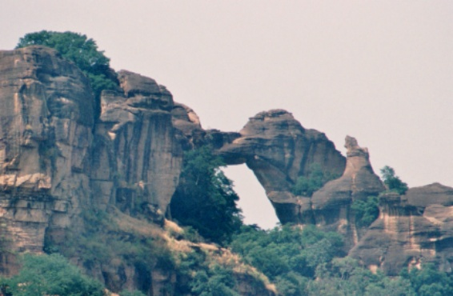 | 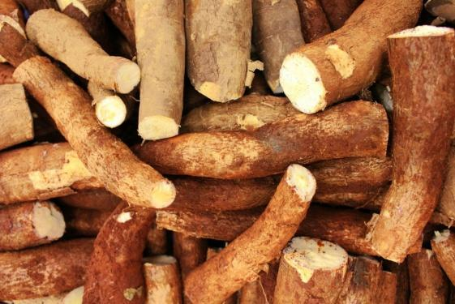
Figure A: Arche de Kamandjan, Siby | Figure B: Cassava Root Crops in Close-Up Photography, Comoros
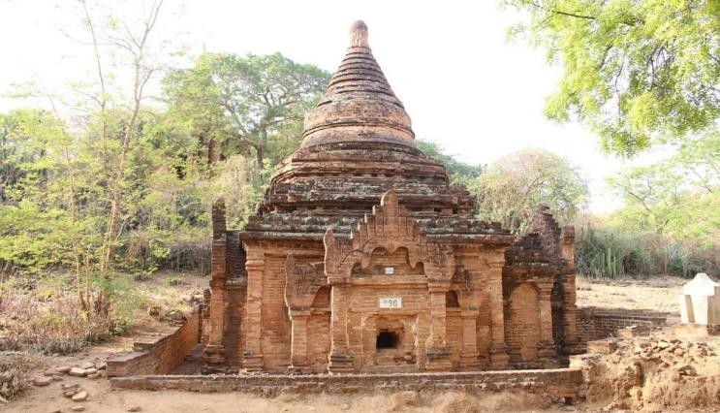 | 
Figure C: Bagan, Myanmar | Figure D: Image generated using Pikaso from the prompt Depigmentation
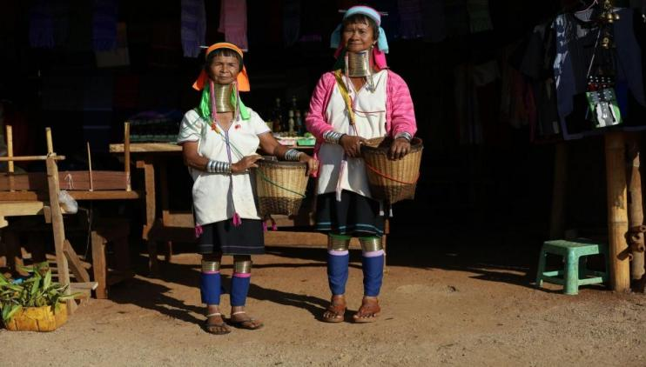

Figure E: Women in traditional clothes holding a basket, Burma

