**Urban Transformation in the Rif Mountains: Assessing the Development Challenges of Emerging Centers in Al Hoceima**

***Iliass Bouhlal***

Ibn Tofail University, Faculty of Human and Social Sciences, Department of Geography, Laboratory of Territories, Environment, Kénitra. Morocco; e-mail: [ilyass.bouhlal@uit.ac.ma](mailto:ilyass.bouhlal@uit.ac.ma) ORCID <https://orcid.org/0009-0009-9032-8926>

**Abstract :**

This research presents a systematic examination of urbanization dynamics in Morocco's Al Hoceima Province, analyzing their historical trajectory from colonial establishment to current developmental challenges. The investigation demonstrates that while Spanish colonial administration successfully instituted key urban centers including Al Hoceima and Targuist, post-independence urban growth has exhibited marked spatial disparities and structural deficiencies. Contemporary analysis reveals that emerging urban hubs confront persistent obstacles including inadequate infrastructure development, economic peripheralization, and the constraining influence of rural cannabis-based economies, collectively inhibiting their capacity to function as effective regional development catalysts.

Rural centers in mountainous areas currently constitute vital and strategic areas for the growth of emerging urban centers. As a result of the inevitability of demographic growth and the expansion of marginal orbits, these rural centers are witnessing rapid transformations and successive upgrades, with which roles and functions change according to the context of their emergence and the level of their development and integration.

In the face of these different interactions, territorial dynamics emerge at all levels (social, economic, urban and environmental). They also make these emerging centers areas of attraction for several attractions due to the multiplicity of stakeholders and actors and the overlap of current and future challenges that control and influence urban management and planning.

**Keywords:** Emerging centers; Ketama; Rif Mountains; Al Hoceima; Territorial development

**Introduction**

The studied centers appeared and grew as a result of colonial intervention during the period of the Spanish protectorate, which adopted a spatial organization based on administrative and military centers and weekly markets, and after independence as a result of natural growth and the flow of rural migration streams, and the settlement of some development projects.

However, this territorial dynamic was controlled by various factors that were not accompanied by development in terms of infrastructure and public services, which made it attractive to nearby urban centers such as the cities of Targuist, Al Hoceima, Taounate and Bab Berd.

The term "emerging centers" is a new concept that has emerged in recent years. It refers to all agglomerations, outside of municipalities, which are experiencing remarkable dynamism in the development of their population and the transformation of their territories (El-Araby & Faleh, 2017).

It also indicates the stage of transformation of a rural center into an urban center through a significant increase in the number of its population, the multiplicity of basic public facilities presents there and the increase in population density in the center.

**The objectives of the research**

Our study aims, first, to examine the process that controls the genesis of urban and emerging centers, its evolutions from a rural space to an emerging urban space, as well as the understanding of the socio-spatial mutations of this space which is in a crossroads situation, under the influence of the agglomeration of Tangier-Tetouan -Alhoceima and the East.

**Material and methods**

The work methodology is based on a bibliographic research to collect the basic information necessary to carry out our research, likewise, we opted for the survey as a data collection method. The approaches concerned:

- Data collection: This is reliable quantitative and qualitative data relating to the different areas of socio-economic development.

- Cartography and GIS: Use of geographic information system (GIS) to establish comparative thematic maps of the distribution of different socio-economic and spatial phenomena.

- Analyze census data related to the population, whether during the colonial period or during the period of independence.

**Location of the study area: a strategic position**

The province of Al Hoceima is located in the north of the kingdom of Morocco, which belongs to the region of Tangier-Tetouan-Al Hoceima, and covers an area of 3550 km2, and the population of the province according to the census of 2024 was about 371,527 people (Figure1).

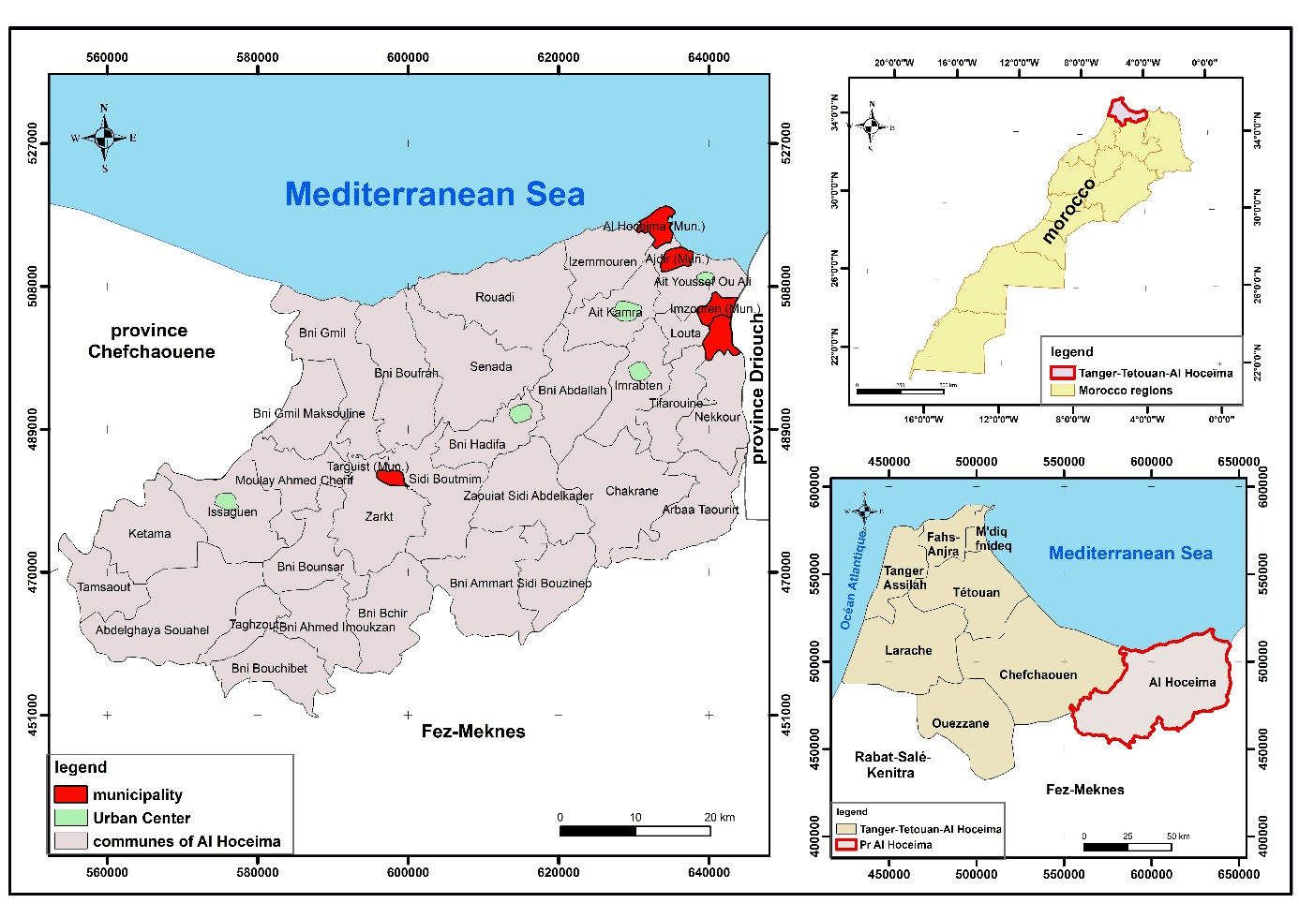

Source. administrative division in 2015

**Figure 1. Location of the study area**

The Al Hoceima region has unique resources that can be a major lever for urban development if exploited within the framework of local projects. Among its resources are the diversity of its landscapes, its human capital dominated by the working class, its economic resources, and the richness of its tangible and intangible heritage (Bouhlal et al., 2024).

1. **Urbanization dynamics in the province of Al Hoceima**

The phenomenon of urbanization in the province of Al Hoceima developed through two main stages: the colonial phase and the independence phase. The latter encompasses three different historical periods, each with its own demographic characteristics.

**1.1 Colonial period: the birth of the city of Al Hoceima and the beginning of urban life**

The colonial period is a very important period in the life of the city of Al Hoceima and its surroundings, whether in the construction of urban centers or the architectural structures that formed a colonial heritage in this period.

Several factors combined to establish the city of Al Hoceima on the Mediterranean coast, and the year 1925 was a decisive step in the birth of the city of Al Hoceima. After the military landing that took place in the region, in 1927 the urban site was established on a Spanish military base and in 1928 it was transformed into an urban site.

This city had several names during the colonial era. Before the military landing, it was called Taghzouith and, in mid-1926, El Sabri (1999), it was called quemado (María, 2013).In 1927 the town was known as Villa Sanjurjo, named after its founder, General Sanjurjo (Lemallam, 2011).

In 1932, the name of Villa Sanjurjo was replaced by the name of Al Hoceima, according to the dahir signed by the head of civil affairs (dahir cambiando la denominacion del poblado de villa sanjurjo, par la de villa Alhucemas).

**Table 1. Population growth of the city of Al Hoceima during the colonial period**

|  |  |  |  |  |  |
| --- | --- | --- | --- | --- | --- |
| **Years** | **1925** | **1929** | **1936** | **1945** | **1956** |
| **Population** | 1000 | 3600 | 4829 | 10576 | 12464 |

**Source:** **Alta Comisaría de España 1949, Acción de España en Marruecos, la obra material, Tetuan.**

It is noted (Table 1) above that the city has witnessed significant demographic growth since its establishment, as the population increased from 1,000 in 1925 to more than 12,000 in 1956. (RAMÓN, 2019).

As for the distribution of the population within the city, it was marked from the beginning by discrimination, as it included Spanish population groups that settled in the city center, while Moroccans settled in the marginal neighborhoods.

In addition to the construction of the city of Al Hoceima, the city of Targuist was created in early 1926 as a military administrative center by the Spanish colonial forces to urbanize the region (Antonio, 2013). The region also witnessed the construction of two urban centers, Imzouren and Bni Bouayach.

**1.2 Independence period: characterized by different demographic periods**

It is true to say that the emergence of independence did not radically change the general urban system of urbanization. The central Rif in general remained, like other marginalized areas, on the margins of the urbanization movement that developed in Morocco.

**Table 2. Legal population by municipalities and urban centers in the in the province of Al Hoceima**

|  |  |  |  |  |  |  |
| --- | --- | --- | --- | --- | --- | --- |
| **Municipality /** **Circle** | | **1994** | **2004** | **2014** | **2024** | **Annual growth rate % 2014-2024** |
| **Municipality** | **Al Hoceima (Mun)** | **55216** | **55357** | **56716** | **50225** | **-1,21** |
| **Bni Bouayach (Mun)** | **13128** | **15497** | **18271** | **20013** | **0,91** |
| **Imzouren (Mun)** | **25547** | **28927** | **33852** | **34848** | **0,29** |
| **Targuist (Mun)** | **9593** | **11560** | **13390** | **14638** | **0,90** |
| **Ajdir (Mun)** | **3669** | **4711** | **5314** | **5630** | **0,58** |
| **Circle of Bni Ouriaghel Acharkia** | **Sidi Bouafif urban center** | **-** | **-** | **3350** | **3884** | **1,49** |
| **Tamassint Urban Center** | **1903** | **1788** | **1831** | **1796** | **-0,19** |
| **Circle of Bni Ouriaghel Algharbia** | **Bni Hadifa** **urban center** | **1939** | **2061** | **2171** | **2115** | **-0,26** |
| **Ait** **Kamra urban center** | **-** | **-** | **-** | **3140** | **-** |
| **Circle of Ketama** | **Issaguen urban center** | **1593** | **1638** | **2474** | **2688** | **0,83** |

**Source: statistics for 1994, 2004, 2014 and 2024**

At the urban level (Table 2), the population of the municipality of Al Hoceima decreased from 56716 people in 2014 to 50225 people in 2024, recording an annual growth rate of -1,21%. As for the other urban communities, an increase in the population was recorded, since the annual growth rate in the municipalities of Bni Bouayach, Targuist, Ajdir and Imzouren reached respectively: 0,91%, 0,90%, 0,58% and 0,29%.

At the rural level, out of 31 rural communes in the province, only four communes recorded a positive annual population growth, namely the commune of Izemmouren with a growth rate of 2,13%, the commune of Ait Youssef Ou Ali with a rate of 0,88% and the commune of Ait Kamra with a rate of 0,74%. Then, the commune of Issaguen had a rate of 0,42%, while the rest of the communes experienced a decline in the annual population growth rate, which exceeded -3%, particularly in the community of Chakrane and the community of Arbaa Taourirt.

The disparate sustainability levels between urban areas appear to be related to the rapid economic growth, typical of an emerging economy (Bounoua et al., 2020).

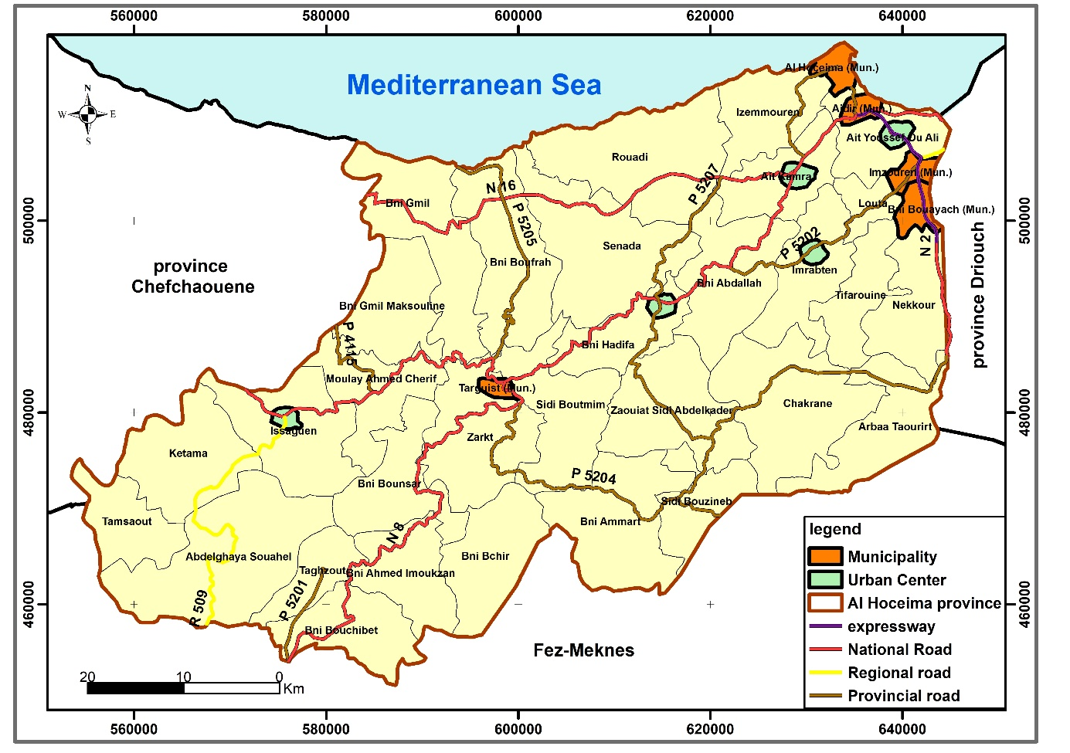

Source: administrative division in 2015

**Figure 2. Distribution of urban centers** **in the province of Al Hoceima**

Over the last three decades, a few small centers have emerged in the province of Al Hoceima (Figure 2), the most important of which is the center of Ajdir, elevated to the rank of municipality, alongside the centers of Issaguen, Bni Hadifa and Tamassint. Then, in 2004, the Sidi Bouafif Center in the north, and finally the Ait Kamra Center in 2024.

Source. statistics for 1994, 2004, 2014 and 2024

**Figure 3.** **Legal population by municipality in the province of Al Hoceima**

Urban realities are at the heart of changes transforming the Morocco. Over only a few decades urbanization has been massive and rapid, profoundly disrupting lifestyles and social structures (Belguidoum et al., 2015).

Since the dawn of independence, the Al Hoceima region has witnessed a set of interventions concerning urban development. However, those who follow the dynamics of the urban network notice the slow development of the urbanization process in the Al Hoceima.

Consequently, these development projects did not allow for the establishment of a national development strategy that equates marginalized areas with the urban area, but also created conflicts between local communities and the state (El Kahlaoui, 2024).

By comparing the results of the general population and housing census between 2014 and 2024, it is noted that the population of the city of Al Hoceima decreased by 6491 people (Figure 3). This decrease can be explained by a group of factors, the most important of which are: the Rif events in 2017 and the negative effects that resulted from them, then the economic crisis that the city is experiencing in general, and the rest of the urban centers in particular, in addition to other factors, including immigration, weak investments, etc.

Source. statistics for 1994, 2004, 2014 and 2024

**Figure 4.** **Legal population by urban centers in the province of Al Hoceima**

If most urban cities in Morocco witnessed a significant development in their population during the last census of 2024, the matter is different in the Al Hoceima province, as the city of Al Hoceima and some urban centers witnessed a decrease in their population (Figure 4), as the Tamassint Center recorded a decrease in population growth by -0.19%, the Bni Hadifa Center by -0.26%, and the city of Al Hoceima by -1.21%.

In this context, the rural commune of Ait Kamra was promoted in 2024 to the rank of urban commune and is therefore experiencing the emergence of new challenges to overcome, in particular the main constraints to its spatial cohesion, its operation and its management of urban services.

**1.3 Evolution of the urbanization rate in the province of Al Hoceima**

The urbanization rate in Morocco has experienced rapid development in recent decades, leading to a rapid increase in the percentage of the urban population, reaching 60,8% after 55,1% in 2004.

In contrast, the evolution of the urbanization rate in the province of Al Hoceima has been modest, with newly developed urban centers not contributing to the development of urbanization compared to other Moroccan regions.

|  |
| --- |
|  |

Source. statistics for 2004, 2014 and 2024

**Figure 5.** **The percentage of urbanization in the province of Al Hoceima compared to Morocco**

At the level of the territorial municipalities in which the urban centers are located, the percentage of urbanization is very different, since the urban center of Bni Hadifa recorded a percentage of 44,8%, exceeding the general average recorded at the provincial level, followed by the center of Ait kamra with a percentage of 38%, while the rest of the centers recorded low percentages, the Issaguen Center ranked last with a percentage of 15,1% (Figure 5).

Generally, the urban phenomenon has become the main structuring factor of space and society in Morocco (ERRAOUGUI et al., 2022). As a result, the challenge of urban centers, from a land use planning and social and cultural point of view, is significantly the transition from rural to urban, learning new forms of social life, and acquiring a form of citizenship that changes relationships with others, with space, etc.

This development of urban development is conducive to an inflation of the rural population, with adverse impacts on territorial resource areas, considered such as fragile parts and insufficiency preparations to respond to the normal size of the rural population, as a result of the equipment development. social et economic activities.

1. **Contributions of emerging centers to the restructuring of space**

Cities are considered a key lever for achieving economic, social and regional development. On the other hand, there is the emergence of a set of centers that can play at the local level the roles that cities play at the regional and national levels. These centers are called "emerging centers"(Figure 6).

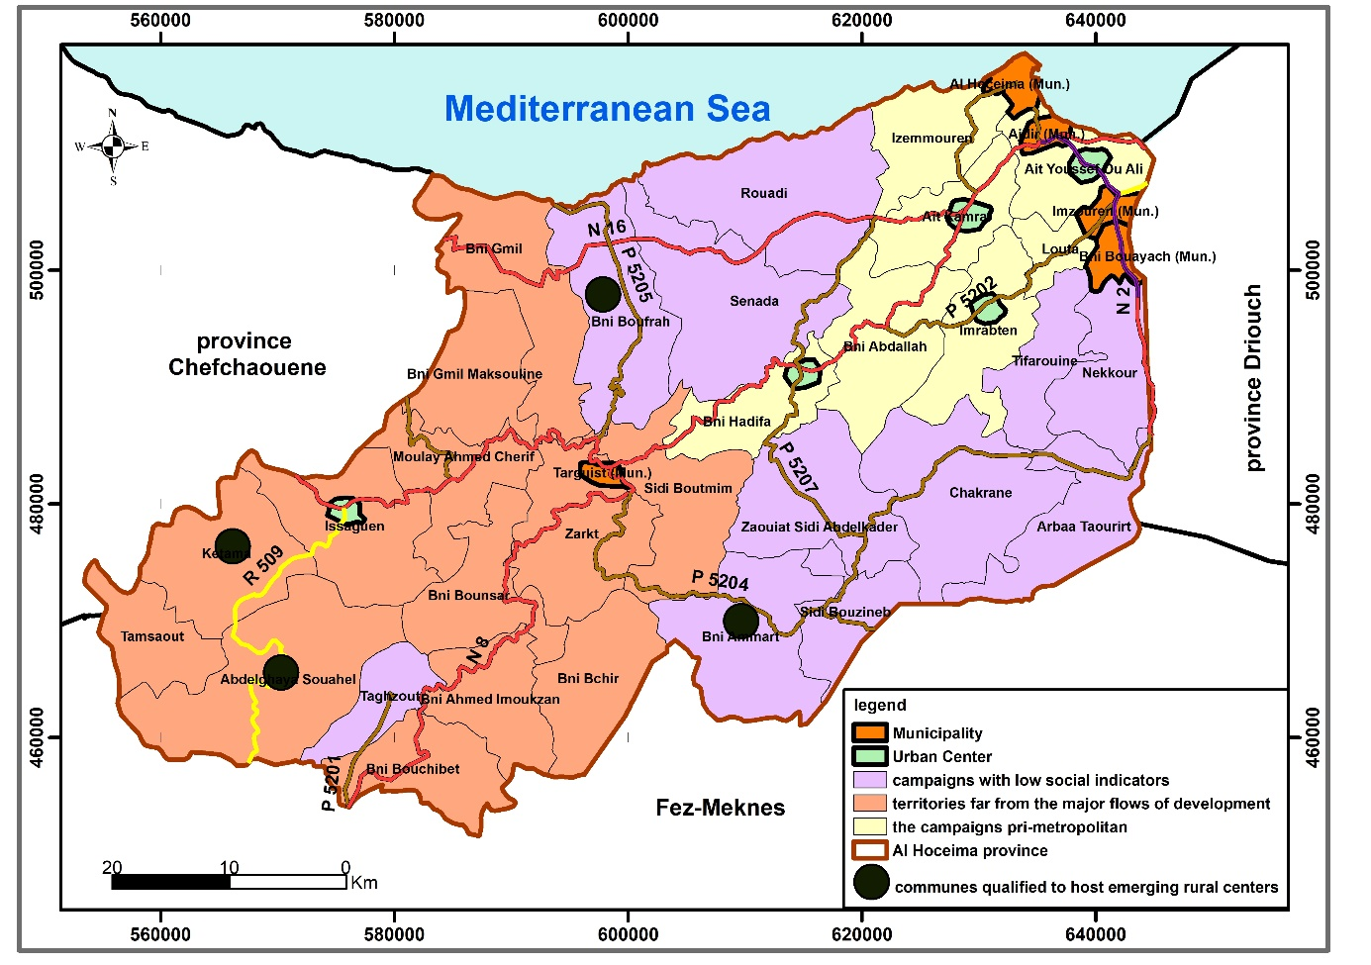

Source. Débat national pour l’élaboration des orientations de la politique publique d’aménagement du territoire, 2019

**Figure 6. Preliminary identification of incubation spaces for emerging centers**

The development of the growth rate of emerging centers is a result of their ability to manage the interactions between the urban and rural areas. The stronger the manifestations of influence, the more this accelerates their expansion. Consequently, they absorb a significant amount of the various currents coming from the countryside towards the cities. Among the roles that these centers can play are the following:

- Bringing the urban model closer to the population and reducing the rural exodus to the cities.

- It constitutes a meeting point for the interventions of actors at the local level and creates the conditions for the development and emergence of individual and collective initiatives.

- These small urban centers are easy to control in their development, unlike cities which suffer from several problems that are difficult to solve.

- Emerging centers also play, over time and for a duration that varies from one center to another, a role of reception, distribution, rest and departure, for population movements in search of alternatives in the cities.

1. **Constraints of urban development and prospects for sustainability of emerging centers**

**3.1 Constraints of urban development in the province of Al Hoceima**

The urban world of the province of Al Hoceima suffers from various forms of under-equipment which, by their combined effects, have a negative impact on both economic activity and the daily life of the population. It is possible to highlight particularly restrictive elements:

- A loose and very unbalanced urban framework, the counterpart of the hyper-concentration of urbanization on the coastal strip of the province is the pronounced urban deficiency of the interior spaces. The urban agglomerations that punctuate these spaces are of small size, born and populated mainly by rural immigrants of modest means. Their summary economic and socio-cultural base offers the populations and activities of the surrounding rural world only primary level services, on the one hand, and participates only weakly, through the rare existing economic establishments, most of which are modest.

- The road infrastructure is insufficient and is limited to a Mediterranean route;

- The road network is poorly developed and the centers are not well served, which leads to anarchic and poorly controlled urbanization;

- The area is subject to risks (Rfifi & Ait Brahim. 2018).

-The impact of cannabis cultivation on the development of urban centers, as it is noted that most rural residents do not pay any attention to settling in urban areas, and prefer to settle in their original homeland, and the evidence for this is the increasing number of modern housing in various rural areas (Bouhlal et al., 2024).

**3.2 Specific planning approaches for contrasting urban situations**

The major differences that exist at all levels between the various categories of urban spaces identified above, each constituting a particular situation, require the adoption of equally specific strategic planning approaches (Hooman et al., 2021).

The objective of the actions to be undertaken is twofold: on the one hand, to control and correct the growth of all urban agglomerations, medium and small, in order to qualify them as best as possible to fully fulfill their role as a space for residence, work, provision of services, circulation, culture, leisure and emancipation; on the other hand, the construction of an urban framework that is as dense, solid and balanced as possible, capable of framing the entire provincial space, in a constructive and sustainable manner.

Schematically, four major categories of development actions seem necessary to undertake resolutely, in order to further improve the level of economic and socio-cultural "performance" of cities.

* Combat land waste and expand construction areas, and insist on producing urban areas with integrated functions, harmonious landscape and environmental friendliness.
* Control and reorganize the space of coastal urban agglomerations.
* Urban upgrading of small inland towns and consolidation of their economic base.
* Equipment and promotion of semi-urban and rural centers.

The same will apply to existing small centres and those that should gradually emerge, particularly those that benefit from remarkable road situations and experience a certain demographic dynamism, encouraging the establishment of different economic activities. These activities and facilities would provide small centres with new economic and social functions, which would enable them to strengthen sub-regional urban networks.

The phenomenon of urbanization is rare and very modest in the mountainous areas of the province of Al Hoceima. These are small centers far from each other, surrounded by long agricultural or forest areas. With the exception of a few that have managed to develop somewhat, these centers are characterized by a clear demographic stagnation and a deep economic crisis. The deterioration of its economic and social conditions requires taking decisive and urgent measures to revive it by encouraging productive activities and improving equipment and services.

If the prospective vision presented by the Regional Land Use Plan underlines the need for a distribution of fundamental tasks, functions and roles between the different urban centers, from the point of view of integration and mutual support between them (S R A T. Tanger-Tétouan-Al Hoceima 2021-2046), the situation of the current urban apparatus in the province of Al Hpceima suffers from disintegration, imbalance and weak functional strength.

Under these conditions, these centers are still not properly exploited as a lever for local development in the study area, because the problems they suffer from do not allow them to play the role assigned to them as they should. (Its fragility leads to low attractiveness).

With a view to promoting harmonious development of rural areas, it will be necessary to reshape the urbanization of rural areas in an integrated manner with small and medium-sized towns in order to connect rural living areas to these emerging centers and thus foster the creation of attractive economic opportunities (The Special Commission on the Development Model 2021).

**CONCLUSION**

This study provides a comprehensive analysis of the urbanization processes in Al Hoceima Province, demonstrating how historical colonial foundations and contemporary development challenges have shaped its current urban landscape. The research reveals that while Spanish colonial administration established key urban centers such as Al Hoceima and Targuist, post-independence urban development has been characterized by significant spatial disparities and structural weaknesses.

Emerging urban centers face persistent challenges including inadequate infrastructure, economic marginalization, and the constraining effects of rural cannabis-based economies, all of which hinder their potential as drivers of regional development. The study identifies a critical paradox: despite their strategic importance as potential decentralized growth nodes, these centers exhibit troubling demographic trends (notably Al Hoceima's -1.21% annual population growth) and lag significantly behind national urbanization averages (37.5% versus Morocco's 60.8%).

These findings underscore the urgent need for holistic urban planning approaches that simultaneously address infrastructure modernization, economic diversification, and institutional reform. The 2017 social protests and ongoing migration patterns further highlight the region's systemic vulnerabilities and the pressing need for policy interventions that bridge historical spatial inequalities while responding to contemporary socio-economic realities. To realize the transformative potential of these urban centers, policymakers must implement tailored strategies that combine targeted investment with participatory governance frameworks. Future research directions should prioritize investigations into climate adaptation strategies and innovative governance models to foster sustainable urban development in this geographically and politically significant region.

**Conflict of Interest in the Manuscript**

The manuscript has no conflict of interest.

**Bibliographic references**

A.G.A, sección civil marruecos, asunto, dahir cambiando la denominacion del poblado de villa sanjurjo, par la de villa Alhucemas. 81/9999 caja M.21, N, A-1, Ano 1932.

Alejandro Muchada Suarez Notas para una teoría de la vivienda y la ciudad rifeña, De la ciudad – territorio a la megápolis mediterránea. <https://www.academia.edu/14152543/Notes_for_a_theory_of_housing_and_city_of_the_Rif_Morocco>

Alta Comisaría de España (1949). Acción de España en Marruecos, la obra material, Tetuan. https://books.google.co.ma/books/about/Acci%C3%B3n_de_Espa%C3%B1a

Antonio, B. N. (2013). Arquitectura y estructura urbana en el Rif Central durante la primera mitad del siglo XX. le patrimoine dans les montagnes rifaines; état et perspectives, institut royal de la culture amazighe, el maarif al jadida Rabat. PP, 19 – 76. <file:///C:/Users/USER/Downloads/ArquitecturaRif%20(1).pdf>

Belguidoum, S., Raffaele, C., & Iraki, A. (2015). Cities and Urbanity in the Maghreb. Dossier : Villes et urbanités au Maghreb, Année du Maghreb. N 12. <https://doi.org/10.4000/anneemaghreb.2510>

Bouhlal, I., Ayoub, B., Hamid, B., & Abdennour, S. (2024). Transforming Cannabis Cultivation in Northern Morocco: A Geographical Analysis from Prohibition to Legitimization. J. Glob. Innov. Agric. Sci. 12 (2): 537-544. <https://doi.org/10.22194/JGIAS/24.1273>

Bouhlal, I., Chaichai, B., Benssi, H., Sadik, A., Batchi, M., & El Mansouri, S. (2024). Territorial Resources in the Province of Al Hoceima Between Undervaluation and Territorial Development Issues Case: of the Commune Abdelghaya Souahel. J. Glob. Innov. Agric. Sci. 12 (4): 1291-1300. <https://doi.org/10.22194/JGIAS/24.1578>

Bounoua, L., Fathi, N., El Berkaoui, M., El Ghazouani, L., & Messouli, M. (2020). Assessment of Sustainability Development in Urban Areas of Morocco. Journal Urban Science. 2020, 4, 18. <https://doi.org/10.3390/urbansci4020018>

El Kahlaoui, S. (2024). Claiming Democracy and Environmental Justice at the Margins: Land Rights and Urban Informality as Sites of Mobilization in Morocco. MIDDLE EAST CRITIQUE, rading as Taylor & Francis Group. <https://doi.org/10.1080/19436149.2024.2398298>

El Sabri, S. (1999). Le fait urbain dans la province d'Al Hoceima (Rif central) : Passé, présent et devenir, in Maroc-Europe : Histoire économies sociétés n°2, p. 21-53.

El-Araby, A., & Faleh, A. (2017). Emerging Rural Centers, Territorial Projects, Regional Development Players and Prospects. The Case of the Province of Zagora (Morocco). Annals of Valahia University of Targoviste Geographical Series. 17(2): 170-183. <https://doi.org/10.1515/avutgs-2017-0016>

Erraougui, K., Kasbaoui, A., Daiboun, T. (2022). Les mutations socio-spatiales des centres émergents au Maroc. Le cas de Sidi Allal Bahraoui, province de Khémisset. Revue espace géographique et société marocaine, NO 57. <https://doi.org/10.34874/IMIST.PRSM/EGSM/30559>

HCP Recensement Général de la Population et de l'Habitat (RGPH), 1994, 2004, 2014, 2024.

Hooman, G., Sepideh, A. B., Linda, M., & Mahshid, J. (2021). Transformation of Urban Spaces within Cities in the Context of Globalization and Urban Competitiveness. Journal of Urban Planning and Development, Case Study, Volume 147, Issue 3. <https://doi.org/10.1061/(ASCE)UP.1943-5444.000070>

Lemallam, O. (2011). Alhucemas, datos sobre la historia de la ciudad y su reconstrucción, en AA. VV: Una aproximación e los edifcios históricos y patrimoniales de Málaga, Tetuán, Nador, Tánger y Alhucemas, Málaga: Servicio de Programas del Ayuntamiento de Málaga, Observatorio de Medio Ambiente Urbano omau, pp. 325-343. <file:///C:/Users/USER/Downloads/APROXIMACION_A_LOS_EDIFICIOS_HISTORICOS.pdf>

María, R. M. (2013). De Villa Sanjurjo a Alhucemas: evolución de una ciudad colonial y su entorno en el contexto del Rif central, le patrimoine dans les montagnes rifaines; état et perspectives, institut royal de la culture amazighe, el maarif al jadida Rabat. PP. 77 – 92. <https://books.google.co.ma/books/about/De_Villa_Sanjurjo>

Ministère de l’intérieur Conseil de la région Tanger - Tétouan - Al Hoceima. (2021). Schéma régional d’aménagement du territoire de la région Tanger-Tétouan-Al Hoceima 2021-2046. <https://data.gov.ma/data/fr/dataset>

Ministère de l'Aménagement du Territoire National, de l'Urbanisme, de l'Habitat et de la Politique de la Ville. (2019). Débat national pour l’élaboration des orientations de la politique publique d’aménagement du territoire. <https://lematin.ma/journal/2019>

RAMÓN, D. R. (2019). El desembarco de Alhucemas. la operación definitiva del Colonialismo Español en Marruecos (1911-1925). TESIS DOCTORAL UNIVERSIDAD AUTÓNOMA DE MADRID (UAM). <file:///C:/Users/USER/Downloads/diez_rioja_ramon.pdf>

Rfifi, M., & Ait Brahim, L. (2018). Dynamique d’artificialisation et gestion des zones côtières : cas d’étude applique au littoral d’Al-Hoceima (rif oriental du Maroc). American Journal of Innovative Research and Applied Sciences. <file:///C:/Users/USER/Downloads/Rfifi-Manuscript_2018.pdf>

The Special Commission on the Development Model (2021). The new development mode, Releasing energies and regaining trust to accelerate the march of progress and prosperity for all, general report. <https://www.csmd.ma/documents/CSMD_Report_EN.pdf>