Transformation of Wetland Landscapes and the Impact on Pre-Sriwijaya Site Preservation in the Eastern Coastal Region of South Sumatra

Abstract
This study examines the development of early settlements and maritime networks in the eastern coastal region of South Sumatra—including Karangagung Tengah, Teluk Cengal, and Air Sugihan—as an important part of the Pre-Sriwijaya to Sriwijaya phases. Using a descriptive-analytical approach based on archaeological, geomorphological, and recent field data, this research demonstrates that the eastern coast of South Sumatra has long served as a space for cultural and economic interaction since the early centuries CE. Findings such as pottery, Indo-Pacific and Indian beads, metal artifacts, sewn-plank boats, wooden house posts dated to the 2nd–4th centuries CE, and ceramics from China, India, and Persia indicate the existence of intensive international trade networks.The settlement patterns identified align with Gordon Willey’s settlement ecology theory, in which communities occupied the banks of small tidal rivers functioning as transportation routes and centers of socio-economic activity. The opening of transmigration areas since the 1980s has caused drastic changes to the ecological landscape, including the disappearance of ancient river channels that once hosted major archaeological sites. Historically, this region functioned as a maritime hub connecting the Bangka Strait, the Java Sea, and the Malacca Strait. Thus, this study affirms the strategic role of the eastern coast of South Sumatra as an early habitation zone, a center of maritime activity, and an integral part of the Sriwijaya port network.
Keywords: Pre-Sriwijaya; Sriwijaya; Karangagung Tengah; Teluk Cengal; Air Sugihan
Introduction
Indonesia, as an archipelagic state, has extensive coastal waters, which account for about two-thirds of its total territory. This vast area consists of large and small islands connected to each other. This wide geographic space hosts diverse ethnic groups with distinct cultures, and most show strong maritime traits. Around 40 million people live in coastal zones, including shorelines, coastal plains, and riverbanks (Susilowati, Endang. 2017). These communities have occupied these areas for hundreds or even thousands of years, as reflected in archaeological remains. Their environments shaped their cultures, which developed strong maritime characteristics. Maritime communities, therefore, serve as markers of societies whose lives depend closely on seas and rivers, as well as on maritime natural resources used in daily life. These conditions formed and influenced their cultures. In general, Indonesia shows two main national characteristics, a sea river state with maritime orientation and a wet rice lowland state with agrarian orientation (Zuhdi, Susanto. 2006).
The Indonesian archipelago contains four major islands, Kalimantan, Papua, Sumatra, and Sulawesi. Sumatra lies in the westernmost part of Indonesia. The Bukit Barisan mountain range stretches from north to south and divides the island, while the eastern side forms an extensive coastal zone. This division shapes western Sumatra as a hilly region, while eastern Sumatra consists mainly of lowlands (Asnan, 2019). Eastern Sumatra faces the Malacca and Bangka straits; therefore, communities in this region depend heavily on aquatic ecosystems. As a result, eastern Sumatra consists largely of lowlands inhabited by maritime-oriented populations, many of whom work as fishers. Part of this eastern coastal zone falls within the administrative area of South Sumatra Province. Geographically, South Sumatra borders Jambi Province to the north, Bangka Belitung Province to the east, Lampung Province to the south, and Bengkulu Province to the west. Administratively, South Sumatra consists of four municipalities and thirteen regencies: Palembang City as the provincial capital, Prabumulih City, Pagar Alam City, Lubuklinggau City, Banyuasin Regency, Musi Banyuasin Regency, Musi Rawas Regency, North Musi Rawas Regency, Penukal Abab Lematang Ilir Regency, Muara Enim Regency, Lahat Regency, Empat Lawang Regency, Ogan Ilir Regency, Ogan Komering Ulu Regency, Ogan Komering Ulu Timur Regency, Ogan Komering Ulu Selatan Regency, and Ogan Komering Ilir Regency (South Sumatra Province, 2021).
Astronomically, South Sumatra Province lies between 1° and 4° south latitude and 102° and 106° east longitude. The region consists mainly of lowlands, with an average elevation of about 79 meters above sea level and a total area of around 91,592.43 square kilometres. Based on the 2020 to 2023 Interim Population Projection, the population of South Sumatra in 2021 was about 8.6 million. The population includes Komering, Pasemah, Ogan, Palembang, Javanese, Chinese, Bugis, Minangkabau, Acehnese, Batak, and other groups. Most residents practice Islam, while others practice Christianity, Buddhism, Confucianism, and Hinduism (South Sumatra in Figures, BPS South Sumatra, 2022).
The outline of South Sumatra falls into two main zones. First, the eastern coastal zone of Sumatra. Second, the Bukit Barisan highlands. Eastern South Sumatra is a wetland zone with elevations below 5 meters above sea level. Large parts of the province consist of swamps, including areas in Musi Rawas, Musi Banyuasin, Muara Enim, Ogan Komering Ilir, and Banyuasin Regencies. These wetlands include tidal swamps and non-tidal inland swamps, which form the widest areas. The eastern coast of South Sumatra has developed since the Pre-Sriwijaya period alongside tidal rivers. This zone includes Teluk Cengal in Tulung Selapan and Cengal, Air Sugihan, Sunsang, Karangagung Tengah, and Sembilang National Park. Administratively, these areas fall within Ogan Komering Ilir Regency, Banyuasin Regency, and Musi Banyuasin Regency. Based on geographic position and cultural tradition, residents continue to maintain a maritime identity formed over centuries. They transmit maritime traditions of the Sriwijaya polity and the Palembang Sultanate across generations.
In archaeology and anthropology, rivers function as settlement centres, trade routes, and economic resources (Willey, 1953). Gordon Willey's settlement ecology theory shows that settlement forms depend strongly on geography and environment, as field research in Karangagung Tengah indicates. The Bangka Strait, Java Sea, and Malacca Strait route has been discussed since the early Common Era. Scholars describe eastern Sumatra as part of an international trade network linking India, China, Persia, and Southeast Asia (Wolters, 2011; Manguin, 1993). Portuguese records (Rodrigues, 1513; Pires, 1515) mention sailing routes through Lucipara or Maspari near Teluk Cengal. Air Sugihan served as an entry route toward Java and Malacca.
Based on this background, this study addresses the question of what role the government plays in bringing key sites along the eastern coast of South Sumatra into public awareness. What conditions do these sites face today. This research aims to explain the government's role in opening the old zones along the eastern coast of South Sumatra. Another aim is to show how site conditions have changed from the 1980s to the present. The study seeks to support stakeholders involved in preservation and development so they can take direct action to protect and develop the site.
Material or Research Methods
This research applies the historical method to reconstruct historical and archaeological narratives of the eastern coast of South Sumatra. The historical method includes heuristics or source collection, source criticism, interpretation, and historiography. Heuristics involved archival work, documents, articles, and related sources, as well as interviews with historical actors or witnesses. Field surveys covered Karangagung Tengah, Sembilang, Sunsang, and Cengal. Source criticism ensured authenticity and validity through external and internal criticism. Interpretation is followed to reconstruct narratives from collected sources. Historiography then formed these narratives into written form (38)(39)(40).
RESEARCH FINDING
The eastern coast of South Sumatra preserves extensive historical evidence of extensive external contact from the Pre-Sriwijaya phase through the Sriwijaya period, the Palembang Kingdom, the Palembang Sultanate, the colonial era, and the present. The region contains archaeological sites with Chinese ceramics, Indian beads, Persian glass, sewn-plank boat technology, statues, and other artifacts. These finds indicate long-term intercultural interaction and the growth of coastal communities (46)(47)(48). Researchers documented such evidence in Cengal, Air Sugihan, Sunsang, and Karangagung Tengah, including Sembilang National Park.
Administratively, these zones fall within Banyuasin Regency, Musi Banyuasin Regency, and Ogan Komering Ilir Regency. In Musi Banyuasin Regency, Karangagung Tengah in Lalan District forms a key location. In Ogan Komering Ilir Regency, many sites are located in the Cengal and Air Sugihan Districts. These zones consist of peat swamps filled with channels and ditches built by the government. These structures support transport and water control for transmigrant agriculture since the 1980s. Several major rivers flow across the eastern coast, including the Banyuasin, Sembilang, Musi, Lalan, Air Sugihan, Air Saleh, and Lumpur Rivers (Rangkuti, Nurhadi, 2014). Archaeological finds from periods predating Sriwijaya appear across this long coast. Scholars therefore label these zones Pre Sriwijaya, covering Karangagung Tengah, Air Sugihan, and Cengal.
DISCUSSION
Musi Banyuasin Regency
Musi Banyuasin Regency covers 14,265.96 square kilometres. The regency lies between 1.3° and 4° south latitude and between 103° and 104°45' east longitude. Jambi Province borders the north, Penukal Abab Lematang Ilir Regency borders the south, Musi Rawas Regency borders the west, and Banyuasin Regency borders the east. The regency includes fifteen districts: Sungai Lilin, Bayung Lencir, Sanga Desa, Babat Toman, Batanghari Leko, Plakat Tinggi, Lawang Wetan, Sungai Keruh, Jirak Jaya, Sekayu, Lais, Keluang, Babat Supat, Lalan, and Tungkal Jaya. Swamps and brackish tidal lands dominate. Other parts include highlands and hills. Rivers include the Musi, Banyuasin, Batanghari Leko, and tributaries. Pre Sriwijaya sites appear in Lalan District from the Lalan River mouth to the Sembilang River. Scholars identify this zone as Karangagung Tengah.
Karang Agung Tengah
Karangagung Tengah is a key zone linked to the Pre-Sriwijaya period. Since 1983, the government has drained tidal swamps through canals and embankments to control tides and rainwater, and to irrigate transmigrant farms. Authorities built primary, secondary, and tertiary canals. The zone includes 20 primary channels and 27 villages. Each village consists of a primary canal, locally known as a parit. These reclaimed lands supported new settlements for transmigrants from Java. The canals served transport and drainage for agriculture and plantations. These channels connect to three main rivers: the Lalan River, the Banyuasin River (also known as the Calik River), and the Sembilang River. These rivers served as transport routes and settlement zones. This setting provided sheltered access and relative security from external threats. This pattern differs from the more open Sembilang and Banyuasin Rivers, which face the Bangka Strait. Land reclamation there produced negative impacts, including drying and loss of tributaries. Biodiversity declined. Traditional wetland livelihoods changed. Settlement sites appear mainly along small rivers or ancient channels linked to the Lalan River. This river connected upstream zones supplying forest and agricultural products, including damar resin. Freshwater sources appeared along the Sembilang River at Tanah Abang Site (Rangkuti, 2014; Rangkuti, 2017).
Archaeologists identified Karangagung Tengah as a major Pre Sriwijaya site after transmigrant farmers reported artifact finds to the Palembang Archaeology Office. Residents farmed rice and grew coconut and other secondary crops. Some residents found artifacts and reported them to authorities. The Archaeology Office conducted initial excavations in 2000 at Tanah Abang on the Sembilang River. Intensive excavations followed from 2001 to 2006 across Karangagung Tengah. Further exploration resumed four years later and continued until 2014, extending into Sembilang National Park (Palembang Archaeology Office Research Reports 2006 and 2014).
Geomorphologically, the area consists of swamps, clay and silt plains. A 1990 Agricultural Development in Tidal Swamp Land, South Sumatra map divides the zone into peaty soils and tidal swamp clays. Archaeological sites appear mainly in tidal swamp clay zones along small rivers linked to the Lalan River, which flows from Sungai Lilin upstream to the Banyuasin River. Pre-Sriwijaya settlements appeared along these small rivers. Only traces remain today. Since the 1980s, the government built artificial channels called parit. Transmigrants filled, diverted, and excavated waterways to serve farming needs. These actions altered the area sharply. Ancient small rivers are now difficult to identify, even though Pre-Sriwijaya sites appeared along them. A 1986 topographic map still showed these ancient channels clearly (Marhaeni, 2002; Marhaeni, 2005). After the development of agricultural and transmigrant settlements in 1987, Pre Sriwijaya sites changed and faced the risk of loss.
Traces of Pre-Sriwijaya sites in Karangagung Tengah are found across several villages, including Mulyaagung, Karyamukti, Bumiagung, Karangmukti, Sari Agung, Sukajadi, and Purwo Agung. At Purwoagung Site, researchers found large intact earthenware jars, Indo-Pacific beads, and Arikamedu Indian beads. At the Mulyaagung Site, residents found boat remains in 2012. These finds indicate trade networks and cultural contact. Similar earthenware appears in Sembilang National Park. Research estimates the total distribution area at around 400 hectares (Marhaeni, 2002).
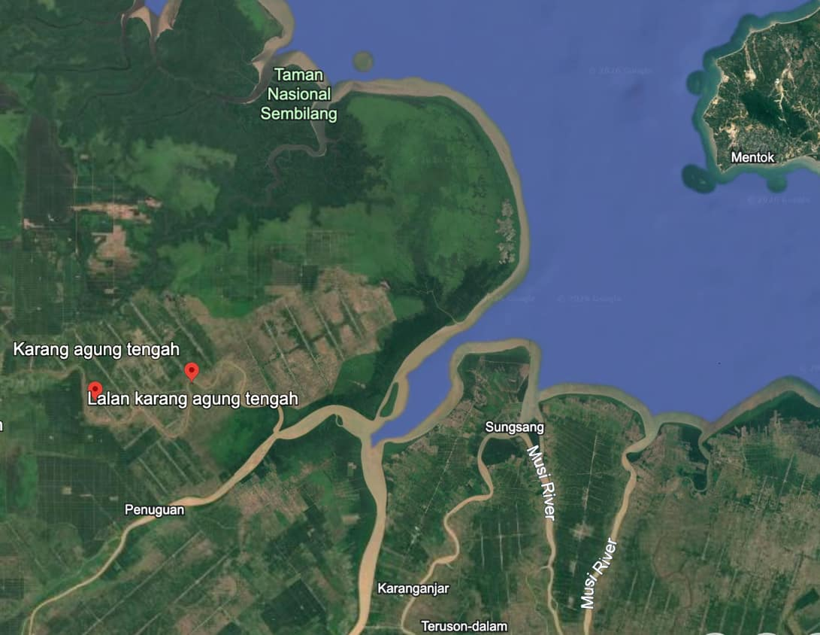
Figure 1: Karangagung Tengah, South Sumatera
(Source: https://earth.google.com/, 2026)
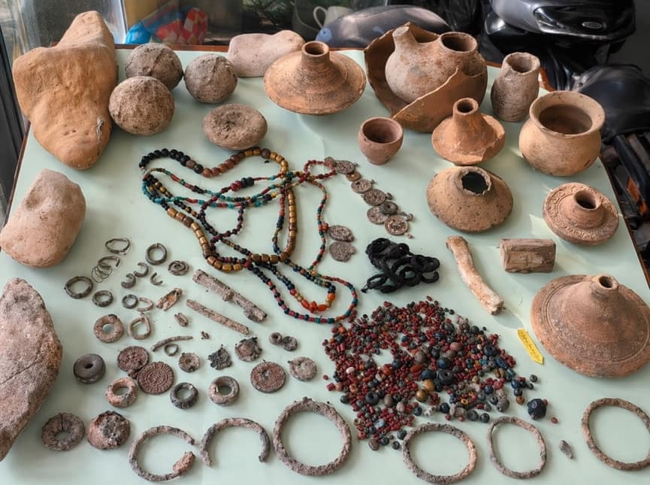
Figure 2: Archaeological finds from Karangagung Tengah.
(Source: Personal documentation, October 2025).
Field research on 9 October 2025 by a Universitas Sriwijaya team showed that ancient river channels are now difficult to recognise. Site patterns extend along former river routes, as seen at Karyamukti and Mulyaagung, linked to the Lalan and Sembilang Rivers. Other sites appear in Purwoagung, Mulyajaya, Karangmukti, and Sukajadi along different tributaries. Archaeology Office research concluded that Pre-Sriwijaya settlements lay along tidal tributaries or ancient rivers whose traces now fade. According to Mr Legimin, a local elder, farmers closed old channels and converted them into coconut and corn gardens. They dug drainage ditches between coconut rows to prevent flooding. These actions erased visual traces of ancient rivers. The ancient channels extended from the Lalan River mouth to the Sembilang River (Interview with Mr Legimin, 9 October 2025).
This situation raises concerns due to the risk of losing important historical records. First-generation residents who knew the excavation locations are now elderly. Younger residents place greater emphasis on the economic value of antique finds than on the site context. Archaeological remains include organic and non-organic artifacts. Organic remains include wooden rudders, animal bones and teeth, coconut shells, ancient wooden house posts, and fossilised wood. Excavations at Mulyaagung revealed posts made from logs about 30 centimetres in diameter, trimmed and sharpened with metal tools. Radiocarbon tests dated these posts to the second to fourth centuries CE, around 1629 to 1624 BP. Non-organic artifacts include earthenware, whetstones, glass and stone beads, tin and bronze earrings, bronze bracelets, and gold rings. Residents also reported decorated pottery sherds, local pottery, glass beads, grindstones, glass slag, ceramic piggy banks, wooden fragments, earthen cooking pots, damar resin lumps, upright wooden posts, clay beads, vertebrate bones, mollusk shells, coconut shells, nibung palm wood, mangrove remains, tin net sinkers, fossilized wood, animal teeth and bones, and gold ornaments. Ship timber and rudder remains also appear. These finds show local communities engaged in sailing and fishing activities (Manguin, 1993; Rediscovered, 2016; Budisantoso and Marhaeni, 2005; Interview with Mr Legimin, 9 October 2025). Karangagung, therefore, stands as an important zone of early human settlement. Communities in this period avoided large rivers and settled in small tidal rivers, linked to subsistence needs and security concerns.
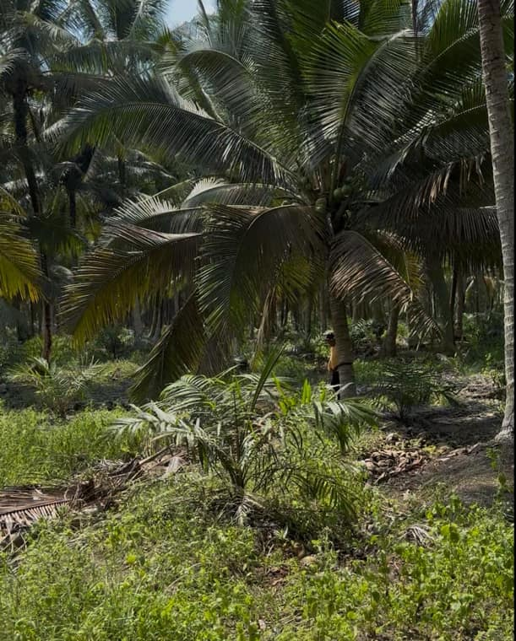  Figure 3: Remains of an ancient river channel.  (Source: Personal documentation, October 2025) | 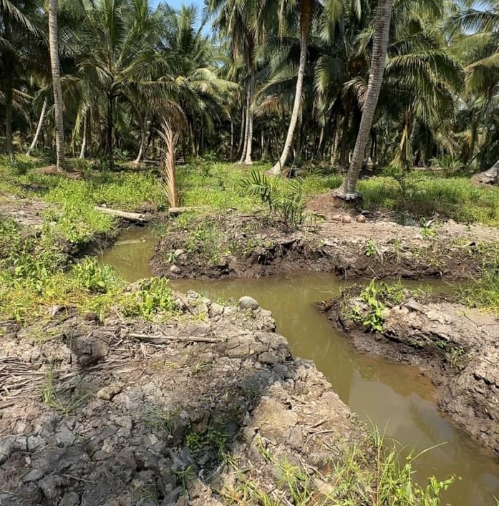  Figure 4: New river channel.  (Source: Personal documentation, October 2025)
Based on this discussion, Gordon Willey's theory, cited in Heddy Shri Ahimsa Putra (1995), remains relevant in showing settlement patterns reflect natural environments, interaction systems, social control, and technological levels of supporting communities. People organise and adapt to environments, forming harmony between settlements and surrounding nature. Settlement patterns, therefore, form direct reflections of environmental conditions. In Karangagung Tengah, settlements extend linearly along the coast, linking villages such as Karyamukti and Mulyaagung.
Ogan Komering Ilir (OKI)
Ogan Komering Ilir Regency lies between 104°20' and 106°00' east longitude and between 2°30' and 4°15' south latitude, with an average elevation of around ten meters above sea level. The regency covers 19,023.47 square kilometres and includes eighteen districts, with Kayuagung as the administrative centre. Tulung Selapan forms the largest district, covering 4,853.40 square kilometres. About seventy-five per cent of the regency consists of swamps and rivers, while the remainder forms dry land. The region falls within a wet tropical zone with high rainfall, averaging sixty rainy days per year. Its coastline stretches across the districts of Sungai Menang, Cengal, Tulung Selapan, and Air Sugihan (Okikab.bps.go.id, 2020). This long coastal zone includes several capes and inlets. Teluk Cengal forms the largest bay, flanked by Tanjung Kait in Tulung Selapan and Tanjung Menjangan.
Teluk Cengal
This area gained recognition as a key site after a major fire in 2015 cleared vegetation and peat layers, exposing historical remains. Residents then collected artifacts for personal keeping and sale. Finds such as ceramics, beads, gold ornaments, ancient wooden posts, and other materials created a new income source through antique hunting. These activities caused further site damage. Surveys by the Palembang Archaeology Office in 2016 recorded abundant community finds. Further study confirmed the strategic location of Teluk Cengal facing the Java Sea, with the Bangka Strait to the west. This position explains past use as an anchorage for traders and sailors. Trade flourished, as shown by the variety and quantity of archaeological remains. These rich finds led researchers to refer to Cengal as the "Gateway of Sriwijaya's Prosperity." Links with the Sriwijaya centre in Palembang likely developed through maritime and river networks. Archaeological finds at Air Sugihan and Air Saleh, west of Teluk Cengal, support this interpretation. Geographically, Teluk Cengal occupies a key position, linking the Bangka Strait, the Sunda Strait, and the Java Sea. Extensive archaeological remains indicate strong potential for functioning as a Sriwijaya port (Utomo, 2015).
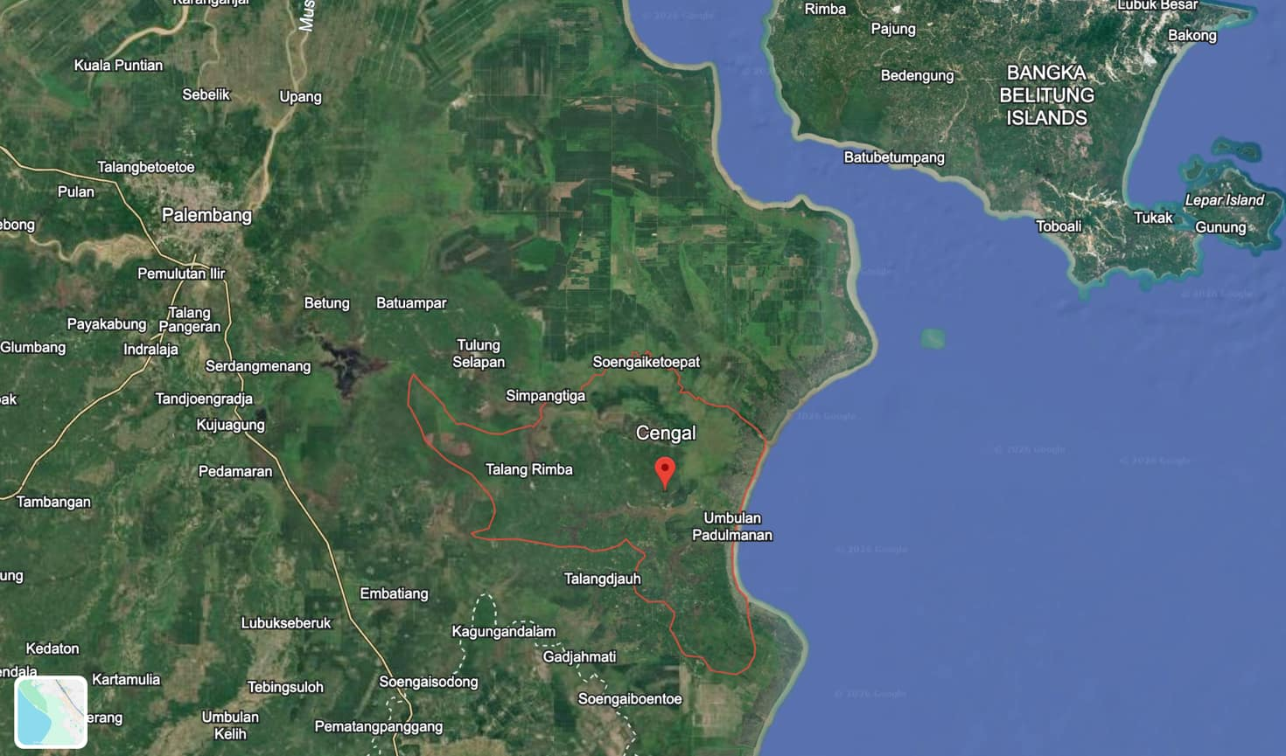
Figure 5: Teluk Cengal
(Source: https://earth.google.com/, 2026).
Portuguese records from the sixteenth and seventeenth centuries show busy shipping routes around the Bangka Strait. Teluk Cengal features a network of interconnected tidal rivers. The bay forms the mouth of the Lumpur River, a major transport route linking the Bangka Strait with inland zones. The Lumpur River includes tributaries such as Langipi, Ketupak, Kemang, Belidang, Tangkallesso, Riding, Lebung Hitam, Jeruju, and Pasir Rivers (Rangkuti, 2017). The largest archaeological concentrations are along the Lumpur River, which flows into the Java Sea. Finds include ancient house posts, Chinese ceramics, Indian beads, Persian glass, and local pottery dating from the seventh to the thirteenth centuries CE. The first ancient boat find in Teluk Cengal occurred in 1992 at Tulung Selapan Village, consisting of ijuk fibre ropes used to bind planks in sewn plank construction. Researchers also found wooden pegs strengthening plank joints (Wiyana et al., 2013). In 2009, researchers found another wooden boat with a bow-to-stern sewn construction in the Pasir River. Other finds included ceramic fragments, coconut shells, wooden spoons, grinding stones, and long, round timbers, similar to remains from Punggul Harjo Site in Central Java, dated to the seventh century.
In 2015, Simpang Tiga Sakti Village in Tulung Selapan yielded boat planks measuring 21 to 25 meters long. Further finds came from Ulak Kedondong Village along the Lumpur River. Besides boats, researchers documented ceramic jars, storage vessels, stone and glass beads, carnelian beads, coins, gemstones, and gold rings (Wiyana et al., 2013). Residents also reported the presence of imported glass fragments, ceramic jars, earthenware, beads, grinding stones, burnt wooden posts, boats, and related materials following the 2015 fires. Illegal excavations occurred at Langipi River, Ketupak River, Canal 12, Pulau Pisang, Bukit Tengkorak, and Jeruju Village sites (Rangkuti and Wiyana, 2016). These locations became key sites after post-fire discoveries. Abundant artifacts include glass beads, ceramic jars, wooden posts, ancient boats, and pottery fragments from the Sriwijaya period. Illegal artifact hunting is highly vulnerable to anthropogenic damage. At the same time, these finds confirm eastern South Sumatra as a major maritime activity zone with intensive international trade, especially between the seventh and thirteenth centuries CE. All evidence indicates sustained naval activity along the eastern coast of South Sumatra, with Teluk Cengal as an important Sriwijaya port. The area served as a stopover for traders exchanging diverse commodities with foreign merchants at regional and international levels.
Several studies confirm that the Bangka Strait and Java Sea routes functioned as sailing and trade corridors since the first century CE. Reid (2015) explains Sriwijaya's growth through integration into Southeast Asian and Asian global trade networks, using monsoon winds for ship movement. Seasonal wind shifts drove port growth as traders waited for wind shifts and interacted with local populations, forming new port communities. Sriwijaya controlled the trade routes through the Bangka and Malacca Straits via port networks along both straits (Reid, 2015).
Historians also examined the Bangka Strait route. Manguin (1984) wrote that Portuguese sailors described the eastern Sumatran waters as muddy, while the coasts of Bangka Island were dotted with many reefs. Maps by Francisco Rodrigues (1513) and Andre Persira Dos Reis (1654) depict a small island at the southern end of the Bangka Strait, now Pulau Maspari in OKI, earlier known as Nucapara or Lucipara. Tome Pires (1512 to 1515) mentioned this island as an important navigation marker for ships bound to Java or Malacca (Cortesao, 1944). In the nineteenth century, European sailors such as J. Stanton again confirmed Lucipara's strategic role as an entry marker toward the Sunda Strait and Java Sea.
Pulau Maspari's proximity to Teluk Cengal strengthens interpretations of the area as a major harbour active in the eighth to tenth centuries CE during Sriwijaya's peak. Finds of ceramics from China, India, and Persia, along with boat remains, demonstrate the intensity of international trade. During this period, Sriwijaya controlled territories across Kambujadesa, the Malay Peninsula, eastern Sumatra, and western Java, including ports such as Grahi, Langkasuka, Tambralingga, Kedah, Pahang, Lamuri, Pane, Kampar, and Palembang. Sriwijaya's attack on Bhumi Java, recorded in the Kota Kapur Inscription, likely targeted Tarumanagara, associated with the Batujaya Site in Bekasi, West Java. This view is supported by the discovery of a tenth-century shipwreck off Cirebon carrying cargo from India, the Middle East, and China (Utomo, 2008).
Sungsang, Maritime Gateway of the Palembang Sultanate
Sungsang formed the most strategic gateway within the Palembang Sultanate's defensive system, especially in the early nineteenth century, when British and Dutch expeditions attempted to penetrate Palembang. Geographically, Sungsang lies at the mouth of the Musi River and served as the first point foreign fleets encountered before entering the sultanate's core zone. Defensively, this location served as a natural checkpoint that required advanced navigation and placed enemies in extreme environmental conditions. The Sungsang estuary remains shallow, with strong currents and sharp tidal changes. These conditions slowed large vessels and increased the risk of fleet damage. The British expeditions in 1812 and the Dutch campaigns from 1819 to 1821 encountered serious obstacles due to large waves, strong counter-currents, and continuous heavy rain.
The Palembang Sultanate used Sungsang's ecological character as both a natural fortress and an early observation zone. The court granted Sungsang residents special status as a sikap, a tax-free zone tasked with providing rowers for royal boats and serving as the kingdom's first line of defence against maritime threats. The eighty-kilometre route from Sungsang to Palembang, marked by winding narrow rivers and extensive swamps, allowed defensive strategies such as releasing large logs and fire rafts to delay enemy fleets. Sungsang functioned as an initial defensive point combining natural conditions, intelligence roles, and obstruction strategies. This dual role made Sungsang fundamental to the Palembang Sultanate's power until the Dutch conquest in 1821.
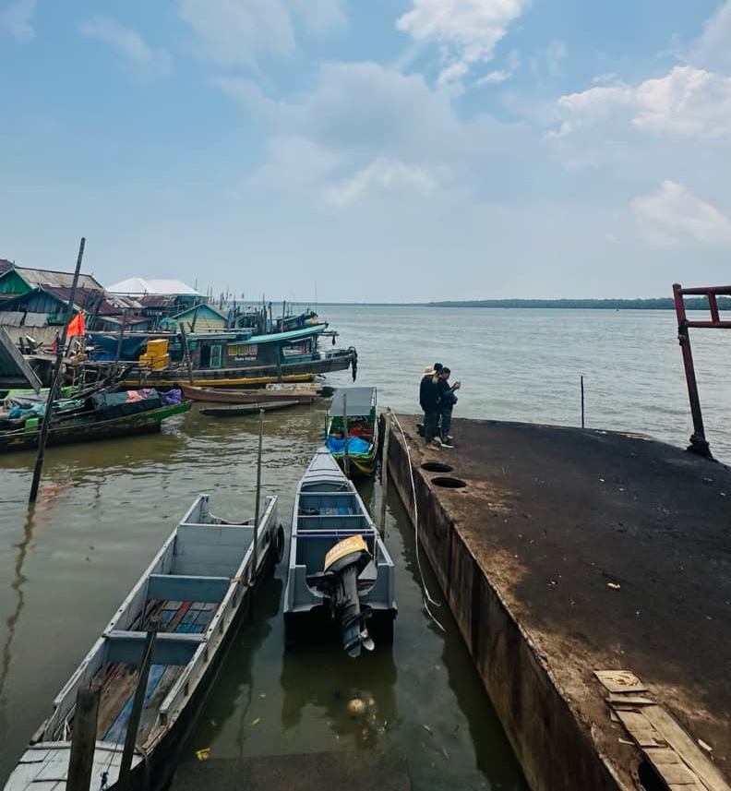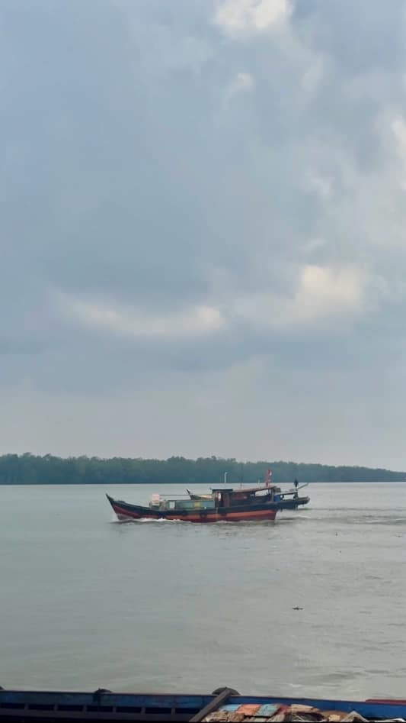
Figures 6 and 7: Sungsang estuary.
(Source: Personal documentation, October 2025)
Air Sugihan Site (Buluran River)
The Air Sugihan Site represents one of the key locations that show early human settlement along the eastern coast of South Sumatra. Archaeological evidence indicates settlement activity since the early Common Era, continuing into the post-Sriwijaya period. The site lies in the Air Sugihan District at coordinates 02.57504° south latitude and 105.29959° east longitude. The area consists of peat swamps covered by mangrove forests and crossed by small rivers flowing into the Bangka Strait. These rivers include the Raden, Simpang, Buluh, and Betet Rivers, all located within the Air Sugihan delta. During the rainy season, water volume rises, while in the dry season, water levels fall. This network of small rivers formed a microsystem of settlement and economic activity during the Pre-Sriwijaya and Sriwijaya periods. Its position within a tidal delta supported adaptive settlement patterns in response to ecological change. Diverse artifacts, including jars, Yue ware bowls, Indian pottery, metal tools, and glass fragments, indicate that the area formed part of a major habitation and trade zone in the past. These small rivers functioned as internal transport routes linking the swamp hinterlands with the major port at Cengal. As a tidal swamp zone east of the Musi River estuary and as a transmigration area since 1980, Air Sugihan reflects strong interaction between human settlement and wetland environments (Rangkuti, 2017; Lobeck, 1940; Thornbury, 1964; Research Team, 2009; Intan, 2015). In this environmental setting, residents used local resources such as nibung palm (Oncosperma tigillarium), jelutung (Dyera polyphylla), and mangrove species (Rhizophoraceae) to build stilt houses and daily tools. Human environment relationships appear in artifact evidence involving flora, fauna, soils, and water (Mundardjito, 2002; Suhandi, 1997). These data confirm that Air Sugihan, Air Saleh, and the surrounding zones formed active areas connected with external networks, supporting dense settlements and diverse remains. This zone formed part of the same system as Teluk Cengal, which scholars associate with a Sriwijaya port.
Archaeological finds at Air Sugihan date from the fifth to sixth centuries CE, including jars from the Sui Dynasty period. Studies conducted between 2002 and 2003 identified fifteen archaeological sites within the Air Saleh and Air Sugihan delta (Indrajaya, 2014). In 2010, researchers documented a sewn construction boat wreck measuring 10.7 meters. Other finds include Song ceramics, small tin earrings from Vietnam, metal artifacts of bronze and gold such as earrings, knives, rings, medallions, pendants, and candle holders, carnelian stone beads, glass beads, ring stones with cattle, swan, and chakra motifs, glass and bronze bracelets, wooden post remains, plain pottery such as cooking pots and jars, and human skeletal remains of approximately two and eighteen years of age. Researchers also found fragments of Yue ware stone bowls, Indian black ware, local pottery, high-necked jars, and whetstones. These finds date to the Sriwijaya period. Excavations in 2011 and 2013 recorded no fewer than 130 stone beads and 128 glass beads (Wiyana et al., 2013; Rediscovered, 2016). One of the most notable finds involved large storage jars believed to store Chinese trade commodities such as liquor, oil, statues, and butter. Similar high-quality ceramics appear in Palembang on land, within Musi River diving contexts, and within the tenth-century shipwreck in Belitung waters. Other remains are scattered across swampy areas along ancient riverbanks. Notably, these remains do not concentrate along the main Air Sugihan or Air Saleh Rivers. This distribution shows past settlement patterns along small rivers, similar to those in Karangagung Tengah. Eastern South Sumatra, therefore, displays parallel conditions across sites. These ancient remains have yet to receive adequate attention from stakeholders, including provincial, regency, district, and village authorities. This situation risks further marginalisation of these valuable historical sites.
CONCLUSION
This study demonstrates that the eastern coastal region of South Sumatra constitutes a crucial zone for understanding early maritime cultural dynamics in Southeast Asia since the early Common Era. Archaeological and historical evidence from Karangagung Tengah, Teluk Cengal, and Air Sugihan confirms the presence of complex settlement systems supported by extensive regional and international trade networks. The discovery of artifacts originating from China, India, and Persia, alongside evidence of sewn-plank boat technology and wooden house posts dated to the 2nd–4th centuries CE, highlights long-term intercultural interactions and maritime connectivity, particularly during the rise of Sriwijaya between the 7th and 13th centuries CE. These findings strongly support settlement ecology theory, demonstrating how tidal river environments shaped settlement distribution, social organization, and technological adaptation.
However, contemporary environmental transformations—especially those driven by transmigration programs and land reclamation since the 1980s—have significantly altered the wetland landscape and threatened the preservation of archaeological sites. The disappearance of ancient river channels, combined with increasing anthropogenic pressures such as agricultural expansion and uncontrolled artifact collection, poses a serious risk of irreversible data loss. These conditions underline the urgency of implementing integrated preservation strategies.
To address these challenges, this study proposes several practical recommendations for stakeholders. First, it is essential to conduct systematic remapping and digital documentation of ancient river networks and site distributions, particularly in the 400-hectare Karangagung Tengah area, using GIS-based approaches. Second, local governments should consider establishing heritage protection status for key sites such as Teluk Cengal to prevent further degradation and regulate artifact exploitation. Third, community-based educational programs should be developed to raise awareness among local residents—especially younger generations—regarding the historical significance of archaeological remains, thereby shifting perspectives from purely economic value toward cultural heritage preservation.
In conclusion, the eastern coast of South Sumatra represents not only a significant archaeological landscape but also a key reference point for reconstructing early Southeast Asian maritime history. Strengthening preservation policies, improving documentation, and fostering community engagement are essential steps to ensure the sustainability of this cultural heritage for future research and public knowledge.
REFERENCES
Asnan, G. (2019). Sungai dan Sejarah Sumatra. Yogyakarta: Ombak.
Budisantoso, Tri Marhaeni.S. (2005). “Pemukiman Pra-Sriwijaya di Pantai Timur Sumatera Kawasan karangagung Tengah Kabupaten Musi Banyuasin Provinsi Sumatera Selatan. Departemen Kebudayaan dan Pariwisata Pusat Penelitian dan Pengembangan Arkeologi Nasional.
Cortesao, Armando. (1944). The Suma Oriental of Tome Pires: An Account of The East. London: Hakluyt Society.
Indrajaya, A. (2014). Arkeologi maritim di pesisir timur Sumatera Selatan: Temuan Air Sugihan dan implikasinya. Berita Penelitian Arkeologi, 18(2), 45–62.
Intan, M. Fadhlan S. (2015). “Eksplorasi Geomorfologi Di Wilayah Air Sugihan, Sumatera Selatan.” In Kehidupan Purba Di Lahan Gambut. Surakarta: PT Aksara Sinergi Media.
Interview with Mr Legimin, 9 Oktober 2025.
Laporan Penelitian Balai Arkeologi Palembang tahun 2006 and 2014.
Lobeck, A. K. (1940). “Geomorphology.” Science Education 24 (5). McGraw-Hill Book Company, Inc.: 296–296. doi:10.1002/sce.3730240525.
Manguin, P.-Y. (1993). Trading ships of the South China Sea: Shipbuilding techniques and their role in the history of the development of Asian trade networks. Journal of the Economic and Social History of the Orient, 36(3), 253–280.
Marhaeni, Tri. S.B. (2002). Arkeologi Pemukiman Klasik di Kawasan Pantai Timur Sumatera Kabupaten Musi Banyuasin Provinsi Sumatera Selatan. dalam Laporan Hasil Penelitian. Palembang: Balai Arkeologi Palembang.
Marhaeni, Tri. S.B. (2002). Permukiman Pra-Sriwijaya di Karang Agung Tengah: Sebuah Kajian Awal. dalam Jurnal Arkeologi Siddhayatra Volume 7 Nomor 2 November 2002. Palembang: Balai Arkeologi Palembang, hlm 65-89.
Marhaeni, Tri.S.B. (2005). Berita Penelitian Arkeologi Permukiman Pra-Sriwijaya di Pantai Timur Sumatera Kawasan Karang Agung Tengah Kabupaten Musi Banyuasin Provinsi Sumatera Selatan, dalam Berita Penelitian Arkeologi No 13. Palembang: Balai Arkeologi Pal.
Mundardjito. (2002). Pertimbangan Ekologi Dalam Penempatan Situs Masa Hindu-Buddha Di Daerah Yogyakarta. Jakarta: Wedatama Widya Sastra.
okikab.bps.go.id, (2020).
Rangkuti, N. (2014). Sebaran Situs Sriwijaya di Kawasan Pasang Surut: Kajian Arkeologi Ruang Di Kawasan Karang Agung Tengah, Sumatera Selatan. Berkala Arkeologi, 55-64.
Rangkuti, N. (2017). Teluk Cengal: Lokasi Pelabuhan Sriwijaya? Bay Of Cengal : The Location Of Sriwijaya Port? Balai Arkeologi DI Yogyakarta. Berkala Arkeologi Vol.37 Edisi No.2 November 2017.
Rangkuti, Nurhadi, (2014). “Hunian “pra-śrīwijaya” di Daerah Rawa Pantai Timur Sumatera, Kalpataru, Majalah Arkeologi Vol. 23 No. 2, November 2014: 81-150.
Rangkuti, Nurhadi dan Budi Wiyana. (2016). “Hasil-Hasil Penelitian Arkeologi di Lahan Gambut Provinsi Sumatera Selatan”. Palembang: Balai Arkeologi (tidak diterbitkan).
Rediscovered, H. (2016). Palembang And Sriwijaya : an Early Malay Harbour-City Rediscovered. Journal of the Malaysian Branch of the Royal Asiatic Society , Vol . 66 , No . 1 (264) Published by : Malaysian Branch of the Royal Asiatic Soc. 66(1), 23–46.
Reid, Anthony. (2015). Asia Tenggara Dalam Kurun Niaga 1450-1680. Jilid 2: Jaringan Perdagangan Global. Jakarta: Yayasan Pustaka Obor Indonesia.
Suhandi, Agraha. (1997). Pola Hidup Masyarakat. Bandung: Fakultas Sastra Universitas Padjadjaran. Indonesia. Bandung: Fakultas Sastra Universitas Padjadjaran.
Sumatera Selatan dalam Angka, BPS Sumsel, (2022).
Susilowati, Endang. (2017). Etnik Maritim dan Permasalahannya. Sabda: Jurnal Kajian kebudayaan. Vol. 7. Hal. 1-18. FIB Universitas Diponegoro.
Thornbury, W.D. (1964). Princyple of Geomorphology. New York: John Willey and Sons. Inc.
Tim Penelitian. (2009). “Laporan Penelitian Peradaban Awal Masa Sejarah: Permukiman Awal Masa Sejarah (Pra-Sriwijaya) Di Pantai Timur Sumatera Selatan.” Jakarta.
Utomo, Bambang Budi. (2015). Kehidupan Purba di Lahan Gambut. Surakarta: PT. Aksara Sinergi Media.
Utomo, Bambang Budi. (2008). Kapal Karam abad ke-10 di Laut Jawa Utara Cirebon (Editor & Penulis). Jakarta: Panitia Nasional BMKT, 2008. ISBN: 979191600-4.
Wiyana, Budi., dkk. (2013). Gambaran Perdagangan di Pantai Timur Sumatera Selatan. dalam Laporan Hasil Penelitian Arkeologi. Palembang: Balai Arkeologi Palembang.
Zuhdi, Susanto. (2006). Laut, Sungai, dan Perkembangan Peradaban Dunia Maritim Asia Tenggara, Indonesia, dan Metodologi Strukturis. Konferensi Nasional Sejarah VIII. Jakarta, 14-16 November 2006.

