Designing Budayaku: An Interactive Application to Enhance Cultural Diversity Learning in Indonesian Primary Schools

J. Julia^{1*}
Email: juli@upi.edu

Rana Gustian Nugraha¹
Email: ranaagustian@upi.edu

Khofifah Rachmawanti¹
Email: khofifahrachma@upi.edu
Rakhmatov Erkin Tagaymuradovich²
Email: rahmatoverkin909@gmail.com
Allaeva Khafiza Rustam Qizi³
Email: hafizaallayeva1994@gmail.com
Dustnazar Omonovich Khimmataliev⁴
Email: d.khimmataliyev@gmail.com

¹ Primary Teacher Education Program, Universitas Pendidikan Indonesia, Bandung, Indonesia
² Department of History and Philosophy, Denov Institute of Entrepreneurship and Pedagogy, Denau, Uzbekistan
³ Department of Methodology of Primary Education, Denov Institute of Entrepreneurship and Pedagogy, Denau, Uzbekistan
⁴ Pedagogical Sciences, Chirchik State Pedagogical University, Chirchik, Uzbekistan

Abstrak
This study presents the development and evaluation of Budayaku application, an interactive mobile learning application designed to enhance cultural diversity education for Indonesian primary school students. Developed using the ADDIE model, the application integrates curriculum-based content with visual, audio, and gamified features to support students’ engagement and understanding. Expert validation was conducted by two content and two media experts, followed by three stages of field testing with a total of 45 fourth-grade students across individual, small-group, and large-group trials. The results indicate that Budayaku application is both feasible and practical. Content and media experts rated the application as “very feasible,” with average scores of 87.99% and 98.66%, respectively. Student responses also showed high practicality levels, with average percentages of 93.59%, 89.06%, and 88.75% across the three trial formats. The study concludes that Budayaku application is a promising digital tool for supporting cultural literacy in primary education. Its consistent performance across settings suggests potential for broader classroom use. Future research is recommended to examine its long-term educational impact and scalability across diverse student populations.
Keywords: budayaku; mobile learning; cultural education; instructional media; primary education

Introduction
In Indonesia, integrating cultural diversity into the primary social studies curriculum is essential for fostering national identity and intercultural understanding. However, pedagogical practices often rely on outdated lecture-based or textbook-driven methods that fail to fully engage students or connect abstract concepts to real-life cultural experiences (Thomas & Quinlan, 2022). This approach risks creating a disconnect between theoretical knowledge and practical appreciation of Indonesia’s cultural richness.
To address this gap, culturally responsive teaching strategies and interactive learning experiences have been shown to increase engagement and comprehension (Ernawati et al., 2024). These approaches allow students to explore cultural elements—such as traditional clothing, languages, and dances—within the context of their own backgrounds (Sabon & Telussa, 2024). A shift toward dynamic instructional models is therefore needed to maximize the educational value of cultural content.
Despite widespread access to digital devices in Indonesian schools, the integration of media into the curriculum remains limited. Teachers often lack time, technical support, and training to develop culturally relevant materials, resulting in students being more exposed to foreign content online than their own heritage (Septyanti et al., 2023). Research highlights that diverse instructional strategies incorporating visual, auditory, and interactive features foster better comprehension, especially of abstract subjects (Chauhan, 2021). Blended learning models, for example, have improved outcomes by combining traditional and digital instruction (Bajis et al., 2021). Improving teacher capacity in digital media use is thus vital to bridge the gap between global exposure and local cultural understanding.
This disparity between technological resources and pedagogical practice points to the need for learning tools that align with students’ visual and kinesthetic learning preferences. Many primary students are digital natives, yet lack culturally grounded media tailored to their context. Therefore, interactive and engaging educational applications are urgently needed.
This study introduces and evaluates Budayaku, an Android-based application designed to enhance cultural diversity education in primary schools. Derived from the Indonesian term for “my culture,” Budayaku application delivers multimedia learning—through text, visuals, animations, and quizzes—to promote student engagement and cultural identification. The research aims to: (1) design a culturally relevant application aligned with curriculum standards, (2) validate content and media through expert review, and (3) assess practicality based on student feedback in individual, small-group, and large-group trials.

Literature Review

Cultural Diversity and Pedagogical Gaps in Primary Education
Cultural diversity education is central to building national identity and mutual respect among young learners in multicultural societies (Valencia et al., 2022; Zhang et al., 2023). Although national curricula introduce themes such as traditional clothing and languages, instruction often remains teacher-centered, limiting student engagement and contextual learning (Xu, 2023). As a result, students struggle to relate abstract cultural content to their lived experiences (Jaffee, 2020).
In Indonesia, studies indicate that cultural themes are underrepresented in classrooms, leading to minimal exposure to diverse perspectives (Rezeki & Sagala, 2021). Culturally responsive pedagogy—emphasizing relevance, inclusivity, and interactivity—can foster deeper understanding and nurture global citizenship (Al’Abri et al., 2022; Risberg, 2022). To strengthen cultural literacy, it is essential to adopt multimodal and innovative learning strategies that empower students through active and meaningful exploration of diversity (GHALAVI & Nastiezaie, 2020).

Technology and Mobile Learning for Cultural Engagement
Technology-enhanced learning (TEL) offers powerful tools to enrich cultural education by combining visual, auditory, and interactive modalities, especially for young learners (Hwang et al., 2021; Sova et al., 2022). Studies show that tools such as animations, audio narration, and interactive storytelling improve engagement and cultural understanding (Ayuwanti et al., 2021; Bramasta et al., 2022; Karunakaran & Dhanawardana, 2023).
However, in developing contexts like Indonesia, TEL integration remains constrained by limited teacher training and infrastructure, leading to an overreliance on generic content (Onojah et al., 2020; Uwineza et al., 2024). This gap calls for culturally embedded digital tools that not only promote learning but also support the preservation of local heritage (Barua et al., 2023; Cancell et al., 2022). Effective use of TEL can transform learning environments to better reflect and celebrate cultural identities (Fadli et al., 2020; Gultom et al., 2022).
Mobile learning (mLearning) specifically enables self-paced, flexible engagement with rich cultural content through gamified and multimedia formats (Alisoy & Sadiqzade, 2024; Batubara et al., 2023). Yet, despite broad access to mobile devices, culturally relevant applications remain rare in Indonesian classrooms (Muslimin, 2024). Research highlights the need for mLearning solutions that include authentic narratives and visuals tailored to students’ cultural identities (Sun & Mo, 2023).

Methods

Research Design
This study employed a design-based research methodology using the ADDIE model, which includes five phases: Analysis, Design, Development, Implementation, and Evaluation (Branch, 2010). This model was selected for its iterative and systematic nature, enabling continuous refinement of the learning product based on stakeholder feedback. The framework supported the alignment of curricular goals, instructional design principles, and mobile application features during the development process (Fang et al., 2011).

Participants
Participants in this study included expert validators and primary school students. The expert group consisted of two content experts (a classroom teacher and a university lecturer in primary education) and two media experts (lecturers in instructional technology). Their input was collected during the development phase to assess the relevance and usability of the application. Meanwhile, a total of 45 fourth-grade students participated in the user testing phase. The students were divided into three groups: individual testing (5 students), small-group testing (15 students), and large-group testing (25 students).

Data Collection
Data were collected through structured questionnaires designed separately for experts and students. The expert questionnaires evaluated curriculum alignment, content accuracy, language clarity, media design, and usability. The student questionnaires focused on appearance, ease of use, and perceived learning value of the application. A five-point Likert scale (from “strongly disagree” to “strongly agree”) was used to capture participants’ perceptions.

Data Analysis
This study used both quantitative summarization and categorical interpretation to evaluate the Budayaku application's feasibility and practicality. Student responses were analyzed using descriptive statistics (mean and standard deviation) via SPSS, highlighting trends in visual design, usability, and learning value, with standard deviations indicating response consistency. Expert evaluations were assessed through percentage-based scoring across four dimensions—content accuracy, curriculum alignment, language clarity, and media design—and categorized into feasibility levels to determine classroom suitability. The criteria used for interpreting expert scores are summarized in Table 1.
Table 1: Feasibility Criteria for Expert Evaluation
Percentage Range | Feasibility Level
81–100% | Very feasible
61–80% | Feasible
41–60% | Fairly feasible
21–40% | Less feasible
0–20% | Not feasible
Similarly, the student response scores were converted into percentages and categorized according to practicality criteria shown in Table 2. These categories served to indicate the perceived usability and learning effectiveness of the application from the learners' perspective.

Table 2: Practicality Criteria For Student Responses
Percentage Range | Practicality Level
81–100% | Very practical
61–80% | Practical
41–60% | Moderate
21–40% | Less practical
0–20% | Not practical
By combining descriptive statistical analysis (for student responses) and percentage-based feasibility classification (for expert evaluations), the study provides a comprehensive understanding of both the technical and pedagogical value of the Budayaku application in supporting cultural diversity learning at the primary school level.

Ethical Considerations
This study adhered to ethical standards for research involving minors. Approval was obtained from the school authority, with written consent from the principal and verbal assent from students under teacher supervision. No identifiable data were collected; all responses were anonymized. Participants faced no physical or psychological risks and could withdraw at any time. Data were used solely for academic purposes and securely stored to ensure confidentiality.

AI Disclosure
To ensure grammar and clarity, the authors used ChatGPT-4 Plus, a generative AI tool developed by OpenAI, for language refinement and structure checking. All content, ideas, and interpretations presented in the article remain the intellectual responsibility of the authors.

Results
This section presents the outcomes of the Budayaku application's development and evaluation process. The results are organized according to the ADDIE model phases, beginning with analysis and followed by design, development, implementation, and evaluation. Each phase provides empirical support for the application’s feasibility, practicality, and instructional value.

Analysis
The analysis phase was conducted to identify the learning needs and contextual challenges in teaching cultural diversity to primary school students. Interviews with teachers revealed that cultural topics—such as traditional clothing, regional languages, houses, and dances—were commonly taught using textbook-based explanations and teacher-centered lectures. Teachers noted limited use of visual aids or digital media due to time constraints and a lack of training in multimedia development. As a result, students often struggled to comprehend abstract cultural concepts and demonstrated low engagement with the material.
Observations of fourth-grade students indicated that most of them were already familiar with smartphones and digital games. Their dominant learning styles were visual and kinesthetic, suggesting the need for interactive, media-rich learning tools. Curriculum analysis based on national learning outcomes for social science confirmed that students are expected to identify, describe, and value Indonesia’s cultural diversity. These findings highlighted a mismatch between pedagogical goals and classroom practices, reinforcing the need for a digital learning solution tailored to students' characteristics and the subject content.

Design

Media Program Outline
The design phase began with the creation of a structured media program outline to define the instructional framework and technical elements of the Budayaku application, ensuring alignment with national learning objectives for fourth-grade social science. The application was developed to help students identify cultural diversity across Indonesian regions, focusing on traditional houses, clothing, dances, and local languages. Content delivery combined illustrated texts, videos, quizzes, and educational games, tailored to suit the visual and kinesthetic learning styles of primary students. The full media program outline is presented in Table 3.
Table 3: Media Program Outline of the Budayaku Application
Component | Description
Application Name | Budayaku_
Grade Level | Grade 4
Subject | Social Science
Main Topic | Cultural Diversity in Indonesia
Learning Objectives | 1. Identify traditional houses, clothing, dances, and languages of Indonesian cultures.  2. Recognize local and national cultural heritage.  3. Appreciate the importance of cultural preservation.
Media Format | Android-based application featuring:  1. Illustrated reading texts  2. Videos of traditional dances  3. Interactive quizzes  4. Cultural games
Table 3 provided a shared reference point for both the development team and expert validators to ensure alignment between pedagogical intentions and digital design throughout the development process.

Flowchart
The flowchart developed during the design phase illustrated the structural logic and user navigation of the Budayaku application, ensuring intuitive, pedagogically sound transitions between features. It mapped the user journey from the splash screen to the main menu, which includes four key sections: “Introduction,” “Learning Materials,” “Quiz,” and “Profile.” Learning content—organized around traditional houses, clothing, dances, and languages—is delivered through illustrated texts and videos, followed by quizzes and cultural games for reinforcement. Additional features like volume control, help buttons, and return-to-menu functions support user autonomy, with visual elements in the flowchart reflecting the actual interface to guide development and evaluation. An overview of the flow structure is presented in Figure 1 below.
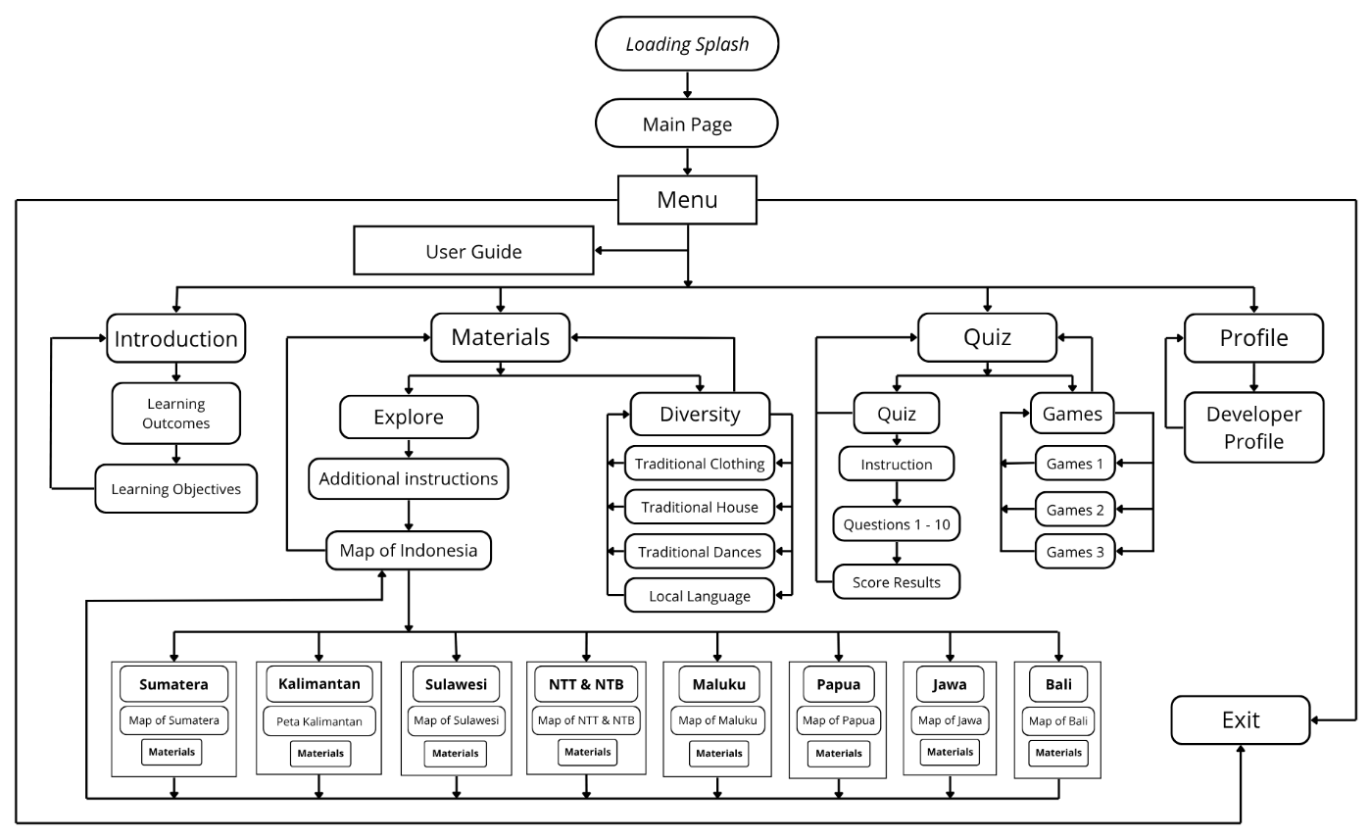
Figure 1: Flowchart of the Budayaku Application
This flowchart served as a foundational reference to ensure the application’s visual and functional consistency, supporting both user engagement and instructional coherence during the development phase.

Storyboard
After completing the flowchart, a visual storyboard was developed to design the user interface and anticipate the learner’s visual experience with the Budayaku application. Created using Canva Pro with Android-optimized dimensions (1920 × 1080 pixels), the storyboard served as a pre-development prototype illustrating each screen’s layout, including text, images, navigation, and color schemes. Key screens included the splash page, main menu with four buttons (“Introduction,” “Materials,” “Quiz,” and “Profile”), content pages with embedded videos, multiple-choice quizzes, and interactive games featuring cultural icons. Consistent layouts, clear fonts, and a neutral color palette were used to ensure readability, reduce cognitive load, and enhance user autonomy. A selection of the storyboard frames used during the design process is presented in Table 4 below.
Table 4: Sample Storyboard Screens of the Budayaku Application
Num | Storyboard Screen | Description
1 | Loading Splash  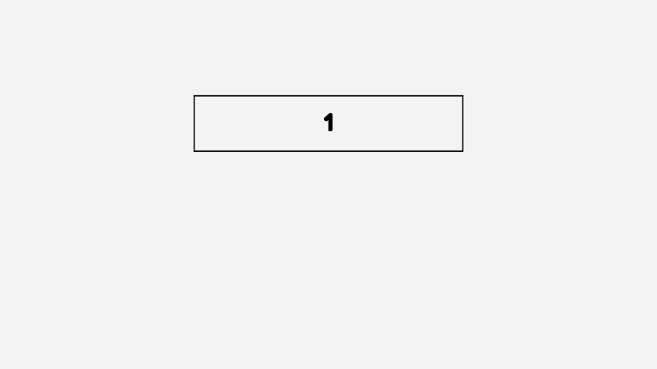 | Box 1 displays the name of the application: Budayaku (Cultural Diversity of Indonesia).
2 | Main Screen  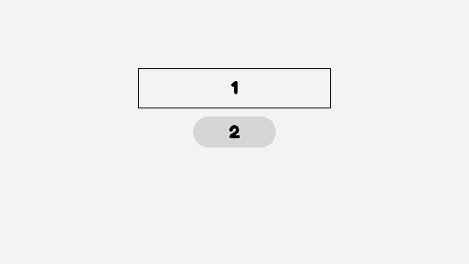 | Box 1 displays the application name: Budayaku (Cultural Diversity of Indonesia).  Box 2 contains the Play button to start the application.
3 | Menu Screen  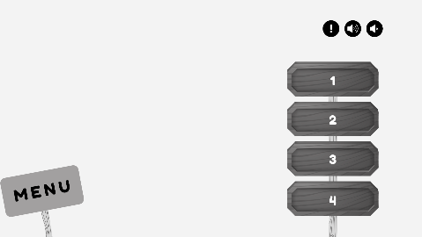 | 1. The page title “Menu” appears in the lower left corner.  2. Available menu options include:  a) Introduction  b) Materials  c) Quiz  d) Profile  3. The upper right corner includes a volume control icon to adjust background music.  4. A button icon indicates the presence of a user guide.
The storyboard contributed to maintaining aesthetic coherence, reinforcing instructional intent, and serving as a blueprint during the application’s coding and multimedia assembly in the development stage.

Development

Overview of the Finalized Application
After the design phase, all visual and audio components were integrated using Smart Apps Creator (SAC) into a fully functional Android Package (APK) exceeding 100 MB due to its rich multimedia features. Budayaku application combines illustrated texts, traditional dance videos, quizzes, and interactive games to engage fourth-grade students in learning about Indonesian cultural diversity. The interface includes a splash screen and a simple, intuitive main menu with four sections: Introduction, Learning Materials, Quiz, and Profile. Each section supports multimodal interaction, with content organized by cultural themes. The user interface features large buttons, colorful icons, and background music to enhance accessibility and create an inviting learning environment. An example of the main menu screen is shown in Figure 2.
 | 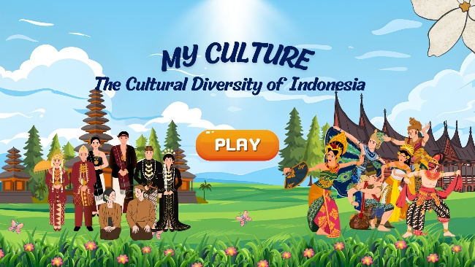
 | 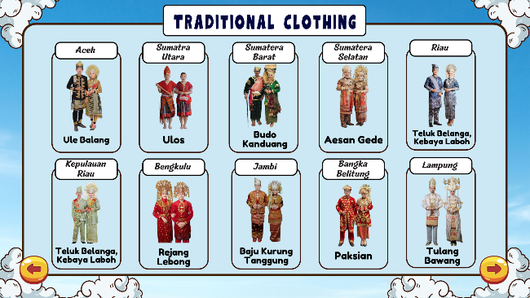
Note: The media is created in Indonesian and translated for international audiences.
Figure 2: Main Menu Screen of the Budayaku Application
All content and interface elements were finalized based on the instructional goals and storyboard developed in the earlier stages. The complete version of Budayaku application was then reviewed by experts for validation prior to implementation with students.

Expert Validation Results
To assess the feasibility of the Budayaku application, two media experts evaluated three key aspects: media design, ease of use, and overall functionality. As shown in Table 5, Validator 1 gave a total score of 58 out of 60, with high ratings across design (20), usability (24), and functionality (14), resulting in a percentage of 98.66%. Validator 2 provided an identical total score with slightly different component scores. The average result confirmed the application to be in the "very feasible" category.
Table 5: Media Expert Validation Results for the Budayaku Application
Validator | Media Design | Ease of Use | Media Functionality | Total Score | Percentage | Category
Validator 1 | 20 | 24 | 14 | 58 | 98.66% | Very Feasible
Validator 2 | 19 | 25 | 14 | 58 | 98.66% | Very Feasible
Average |  |  |  | 58 | 98.66% | Very Feasible
To evaluate the pedagogical feasibility of the Budayaku application, two content experts assessed four key criteria: alignment with curriculum and learning objectives, content accuracy, content relevance (currency), and language clarity/readability. Validator 1, a fourth-grade teacher, awarded a total score of 73 out of 75, resulting in a percentage of 97.33%, categorized as “very feasible.” Validator 2, a university lecturer, gave a score of 59, or 78.66%, classified as “feasible.” The average score across both validators was 66, with a percentage of 87.99%, indicating the application is “very feasible” for classroom implementation. The detailed results are presented in Table 6.
Table 6: Content Expert Validation Results for the Budayaku Application
Validator | Learning Objectives | Content Accuracy | Content Relevance | Language & Readability | Total Score | Percentage | Category
Validator 1 | 15 | 20 | 5 | 34 | 73 | 97.33% | Very Feasible
Validator 2 | 12 | 16 | 3 | 28 | 59 | 78.66% | Feasible
Average |  |  |  |  | 66 | 87.99% | Very Feasible
The combined results of both media and content validation confirmed that the Budayaku application met the criteria for instructional and technical feasibility. All expert suggestions were addressed and incorporated prior to initiating classroom trials with students.

Implementation
After expert validation, the Budayaku application was implemented in a real classroom context to evaluate its practicality from the student perspective. This implementation involved 45 fourth-grade students divided into three phases of field testing: individual trials, small-group trials, and large-group trials. In each phase, students used the application and completed a response questionnaire measuring their perceptions of the application's appearance, usability, and learning value. Scores were interpreted using the practicality classification presented in Table 2.

Individual Trial
To begin the implementation phase, an individual trial was conducted involving five fourth-grade students. After using the Budayaku application independently, each student responded to a 15-item Likert-scale questionnaire. Descriptive statistics—including mean and standard deviation—were calculated for each item to assess the consistency of student perceptions across key indicators such as visual design, textual clarity, usability, and motivation.
Table 7: Descriptive Statistics of Student Responses – Individual Trial
Statement | Mean | Standard Deviation
The visual design of the application motivates me to learn | 5.00 | 0.00
The language used in the application is easy to understand | 4.80 | 0.45
I find the application easy to use in social science learning | 4.40 | 0.89
The application helps me understand Indonesian cultural diversity | 4.60 | 0.55
I prefer learning with the application compared to using textbooks | 4.80 | 0.45
I feel more confident in understanding culture after using this application | 4.40 | 0.89
I am not interested in learning with this application | 5.00 | 0.00
As shown in Table 7, the mean scores for nearly all items were between 4.40 and 5.00, indicating highly favorable perceptions. Particularly notable is the perfect score (M = 5.00, SD = 0.00) on the statement related to motivation and on the reverse item indicating disinterest, which further supports the application's strong appeal. The relatively low standard deviations suggest consistency across responses, with only minor variability in aspects such as perceived ease of use and self-confidence.
In addition to item-level analysis, total scores were computed for each student and converted to percentages for interpretation using the criteria in Table 2. These results are summarized in Table 8.
Table 8: Individual Trial – Student Practicality Scores
Student (S) | Total Score | Percentage | Category
S1 | 73 | 97.33 | Very practical
S2 | 74 | 98.66 | Very practical
S3 | 64 | 85.33 | Very practical
S4 | 69 | 92.00 | Very practical
S5 | 71 | 94.66 | Very practical
Average | 70.2 | 93.59 | Very practical
All five students rated the application in the "very practical" category, with individual percentages ranging from 85.33% to 98.66%. This finding affirms that the Budayaku application meets high standards of usability and relevance when used independently, suggesting its strong potential as a self-paced learning tool for primary education.

Small-group Trial
The second implementation phase involved 15 fourth-grade students working in small collaborative groups. After using the Budayaku application and discussing their experience, students completed a 15-item questionnaire. As shown in Table 9, the mean scores ranged from 4.00 (language comprehension) to 4.73 (learning enjoyment), indicating overall positive responses. Standard deviations varied between 0.46 and 1.00, suggesting moderate differences in perceptions, particularly related to clarity and navigation. These results confirm that the application is well-received in group-based learning contexts.
Table 9: Descriptive Statistics of Student Responses – Small-Group Trial
Statement | Mean | Standard Deviation
The visual design of the application motivates me to learn | 4.27 | 0.80
The language used in the application is easy to understand | 4.00 | 1.00
I find the application easy to use in social science learning | 4.33 | 0.82
The application helps me understand Indonesian cultural diversity | 4.60 | 0.51
I prefer learning with the application compared to using textbooks | 4.20 | 0.94
I feel more confident in understanding culture after using this application | 4.40 | 0.63
I am not interested in learning with this application (reverse item) | 4.67 | 0.72
Total scores from each student were then converted into percentage values to classify the level of practicality, using the same framework as in the previous trial. Table 10 presents the summary.

Table 10: Small-Group Trial – Student Practicality Scores
Student (S) | Total Score | Percentage | Category
S1–S15 | 62–75 | 82.66–100 | Very practical
Average | 66.8 | 89.06 | Very practical
The results show that all students rated the application within the “very practical” range, with an average score of 66.8 points out of 75, equal to 89.06%. These findings indicate that the application maintains its practicality even in collaborative learning scenarios, where students must navigate both the interface and peer discussion.

Large-group Trial
The final implementation phase involved 25 fourth-grade students using the Budayaku application individually in a classroom under teacher guidance. Afterward, students completed a 15-item questionnaire. As presented in Table 11, all mean scores exceeded 4.00, with the highest in learning enjoyment (M = 4.72) and cultural understanding (M = 4.64), while the lowest (M = 4.12) related to language clarity. Standard deviations ranged from 0.46 to 0.87, indicating moderate consistency. These findings confirm the application's strong practicality even in full-classroom settings.
Table 11: Descriptive Statistics of Student Responses – Large-Group Trial
Statement | Mean | Standard Deviation
The visual design of the application motivates me to learn | 4.40 | 0.87
The language used in the application is easy to understand | 4.12 | 0.67
I find the application easy to use in social science learning | 4.32 | 0.63
The application helps me understand Indonesian cultural diversity | 4.64 | 0.64
I prefer learning with the application compared to using textbooks | 4.40 | 0.76
I feel more confident in understanding culture after using this application | 4.68 | 0.63
I am not interested in learning with this application (reverse item) | 4.28 | 0.79
Following the descriptive analysis, students' total scores were converted into percentage values and categorized according to the criteria presented in Table 2.
Table 12: Large-Group Trial – Student Practicality Scores
Student (S) | Total Score | Percentage | Category
S1–S22, S25 | 62–71 | 82.66–94.66 | Very practical
S23–S24 | 59 | 78.66 | Practical
Average | 66.56 | 88.75 | Very practical
These results confirm that the Budayaku application remains highly practical even in a larger classroom setting. The small proportion of students who rated it slightly lower still fell within acceptable limits, reinforcing the application's potential for broad implementation in primary schools.

Evaluation

Overall Evaluation Summary
Expert and student evaluations consistently rated the Budayaku application as highly feasible and practical for educational use. As shown in Table 13, results from content and media validation, along with student feedback across individual, small-group, and large-group trials, all met the “very feasible” and “very practical” criteria based on the established benchmarks in Tables 1 and 2.
Table 13: Summary of Expert and Student Evaluation Results
Evaluation Source | Aspect Evaluated | Average Score (%) | Category
Content Experts (n=2) | Content feasibility | 87.99 | Very feasible
Media Experts (n=2) | Media feasibility | 98.66 | Very feasible
Students – Individual Trial | Practicality | 93.59 | Very practical
Students – Small-Group Trial | Practicality | 89.06 | Very practical
Students – Large-Group Trial | Practicality | 88.75 | Very practical
The consistency of these results—across both expert judgment and user experience—indicates that Budayaku was developed in accordance with instructional design best practices. The application proved to be technically functional, visually appealing, pedagogically aligned, and user-friendly in various learning scenarios.

Effectiveness of the Budayaku Application
Beyond feasibility and practicality, the Budayaku application demonstrated effectiveness through strong expert validation, student engagement, and ease of use. It addressed the lack of accessible, engaging materials for teaching cultural diversity. Students consistently praised its visual appeal, clear language, and interactivity—even in large-group settings. Minor variations in responses did not affect the overall positive trend. Expert feedback also led to key refinements, such as improved layouts and clearer content, reflecting a responsive development process. Overall, Budayaku proved to be an effective, adaptable tool for fostering cultural literacy across various classroom formats.

Discussion
The findings of this study demonstrate that the Budayaku application is a feasible, practical, and pedagogically effective tool for promoting cultural diversity education among primary school students in Indonesia. Developed using the ADDIE model, the application was designed to align with national curriculum standards while addressing the visual and kinesthetic learning preferences of young learners. The consistent results across expert validation and classroom implementation trials reinforce the effectiveness of mobile learning in enhancing student engagement, especially in delivering culturally rich but often underrepresented educational content.
During the validation phase, content experts emphasized the application’s strong alignment with learning objectives, content accuracy, and clarity, while media experts highlighted the quality of visual design and overall usability. These evaluations are consistent with prior studies that underscore the importance of culturally relevant content and learner-centered design in educational technology (Banegas & Beamud, 2020; Waqas et al., 2024). Moreover, Silva et al. (2022) emphasize the need for instructional materials that resonate with learners’ lived experiences to improve comprehension and relevance.
The positive responses gathered from students during individual, small-group, and large-group trials further support the application’s practicality and user-friendliness. In all formats, student feedback consistently reflected high levels of enjoyment, ease of use, and perceived learning value. This aligns with findings from Anuyahong & Pucharoen (2023), who observed that mobile learning platforms can significantly improve student engagement and learning outcomes. Tang & Hew (2022) also note that mobile technologies—particularly those incorporating multimedia and interactive features—can foster behavioral, emotional, and cognitive engagement in classroom settings. Similarly, Balti & Najah (2024) argue that integrating multiple learning modalities can enhance students’ cognitive processes and deepen their learning experiences.
An important observation from this study is the minimal decline in practicality ratings during the large-group trial. Despite the increased complexity of whole-class instruction, the application maintained consistent usability and effectiveness. This suggests a robust interface design capable of supporting diverse instructional settings. These findings align with Biwer et al. (2021), who highlight the role of social interaction in sustaining learner engagement in digital environments. Moreover, although Bustamante et al. (2021) focus on cognitive control, their work supports the broader argument that adaptive and scaffolded features can enhance user experience—especially in contexts with varied learning dynamics.
Budayaku application also addresses a critical gap in cultural literacy by providing immersive, interactive access to local traditions through digital media. In an era where globalized content often overshadows local heritage, tools like Budayaku application can reconnect students with their cultural roots in meaningful ways. Peköz & Gürşimşek (2020) advocate for integrating multicultural perspectives into education to foster cultural intelligence, while Zaki et al. (2024) emphasize that embedding local wisdom into learning platforms strengthens students’ cultural identity and engagement.
Based on this research, the Budayaku application reflects current best practices in mobile-assisted learning and culturally responsive instructional design. Its development process, which incorporated iterative feedback and curriculum alignment, led to a learning tool that is both technically sound and educationally impactful. As such, Budayaku contributes to the growing body of evidence that mobile learning technologies—when developed with contextual sensitivity—can significantly enrich cultural education at the primary school level.

Conclusion
This study developed and evaluated Budayaku, a mobile learning application designed to support cultural diversity education in Indonesian primary schools. The development process, guided by the ADDIE model, produced a curriculum-aligned, multimedia-rich application that received high feasibility ratings from experts and strong practicality scores from students across individual, small-group, and large-group trials. These findings confirm that Budayaku is both pedagogically sound and well-received by learners.
Despite promising results, this study has limitations. It involved a single grade level and school, limiting generalizability, and focused on short-term usability rather than long-term learning outcomes. Expert validation was also based on a small sample. Future research should include more diverse participants and examine sustained educational impact. Further development could incorporate adaptive features, teacher dashboards, and regional content to enhance the application’s scalability and relevance.

References
Al’Abri, K., Ambusaidi, A. K., & Alhadi, B. R. (2022). Promoting global citizenship education (gced) in the sultanate of oman: An analysis of national policies. Sustainability, 14(12), article 7140. https://doi.org/10.3390/su14127140
Alisoy, H., & Sadiqzade, Z. (2024). Mobile-Assisted language learning (mall): revolutionizing language education. Lumin, 1(1), 60–72. https://doi.org/10.69760/lumin.202400002
Anuyahong, B., & Pucharoen, N. (2023). Exploring the effectiveness of mobile learning technologies in enhancing student engagement and learning outcomes. International Journal of Emerging Technologies in Learning (Ijet), 18(18), 50–63. https://doi.org/10.3991/ijet.v18i18.40445
Ayuwanti, I., Marsigit, M., & Siswoyo, D. (2021). Teacher-student interaction in mathematics learning. International Journal of Evaluation and Research in Education (Ijere), 10(2), 660–667. https://doi.org/10.11591/ijere.v10i2.21184
Bajis, D., Chaar, B., Basheti, I. A., & Moles, R. (2021). Teaching asthma first aid to pharmacy students: a comparative study between an online course and simulation by role-play. Pharmacy Education, 21, 92–104. https://doi.org/10.46542/pe.2021.211.92104
Balti, A., & Najah, L. M. (2024). Tutorials and mobile learning in higher education: enhancing and accessibility. Advances in Mobile Learning Educational Research, 4(1), 920–926. https://doi.org/10.25082/amler.2024.01.003
Banegas, D. L., & Beamud, M. d. P. (2020). Content and language integrated learning: a duoethnographic study about clil pre-service teacher education in argentina and spain. Relc Journal, 53(1), 151–164. https://doi.org/10.1177/0033688220930442
Barua, D., Kaisar, A., & Uddin, Md. S. (2023). Students’ acceptance of online higher education in covid-19: bangladesh perspective. Journal of Education and Practice, 14(18), 1–6. https://doi.org/10.7176/jep/14-18-01
Batubara, H. H., Noor, H., Siregar, P., Ihwanah, A., Husni, M., Wibowo, D. R., Maghfurin, A., & Ariani, D. N. (2023). Developing a mobile-assisted project-based learning model for a learning media course. International Journal of Interactive Mobile Technologies, 17(17), 4–18. https://doi.org/10.3991/ijim.v17i17.41705
Biwer, F., Wiradhany, W., Egbrink, M. o., Hospers, H. J., Wasenitz, S., Jansen, W., & Bruin, A. B. H. de. (2021). Changes and adaptations: how university students self-regulate their online learning during the covid-19 pandemic. Frontiers in Psychology, 12, article 642593. https://doi.org/10.3389/fpsyg.2021.642593
Bramasta, I. G. B., Suartama, I. K., & Sudarma, I. K. (2022). Mesari (melajah aksara bali): interactive multimedia based on local wisdom for seventh grade in junior high school. Journal for Lesson and Learning Studies, 5(2), 172–180. https://doi.org/10.23887/jlls.v5i2.48979
Branch, R. M. (2010). Instructional design: The ADDIE approach. Springer New York. https://doi.org/10.1007/978-0-387-09506-6
Bustamante, L., Lieder, F., Musslick, S., Shenhav, A., & Cohen, J. D. (2021). Learning to overexert cognitive control in a stroop task. Cognitive Affective & Behavioral Neuroscience, 21(3), 453–471. https://doi.org/10.3758/s13415-020-00845-x
Cancell, D. R. F., Molina, O. E., Delgado-Yanes, N., & Acosta, J. M. Z. (2022). Experiences in the training of teaching digital competence for using digital social networks. Educational Process International Journal, 11(4), 7–26. https://doi.org/10.22521/edupij.2022.114.1
Chauhan, S. P. (2021). Technology supported classroom for collaborative learning. Interdisciplinary Research in Education, 6(2), 99–106. https://doi.org/10.3126/ire.v6i2.43542
Ernawati, T., Rosana, D., Atun, S., & Susanti, S. (2024). Exploration of culturally responsive teaching and problem-based learning in the diverse learning of prospective science teachers. International Journal of Religion, 5(3), 353–365. https://doi.org/10.61707/t1bg2083
Fadli, F., D., S. I. A., & Rukiyati, R. (2020). Techno - resilience for teachers: concepts and action. Tem Journal, 9(2), 820–825. https://doi.org/10.18421/tem92-53
Fang, M., Zheng, X., Hu, W., & Shen, J. (2011). On the ADDIE-based effective instructional design for higher education classrooms. Advanced Materials Research, 271–273, 1542–1547. https://doi.org/10.4028/www.scientific.net/AMR.271-273.1542
GHALAVI, Z., & Nastiezaie, N. (2020). Relationship of servant leadership and organizational citizenship behavior with mediation of psychological empowerment. Eurasian Journal of Educational Research, 20(89), 1–24. https://doi.org/10.14689/ejer.2020.89.11
Gultom, A. S., Retnowati, R., & Yani, I. (2022). Development of learning media e-booklet science literacy based improving students’ critical thinking ability on immune system materials. Journal of Biology Education Research (Jber), 3(1), 23–31. https://doi.org/10.55215/jber.v3i1.4134
Hwang, W., Hoang, A., & Lin, Y. (2021). Smart mechanisms and their influence on geometry learning of elementary school students in authentic contexts. Journal of Computer Assisted Learning, 37(5), 1441–1454. https://doi.org/10.1111/jcal.12584
Jaffee, A. T. (2020). “I want them to feel safe and to feel loved”: collaborating to teach social studies for middle level emergent bilingual students. Rmle Online, 44(1), 1–16. https://doi.org/10.1080/19404476.2020.1859904
Karunakaran, S., & Dhanawardana, R. (2023). Integration of ICT in the teaching-learning process: challenges and issues faced by social science teachers. European Journal of Education and Pedagogy, 4(4), 24–30. https://doi.org/10.24018/ejedu.2023.4.4.696
Muslimin, A. I. (2024). EFL lecturers’ technostress in low hdi contexts: factors, impacts, coping strategies, and interrelationships. Polyglot Jurnal Ilmiah, 20(2), 88–115. https://doi.org/10.19166/pji.v20i2.8019
Onojah, A. O., Obielodan, O. O., Onojah, A. A., Ajala, A. S., Sotuminu, R. E., & Sulaimon, K. S. (2020). The Proficiency of Undergraduates in Utilizing Social Media for Learning in Nigeria. Indonesian Journal of Curriculum and Educational Technology Studies, 8(1), 32–41. https://doi.org/10.15294/ijcets.v8i1.38157
Peköz, Ç., & Gürşimşek, A. I. (2020). Multicultural attitudes and cultural intelligence of preschool teachers. Journal for Multicultural Education, 14(1), 45–60. https://doi.org/10.1108/jme-05-2019-0043
Rezeki, T. I., & Sagala, R. W. (2021). Semiotics analysis on students’ english textbook in elementary school. Veles Voice of English Language Education Society, 5(2), 120–131. https://doi.org/10.29408/veles.v5i2.3855
Risberg, E. J. (2022). On Bildung and the role of teachers in fostering global citizens. Tidsskrift for Professionsstudier, 18(35), 76–85. https://doi.org/10.7146/tfp.v18i35.134057
Sabon, Y. O. S., & Telussa, R. P. (2024). Ethnomathematics-based learning design of mountainous papua to increase student engagement and create meaningful learning. Jurnal Pendidikan Matematika (Jupitek), 7(1), 66–74. https://doi.org/10.30598/jupitekvol7iss1pp66-74
Septyanti, E., Zulhafizh, Z., Mustika, T. P., & Asnawi, A. (2023). Profile of the needs for digital-based listening learning media in higher education: responding to the challenges of 21st century learning. Jurnal Kependidikan: Jurnal Hasil Penelitian dan Kajian Kepustakaan di Bidang Pendidikan Pengajaran dan Pembelajaran, 9(4), 1150. https://doi.org/10.33394/jk.v9i4.8736
Silva, M. d., Charlo, P. B., Zulin, A., Santos, F. G. T. dos, Jaques, A. E., Haddad, M. do C. F. L., & Radovanovic, C. A. T. (2022). Construction and validation of clinical scenarios for training informal caregivers of dependent persons. Revista Brasileira De Enfermagem, 75(5), 1–8. https://doi.org/10.1590/0034-7167-2022-0140
Sova, M., Siregar, M. T., Ahmaddien, I., Aprinastuti, C., & Kristia, K. (2022). Learning management and ICT on the learning effectiveness: a literature review from diverse lenses. Al-Ishlah Jurnal Pendidikan, 14(2), 1765–1776. https://doi.org/10.35445/alishlah.v14i2.1571
Sun, L., & Mo, S. (2023). Strategies for the integration of traditional music culture in college music teaching under information diffusion modeling. Applied Mathematics and Nonlinear Sciences, 9(1), 1–13. https://doi.org/10.2478/amns.2023.2.01068
Tang, Y., & Hew, K. F. (2022). Effects of using mobile instant messaging on student behavioral, emotional, and cognitive engagement: a quasi-experimental study. International Journal of Educational Technology in Higher Education, 19(1), 1–22. https://doi.org/10.1186/s41239-021-00306-6
Thomas, D., & Quinlan, K. M. (2022). Reimagining curricula: effects of cultural (in)sensitivity of curricula on racially minoritised students’ engagement. Studies in Higher Education, 48(2), 283–298. https://doi.org/10.1080/03075079.2022.2134332
Uwineza, I., Uworwabayeho, A., & Yokoyama, K. (2024). Classroom practices in primary schools’ mathematics teaching supported by the interactive mathematics software for rwanda. International Journal of Evaluation and Research in Education (Ijere), 13(1), 511–522. https://doi.org/10.11591/ijere.v13i1.25244
Valencia, G. A. G., Sabater, M. M., & Fernández, A. S. (2022). Critical global citizenship education: a study on secondary school students. Frontiers in Education, 7, article 867113. https://doi.org/10.3389/feduc.2022.867113
Waqas, A., Correia, J. C., Ahmad, M., Akhtar, T. N., Meraj, H., Angelakis, I., & Pataky, Z. (2024). Therapeutic patient education for severe mental disorders: a systematic review. Cambridge Prisms Global Mental Health, 11, 1–14. https://doi.org/10.1017/gmh.2024.68
Xu, W. (2023). Research on primary and secondary school intangible cultural heritage education and student cultural identity. Journal of Sociology and Ethnology, 5(11), 187–192. https://doi.org/10.23977/jsoce.2023.051125
Zaki, A., Mulbar, U., Husniati, A., & Naufal, M. A. (2024). Integrating local wisdom with project-based learning to enhance 21st-century skills in the society 5.0 era. Journal of Ecohumanism, 3(7), 1821–1831. https://doi.org/10.62754/joe.v3i7.4341
Zhang, S., Du, J., Yue, H., Li, G., & Zhang, D. (2023). Study on the national identity education intentions of pre-service teachers: evidence from pls-sem and fsqca. Sustainability, 15(16), article 12633. https://doi.org/10.3390/su151612633

