The Role of Traditional Palestinian Tile Themes in Contemporary Furniture Design: Advancing Industry Innovation and Preserving Cultural Heritage
Abstract
Objective: This study aims to support the furniture industry in Palestine by creating contemporary furniture pieces inspired by traditional tiles, utilizing advanced manufacturing techniques, and modern materials available in the Palestinian market. Methodology: a descriptive approach was used to define the characteristics of traditional Palestinian tiles. Whereas the analytical approach was used to understand both the cause and the impact that each variable has on the final product. An applied approach was adopted in this study, presenting artworks designed and implemented by the researcher as practical examples that may be adapted internationally under similar circumstances in the future. Findings: The initial step towards promoting local products involves increasing awareness among industry decision-makers about the significance of incorporating innovation in the use of traditional Palestinian architectural icons for the production of contemporary furniture. The second step involves understanding the technological capabilities and the raw materials available in the local market. Conclusion: Prosperity in the furniture industry can be achieved by placing greater emphasis on the capabilities of the Palestinian furniture industry rather than engaging in futile competition with rivaling parties, particularly in areas such as pricing.

Keywords: Contemporary, Tiles, Furniture, Heritage, Palestine

- INTRODUCTION
The interview conducted with the head of the furniture cluster in Nablus, Mr. Sameh Al-Sorakji, concluded that Palestinian furniture today is unable to compete in the global market due to several factors. Among the most important of these is that Palestine is not a source of primary raw materials used in the furniture industry, such as wood and minerals, unlike countries like Canada and Sweden. Additionally, the high cost of living in Palestine further hinders the sector's ability to match the low labor costs in countries like China and India, where the furniture industry benefits from a cheap workforce (Al-Sorakji, 2019). Regarding advanced manufacturing technology and modern finishing equipment, it falls short in comparison to Europe and the US. This inequity is compounded by various factors, with the foremost being the obstructive impact of the Israeli occupation on this sector as a whole (PALTRADE, 2017) (Nasrallah & Awwad, 2004) (Alradea, 2020). The study aims to enhance the current state of the Palestinian furniture industry by bringing together designers and manufacturers, guiding them through diverse artistic curricula and practical approaches. By doing so, they can effectively incorporate a wide range of elements from Palestinian folklore, thereby contributing to the growth and enrichment of the industry. (Jabaree & Bitaw, 2021, p. 31).
- LITERATURE REVIEW
In traditional societies, traditional arts play a significant role by fostering strong ideological and emotional connections amongst all members of the community. The utilization of these traditional arts during significant events serves as a reminder of the society's customs, traditions, and morals, emphasizing the collective effort required to preserve them. Moreover, traditional art serves as a tool of social control in societies, offering a genuine alternative to human-made laws within these communities. It is widely recognized as conservative art on a global scale, as it preserves the heritage and artistic expressions of past generations, passing them down unchanged to future ones. The significance of traditional art lies in its ability to uphold and honor various social, religious, and political values, thereby strengthening the bonds between these ideological systems, institutions, and all members of society (Al-Haidari, 1984).
From this perspective, the true measure of the traditional artist's proficiency becomes evident in their ability to faithfully recreate and carry forward the heritage handed down by their ancestors. Conversely, contemporary artists consistently focus on innovation and progress. Traditional art often adheres closely to established and familiar styles, making it imperative for folk artists to embrace the responsibility of rejuvenation and advancement. This involves adapting to the rapid changes of the present era, while being mindful that the process of development must occur gradually and synchronize with the conservative fabric of society before being fully embraced and integrated (Khasawneh, 2001).
The evolution of materials used by contemporary designers is constrained by several factors, primarily the economic element. This aspect revolves around the accessibility and competition between modern materials and those readily available in the local environment. In the past, designers relied on resources found within their immediate surroundings, and the transportation of raw materials from one region to another was uncommon. Consequently, they were compelled to utilize what was locally accessible (Awad, 2012). Moreover, the themes explored by traditional artists were shaped by their surrounding environment. Agricultural communities, for instance, decorated their creations with symbols such as wheat spikes, palm fronds, and harvest themes (Amiry S. , 2003). On the other hand, coastal populations incorporated fishing and sea-related elements into their artwork. Therefore, traditional art serves as a distinct mirror reflecting the artist's immediate environment, and the modern artist must not overlook this crucial source of inspiration in their present-day creations (Makhoul, Horn, & Sharaf, 2020).
Developing nations strive to achieve progress by consistently elevating the quality of life for their citizens and enhancing their overall national productivity (PALTRADE, 2017, p. 20). Renowned sociologist Smelser has long recognized that development entails the transition from a society reliant on traditional primitive modes of production to one based on technology and practical knowledge. Many sociological researchers have consistently upheld the view that development is an intricate process in which folklore plays a central role in its realization. Adams and Leeds suggest that the link between development and heritage is strong and direct, encompassing not only objectives and content but also the implemented programs and the individuals involved in them. Maximizing the benefits of development initiatives requires taking cultural customs and traditions into account, as they play a unifying role for groups striving for development. Hence, the main goal of development is to modify a society’s customs and traditions, adapting them through the optimal use of available natural and technological resources (Subhi, 2007).
The Israeli occupation strives to steal everything that remains on the land of Palestine in terms of culture, history, and civilization, daily, to establish its foothold on the ground it has occupied. Occupying powers often use art to claim a deep historical connection to the land, attempting to institute a sense of cultural connection. No society exists without civilization, and art is an integral part of civilization; it often becomes a significant cultural legacy. The aforementioned explains why the Israeli invader constantly strives to construct a shared history with the original owners of the land to gradually seize it from them and claim ownership (Abu Amira, 2015). This was observed and documented during the supposed Fashion Week in Tel Aviv. Israeli women were seen wearing dresses inspired by the popular Palestinian Kufiyya, which symbolizes the Palestinians' struggle and history on their land. The two designers, Gabi Ben Haim and Moki Harel, incorporated the Palestinian Kufiyya in black-and-white and red-and-white variations, with traditional Palestinian farmer embroidery on the dress. Moreover, Palestinian symbols such as the Kufiyya and the Dome of the Rock were used as expressions of the occupation on international forums and festivals (Alfajr TV, 2015). At the International Cannes Festival in France, the Israeli Minister of Culture and Sports was seen carrying the image of the Al-Qibli Mosque and the Dome of the Rock in an attempt to assert that Jerusalem is the eternal capital of 'Israel' (France24, 2017) (Al-Helou, 2015). Furthermore, in continuation of the same occupation policy that continues to steal Palestinian heritage, the Israeli occupation promoted Palestinian culture as a local Israeli culture during the Miss Universe contest that was held in the occupying state in 2021. There, the Miss Universe contest organizers granted the contestants permission to compete wearing traditional Palestinian attire as Israeli local attire, and this was accompanied by an offer to visit Israel. They also had wrapped grape leaves 'Dawali' and other popular Palestinian dishes, and presented them as popular Israeli dishes. All of these actions can be considered as instances of cultural appropriation and direct contributions to the theft of Palestinian heritage and history (Al Jazeera Live, 2021).
2.1. ARTISTIC INSPIRATION METHODS
Artistic creativity is known as the possession of an individual to generate new ideas or develop existing ones to create novel products, artistic, or literary works, which bear material or moral values for individuals or society, particularly in various artistic areas (Lindauer, 2011). The importance of artistic inspiration methods in designing can be summarized in encouraging novel design ideas or reinterpretations of old concepts through innovative artistic formulas. Most works of art are traditional or reproduced pieces. The true brilliance, however, lies in the art of steering clear of mere duplication, for therein lies the risk of losing the very soul and essence of the creation. Through modern artistic methods, one can take the first concrete steps towards artistic focus and creativity. One of the most prominent elements of artistic creativity is uniqueness and originality. Navigating through timeless artworks with a contemporary vision is key (Shraim, 2015). Among the most prominent artistic methods are the following:
2.1.1. MODIFICATION AND MODULATION
Artistic modification entails departing from conventional artistic norms regarding positions, proportions, and dimensions, while also reshaping natural forms. This process involves embedding these shapes into artistic and aesthetic molds and decorative patterns, often repeated while safeguarding their innate characteristics and features within an innovative framework (Taha, 2003). A significant example of artistic modification in Palestine is the evolution of Islamic decorations, which progressed through three developmental phases. Initially, these decorations were influenced by Eastern Greek and Roman ornamentation, as well as the decorative arts and engravings of Iraq and Persia. Islamic art adhered to religious standards, incorporating elements that harmonized with Islamic principles while rejecting or adapting those that conflicted with them, such as nudity and the portrayal of divine entities. The developmental journey of modification in Islamic arts can be categorized into three main phases:
In the first phase, drawings and decorations displayed a semblance of reality, with a clear influence from preceding civilizations, particularly evident in floral motifs. An exemplary instance of this influence is found in the adornments of the Mshatta Palace, which bear a striking resemblance to Coptic decorations found in Egyptian antiquities, featuring intricate carvings depicting various levels of leaves and clusters of grapes.
The second phase, termed the stage of practice and innovation, marked a period during which Muslims demonstrated prowess in the art of modification, excelling in innovation. This phase commenced in the early 3rd century AH/9th century AD, preceding the conclusion of the initial Abbasid era. It was closely associated with the discovery of stucco decorations unearthed by archaeologists in the city of Samarra, established by the Abbasid Caliph al-Mu'tasim Billah in 222 AH/836 AD for his Turkish soldiers. Archaeologists uncovered substantial quantities of drawings and plaster decorations commonly utilized to adorn buildings during the Abbasid era and subsequent breakaway states. During this phase, botanical motifs began to emerge, albeit bearing some departure from their natural origins. Decorative elements were imbued with internal patterns resembling palm veins and geometric shapes. Notably, these decorations featured less deeply engraved designs compared to the preceding phase, (Al-Tayesh, 2013).
In the third phase, plant elements underwent significant modification, straying far from their natural forms, rendering it difficult to discern their starting or ending points. This stylistic shift heralded a profound transformation in Islamic decoration overall, particularly in the realm of artistic modification. Characterized by its implementation of oblique or beveled engraving, this style also eschewed deep incisions. Key decorative elements in this style included full palm fans, their halves, and winged leaves, which supplanted the grape leaves prevalent in the preceding stages.
Termed the stage of creativity, this phase marked the pinnacle of artistic modification, steering it onto a path of proper development. Muslim artists recognized the importance of deepening engravings on surfaces to enhance the visibility and clarity of decorative elements while maintaining their flow and achieving greater harmony and symmetry. This phase commenced during the Fatimid era and persisted through the Ayyubid and Mamluk dynasties. Notably, the art of modification flourished during the Fatimid dynasty, with plant elements, geometric shapes, and inscriptions adorning buildings and wooden surfaces (Hasan Z. M., 2017). One of the most renowned and breathtaking examples showcasing the art of modification can be found in the interior of Al-Azhar Mosque. Here, intricate floral and geometric inscriptions adorn the walls, alongside modified plant decorations elegantly embedded within the plaster frame beneath the ceiling. Muslim artists increasingly incorporated modified plant elements and geometric shapes, creating compositions in which these elements seamlessly intertwine, thereby enhancing the artwork’s aesthetic value.
The art of modification in Islamic arts can be categorized into four distinct components: Calligraphy, vegetal patterns, geometric patterns, and figural representation (Basha, 2000).
2.1.2. ABSTRACTION AND REDUCTION
Abstraction and reduction were the foundation of ancient primal arts. In these early forms of artistic expression, the earliest artists resorted to these methods to convey their ideas and design requirements within caves and through pictorial writings such as hieroglyphics in ancient Egypt (Hamdi, 2021). The pioneering artist reduced the vocabulary to a group of design shapes and realistic images supported by lines that are devoid of any details. They then rephrased them in a monochromatic space or using simple flat patterns. By doing so, they bypassed numerous intricacies and transformed the shapes into symbolic representations that achieve both the aesthetic and functional objectives simultaneously. Notably, the designer intentionally curtailed various color attributes of the shape, confining them to one or two colors while deliberately disregarding others. This deliberate choice adds strength to the designed shape and redirects attention away from excessive detailing (Nema, 2013).
It can be summarized that artistic abstraction has always relied on the simplification of shapes, colors, and their symbolic representations, veering away from precise depictions of reality and natural objects. The shapes in this context have a pure, abstract, and moral essence, rather than being pictorial, realistic, and visual.
2.1.3. EXAGGERATION AND OMISSION
Exaggeration has long been utilized in discourse to convey ideas or specific messages, often distancing the speaker from factual accuracy. Although this form of expression is considered extreme in communication, it is not always deemed reprehensible. The objective of exaggeration is to captivate attention, evoke surprise, and sometimes provoke disapproval from the audience, thereby prompting a call for moderation, truth, and fairness in speech.
This elucidates why certain individuals condemn exaggeration, perceiving it as straying far from reality, while simultaneously advocating for increased empathy toward the subject being conveyed. However, those who denounce this artistic mode of expression often lack effective alternatives for addressing inherently challenging topics without resorting to exaggeration. Indeed, exaggeration constitutes one of the most significant forms of this art, enabling nuanced and impactful communication (Aljodaibe, 2023).
Caricature art exemplifies a form of exaggerated expression in drawing and calligraphy. In this genre, artists often employ exaggeration of certain details to convey messages to viewers in a sarcastic manner, occasionally distorting reality. This is notably evident when caricature artists depict politicians in unfavorable or absurd scenarios, purposefully exaggerating facial features to evoke strong reactions and convey intended meanings effectively (AlQadi, 2020). Before the advent of caricature art, Arabs excelled in the art of exaggeration within their poetry and prose, particularly in themes of love, courage, and bravery. Ultimately, the objective remains the same: to captivate the audience, stirring their emotions and drawing their attention, thereby conveying the intended message of the written or recited work. Exaggeration, as a means of conveying meaning, does not necessarily entail contradicting facts. Rather, it involves leveraging existing facts or widely accepted perceptions to convey the desired meaning. It is often noted that exaggeration doesn't solely involve amplifying or embellishing the meaning; at times, simplification can be equally effective. Thus, exaggeration, in its broad scope, manifests in various forms and can emerge as one of the most powerful tools of communication among people (Tillier, 2017). The artist encounters a delicate balance when employing intentional exaggeration to evoke a positive impact on the audience. However, excessive exaggeration can inadvertently result in a negative effect, leading to dryness, monotony, or an insufficient conveyance of meaning. This risk is compounded when the method lacks sustainability. The true challenge lies in the artist's discernment of where, how, and when to employ exaggeration. It is the method and medium through which the artist communicates their idea to the audience that ultimately determines the level of creativity in visual, literary, and poetic arts.
Abstraction in the arts should not be equated with falsehood or deceit. Artists often perceive limited value in merely replicating the world as it exists. Presenting an artistic or poetic image that closely mirrors reality can result in a redundant experience, stifling imagination. Instead, artists aim to convey messages that may transcend the depiction of reality itself. This aspiration drives their creative endeavors, seeking to offer viewers and readers insights that surpass mere replication of the tangible world (Hasan Y. , 2018). It is worth noting that when an artist employs exaggeration, enlargement, reduction, or the omission of certain parts or elements in their artistic work to embody their design concept, this approach is not indicative of the artist's inability to render the remaining parts perfectly. Instead, it reflects the artist's intention to emphasize specific aspects, whether through exaggeration or omission.
- RESEARCH PROBLEMS
The furniture industry in Palestine, like the Palestinian people as a whole, faces a range of challenges and difficulties. This research aims to address several key points, including the following:
- Appropriating Palestinian cultural elements and heritage, falsely attributing them to others, and dispossessing the original owners (Khadra, 2019) (Al Jazeera, 2019). Additionally, there is a practice of attributing products manufactured in Palestine to external entities while using phrases like 'made in the Holy Land,' intentionally erasing any reference to the Palestinian state.
- The local community has a weak connection to Palestinian cultural heritage, driven by the belief that it does not align with modern life and lacks compatibility with the contemporary era, which has implications for the furniture industry (Al-Sorakji, 2019).
- The current low competitiveness of Palestinian furniture is evident at both regional and global levels, and even in comparison to imported furniture in the local market (Al-Sorakji, 2019).
- Local furniture designers often limit themselves to a narrow set of Palestinian folklore symbols, such as folk embroidery, while overlooking other rich folklore icons, including various traditional crafts. This narrow focus has resulted in repetitive designs and a sense of monotony among the audience.
- The apparent stagnation in the use of icons of Palestinian folklore and the local designer's distance from embracing renewal and innovation in their designs has become evident. This includes the spread of design copying, which poses a significant challenge to the evolution and uniqueness of Palestinian furniture design.
- RESEARCH OBJECTIVES
The research has long-term and short-term objectives, which can be summarized as follows:
- Preserving and promoting the Palestinian cultural heritage.
- Promoting Palestinian identity both regionally and globally.
- Providing the local furniture industry with competitive designs for both global and local markets.
- Encouraging designers to explore a diverse range of everyday Palestinian folklore icons beyond fixed, preconceived symbols and demonstrate their adaptability and potential in contemporary furniture.
- Motivating local designers to infuse their unique cultural elements and personal experiences inspired by traditional folklore into their future works.
- RESEARCH HYPOTHESES
The research has multiple hypotheses revolving around the following key points:
- By incorporating Palestinians' visual heritage into everyday furnishings, this heritage can be preserved and shielded from the threat of pillage or extinction.
- Encouraging the concept of 'Made in Palestine' will serve to reinforce the Palestinian identity locally and globally.
- Providing the local industry with contemporary designs derived from the unique Palestinian environment, with its geographical diversity and environmental richness, will foster the creation of innovative and practical products that can compete in both the local and global markets.
- Presenting realistic examples of how artistic concepts of reduction, abstraction, modulation of color, and calligraphy are applied to elements derived from the Palestinian architectural heritage will encourage other designers to explore the rest of this heritage and motivate them to take bold steps by incorporating these elements in their contemporary furniture projects later on.
- SIGNIFICANCE OF THE RESEARCH
- Identifying the most prominent icons of Palestinian folklore, particularly in Palestinian architecture, and understanding their potential role in advancing the Palestinian furniture industry. This knowledge can help maximize the benefits of development programs.
- Facilitating the modernization and adaptation of selected traditional tiles in Palestine to align with the rapid changes of the modern era.
- Utilizing advanced materials and modern manufacturing machinery to enhance social development by improving living standards and expanding national production. This, in turn, can increase the competitiveness of local products both domestically and internationally.
- METHODOLOGY
The descriptive approach will be used to identify the main artistic elements that make up traditional Palestinian tiles, in terms of form, color, and the repetitive patterns. This aims to serve as a reference for creating modern furniture that is inspired by one of the most prominent icons of traditional Palestinian folklore heritage; traditional tiles. The most important contemporary raw materials, advanced technologies, and modern industrial machinery available today in the local Palestinian market will also be described, as these can later be utilized to develop the contemporary Palestinian furniture industry based on what is currently accessible. Furthermore, the descriptive approach will be employed to identify key modern artistic styles in contemporary art, forming the basis for creating furniture designs that embody the spirit of the age and resonate with today’s younger generation.
All findings that emerged from the descriptive approach will be subjected to the analytical approach to achieve a deeper understanding of the artistic and aesthetic elements of contemporary Palestinian tiles and how they can be used for later application in proposed practical samples. These samples can then be presented to designers, manufacturers, and decision makers in the furniture industry, especially those interested in export activities and entering new markets. The impact of using modern manufactured raw materials and advanced computerized machinery will be analyzed to assess their significance in adapting wood for the production of contemporary furniture with a distinct Palestinian character. In addition, the analytical approach will be employed to examine the close relationship between modern artistic styles and the creation of contemporary artistic furniture capable of reaching international markets and revitalizing the domestic market.
All of the above outcomes will be integrated through the applied approach by implementing them directly in a proposed project designed and executed by the researcher, consisting of three sets of tea tables. These tangible samples can be presented to stakeholders in the contemporary Palestinian furniture sector and to decision makers to showcase their potential for inclusion in international exhibitions. This will both demonstrate their acceptance in the global market and provide a concrete applied model that could inspire other designers and innovators to develop contemporary Palestinian furniture derived from other traditional heritage icons, similar to what has been done here with traditional Palestinian tiles.

Figure 1 The chart illustrates the methodology followed in preparing this research
- RESEARCH SCOPE
The research scope can be summarized as follows:
- Practical and realistic applications on various household tables, such as tea tables used in living rooms.
- Utilizing locally available woods like olive, oak, and cypress.
- Incorporating patterns and designs from traditional Palestinian folk architecture's floor tiles as a primary source of inspiration for future furniture designs.
- Using technologies and materials readily available in the local market.
- RESEARCH CONSTRAINTS
The research constraints are summarized in the following points:
- Difficulty accessing data.
- Limited literature related to the topic.
- High raw material costs leading to increased expenses for practical examples.
- Restrictions on transportation between Palestinian cities.
- Challenges in obtaining entry permits to the occupied Palestinian territories, particularly in the Gaza Strip.

- THE PRIMARILY USED TOOLS AND MATERIALS IN THE APPLICATION
- Various locally available natural and engineered woods, including oak, sandwich wood, High-Density Fiberboard (HDF), and Medium-Density Fiberboard (MDF).
- Automatic iron cutting machines with plasma cutting technology.
- Computer Numerical Control (CNC) machines for automatic wood cutting and shaping in both two- and three-dimensional forms.
- Automatic wood turning machines.
- Color digital printers.
- Various types of epoxy resins.
- PRACTICAL APPLICATIONS OF PALESTINIAN FOLK ARCHITECTURE ICONS IN CONTEMPORARY FURNITURE
The applied examples presented in this study (Figures 6, 7, 9), which constitute a primary and complementary part of this study, were designed and implemented by the researcher. These examples are sets of tea tables inspired by the traditional tiles found in old Palestinian stone houses (Figure 2-3) and are referred to as the 'Colored Baladi Tiles' or 'Mosaico'. These tiles were a prevalent feature in the early nineteenth century (Amiry S. , 2003).

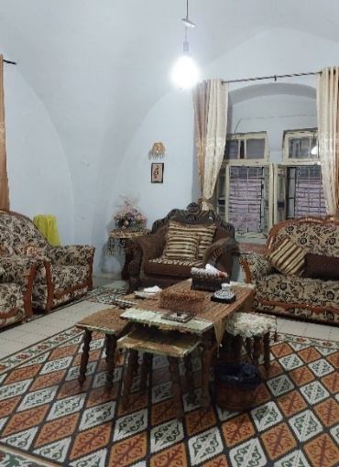:
Figure 2 The living room of a stone house with colored mosaic tiles, Suleiman Al-Shouli’s house, Asira Al-Shamaliya 2023. Photograph by the author
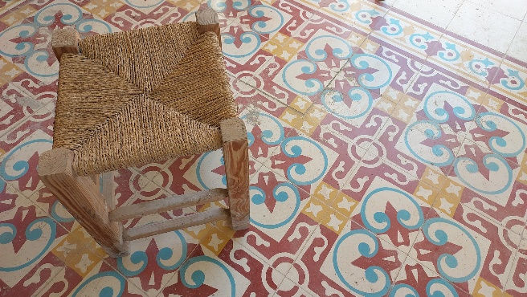
Figure 3 Colored Baladi tiles in a stone house belonging to the workshop of Mr. Jalal Aslan from Nablus, 2023 Photograph by author
These colored tiles continue to be manufactured locally and manually using specialized soil with the addition of cement (Figure 4) in various dimensions, the most famous of which is (20X20) cm (Hamdan, 1996)

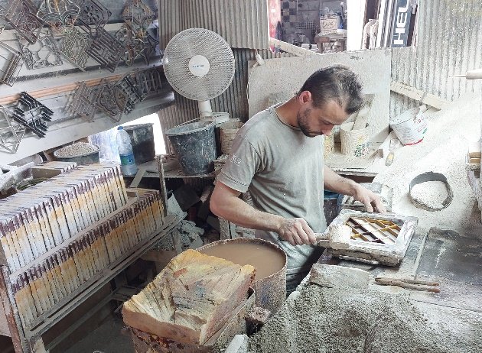
Figure 4 Louai Arafat making colored Baladi tiles using traditional methods at the Jalal Aslan workshop in Nablus, 2023 Photograph by author
In this research, the designs of a group of tea tables were inspired by the traditional Palestinian tiles (see Figures 5, 8, 9). These tiles, widely recognized as 'mosaic' tiles on an international scale and locally referred to as 'colored Baladi' tiles, have historically decorated stone houses throughout various regions in Palestine long before the importation of ceramics and porcelain (Aslan, 2021). Regrettably, the influx of foreign ceramics and porcelain created stiff competition for these traditional tiles, resulting in the closure of numerous local tile factories in Palestine, and now, the art of crafting these unique tiles faces the threat of extinction (Sarhan, 1989).
From here lies the significance of preserving this industry with all its wonderful aesthetic and decorative formations, mirroring the Palestinian environment. The exquisite colors and intricate engravings it showcases never fail to mesmerize anyone who beholds them (Amiry & Sobeh, Traditional Floor Tiles in Palestine, 2018)
In a series of works inspired by traditional Palestinian tiles (see Figure 5), the patterns and colors of these tiles were occasionally retained in their original form, while modifications were made in terms of the materials used, installation techniques, and integration into the desired furniture pieces.

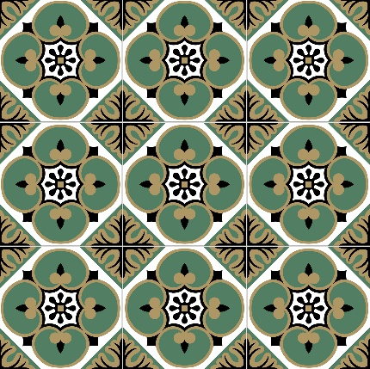
Figure 5 Traditional tiles from Samih Al-Tamimi’s House, Nablus (Amiry & Sobeh, Traditional Floor Tiles in Palestine, 2018)
In the initial example, the approach involved employing modern digital printing techniques to reproduce selected forms of colored traditional tiles after identically drawing and coloring them using various computer programs (see Figure 5).
The next step involved using resin materials to preserve the printed tiles. This preservation technique not only enhances their durability but also preserves the colors and protects the product from potential damage.
As for the structure of the piece, wooden joinery was employed using solid, aged oak wood, and modern computerized machinery was used to craft the table legs (see Figure 6). The design of the table legs was inspired by the styles commonly used in the coastal cities of Palestine during the early twentieth century (1925 - 1936).
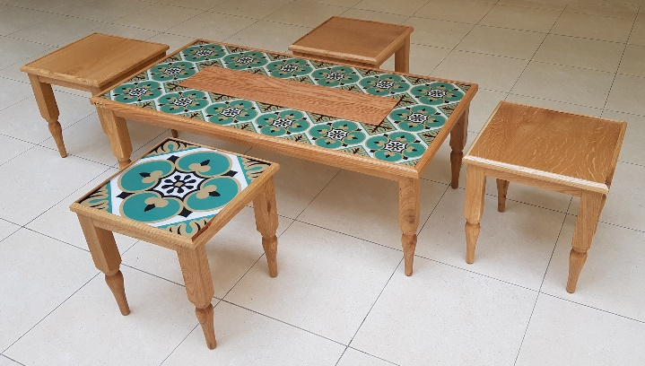
Figure 6 A center table with a Four-piece set of coffee tables inspired by traditional Palestinian tiles, made entirely of solid oak wood, and the surface covered with epoxy coating, (120X60) cm, Nablus 2019. Photograph by the author
In the next design (see Figure 7), traditional tile designs were integrated into contemporary furniture with a focus on appealing directly to the youth category. The traditional patterns of the tiles were retained (see Figure 8), but the traditional colors were substituted with vibrant, youthful hues that would convey a sense of energy and vigor. The goal of the second design is to urge young people to embrace this type of contemporary furniture in their modern homes as a reflection of their youthful spirit, love of innovation, freedom, and candidness. To achieve this, the main printing colors, known as CMYK (Cyan, Magenta, Yellow & Black), were employed, along with the use of pure white as the background color. Additionally, resin was used for the previously mentioned rationale (Figure 6). Moreover, the design also caters to a younger audience by emphasizing affordability. The pieces intended for young people are produced in large quantities, offering competitive prices, all while maintaining high-quality materials in the manufacturing process.
The main reason for the ease of manufacturing and cost reduction is attributed to:
- The structure from which the piece is crafted is entirely made of MDF wood (see Figure 7), which is more affordable than solid natural wood (see Figure 6).
- MDF wood can be easily shaped using CNC machines, allowing for large-scale production.
- MDF wood is known for its ease of sanding and its capacity to seamlessly accept painting processes, making it highly efficient and time-saving when it comes to achieving the final finishing.
- The design allows for easy manual assembly and disassembly by the consumer.
All of these factors contribute to the design's ease of implementation and its potential for large-scale production within a short timeframe. As a result, the final cost of the product is positively impacted, making it more affordable and accessible to a wider range of young people.
The second example (Figure 7) aims to show that the product reflecting the heritage and identity of the Palestinian people is not limited to an exclusive class of individuals from high-income societies, but it can cater to a broad segment of customers, as it is not only economical and practical but also available in large quantities. This design also encapsulates the Palestinian environment, depth, and civilization, which should be taken with pride by the future Palestinian generations, regardless of their diverse material capabilities.

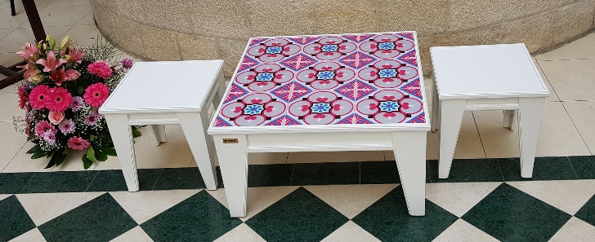
Figure 7 A center table with a Four-piece set of coffee tables inspired by traditional Palestinian tiles, made entirely of solid oak wood, and the surface covered with epoxy coating, (120X60) cm, Nablus 2019. Photograph by the author
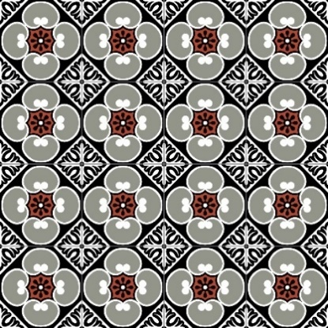
Figure 8 Traditional tiles from Eid Shaker Amr’s house, Hebron (Amiry & Sobeh, Traditional Floor Tiles in Palestine, 2018)
- A comparison of furniture prices featured in this study
Proposal 3  (Figure 8) | Proposal 2  (Figure 6) | Proposal 1  (Figure 5) | Design
249$ | $152 | $360 | Consumer price
The third proposal (see Figure 9) deviates from the previous designs (Figure 6, 7) by targeting a middle-income group who seek furniture inspired by traditional Palestinian tiles (See Figure 10) at an affordable price without compromising on quality.

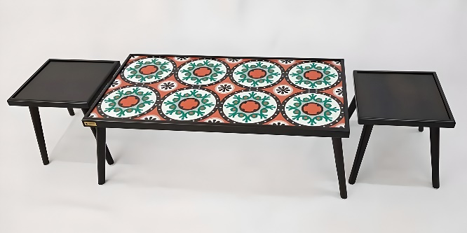:
Figure 9 A center table with two coffee tables inspired by traditional Palestinian tiles. Made of solid natural beech wood, this table is characterized by its high durability, ease of use, manufacture, installation, and transportation, (120X60) cm, Nablus 2019. Photograph by the author
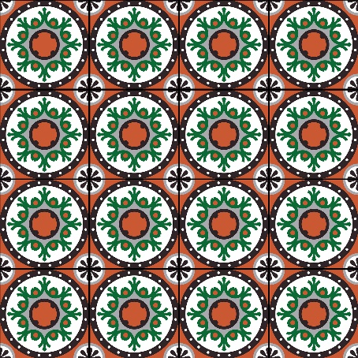
Figure 10 Floor tiles in Ishaq Khalaf’s house, Ramallah (Amiry & Sobeh, Traditional Floor Tiles in Palestine, 2018)

This piece is crafted using resin and natural hardwood materials such as beech and HDF to guarantee durability while maintaining a good price. In terms of manufacturing, this piece can be produced in large quantities using computerized machines throughout various stages of its manufacture. This process significantly reduces the reliance on human labor, thus accelerating the overall production speed.
Moreover, the design features a minimalist composition, consisting of only a few pieces. The aim was to ensure that the furniture is easy to install and quick to assemble, without the need for any specialized tools.
Additionally, careful consideration was given to making the design easily assembled and arranged in cardboard boxes with dimensions that simplify the processes of transportation, storage, and shipping. This approach ensures competitive prices and opens up the possibility of future exports abroad.

- RESULTS
The results of the research can be summarized as follows:
- The study showed the importance of the role that contemporary folk artists could play in developing the local furniture industry, demonstrating how their contributions open up new markets and opportunities.
- The study demonstrated the crucial role that traditional elements derived from Palestinian folk architecture played in developing the contemporary furniture industry globally.
- The study examined various aspects of the current furniture industry in Palestine, including factors such as cost-effectiveness, technological capabilities, and design proficiency. It aimed to identify both strengths and weaknesses within these areas.
- The study highlighted the significance of integrating modern technology and utilizing locally available raw materials within the Palestinian furniture industry.
- DISCUSSION
The research demonstrated the potential of incorporating traditional Palestinian tiles, an icon of Palestinian folk architecture, into contemporary furniture. It explored three specific aspects: The first emphasized the importance of the story behind the pattern and color of each furniture piece. It encouraged Palestinian furniture designers to draw inspiration from the diverse icons found within rich Palestinian heritage, rather than limiting their designs to a single element. Traditional handicrafts and Palestinian folk architecture can significantly enrich the contemporary furniture industry and serve as a powerful means to communicate the Palestinian cause to the farthest corners of the world. As a universal language, art offers a unique opportunity for designers to communicate more than just a functional piece of furniture. This research highlights the importance of using Palestinian furniture as a platform that reflects identity and important issues, while also conveying a clear message to all users. It acts as a tangible, constant reminder as individuals interact with it regularly throughout the year. The second aspect addressed the artistic dimension, focusing on a key point for Palestinian designers. It emphasized the importance of leaving a personal mark on creations inspired by Palestinian cultural heritage. The research encourages designers to move beyond simply copying existing contemporary furniture designs. Instead, it promotes abstraction and reduction, skillfully transforming familiar elements into modern artistic forms. The third aspect specifically invites local artisans to utilize modern technology and raw materials they may not have previously used. It urges them to break away from their familiar practices. The study offers a compelling call to initiate global competitiveness and foster local innovation. It presents vivid examples that artisans can use as a foundation for more advanced developments in the near future. The findings show how these steps can directly benefit the Palestinian furniture industry locally and increase its share in global markets by giving this sector a vital advantage and real opportunities to expand into new markets and achieve better gross margins than in their home country. There is no doubt that exporting goods is crucial to any economy because it enhances a nation's prospects for economic growth and development.
It is worth noting that the Palestinian experiment in this sector could be applied to and benefit different countries, particularly those interested in furniture design. Many developing countries aspire either to develop their local industry or increase their value-added contribution to exports. Traditional handicrafts and local folk architecture in most developing countries can enhance the contemporary furniture industry in their own contexts, as occurred in the Palestinian case. On the other hand, art is undoubtedly a universal language; therefore, local art not only supports indigenous peoples in building relationships and friendships around the world but also allows them to have their voices heard in the public sphere. Moreover, it gives them the opportunity to present their identity and cultural heritage to the entire world.
The use of an icon from Palestinian folklore can be extended to any popular culture threatened with extinction by internal or external factors. Likewise, elements of a nation’s traditional folk architecture, as demonstrated in this case study, can play a constructive role in preserving and transmitting national heritage to future generations through functional and artistic works that keep pace with contemporary trends and employ current methods.
- RECOMMENDATIONS
The research formulated a set of recommendations to reinvigorate the furniture industry in Palestine:
- Designers and industry leaders should prioritize investment in design, with a focus on integrating expressive and aesthetic elements alongside functional and economic considerations.
- Emphasize the importance of fostering a culture of leadership and creativity as the foundation for achieving excellence and uniqueness both locally and globally.
- Utilize the rich heritage of Palestinian folk architecture and incorporate its elements into contemporary furniture designs.
- Reevaluate and explore the designers’ techniques, as well as the technology and raw materials available within the local market, to maximize their potential for serving the Palestinian furniture sector effectively.

REFERENCES
Abu Amira, S. (2015, November 13). "Israel" is stealing Egyptian-Palestinian history, heritage and art. Retrieved 2019, from Egyptian Geographic: http://egyptiangeographic.com/ar/news/show/98
Al Jazeera (Director). (2019). The Rest of the Story: Theft of Palestinian heritag [Motion Picture].
Al Jazeera Live (Director). (2021). Cultural theft: Denouncing Israel's cultural appropriation of Palestinian heritage during the Miss Universe contest [Motion Picture].
Alfajr TV. (2015, October 14). Israel steals Palestinian heritage under the pretext of "coexistence". Retrieved from Alfajr TV: AlfajrTV: http://alfajertv.com/news/3936841.html
Al-Haidari, I. (1984). Ethnology of Traditional Arts. Latakia: Dar Al-Hiwar for publication and distribution.
Al-Helou, Y. (2015, October 15). Palestinian Heritage. Retrieved from The Palestinian Information Center: https://english.palinfo.com/news/2019/10/15/Is-Israel-stealing-Palestinian-cuisine
Aljodaibe, T. (2023, October 6). Economic. Retrieved from Alarabiya: https://ara.tv/nyvye
AlQadi, K. (2020, February 22). Weekly. Retrieved from Al-Quds Arabi: https://www.alquds.co.uk
Alradea, H. (2020, April 24). The Carpenter and the Siege.. What Happened to the Furniture in Gaza? Retrieved from Meras: https://wp.me/pbmxIP-3RU
Al-Sorakji, S. (2019, April 23). The Prominent Challenges Facing the Furniture Industry in Palestine Today. (E. Abu-Hannoud, Interviewer)
Al-Tayesh, A. A. (2013). Early Islamic Decorative Arts in the Umayyad and Abbasid Eras. Cairo: Zahraa Al Sharq Library.
Amiry, S. (2003). Throne Village Architecture: Palestinian Rural Mansions In the Eighteenth and Nineteenth Centuries. Ramallah: RIWAQ-Centre for Architectural Conservation.
Amiry, S., & Sobeh, L. (2018). Traditional Floor Tiles in Palestine. Ramallah: Riwaq- centre for architectural conservation.
Aslan, J. (2021, September 21). Nabulsi traditional tiles industry.. A modernist touch on history. (Quds News Network, Interviewer)
Awad, J. (2012). Rural Houses in Palestine. Ramallah: RIWAQ-Centre for Architectural Conservation.
Basha, H. (2000). Islamic Painting in the Middle Ages. Cairo: Dar Alnahda.
France24. (2017, May 18). Middle East: The Israeli Minister of Culture celebrates Jerusalem, with the words "The Eternal Capital of Israel," on her dress at the Cannes Festival. Retrieved May 17, 2019, from France24: https://f24.my/1F1O
Hamdan, O. (1996). Vernacular Architecture in Palestine. Al-Bireh: The Family Revival Society.
Hamdi, N. M. (2021). Interior Design Between Minimalism and Maximalism. International Design Journal, 303-307.
Hasan, Y. (2018). Exaggeration in Arts. Donia Alwatan, 7.
Hasan, Z. M. (2017). Islamic Art in Egypt. Windsor: Hindawi Foundation.
Jabaree, A., & Bitaw, W. (2021). Developing the competitiveness of the national product and its share: the metallurgical industry sector. Ramallah: Palestine Economic Policy Research Institute (MAS).
Khadra, H. (2019, November 4). Hyatt. Retrieved August 22, 2019, from Theft of Palestinian Heritage.. in the Open: http://www.hayatweb.com/article/288666
Khasawneh, D. (2001). Memoris Engraved in Stone: Palestinian Urban Mansions. Ramallah: RIWAQ-Centre for Architectural Conservation.
Lindauer, M. S. (2011). Art, Artists, and Arts Audiences: Their Implications for the Psychology of Creativity. Encyclopedia of Creativity, 58-65.
Makhoul, B., Horn, G., & Sharaf, R. (2020). Contemporary Palestinian Art: Origins, Nationalism, Identity. Beirut: Institute for Palestine Studies.
Nasrallah, A., & Awwad, T. (2004). The Current Status of Industrial Sector in Palestine. Ramallah: Ministry of National Economy.
Nema, A. G. (2013). Reduction in Graphic Design. Amman: Fadaat for publishing and distribution.
PALTRADE. (2017). The Annual Report 2017. Ramallah: Palestine Trade Center.
Sarhan, N. (1989). Encyclopedia of Palestinian Folklore. Amman: Directorate of Libraries and National Documents.
Shraim, J. (2015, October 15). The importance of Artistic Creativity. The East.
Subhi, S. K. (2007). Patterns of Traditional Costumes in the Arab World. Cairo: Alam Al Kotob.
Taha, H. H. (2003). he Ability of Modification as an Artistic Idiosyncrasy in Arabic Calligraphy and as an Approach Into Enrichment of the Ornamental Designs. Cairo: Helwan University.
Tillier, B. (2017). Caricature and the laughter of incongruity. Revue française de psychanalyse, 17.

