**INTERNET DEPENDENCY IN YOUTH: A COMPARATIVE SURVEY OF SECONDARY AND HIGHER EDUCATION STUDENTS**

**Dr. Shrikant1****, Dr. Rahul Kanojiya2, Mr. Abhishek Singh3**

**1** **Lakshmibai National Institute of Physical Education (NERC), Guwahati, Assam.**

**2 Lakshmibai National Institute of Physical Education, Gwalior, Madhya Pradesh.**

**3 Lakshmibai National Institute of Physical Education (NERC), Guwahati, Assam.**

**Corresponding Author: Dr. Shrikant, E-mail:** [**shrikant10jan@email.com**](mailto:shrikant10jan@email.com)

**ABSTRACT**

**Aim of Study:** This study aimed to examine and compare the severity of internet addiction among secondary (school) and higher (college) education students aged 16 to 18 in Kamrup district, Assam. It also sought to investigate the influence of gender differences on levels of internet addiction within these educational groups.

**Materials and Methods:** A cross-sectional survey was conducted with 200 participants: 100 school students (50 boys and 50 girls) and 100 college students (50 boys and 50 girls) selected via simple random sampling. Data was collected using the Internet Addiction Scale (IAS), a 20-item standardized questionnaire. Descriptive statistics and analysis of variance (ANOVA) were used to analyze the data, with significance set at p < 0.05.

**Results:** The results showed that internet addiction levels varied significantly across educational levels and gender. College boys had the highest mean score (41.36), followed by school boys (40.90), college girls (38.26), and school girls (31.06). ANOVA revealed a statistically significant difference in internet addiction among the four groups (F=6.309, p=0.001).

**Conclusions:** Internet addiction was found to be more prevalent among college students and male students overall. The findings underscore the urgent need for educational institutions to implement targeted interventions and digital literacy programs to promote responsible internet use, especially among adolescents.

**Keywords:** Internet addiction, adolescents, college students, school students, gender differences, digital behavior, cross-sectional study.

**INTRODUCTION**

The internet has become an integral element of modern life, changing the way people obtain information, interact, and participate in academic and social activities. While the internet's benefits are clear, its fast absorption into everyday routines has resulted in harmful usage habits, particularly among teens and young adults. This syndrome, known as online addiction, is defined by excessive or poorly managed preoccupations, cravings, or behaviors related to internet use that cause distress or impairment (Young, 1998). Students at secondary and higher education institutions are particularly vulnerable owing to the twin pressures of academic demands and social growth, along with the near-ubiquitous presence of digital tools.

Alarmingly high rates of internet addiction among students in different locations have been found by a number of research. For example, a study by Kuss and Lopez-Fernandez (2016) shows that teens and college students are more prone to excessive internet use, mostly because of its academic value as well as its social and recreational purposes. Negative consequences including poor academic performance, decreased physical activity, sleep difficulties, anxiety, and depression have been connected to the compulsive usage of online platforms, which include social networking, gaming, and streaming (Elhai et al., 2016). These effects imply that internet addiction is a serious public health issue that requires attention rather than being a minor one.

Cross-sectional survey methodologies have been widely utilized to investigate the prevalence and causes of internet addiction, providing a snapshot of behaviors and relationships at a certain point in time. They are particularly valuable in educational contexts, where huge populations may be easily sampled to identify at-risk groups and connect consumption patterns with demographic, psychological, and academic variables (Cheng & Li, 2014). By capturing a varied variety of student experiences across educational levels, such surveys aid in the development of tailored interventions and digital literacy programs.

It is especially critical to comprehend internet addiction in the context of secondary school as well as college. While college students frequently deal with newfound independence and academic stress, secondary school children are going through a crucial period of cognitive and emotional development. This might result in obsessive internet use as a coping strategy (Gu & Mao, 2023); (Hasan & Jaber, 2019). Additionally, the digitization of education was sped up by the COVID-19 epidemic, which increased screen time and internet reliance and may have exacerbated addictive behaviors (Dong et al., 2020).

The major goal of this study is to analyse and compare the severity of internet addiction among high school and college students aged 16 to 18, as well as to investigate the extent to which gender differences contribute to variances in online addiction rates. The findings are intended to help design age-appropriate and gender-sensitive programs to encourage adolescents to use the internet more responsibly.

**MATERIALS AND METHODS**

**Study Participants:** A total of 200 participants (N=200) were selected for this study. The sample consisted of 100 school students (50 boys and 50 girls) and 100 college students (50 boys and 50 girls). All participants were within the age range of 16 to 18 years. The subjects were selected from Kamrup, district Sonapur, Guwahati (Assam). A simple random sampling technique was employed for the selection of participants.

**Study Organization:** This cross-sectional study was designed to compare internet addiction levels between school and college students, and specifically to examine gender differences within these groups. The research focused on assessing a single psychological variable: internet addiction.

**Procedure:** Data collection was conducted using a standardised questionnaire survey method. The primary tool utilised was the Internet Addiction Scale (IAS), developed by Mrs. Daman Deep Kaur Gulati, Dr. Jose J. Kurisunkal, and Dr. Mamta Bakliwal (2021). This questionnaire comprises 20 items designed to measure internet addiction. Before administering the questionnaire, participants were informed about the study's purpose.

**Confidentiality:** of their responses was assured, and it was clarified that their data would be used solely for research purposes. Participants were asked to provide sincere and honest responses while seated in a comfortable space. Copies of the IAS were distributed, and instructions were provided before participants proceeded to complete the questionnaire. Upon completion, the questionnaire booklets were collected for record-keeping and subsequent data calculation.

**Statistical Analysis:** For the purpose of data analysis, descriptive statistics including mean and standard deviation were employed to summarise the internet addiction scores. To compare the data and test the hypotheses, Analysis of Variance (ANOVA) was applied. The level of significance for all statistical tests was set at 0.05.

**RESULTS**

The statistical analysis of internet addiction scores for male and female categories across school and college students is presented below.

**Descriptive Statistics:**

**Table 1** provides the number of participants, mean, and standard deviation for internet addiction across the four groups.

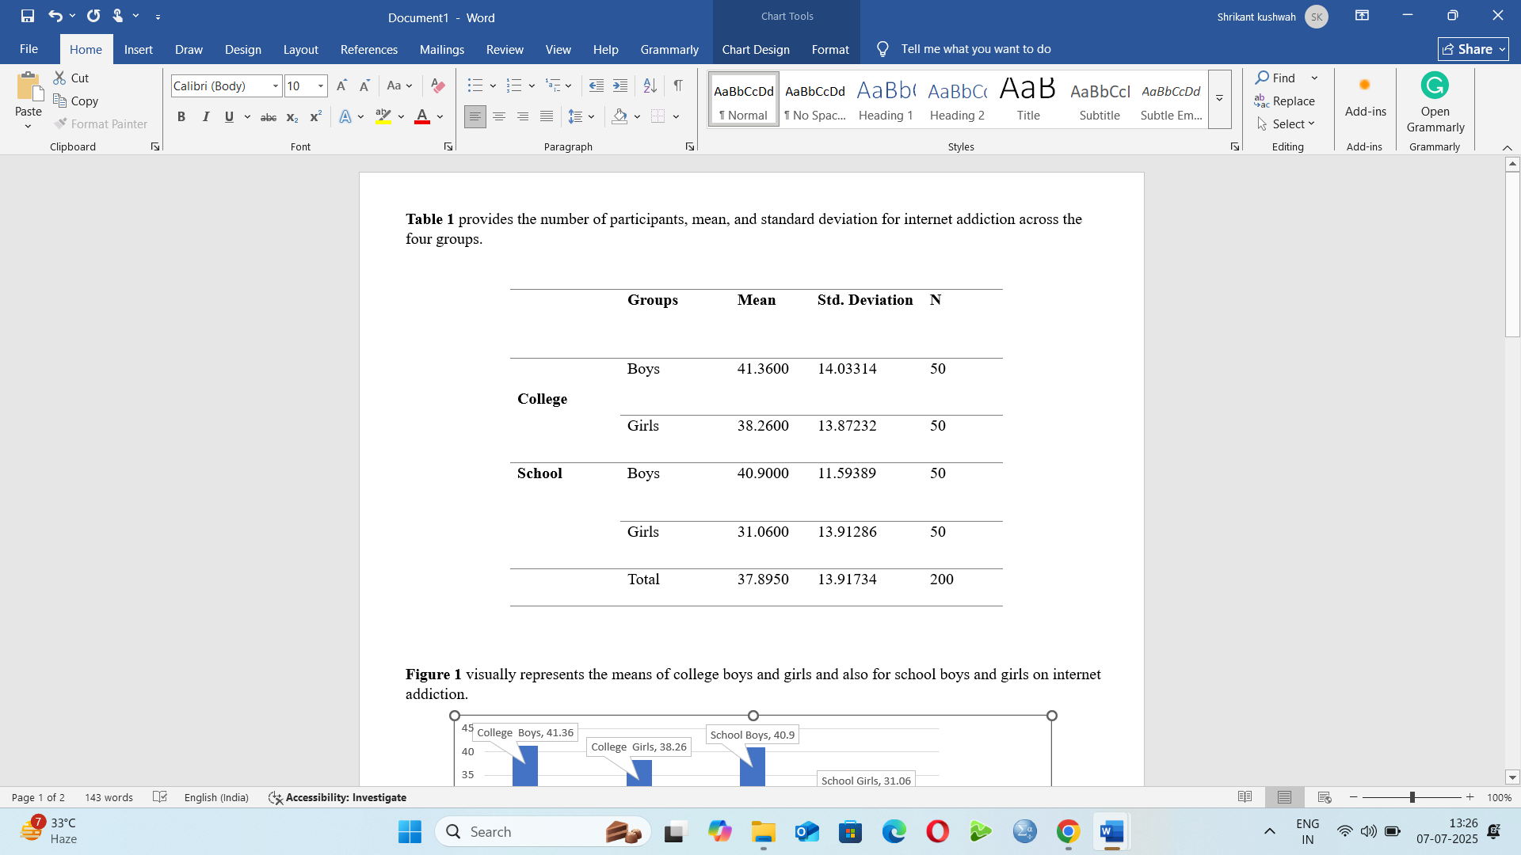

Table 1 show the number of participants along with that, it provides the mean and standard deviation of college boys and girls and also for school boys and girls on internet addiction. The mean and standard deviation of internet addiction on college boys and girls are 41.36±14.03; 38.26±13.87 respectively. The mean and standard deviation of internet addiction on school boys and girls are 40.90±11.59; 31.06±13.91 respectively.

**Figure 1** visually represents the means of college boys and girls and also for school boys and girls on internet addiction.

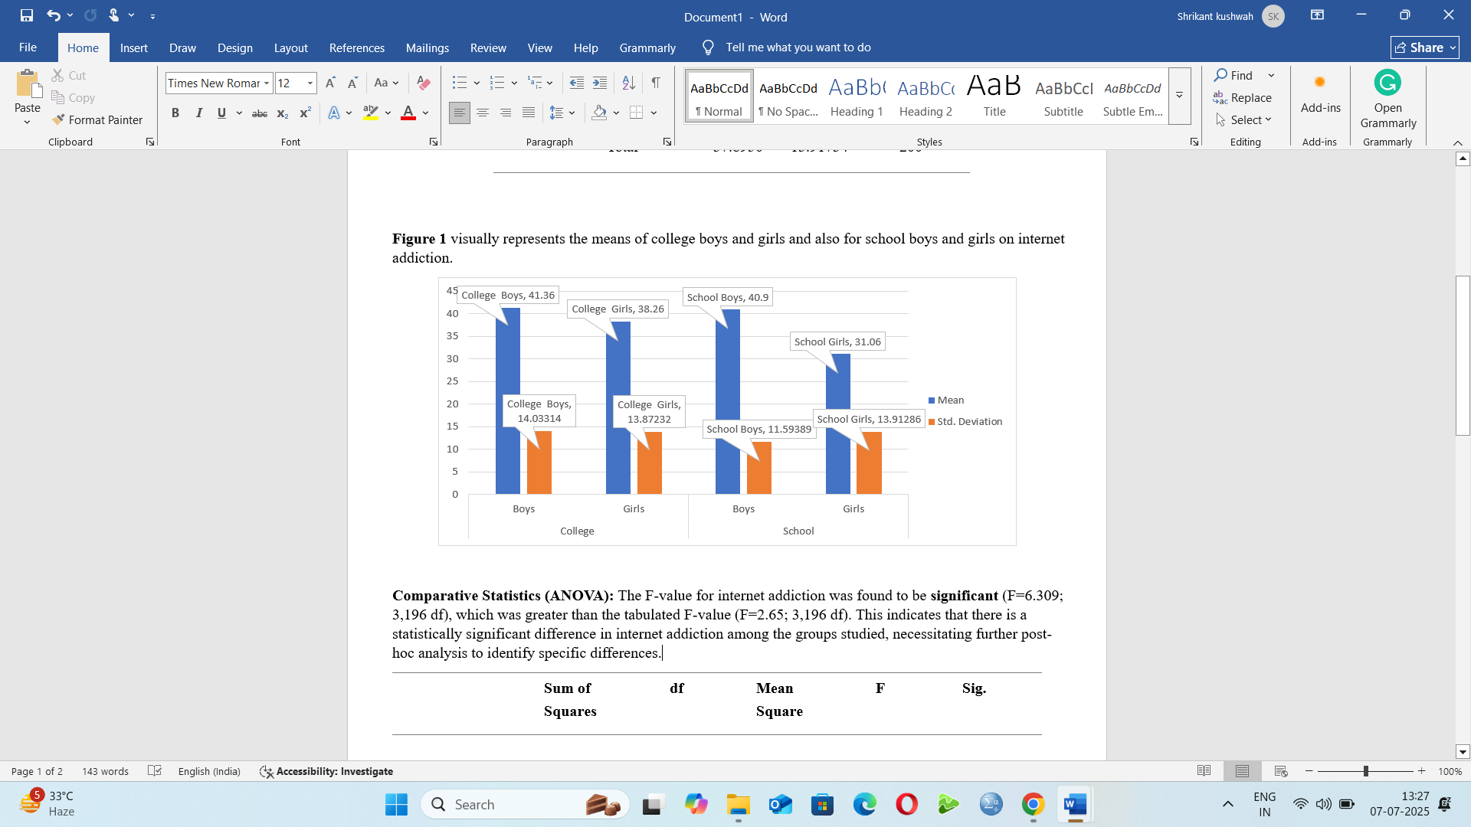

**Comparative Statistics (ANOVA):** Table 2, The F-value for internet addiction was found to be significant (F=6.309; 3,196 df), which was greater than the tabulated F-value (F=2.65; 3,196 df). This indicates that there is a statistically significant difference in internet addiction among the groups studied, necessitating further post-hoc analysis to identify specific differences.

**Table 2.** Comparative statistics (ANOVA) of internet addiction between college and school students.

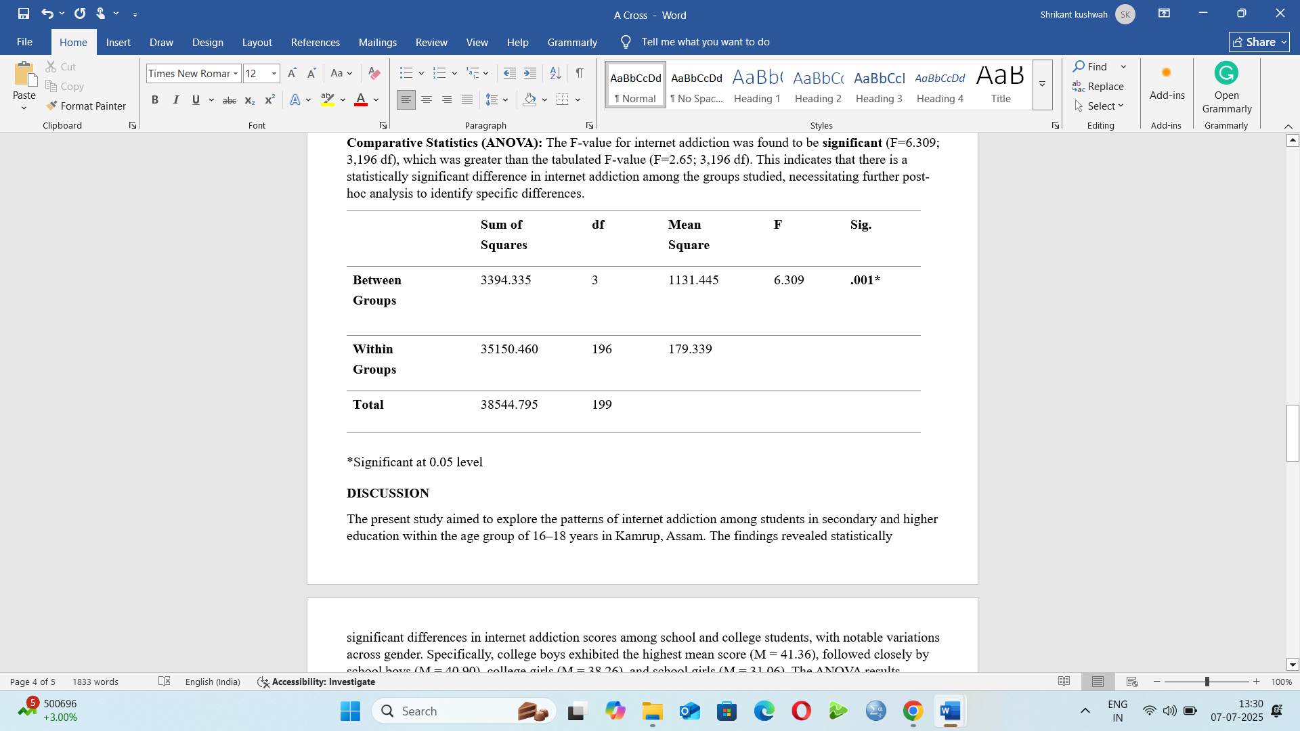

*Significant at 0.05 level

**DISCUSSION**

The present study aimed to explore the patterns of internet addiction among students in secondary and higher education within the age group of 16–18 years in Kamrup, Assam. The findings revealed statistically significant differences in internet addiction scores among school and college students, with notable variations across gender. Specifically, college boys exhibited the highest mean score (M = 41.36), followed closely by school boys (M = 40.90), college girls (M = 38.26), and school girls (M = 31.06). The ANOVA results confirmed these groups differences were significant (F = 6.309, p < 0.05).

These findings align with other studies showing that college students are more susceptible to internet addiction overall, most likely as a result of their increasing independence, lack of parental supervision, and easier access to personal gadgets and the internet (Gedam et al., 2017). College students' higher mean scores point to a propensity for compulsive usage, which may be fueled by demands from their studies, social networking, and entertainment. It is well recognized that adolescents are especially vulnerable to behavioral addictions, such as excessive internet usage, which can negatively affect social and psychological functioning (Tabak & Zawadzka, 2017).

Differences by gender were also noteworthy. Generally speaking, boys outperformed girls in both educational categories. This supports earlier research that found men are more likely to engage in harmful online behaviors, maybe as a result of their increased participation in online gaming and content consumption (Theophilou et al., 2023).   
Internet addiction has been shown to have negative impacts on psychological well-being in addition to academic achievement. Extended use of screens has been linked to musculoskeletal problems, poor sleep hygiene, low self-esteem, and increased irritability. These detrimental effects highlight how urgently preventative measures and digital literacy initiatives aimed at younger pupils are needed to promote safer online practices.

**CONCLUSION**

In summary, this study confirms that internet addiction is a significant issue among adolescents, with higher prevalence in college students and males. These patterns emphasize the need for timely interventions at both the school and college levels to mitigate the psychological, physical, and academic risks associated with excessive internet use.

**REFERENCES**

Cheng, C., & Li, A. Y. (2014). Internet Addiction Prevalence and Quality of (Real) Life: A Meta-Analysis of 31 Nations across seven world Regions. Cyberpsychology Behavior and Social Networking, 17(12), 755–760. <https://doi.org/10.1089/cyber.2014.0317>

Dong, H., Yang, F., Lu, X., & Hao, W. (2020). Internet addiction and related psychological factors among children and adolescents in China during the coronavirus disease 2019 (COVID-19) epidemic. Frontiers in Psychiatry, 11. <https://doi.org/10.3389/fpsyt.2020.00751>

Elhai, J. D., Dvorak, R. D., Levine, J. C., & Hall, B. J. (2016). Problematic smartphone use: A conceptual overview and systematic review of relations with anxiety and depression psychopathology. Journal of Affective Disorders, 207, 251–259. https://doi.org/10.1016/j.jad.2016.08.030

Gedam, S., Ghosh, S., Modi, L., Goyal, A., & Mansharamani, H. (2017). Study of internet addiction: Prevalence, pattern, and psychopathology among health professional undergraduates. Indian Journal of Social Psychiatry, 33(4), 305. https://doi.org/10.4103/ijsp.ijsp_70_16

Gu, X., & Mao, E. (2023). The impacts of academic stress on college students’ problematic smartphone use and Internet gaming disorder under the background of neijuan: Hierarchical regressions with mediational analysis on escape and coping motives. Frontiers in Psychiatry, 13. <https://doi.org/10.3389/fpsyt.2022.1032700>

Hasan, A. A., & Jaber, A. A. (2019). The relationship between Internet addiction, psychological distress, and coping strategies in a sample of Saudi undergraduate students. Perspectives in Psychiatric Care, 56(3), 495–501. https://doi.org/10.1111/ppc.12439

Kuss, D. J., & Lopez-Fernandez, O. (2016). Internet addiction and problematic Internet use: A systematic review of clinical research. World Journal of Psychiatry, 6(1), 143. https://doi.org/10.5498/wjp.v6.i1.143

Tabak, I., & Zawadzka, D. (2017). Loneliness and Internet addiction of Polish adolescents. Psychiatria I Psychologia Kliniczna, 17(2), 104–110. https://doi.org/10.15557/pipk.2017.0011

Theophilou, E., Hernández‐Leo, D., & Gómez, V. (2023). Gender‐based learning and behavioural differences in an educational social media platform. Journal of Computer Assisted Learning, 40(6), 2544–2557. <https://doi.org/10.1111/jcal.12927>

Young, K. S. (1998). Internet addiction: The emergence of a new clinical disorder. CyberPsychology & Behavior, 1(3), 237–244.