Unpacking the Role of Opinion Leaders in Diffusion Process: A Bibliometric Analysis

Hani Febriyanti^{1,*} , Sri Sumaryati², Fatma Sukmawati³
^{1,3} Educational Technology, Sebelas Maret University, Surakarta, Indonesia
² Accounting Education, Sebelas Maret University, Surakarta, Indonesia

Email:
1.hanifebri11@student.uns.ac.id, 2. srisumaryati@staff.uns.ac.id, 3.fatmasukmawati@staff.uns.ac.id

Keywords:
Opinion leader
Diffusion
Innovation
Social network
Bibliometric analysis
Abstract
This study explores the role of opinion leaders in the diffusion process, focusing on their influence in driving the adoption of innovations. Using bibliometric analysis, the study examines the co-occurrence of author keywords and citations number from the Scopus database, covering the period from 2006 to 2024. The findings reveal thematic clusters highlighting key research areas such as diffusion of innovation, social networks, and technology adoption. The analysis also identifies the most influential authors and frequently used keywords in the field. These insights offer a comprehensive understanding of opinion leaders' contributions to the diffusion of innovations, providing valuable implications for research and practice in educational technology and related domains. However, limitations include the reliance on a single database, which may not fully capture all relevant studies, and the emphasis on bibliometric methods, which might overlook qualitative nuances. Future research should consider integrating diverse databases and employing mixed-method approaches to deepen the analysis.

Introduction
The concept of innovation diffusion introduced by Everett Rogers is a theory that explains how innovations such as ideas, technologies, and practices spread in a social system. This diffusion process does not happen instantly, but through a mechanism that involves various social elements, such as individuals, groups, and institutions that play a role in accepting or rejecting innovations. Social interaction is key in innovation diffusion, where two-way communication between individuals or groups enables the exchange of information and influence (Rogers, 1983). In this process, some actors have a more dominant role than others, one of which is opinion leaders.
Opinion leaders are individuals who have significant influence in their social community, either due to their knowledge, expertise or social status recognized by other community members (Rogers, 1983). They act as a bridge between the innovation and society, helping to accelerate the adoption of the innovation by explaining its benefits, reducing uncertainty, and providing concrete examples of implementation. Opinion leaders play an important role in the success of a diffusion especially in the early stages of diffusion when other members of the community still tend to be hesitant or skeptical of new innovations. Opinion leaders are considered to have the capacity to influence others. Regarding personal predispositions, Weimann (1991) confirmed the “Personality Strength Scale” and showed that people with high personality strength scores tend to become an opinion leaders and occupy a central position in the social network. These kinds of people are usually charismatic and see themselves as having the possibility to influence the attitudes and behaviors of others
There are many domains where information can be disseminated more effectively when opinion leaders are targeted. For example, in the medical field, detecting opinion leaders has been used to raise awareness and promote new and effective treatments (Iyengar et al., 2014), such as in HIV prevention or child health promotion (Guldbrandsson et al., 2012). Climate change awareness campaigns also rely on opinion leaders to effectively disseminate information (Nisbet & Kotcher, 2009).
This study uses bibliometric analysis to investigate the progression of research on the role of opinion leaders around the world. Additionally, it highlights the authors along with the research themes prevalent in the literature. Thus, this study maps the research landscape on the role of opinion leaders around the world, where many pioneering researchers in the field are located and the context specifications are very broad. The study recognizes the contributions and, to a lesser extent, challenges to the development of the field, enabling researchers to pinpoint contexts that require further exploration. Such efforts, in turn, can encourage more in-depth theorization and conceptualization of the subject matter.

Method
  - Aims of the study
Theoretical, conceptual and empirical contributions related to opinion leaders are spread across various disciplines and related journals, including education, health, economics, social science, politics, and others. Studies related to opinion leaders can also be found in other academic outputs such as books. Although the study of opinion leaders has a wide potential appeal, bibliometric analysis in this area and identifying trends, patterns, gaps, and potential future directions is challenging. A bibliometric approach is an alternative that can analyze a larger volume of studies covering a longer period of time with less time and resources, and offer a comprehensive overview of the evolution and current state of the field (Hajar & Karakus, 2024).
This study focuses on the critical role of opinion leaders in the diffusion process, particularly how these influential individuals facilitate the adoption of innovations in a social system. Based on the Diffusion of Innovations theory introduced by Everett Rogers, opinion leaders act as a link between innovators and the wider public, utilizing their credibility, social connections and communication skills to support the spread of innovations.
This study aims to analyze and map the existing literature on the role of opinion leaders in the diffusion process using a bibliometric analysis approach. The main objectives are:
- Identify publication trends as well as thematic clusters related to this topic.
- Explore the characteristics and strategies of opinion leaders that support the successful diffusion of innovation.
- Find research gaps and provide recommendations for future research, particularly related to the effective contribution of opinion leaders in supporting the diffusion of innovations in various fields.

  - Search strategy and data collection
This research uses a bibliometric analysis approach, which is a quantitative method to systematically review the literature and identify patterns and trends in scientific publications. The research data was obtained from the Scopus database, which has a wide coverage and is recognized as a source of high-quality literature.
Articles and reviews relevant to the topic were selected based on certain keywords that have a correlation with the role of opinion leaders. The search was conducted using filters with specific criteria such as article title, journal title, and year range selection.
The search strategy began by searching the Scopus database using a combination of keywords, namely “opinion leaders”, “diffusion process”, “diffusion of innovations”, and “role of opinion leaders”. The search was designed to include all publications relevant to the main focus of the study. Filters were applied to limit the results to articles published in peer-reviewed journals between 2006 and 2024. Additionally, only English-language articles were included to ensure data uniformity.
Once search results were obtained, metadata from relevant publications, such as title, abstract, keywords, author names, and number of citations, were exported in RIS format using the reference manager application Zotero. This data was then analyzed using VOSviewer bibliometric software. VOSviewer is a freely available software platform that facilitates bibliometric analysis as it uses text mining to identify various elements in publications and can build and display bibliometric results (Van Eck & Waltman, 2017). VOSviewer allows mapping of keyword networks, interauthor relationships, and identification of thematic clusters.
The online search was completed on December 7, 2024, yielding 228 initial documents. However, after filtering to eliminate irrelevant items, the number was reduced to 38 documents. The distribution of documents by publication year showed an increasing trend since 2006, with the following distribution: 2006 (1), 2007 (2), 2011 (1), 2014 (2), 2016 (4), 2017 (1), 2018 (3), 2019 (4), 2020 (4), 2021 (8), 2022 (3), 2023 (4), and 2024 (1).
The earliest publication in the dataset dates back to 2006, addressing the role of opinion leaders in the diffusion of new knowledge with a case study of integrated pest management in the United States (Feder & Savastano, 2006). One year later, there was a study set in the US on the impact of opinion leader-endorsed evidence summaries on the quality of prescribing for patients with cardiovascular disease.

  - Data analysis procedures
The data analysis procedures in this study adopt a bibliometric approach with a focus on two main techniques, namely co-occurrence analysis and co-authorship analysis. To carry out these analyses, we used VOSviewer software, which enables visualization and in-depth processing of bibliographic data, in accordance with the guidelines set out by Van Eck & Waltman (2017). In the first stage, a co-occurrence analysis was conducted to explore keywords that often appear together in publications. This analysis aims to identify dominating thematic patterns and see how certain topics evolve over time. By calculating the frequency of co-occurrence of two authors' keywords, we were able to map the relationships between topics in the existing literature, as well as illustrate the changing dynamics in research on the role of opinion leaders in the innovation diffusion process.
In the next stage, co-authorship analysis was used to explore the network of collaboration between authors in this field. This analysis highlights the number of publications co-authored by a particular author and reveals the strength of the relationship between frequently collaborating authors. The strength of these relationships reflects their level of involvement in advancing related research, and can provide insight into influential collaborations in the development of opinion leader theories and concepts in the context of diffusion. These two approaches combined provide a broader picture of scholarly developments in the field, as well as identifying trends and potential future research directions.

Results
  - Topical focuses
The keywords in the literature on research on the role of opinion leaders were analyzed using co-occurrence in the VOSviewer application. In this analysis, the minimum number of occurrences of keywords was set at 2. The results of the analysis illustrate the relationship and interrelationship of the main concepts in research related to “Opinion Leaders.”
The analysis conducted in this study found 126 keywords, with 68 words meeting the threshold and classified into 13 clusters with the following information:
- Cluster 1: crowdfunding projects, diffusion analysis, dynamic network analysis, feedback mechanism, information diffusion, large-scale group decision, popular mobile game, social network, user-generated content
- Cluster 2: artificial intelligence, centrality, complex networks, eco-innovation diffusion, network centralities, social networks, waste separate collection
- Cluster 3: behavior change, communication studies, gender differences, opinion leadership, peer role, social media, social networking
- Cluster 4: bounded confidence model, bounded confidence rule, characteristics, herd behavior, opinion dynamics, opinion leader subgroup
- Cluster 5: cloud computing, COVID-19 rumors, online social network, reputation, troll, trust
- Cluster 6: carbon capture and storage, demonstration projects, diffusion, innovations, opinion leaders
- Cluster 7: implementation, knowledge brokers, knowledge translation, realist review, rehabilitation
- Cluster 8: multi-agent-based simulation, online promotion strategies, opinion leader, policy advocacy, policy making
- Cluster 9: consumer advice network, content community, network structure, sustainable marketing
- Cluster 10: flaming, negative comment, social cue, source credibility
- Cluster 11: in-out perspective, knowledge sharing, online community, social capital theory
- Cluster 12: consensus reaching process, large-scale group decision making, social network analysis
- Cluster 13: decision engineering, product involvement, purchase decision

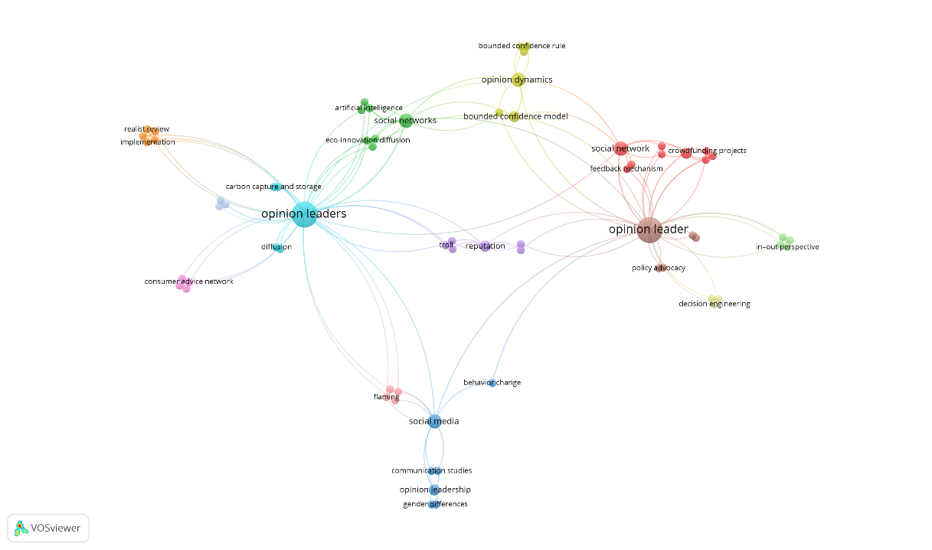
Fig. 1. Topical focuses of opinion leaders (network visualisation)

The “Opinion Leader” and “Opinion Leaders” nodes are at the center of the map, reflecting the central role of these terms in the literature. The larger size of the nodes indicates that these concepts appear frequently in publications and are the main focus of research. This node has many connections to other terms, such as “Social Networks,” “Diffusion,” and “Reputation,” indicating that the role of opinion leaders is particularly relevant in the context of information dissemination, reputation, and social networks.
The relationship between nodes is represented by a line connecting one node to another. The thicker the line, the more often the terms appear together in the literature. For example, “Opinion Leaders” has a strong relationship with “Social Networks” and “Diffusion,” indicating a research focus on how opinion leaders influence the spread of innovations through social networks. On the other hand, terms like “Social Media” are closely connected to “Behavior Change” and “Source Credibility,” reflecting the relevance of social media in changing behavior through the trust built by opinion leaders.
The map also reveals the clustering or grouping of topics. Different colors indicate clusters of interrelated research. The red cluster highlights the relationship between “Opinion Leaders,” “Social Networks,” and “Crowdfunding Projects,” while the green cluster focuses more on “Opinion Dynamics” and “Eco-Innovation Diffusion.”

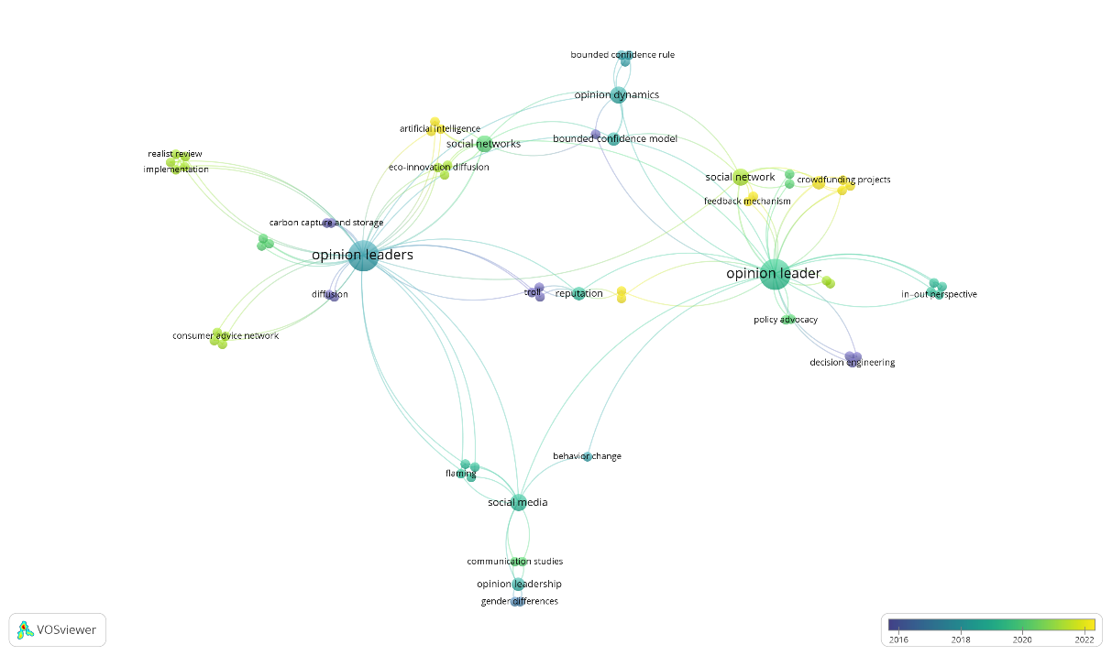
Fig. 2. Topical focuses of opinion leaders (overlay visualization)

The figure maps the development of research related to “opinion leaders” in the diffusion process by year of publication, with node colors indicating the timing of the research (dark blue for older years, around 2016 or earlier, to yellow for more recent years, around 2022 or later). The main nodes “opinion leader” and “opinion leaders” are at the center of the network, reflecting the core themes underlying the related literature. Nodes in blue and green, such as diffusion, consumer advice network, and bounded confidence model, indicate the early focus of research on the basic mechanisms and theories on the role of opinion leaders.
Meanwhile, the yellow nodes, such as eco-innovation diffusion, crowdfunding projects, and artificial intelligence, reflect more recent topics, where the role of opinion leaders is applied in modern contexts, such as technology-based innovation and fundraising. The social media subtopic, sustainability in light green, connects old and new themes, reflecting the importance of social media in the study of behavior change, gender differences, and communication.
Early research focused mostly on fundamental theories, such as the bounded confidence model and opinion dynamics, which support the understanding of social influence and information dissemination. Over time, the literature evolved towards more contextualized practical applications, such as policy advocacy and decision engineering. This reflects the evolution of research from theory to direct implementation in various fields, demonstrating the continued relevance of the role of opinion leaders in the diffusion process across various social and technological aspects.

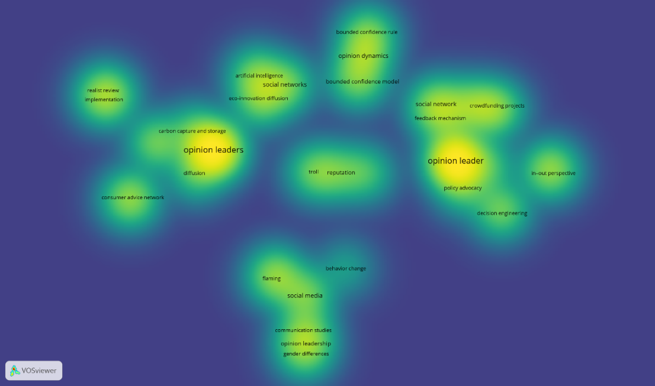
Fig. 3. Topical focuses of opinion leaders (density visualization)

This figure is a density visualization showing the intensity and level of attention to various topics in the literature on “opinion leaders.” The yellow-colored areas reflect the highest density items, indicating a very high intensity of discussion, while the green to blue colors indicate a lower intensity. The nodes “opinion leaders” and “opinion leader” occupy the center of the network with the highest density (in bright yellow), indicating that both terms are at the core of the academic discussion and continue to be the main focus of exploration.
Several other subtopics, such as social networks, social media, policy advocacy, and diffusion, have fairly high densities (yellowish green), indicating that these aspects are widely discussed, both in theoretical and applied contexts. In addition, themes such as eco-innovation diffusion and crowdfunding projects also show significant density, reflecting increased attention to the application of the concept of opinion leaders in sustainability issues and modern technology.
On the other hand, there are areas with medium to low density, such as bounded confidence model, bounded confidence rule, in-out perspective, and decision engineering, which have relevance but are less intensively discussed than the main themes. Consumer advice networks and realist review also have lower densities, suggesting that while these topics remain relevant, they have not been the main focus in the literature.
The interconnectedness of the subtopics is also evident in the role of social media as an important link between the various themes, reflecting this platform as a key platform for measuring the influence of opinion leaders. Topics such as behavior change and communication studies, while not central, still have significant connections to the main themes. Overall, this visualization shows that the research focus is concentrated on core themes, such as “opinion leaders” and “opinion leaders,” while low-density subtopics provide great opportunities for further exploration in the future. Literacy about the role of opinion leaders continues to grow, opening up new dimensions for research.

  - Citation Analysis
The top five most cited articles were published between 2014 and 2018. The following are the number of article citations in order from highest to lowest on the topic of opinion leaders:

Table 1
Five most cited article

No | Title | Author(s) | Year | Cites | Publisher
1 | Using online opinion leaders to promote the hedonic and utilitarian value of products and services | Hsin-Chen Lin, Patrick F. Bruning, Hepsi Swarna | 2018 | 236 | Business Horizons
2 | The Multiple Facets of Influence: Identifying Political Influentials and Opinion Leaders on Twitter | Elizabeth Dubois, Devin Gaffney | 2014 | 216 | American Behavioral Scientist
3 | Understanding influence power of opinion leaders in e-commerce networks: An opinion dynamics theory perspective | Zhao Yiyi, Kou Gang, Peng Yi, Chen Yang | 2018 | 194 | Information Sciences
4 | Is this opinion leader's review useful? Peripheral cues for online review helpfulness | Zhu Ling, Yin Guopeng, He Wei | 2014 | 185 | Journal of Electronic Commerce Research
5 | A new method for trust and reputation evaluation in the cloud environments using the recommendations of opinion leader's entities and removing the effect of troll entities | Matin Chiregi, Nima Jafari Navimipour | 2016 | 104 | Computers in Human Behavior

Based on the data obtained, the authors Hsin-Chen Lin, Patrick F. Bruning, Hepsi Swarna with their article in 2018 occupy the first position of the article that is often cited with the number of citations 236 times. Followed by Elizabeth Dubois and Devin Gaffney with their 2014 article which has been cited 216 times.
In terms of journals, the journal “Computers in Human Behavior” has contributed 3 articles about opinion leaders which is also the most. While the other 35 articles are articles from different journals. In terms of authors, there are no authors who are the same between one another in the total 38 articles analyzed.

Discussion and Implications of the study
The results of this study reveal the dynamics and evolution of the literature on the role of opinion leaders in the innovation diffusion process, showing that research in this field continues to grow both in theoretical and applied contexts. Visualization of the bibliometric data shows that the themes of “opinion leaders” and “diffusion” form the main core of the research, surrounded by subtopics such as “social networks,” “behavior change,” and “eco-innovation diffusion.” The existence of these themes reflects the importance of opinion leaders as catalysts in the spread of innovations in various domains, ranging from technology to environmental sustainability.
The findings show that in recent literature, attention has increased on the application of the role of opinion leaders in modern issues such as crowdfunding projects, artificial intelligence, and policy advocacy. This indicates a shift in focus from basic theory towards practical implementation in more complex social and technological contexts. For example, the strong connection between “opinion leaders” and “social media” shows how digital platforms have become a key medium for opinion leaders to influence behavior change in the modern era.
However, although some subtopics such as “bounded confidence model” and “decision engineering” have conceptual relevance, they are less intensively explored in the literature. This suggests a research gap that could be an area for further exploration.
This research has significant implications for theory, practice and policy development in various disciplines. Theoretically, the research findings enrich the understanding of the role of opinion leaders in the innovation diffusion process by highlighting key themes such as social networks, social media, source credibility and behavior change. The emphasis on the application of the opinion leader concept in modern contexts, such as technology, sustainability, and policy advocacy, demonstrates the continued relevance of this topic and provides new directions for theoretical exploration.
Practically, this research provides guidance for practitioners in various fields, including education, health, and business, to leverage opinion leaders as catalysts in spreading innovation and influencing the behavior of target groups. This is particularly relevant in designing social network-based campaigns or in overcoming challenges such as distrust of new innovations. In addition, this research also has policy implications, where an understanding of the dynamics of the role of opinion leaders can assist policymakers in designing more effective interventions that harness the power of social networks and media to accelerate the adoption of innovations at the community level. Thus, this research not only enriches the academic literature, but also makes a real contribution to the development of innovation strategies in various sectors.

Conclusion and Limitations of the study
This study highlights the pivotal role of opinion leaders in the diffusion process of innovations, emphasizing their influence across various domains such as education, health, technology, and policy advocacy. By employing bibliometric analysis, the research unveils significant trends and patterns in the scholarly discussion surrounding opinion leaders, including the central themes of social networks, credibility, behavior change, and the integration of media technologies. The findings demonstrate how opinion leaders act as bridges between innovators and broader communities, fostering the adoption and dissemination of new ideas and practices. This study not only deepens theoretical understanding but also provides practical insights for leveraging opinion leaders to enhance the effectiveness of innovation strategies.
Despite its contributions, this study is not without limitations. The reliance on bibliometric analysis restricts the scope of inquiry to published academic works, potentially overlooking valuable insights from grey literature, industry reports, or case studies. The analysis is also dependent on the quality and availability of indexed data from Scopus, which may not encompass all relevant publications in this field. Furthermore, the approach does not capture the nuances of how opinion leaders operate within specific cultural or contextual settings, which may vary significantly across regions and disciplines. Future research could address these limitations by incorporating mixed-methods or extending the analysis to include a broader range of data sources, providing a more comprehensive understanding of the role of opinion leaders in the diffusion of innovations.

Acknowledgements
The authors would like to acknowledge the use of DeepL Translator in assisting with the translation of texts during the preparation of this manuscript. The tool significantly contributed to ensuring the accuracy and clarity of the translated materials.

Appendix

Table 2
Article information

Author(s) | Citations | Judul | Year | Journal
Hsin-Chen Lin, Patrick F. Bruning, Hepsi Swarna | 236 | Using online opinion leaders to promote the hedonic and utilitarian value of products and services | 2018 | Business Horizons
Elizabeth Dubois, Devin Gaffney | 216 | The Multiple Facets of Influence: Identifying Political Influentials and Opinion Leaders on Twitter | 2014 | American Behavioral Scientist
Zhao Yiyi, Kou Gang, Peng Yi, Chen Yang | 194 | Understanding influence power of opinion leaders in e-commerce networks: An opinion dynamics theory perspective | 2018 | Information Sciences
Zhu Ling, Yin Guopeng, He Wei | 185 | Is this opinion leader's review useful? Peripheral cues for online review helpfulness | 2014 | Journal of Electronic Commerce Research
Matin Chiregi, Nima Jafari Navimipour | 104 | A new method for trust and reputation evaluation in the cloud environments using the recommendations of opinion leader's entities and removing the effect of troll entities | 2016 | Computers in Human Behavior
Gershon Feder, Sara Savastano | 72 | The role of opinion leaders in the diffusion of new knowledge: The case of integrated pest management | 2006 | World Development
Gerd Flodgren, Mary Ann O'Brien, Elena Parmelli, Jeremy M Grimshaw | 70 | Local opinion leaders: Effects on professional practice and healthcare outcomes | 2019 | Cochrane Database of Systematic Reviews
Xi Liang, David Reiner, Jia Li | 63 | Perceptions of opinion leaders towards CCS demonstration projects in China | 2011 | Applied Energy
Shuwei Chen, David H. Glass, Mark McCartney | 55 | Characteristics of successful opinion leaders in a bounded confidence model | 2016 | Physica A: Statistical Mechanics and its Applications
Sandra Tobon, Jesús García-Madariaga | 55 | The influence of opinion leaders’ eWOM on online consumer decisions: A study on social influence | 2021 | Journal of Theoretical and Applied Electronic Commerce Research
M. van den Nieuwboer, L.H.M. van de Burgwal, E. Claassen | 54 | A quantitative key-opinion-leader analysis of innovation barriers in probiotic research and development: Valorisation and improving the tech transfer cycle | 2016 | PharmaNutrition
Zongshui Wang, Haiyan Liu, Wei Liu, Shouyang Wang | 49 | Understanding the power of opinion leaders’ influence on the diffusion process of popular mobile games: Travel Frog on Sina Weibo | 2020 | Computers in Human Behavior
Jia Chen, Gang Kou, Haomin Wang, Yiyi Zhao | 48 | Influence identification of opinion leaders in social networks: an agent-based simulation on competing advertisements | 2021 | Information Fusion
Stefanie Walter &Michael Brüggemann | 45 | Opportunity makes opinion leaders: analyzing the role of first-hand information in opinion leadership in social media networks | 2020 | Information Communication and Society
Pengqun Gao, Jing Huang, Yejun Xu | 41 | A k-core decomposition-based opinion leaders identifying method and clustering-based consensus model for large-scale group decision making | 2020 | Computers and Industrial Engineering
Ateeq Ur Rehman, Aimin Jiang, Abdul Rehman, Anand Paul, Sadia din, Muhammad Tariq Sadiq | 37 | Identification and role of opinion leaders in information diffusion for online discussion network | 2023 | Journal of Ambient Intelligence and Humanized Computing
Baozhuang Niu, Xinhu Yu, Qiyang Li, Yulan Wang | 35 | Gains and Losses of Key Opinion Leaders’ Product Promotion in Livestream E-commerce | 2023 | Omega (United Kingdom)
Sumit R. Majumdar, Ross T. Tsuyuki Pharm D, Finlay A. McAlister | 35 | Impact of opinion leader-endorsed evidence summaries on the quality of prescribing for patients with cardiovascular disease: A randomized controlled trial | 2007 | American Heart Journal
Jose U. Scher, Georg Schett | 33 | Key opinion leaders — a critical perspective | 2021 | Nature Reviews Rheumatology
Luwei Rose Luqiu, Michael Schmierbach, Yu-Leung Ng | 32 | Willingness to follow opinion leaders: A case study of Chinese Weibo | 2019 | Computers in Human Behavior
Lindsay H. Hoffman, Caroll J. Glynn, Michael E. Huge, Rebecca Border Sietman, Tiffany Thomson | 28 | The role of communication in public opinion processes: Understanding the impacts of intrapersonal, media, and social filters | 2007 | International Journal of Public Opinion Research
Katherine G Quinn | 24 | Applying the Popular Opinion Leader Intervention for HIV to COVID-19 | 2020 | AIDS and Behavior
Inga Saboia, Ana Margarida Pisco Almeida, Pedro Sousa, Cláudia Pernencar | 21 | I am with you: A netnographic analysis of the Instagram opinion leaders on eating behavior change | 2018 | Procedia Computer Science
Yi Feng Wang, Sun Kyong Lee, Qing Ye | 19 | Opinion leaders in eco-innovation diffusion: Analysis of information networks for waste separation in Shanghai | 2021 | Resources, Conservation and Recycling
Lokesh Jain, Rahul Katarya, Shelly Sachdeva | 18 | Opinion Leaders for Information Diffusion Using Graph Neural Network in Online Social Networks | 2023 | ACM Transactions on the Web
Meng-jie Liao, Jian Zhang,  Rui-mei Wang, Lin Qi | 18 | Simulation research on online marketing strategies of branded agricultural products based on the difference in opinion leader attitudes | 2021 | Information Processing in Agriculture
E. Gentina, D. Kilic, P.-F. Dancoine | 18 | Distinctive role of opinion leaders in the social networks of school adolescents: an investigation of e-cigarette use | 2017 | Public Health
Bertalan Meskó, Nóra Radó, Zsuzsa Győrffy | 17 | Opinion leader empowered patients about the era of digital health: A qualitative study | 2019 | BMJ Open
Lokesh Jain | 15 | An entropy-based method to control COVID-19 rumors in online social networks using opinion leaders | 2022 | Technology in Society
Nan Wang, Wenxuan Xie, Victor Tiberius, Yong Qiu | 14 | Accelerating new product diffusion: How lead users serve as opinion leaders in social networks | 2023 | Journal of Retailing and Consumer Services
Fulian Yin, Xiaowei Zhu, Xueying Shao, Xinyu Xia, Yanyan Pan, Jianhong Wu | 14 | Modeling and quantifying the influence of opinion involving opinion leaders on delayed information propagation dynamics | 2021 | Applied Mathematics Letters
Dina Gaid, Sara Ahmed, Rehab Alhasani, Aliki Thomas, André Bussières | 14 | Determinants that influence knowledge brokers' and opinion leaders' role to close knowledge practice gaps in rehabilitation: A realist review | 2021 | Journal of Evaluation in Clinical Practice
Yanhong Li, Guangxu Li, Gang Kou | 14 | Consensus in the Presence of Multiple Opinion Leaders: Effect of Bounded Confidence | 2016 | IEEE Transactions on Signal and Information Processing over Networks
Kim Thomas | 12 | Key opinion leaders supercharged by the internet: Paid doctor and patient influencers on social media | 2019 | The BMJ
Lianren Wu, Jinjie Li, Jiayin Qi, Deli Kong, Xu Li | 12 | The role of opinion leaders in the sustainable development of corporate-led consumer advice networks: Evidence from a chinese travel content community | 2021 | Sustainability (Switzerland)
Ye Hua, Quan Yuan | 10 | The launch of new products: New technology driven firm-user interactions with key opinion leaders for single and multiple interactions | 2022 | Electronic Commerce Research and Applications
Duy Dang-Pham, Karlheinz Kautz, Ai-Phuong Hoang, Siddhi Pittayachawan | 10 | Identifying information security opinion leaders in organizations: Insights from the theory of social power bases and social network analysis | 2022 | Computers and Security
Liang Zhao, Zhe Sun, Si Chen, Ritika Gugnani, Nidhi Sahore | 5 | Social media opinion leaders and information diffusion of crowdfunding projects: Evidence from China | 2024 | Technological Forecasting and Social Change

References

Chen, J., Kou, G., Wang, H., & Zhao, Y. (2021). Influence identification of opinion leaders in social networks: An agent-based simulation on competing advertisements. Information Fusion, 76, 227–242. https://doi.org/10.1016/j.inffus.2021.06.004
Chen, S., Glass, D. H., & McCartney, M. (2016). Characteristics of successful opinion leaders in a bounded confidence model. Physica A: Statistical Mechanics and Its Applications, 449, 426–436. https://doi.org/10.1016/j.physa.2015.12.107
Chiregi, M., & Navimipour, N. J. (2016). A new method for trust and reputation evaluation in the cloud environments using the recommendations of opinion leaders’ entities and removing the effect of troll entities. Computers in Human Behavior, 60, 280–292. https://doi.org/10.1016/j.chb.2016.02.029
Dang-Pham, D., Kautz, K., Hoang, A.-P., & Pittayachawan, S. (2022). Identifying information security opinion leaders in organizations: Insights from the theory of social power bases and social network analysis. Computers & Security, 112, 102505. https://doi.org/10.1016/j.cose.2021.102505
Dubois, E., & Gaffney, D. (2014). The Multiple Facets of Influence: Identifying Political Influentials and Opinion Leaders on Twitter. American Behavioral Scientist, 58(10), 1260–1277. https://doi.org/10.1177/0002764214527088
Feder, G., & Savastano, S. (2006). The role of opinion leaders in the diffusion of new knowledge: The case of integrated pest management. World Development, 34(7), 1287–1300. https://doi.org/10.1016/j.worlddev.2005.12.004
Flodgren, G., O’Brien, M. A., Parmelli, E., & Grimshaw, J. M. (n.d.). Local opinion leaders: Effects on professional practice and healthcare outcomes - Flodgren, G - 2019 | Cochrane Library. Retrieved December 8, 2024, from https://www.cochranelibrary.com/cdsr/doi/10.1002/14651858.CD000125.pub5/full
Gaid, D., Ahmed, S., Alhasani, R., Thomas, A., & Bussières, A. (2021). Determinants that influence knowledge brokers’ and opinion leaders’ role to close knowledge practice gaps in rehabilitation: A realist review. Journal of Evaluation in Clinical Practice, 27(4), 836–846. https://doi.org/10.1111/jep.13482
Gao, P., Huang, J., & Xu, Y. (2020). A k-core decomposition-based opinion leaders identifying method and clustering-based consensus model for large-scale group decision making. Computers & Industrial Engineering, 150, 106842. https://doi.org/10.1016/j.cie.2020.106842
Gentina, E., Kilic, D., & Dancoine, P.-F. (2017). Distinctive role of opinion leaders in the social networks of school adolescents: An investigation of e-cigarette use. Public Health, 144, 109–116. https://doi.org/10.1016/j.puhe.2016.11.020
Guldbrandsson, K., Nordvik, M. K., & Bremberg, S. (2012). Identification of potential opinion leaders in child health promotion in Sweden using network analysis. BMC Research Notes, 5(1), 424. https://doi.org/10.1186/1756-0500-5-424
Hoffman, L. H., Glynn, C. J., Huge, M. E., Sietman, R. B., & Thomson, T. (2007). The Role of Communication in Public Opinion Processes: Understanding the Impacts of Intrapersonal, Media, and Social Filters. International Journal of Public Opinion Research, 19(3), 287–312. https://doi.org/10.1093/ijpor/edm014
Hua, Y., & Yuan, Q. (2022). The launch of new products: New technology driven firm-user interactions with key opinion leaders for single and multiple interactions. Electronic Commerce Research and Applications, 56, 101206. https://doi.org/10.1016/j.elerap.2022.101206
Iyengar, R., Van den Bulte, C., Eichert, J., & West, B. (2014). How Social Network and Opinion Leaders Affect the Adoption of New Products. NIM Marketing Intelligence Review, 3(1), 16–25. https://doi.org/10.2478/gfkmir-2014-0052
Jain, L. (2022). An entropy-based method to control COVID-19 rumors in online social networks using opinion leaders. Technology in Society, 70, 102048. https://doi.org/10.1016/j.techsoc.2022.102048
Jain, L., Katarya, R., & Sachdeva, S. (2023). Opinion Leaders for Information Diffusion Using Graph Neural Network in Online Social Networks. ACM Trans. Web, 17(2), 13:1-13:37. https://doi.org/10.1145/3580516
Li, Y., Li, G., & Kou, G. (2022). Consensus reaching process in large-scale group decision making based on opinion leaders. Procedia Computer Science, 199, 509–516. https://doi.org/10.1016/j.procs.2022.01.062
Liang, X., Reiner, D., & Li, J. (2011). Perceptions of opinion leaders towards CCS demonstration projects in China. Applied Energy, 88(5), 1873–1885. https://doi.org/10.1016/j.apenergy.2010.10.034
Liao, M., Zhang, J., Wang, R., & Qi, L. (2021). Simulation research on online marketing strategies of branded agricultural products based on the difference in opinion leader attitudes. Information Processing in Agriculture, 8(4), 528–536. https://doi.org/10.1016/j.inpa.2020.12.001
Lin, H.-C., Bruning, P. F., & Swarna, H. (2018). Using online opinion leaders to promote the hedonic and utilitarian value of products and services. Business Horizons, 61(3), 431–442. https://doi.org/10.1016/j.bushor.2018.01.010
Luqiu, L. R., Schmierbach, M., & Ng, Y.-L. (2019). Willingness to follow opinion leaders: A case study of Chinese Weibo. Computers in Human Behavior, 101, 42–50. https://doi.org/10.1016/j.chb.2019.07.005
Majumdar, S. R., Tsuyuki, R. T., & McAlister, F. A. (2007). Impact of opinion leader–endorsed evidence summaries on the quality of prescribing for patients with cardiovascular disease: A randomized controlled trial. American Heart Journal, 153(1), 22.e1-22.e8. https://doi.org/10.1016/j.ahj.2006.07.030
Meskó, B., Radó, N., & Győrffy, Z. (2019). Opinion leader empowered patients about the era of digital health: A qualitative study. BMJ Open, 9(3), e025267. https://doi.org/10.1136/bmjopen-2018-025267
Nisbet, M. C., & Kotcher, J. E. (2009). A Two-Step Flow of Influence?: Opinion-Leader Campaigns on Climate Change. Science Communication, 30(3), 328–354. https://doi.org/10.1177/1075547008328797
Niu, B., Yu, X., Li, Q., & Wang, Y. (2023). Gains and Losses of Key Opinion Leaders’ Product Promotion in Livestream E-commerce. Omega, 117, 102846. https://doi.org/10.1016/j.omega.2023.102846
Quinn, K. G. (2020). Applying the Popular Opinion Leader Intervention for HIV to COVID-19. AIDS and Behavior, 24(12), 3291–3294. https://doi.org/10.1007/s10461-020-02954-7
Rehman, A. U., Jiang, A., Rehman, A., Paul, A., din, S., & Sadiq, M. T. (2023). Identification and role of opinion leaders in information diffusion for online discussion network. Journal of Ambient Intelligence and Humanized Computing, 14(11), 15301–15313. https://doi.org/10.1007/s12652-019-01623-5
Rogers, E. M. (1983). DIFFUSION OF INNOVATIONS 3RD E REV. Free Press.
Saboia, I., Pisco Almeida, A. M., Sousa, P., & Pernencar, C. (2018). I am with you: A netnographic analysis of the Instagram opinion leaders on eating behavior change. Procedia Computer Science, 138, 97–104. https://doi.org/10.1016/j.procs.2018.10.014
Scher, J. U., & Schett, G. (2021). Key opinion leaders—A critical perspective. Nature Reviews Rheumatology, 17(2), 119–124. https://doi.org/10.1038/s41584-020-00539-1
Thomas, K. (2019). Key opinion leaders supercharged by the internet: Paid doctor and patient influencers on social media. BMJ, 365, l2336. https://doi.org/10.1136/bmj.l2336
Tobon, S., & García-Madariaga, J. (2021). The Influence of Opinion Leaders’ eWOM on Online Consumer Decisions: A Study on Social Influence. Journal of Theoretical and Applied Electronic Commerce Research, 16(4), Article 4. https://doi.org/10.3390/jtaer16040043
van den Nieuwboer, M., van de Burgwal, L. H. M., & Claassen, E. (2016). A quantitative key-opinion-leader analysis of innovation barriers in probiotic research and development: Valorisation and improving the tech transfer cycle. PharmaNutrition, 4(1), 9–18. https://doi.org/10.1016/j.phanu.2015.09.003
van Eck, N. J., & Waltman, L. (2017). Citation-based clustering of publications using CitNetExplorer and VOSviewer. Scientometrics, 111(2), 1053–1070. https://doi.org/10.1007/s11192-017-2300-7
Walter, S., & Brüggemann, M. (2020). Opportunity makes opinion leaders: Analyzing the role of first-hand information in opinion leadership in social media networks. Information, Communication & Society, 23(2), 267–287. https://doi.org/10.1080/1369118X.2018.1500622
Wang, N., Xie, W., Tiberius, V., & Qiu, Y. (2023). Accelerating new product diffusion: How lead users serve as opinion leaders in social networks. Journal of Retailing and Consumer Services, 72, 103297. https://doi.org/10.1016/j.jretconser.2023.103297
Wang, Y. F., Lee, S. K., & Ye, Q. (2021). Opinion leaders in eco-innovation diffusion: Analysis of information networks for waste separation in Shanghai. Resources, Conservation and Recycling, 174, 105822. https://doi.org/10.1016/j.resconrec.2021.105822
Wang, Z., Liu, H., Liu, W., & Wang, S. (2020). Understanding the power of opinion leaders’ influence on the diffusion process of popular mobile games: Travel Frog on Sina Weibo. Computers in Human Behavior, 109, 106354. https://doi.org/10.1016/j.chb.2020.106354
WEIMANN, G. (1991). THE INFLUENTIALS: BACK TO THE CONCEPT OF OPINION LEADERS? Public Opinion Quarterly, 55(2), 267–279. https://doi.org/10.1086/269257
Wu, L., Li, J., Qi, J., Kong, D., & Li, X. (2021). The Role of Opinion Leaders in the Sustainable Development of Corporate-Led Consumer Advice Networks: Evidence from a Chinese Travel Content Community. Sustainability, 13(19), Article 19. https://doi.org/10.3390/su131911128
Yin, F., Zhu, X., Shao, X., Xia, X., Pan, Y., & Wu, J. (2021). Modeling and quantifying the influence of opinion involving opinion leaders on delayed information propagation dynamics. Applied Mathematics Letters, 121, 107356. https://doi.org/10.1016/j.aml.2021.107356
Zhao, L., Sun, Z., Chen, S., Gugnani, R., & Sahore, N. (2024). Social media opinion leaders and information diffusion of crowdfunding projects: Evidence from China. Technological Forecasting and Social Change, 200, 123110. https://doi.org/10.1016/j.techfore.2023.123110
Zh
ao, Y., Kou, G., Peng, Y., & Chen, Y. (2018). Understanding influence power of opinion leaders in e-commerce networks: An opinion dynamic
s theory perspective. Information Sciences, 426, 131–147. https://doi.org/10.1016/j.ins.2017.10.031
Zhu, L., Yin, G., & He, W. (2014). Is this opinion leader’s review useful? Peripheral cues for online review helpfulness. Journal of Electronic Commerce Research, 15(4), 267–280. Scopus.

