Enhancing Physical Literacy through Play-Based Mini-Basketball: A Model for Engaging Elementary School Students in Physical Education

Ahmad Septiandika Adirahma¹, Sapta Kunta Purnama², Mohammad Furqon Hidayatullah³, Muchsin Doewes⁴

^{1,2,3,4}Faculty of Sport Universitas Sebelas Maret
INDONESIA

septiandika@student.uns.ac.id

Abstract:
Many elementary students demonstrate low physical literacy and limited engagement in physical education, often due to teacher-centered approaches and a lack of interactive learning strategies. Developing students’ movement competence, confidence, and motivation through enjoyable activities is crucial to fostering sustainable physical activity habits. This study employed a research and development design based on the Plomp model, consisting of preliminary research, prototyping, and assessment phases. A play-based mini-basketball learning model was developed and validated by three physical education experts. The model incorporated contest-based games, chasing activities, and teamwork-oriented drills to enhance students’ physical literacy. Effectiveness was tested through experimental implementation with 164 elementary students in Phase C (Grades 5–6).The study aimed to examine the validity, practicality, and effectiveness of a play-based learning model in improving the cognitive, affective, and psychomotor domains of physical literacy among elementary school students. Findings indicated that the model achieved high validity (Aiken’s V > 0.88) and practicality (87%). Statistical analyses revealed significant improvements (p < 0.05) in basketball skills, including passing, dribbling, and shooting, as well as in affective aspects such as teamwork, responsibility, and motivation. Students demonstrated higher engagement and enjoyment during learning activities. The play-based mini-basketball learning model effectively enhances physical literacy by integrating cognitive, affective, and psychomotor development. This approach offers a practical, engaging, and sustainable strategy for physical education, promoting active participation and long-term interest in physical activity.
Keywords: Physical literacy, play-based learning, mini basketball, cognitive skills, affective skills, psychomotor skills, physical education, student engagement, tactical understanding, motivation.

Introduction
Physical literacy is increasingly acknowledged as a key foundation for promoting lifelong physical activity and well-being. Globally, a decline in children’s engagement in physical activity has raised significant concerns about motor development and long-term health outcomes (Jibril, 2021). As a critical part of the education system, physical education is uniquely positioned to address this issue by cultivating movement competence, confidence, and motivation from an early age. Physical literacy, in this context, encompasses fundamental movement skills, an understanding of sports concepts, and awareness of the importance of physical activity in daily life (Wang & Wang, 2024). Physical activity is widely recognized for its considerable physical health benefits and is strongly recommended as part of daily routines (Liskustyawati et al., 2020). Moreover, it plays a vital role in enhancing mental health, contributing significantly to overall psychological well-being (Shidiq et al., 2024). Recent studies have demonstrated that the Sport Education model can significantly improve students’ intrinsic motivation by addressing their psychological needs for autonomy, competence, and relatedness. This model emphasizes student roles, collaboration, and team responsibility, creating a more engaging and supportive learning climate that encourages sustained participation and effort in physical education (Dese & Wibowo, 2025)). Fostering an environment in physical education that supports students' autonomy, competence, and relatedness is essential for enhancing their motivation and engagement (Navarro-Patón et al., 2024). These needs correlate with higher autonomous motivation and lower controlled motivation levels (de Bruijn et al., 2022). Physical education's main objective includes movement instruction and learning via movement, promoting emotional and psychomotor growth (Tilga et al., 2020). Physical activity can enhance physical fitness (Umar et al., 2023) The improvement occurs not only in the physical aspect but also in physiological functions (Umar et al., 2022)
In addition, research on traditional game-based learning models has shown their effectiveness in promoting the development of fundamental motor skills in primary school students. These models use culturally familiar and enjoyable activities to enhance agility, coordination, and movement control while maintaining high levels of student engagement and active participation (Mödinger et al., 2022). Integrating well-structured locomotor activities into physical education curricula can significantly enhance students' motor skills and overall physical fitness(Maliki et al., 2025).
In Indonesia, the Physical Education, Sports, and Health curriculum is tasked with promoting students’ physical literacy (Santoso et al., 2021). However, many elementary students still show low levels of participation, limited motivation, and underdeveloped motor skills (Mitova et al., 2022). These challenges are compounded by the limited use of interactive, student-centered instructional strategies, which tend to result in passive learning experiences. Student ability levels must be considered when forming groups and evaluating learning processes, as these factors influence how students engage with and benefit from physical education (D’Anna et al., 2024). The physical activities performed can influence an individual’s daily performance (Umar et al., 2024). Moreover, such activities may also have an impact on the surrounding environment (Josiah et al., 2021). Students acquire motor skills through structured learning in physical education (de Ojeda, 2018). Learning in physical education strongly connects to movement-based education and physical literacy (Febria Friskawati et al., 2020). Many elementary students demonstrate low physical literacy due to a lack of engaging approaches in Physical Education, Sports, and Health (A. Wibowo et al., 2023).
To better understand how instructional methods contribute to these challenges, it is essential to examine the pedagogical approaches currently used in the Physical Education, Sports, and Health. Pedagogical strategies play a central role in shaping students’ experiences and attitudes in physical education (Yoon & Seo, 2020). Research has shown that overly technical and teacher-centered methods can limit students’ sense of autonomy and enjoyment, ultimately reducing motivation and engagement. To foster active participation, learning environments must be emotionally supportive, inclusive, and responsive to the needs of young learners.
In response to these pedagogical limitations, researchers have increasingly promoted game-based approaches as viable alternatives to traditional instruction. One promising solution is the integration of play-based or game-based learning in physical education. These approaches center around playful, challenge-based activities that enhance both motor and social-emotional development (Cocca et al., 2020). Game-based methods are especially effective for younger students, as they encourage creativity, cooperation, and tactical understanding in a low-pressure context (König et al., 2020). Mini-basketball, with its dynamic nature and flexibility, offers an ideal platform to apply this pedagogy.
Besides teaching methods, teachers play a critical role in shaping students' learning experiences (Killough et al., 2020). Physical Education, Sports, and Health teachers who understand differentiated instruction and motivational strategies effectively tailor lessons to students' individual needs, improving learning outcomes (Manninen & Yli-Piipari, 2021). Parental and community support strengthens the culture of physical activity inside and outside school. A holistic and collaborative approach in Physical Education, Sports, and Health enhances not only motor skills but also a broader understanding of physical activity’s benefits in everyday life (Metz et al., 2024).
Conventional teaching methods tend to lack interactivity and fail to engage students effectively (Liao et al., 2023). Teacher-centered instruction often results in passive students with minimal motivation to actively participate in physical activities (Bieniek & Deutsch, 2020). A lack of diverse teaching strategies and limited integration of technology or game-based approaches further diminishes student interest in Physical Education, Sports, and Health. In some cases, students merely follow instructions without understanding fundamental movement concepts or recognizing the benefits of physical activity, leading to poor physical literacy. Innovative and engaging learning models, such as game-based approaches, provide a solution by fostering greater student involvement and improving motor skill development (Darni & Handayani, 2020). Mini basketball serves as an enjoyable activity that enhances students’ fundamental motor skills but remains underutilized in Physical Education, Sports, and Health. Limited teacher training and inadequate facilities pose challenges to implementing mini basketball in elementary schools. Teachers can incorporate mini basketball activities to improve shooting accuracy, passing, and dribbling skills, making physical education lessons more effective (Milovanovic, 2023). Engaging in these activities boosts both brain function and motor skills (Yang et al., 2024).
While previous studies have explored the benefits of play-based learning in general, few have systematically examined its application in structured sports settings like mini-basketball, particularly in the Indonesian elementary school context. This study aims to develop and test a structured play-based learning model using mini-basketball to enhance students’ physical literacy, focusing on cognitive, affective, and psychomotor domains. The study also investigates how motivation and engagement can be improved through tailored, game-based instructional design. Comprehensive physical education models that integrate cognitive, affective, and psychomotor domains are effective in promoting holistic student development (Astuti et al., 2024). Motivation serves as a key factor in ensuring students engage in learning effectively (Song & Kao, 2023). Several factors influence motivation, including skill level, game models, and individual motivational differences (R. Wibowo et al., 2021). Understanding and addressing students' anxiety in physical education is crucial, as emotional states significantly influence their motivation and performance (Correia & Rosado, 2019). Motivation acts as the driving force behind active participation in physical activities (Chang et al., 2020). Furthermore, teachers can enhance learning experiences by fulfilling student needs, including intrinsic motivation, engagement, and academic achievement (Linnenbrink-Garcia et al., 2016).

Material & methods
Study Design
This study applied a Research and Development approach using Plomp model, consisting of three main phases (Plomp & Nieveen, 2013). The research process began with a needs analysis and literature review, including preliminary observations in elementary schools to identify challenges in basketball instruction and determine the need for a play-based model. The literature review established a theoretical foundation for the learning model. The development phase introduced three core components: Contest-Based Learning, which used challenge-based games to improve passing, shooting, and lay-up skills; Chasing Activities, which emphasized dribbling and defense to enhance ball control and tactical awareness; and Cooties-Based Drills, which strengthened teamwork and communication in mini-basketball games. Three experts evaluated content validity, while direct classroom observations assessed construct validity.

Participant
A classroom action research (CAR) study in one school, involving 30 students, assessed the model’s practicality. To evaluate effectiveness, an experimental study took place across six elementary schools with 164 students. The effectiveness assessment included basic motor skill tests, student participation observations, and motivation questionnaires. The study focused on Phase C elementary students (Grades 5-6, ages 10-12). Through this structured research process, the play-based learning model aimed to enhance students’ basketball skills, motivation, and physical literacy in physical education.

Procedures and data collecting
The research was conducted in three main phases: preliminary research, prototyping, and assessment (Plomp & Nieveen, 2013)
- Preliminary Research Phase: involved a needs analysis and literature review to explore play-based learning models that enhance mini-basketball skills.
- Prototyping Phase: Development and Formative Evaluation, focused on designing the learning model, validating it with experts, and conducting small-scale classroom trials.
- Assessment Phase: The final phase, Semi-Summative Evaluation, tested the model’s effectiveness through experimental studies in multiple elementary schools.

Statistical analysis
This study follows a three-phase procedure that has been implemented by several experts, including according to Plomp and Nieveen (2013): initial research, prototyping, and assessment. This model was chosen because it is suitable for designing and testing products that can be carried out repeatedly, especially in an educational context (Dafun Jr. et al., 2024). Recent research in the field of physical education also supports its use in examining play-based and culturally relevant learning models (Suherman et al., 2024).
- Preliminary Research Phase: This phase involves a needs and context analysis for product design, including curriculum requirements for basketball learning, semester lesson plans, and analysis of product materials.
- Prototyping Phase: During this phase, the product is designed as a series of tests that include preparation, execution, and final stages of technical skills: contest passing, shooting, And dribbling; chasing passing, shooting, And dribbling; And cooties passing, shooting, And dribbling. The development prototypes that had been collected using the Guttman scale were then evaluated by three physical education experts based on four criteria: clarity, relevance, coherence, and adequacy. This method has been commonly used in educational development research to ensure the suitability of items to learning objectives (Suherman et al., 2024).
- Assessment Phase:
The final phase of instrument development focuses on conducting tests to obtain external validity, in an effort to ensure that the instrument developed has a high level of reliability and accuracy.
Data analysis was carried out through descriptive statistics and construct validity testing, Product components that include elementary school students' basketball skills must be consistent with their basketball playing skills in matches. Components of basketball skills for elementary school students include: passing, shooting, And dribbling with AAHPERD test battery (Anang et al., 2023), Internal consistency reliability α coefficient from test battery ranged from 0.84 to 0.97. High scores represent performance superior in basketball skills. To assess basketball playing skills in matches that are assessed using observation TSAP (Team Sport Assessment Procedure) (Otero-Saborido et al., 2015). The 3 experts who participated in this study were all specialists in team sports (basketball). These experts design game situations, record sequences. The students were videotaped. To ensure the validity of the content, testing is used based on the Aiken's V, with the condition that ≥ 0.8 indicates that the learning material and play-based activities are considered relevant. Furthermore, to ensure practicality, testing is carried out using statistics, if the test value is above the middle value (eg mean > 3.5 on a scale of 1–5) and is statistically significant, then the program is considered practical and easy to apply in a learning context(Maliki et al., 2025).
Finally, testing was carried out using the t-test. The use of the t-test in evaluating pre-test and post-test differences in this study is in line with best practices in physical education research (Perdana et al., 2025). The results of the t test showed a significant difference (p < 0.05) between the pre-test and post-test of basketball skills, so the play-based learning program was proven to be effective in improving students' skills (Dese & Wibowo, 2025)
This procedure is in line with the approach in developing the latest instruments in the fields of education and psychometrics, which emphasizes the importance of a combination of expert validity, statistical analysis, and empirical testing to ensure instruments are valid, reliable, and applicable in the field context. (Sarbassova et al., 2025). To standardize the instruments, the following tests were performed:
- Validity Test: Assessing the suitability of the instrument to measure the desired test item.
- Reliability Test: Evaluates the consistency and trustworthiness of the instrument.
- Practicality Test: Checks the practicability and usability of the instrument.
- Effectiveness Test: Measures the efficiency of the instrument in practical applications.
All data were analyzed using IBM SPSS 29.0 software.

Results
Product description
The mini-basketball play-based learning model simplified basketball fundamentals into an engaging, interactive, and easily understood format for elementary students. The model provided enjoyable learning experiences while improving students’ cognitive, psychomotor, and affective development through stimulating gameplay. Three key components supported this approach. Contest-Based Learning introduced challenge-based games to develop essential basketball skills such as passing, shooting, and lay-ups. Competitive elements encouraged students to improve their performance in an enjoyable environment. The game challenges adjusted to individual skill levels, allowing students to experience success and maintain motivation. This competitive structure also helped students understand game strategies and build mental resilience under pressure. Chasing Activities focused on dribbling and defensive drills to enhance ball control and tactical awareness. These activities developed fine motor skills, balance, and hand-eye coordination, all essential for basketball. Engaging in fast-paced dribbling and defensive maneuvers helped students refine agility, quick decision-making, and game awareness under pressure. Additionally, the activities promoted teamwork and communication, strengthening students’ social skills in a collaborative setting. Cooties-Based Drills reinforced teamwork and communication. Students learned how to work together effectively, understand team roles, and share responsibilities in real-game situations. These cooperative games emphasized synergy, group strategies, and mutual support to achieve shared objectives. The strong social interaction within the activities nurtured empathy, sportsmanship, and leadership.

Passing Skills
- Contest Passing: Passing Around a Triangle
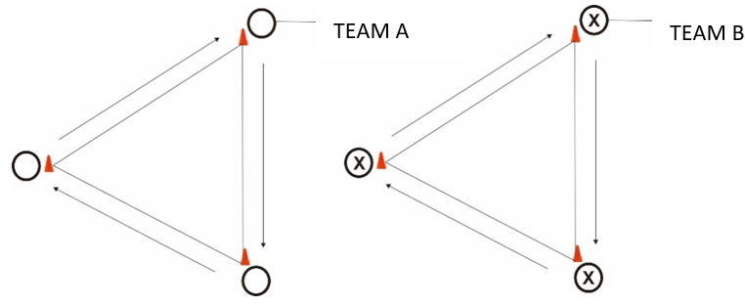
Set-Up:
Each team of three players has one basketball and a triangle (equilateral, 3 meters per side). One team is TEAM A and the other is TEAM B.
Execution:
At the teacher’s signal, each team performs chest passes as fast as possible around their triangle. The team that completes the most passes or circuits within the set time (2 minutes) wins.

- Chasing Passing: Cat in the Ring
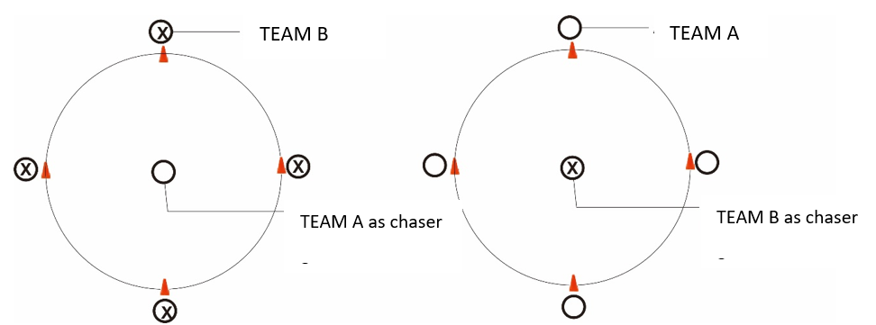
Set-Up:
A circle with a 3-meter diameter. Four players are positioned around the circle, and one player stands in the middle trying to intercept the basketball as the outer players perform chest passes. (If TEAM B is on the outside, TEAM A is in the center, and vice versa.)
Execution:
The four outer players must stay in their positions and perform chest passes for 2 minutes. The middle player tries to intercept the ball during a pass. If they succeed, they switch positions with the player they intercepted. Additionally, if an outer player moves from their position while receiving a pass, they must switch with the middle player.

- Cooties Passing: Distract Passing
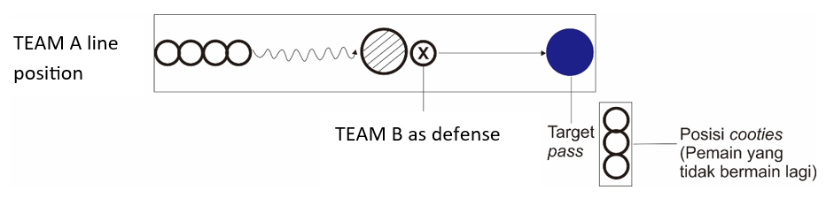
Set-Up:
This game tests passing accuracy and defensive evasion. One TEAM B player guards the passing target area. Four TEAM A players line up. The game duration is 4 minutes. The target is a 1-meter diameter circle marked on a wall. Passing is performed from 2 meters away.
Execution:
TEAM B acts as the defender. TEAM A players dribble toward the target zone. Once they enter the shaded area, the TEAM B defender may try to deflect or intercept the pass. If TEAM B successfully touches or catches the ball, that TEAM A player is out.
Note:
Roles between defenders and passers can be switched alternately.

Shooting Skills
- Contest Shooting: Goal Scoring
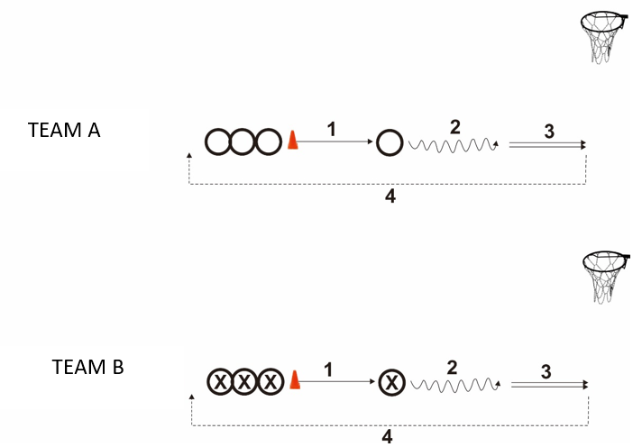
Set-Up:
Two basketball hoops and poles. Each team of four players has one basketball. One team is TEAM A and the other is TEAM B.
Execution:
Within 5 minutes, teams compete to make as many baskets as possible. Each round, one player chest passes to a middle player (2-meter distance), who dribbles (2 meters), shoots, and then returns to the back of the line. The team with the most successful shots wins.

- Chasing Shooting: Cat in Half-Circle
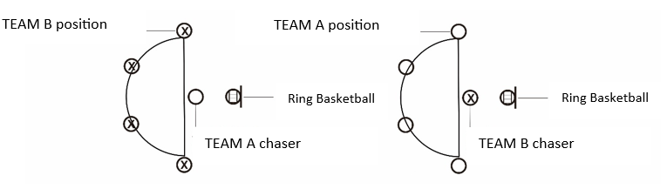
Set-Up:
A half-circle with a 2-meter diameter. Four players are placed around the arc, each holding a basketball. One player stands in the middle. (If TEAM B is outside, TEAM A is in the middle, and vice versa.)
Execution:
For 2 minutes, outer players take turns shooting while remaining in place. The middle player tries to intercept or steal the ball during a shot. If successful, they switch roles with the player they intercepted. Outer players who move from their spot while receiving a pass must also switch with the middle player.

- Cooties Shooting: Pressure Cooties
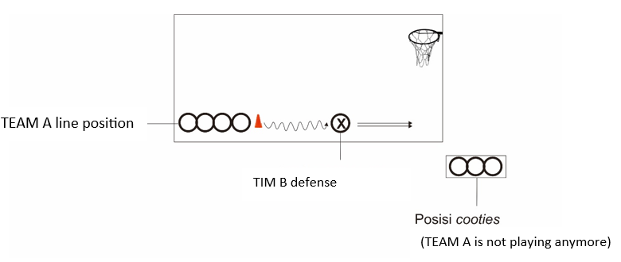
Set-Up:
The objective is to protect the basket and challenge the shooter. One TEAM B player defends the basket area. Four TEAM A players line up on the opposite side. Game duration is 4 minutes. Dribble distance is 2 meters.
Execution:
TEAM A players dribble toward the basket and attempt a shot. TEAM B tries to interfere with the shot without touching the shooter, but may try to steal the ball. If TEAM B steals the ball, the TEAM A player is out. If the shot is taken (even if missed), the TEAM A player returns to the line.
Note:
Roles between defenders and shooters can be alternated.

Dribbling Skills
- Contest Dribbling: Dribbling Faster
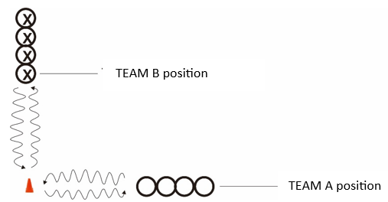

Set-Up:
A straight line 3 meters long. Each team of four players has one basketball. One team is TEAM A and the other is TEAM B.
Execution:
At the teacher's signal, each team dribbles back and forth as fast as possible to an orange cone. All members must complete dribbling, and the team with the fastest total dribbling time within 2 minutes wins.

- Chasing Dribbling: Cat in Center
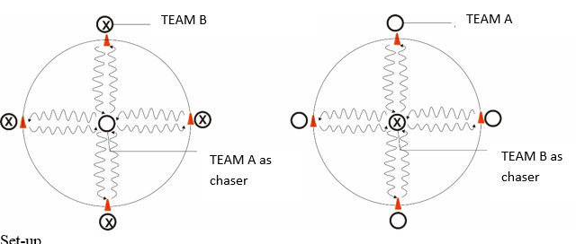

Set-Up:
A 3-meter diameter circle. Four players stand around the circle with a basketball, and one player is in the center. (If TEAM B is outside, TEAM A is in the center, and vice versa.)
Execution:
All four players dribble toward the center and then back to their positions continuously for 2 minutes. The center player tries to steal the ball during dribbling. If successful, the center switches places with the player from whom they stole the ball.

- Cooties Dribbling: Cooties in Square Dribbling
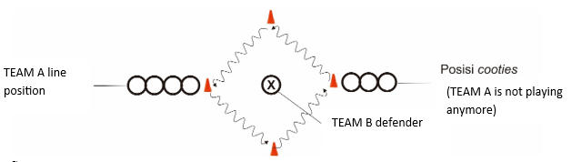
Set-Up:
Four orange cones are placed in a square formation, 2 meters apart. Four TEAM A players line up at one cone. One TEAM B player is the defender in the middle. Game time is 4 minutes.
Execution:
TEAM A players dribble through the four cones while TEAM B tries to interfere and steal the ball. If TEAM B takes the ball, the TEAM A player is out. If the player keeps control of the ball, they return to the line.
Note:
Defender and attacker roles can be alternated.

This section presents the results of the model validation process, practicality testing, and effectiveness evaluation through structured quantitative data supported by descriptive and inferential analysis. All phases of testing were aligned with the methodological steps described in the previous section.
- Content and Construct Validity
The content validity of the developed basketball learning model was evaluated by three experts using a five-point Likert scale across four dimensions: relevance, clarity, coherence, and adequacy. The resulting average content validity score was 4.5 out of 5.00, indicating high acceptance. This score was obtained through item-by-item expert judgment using the Aiken’s V index, with all items scoring above 0.88 and thus deemed valid without modification. Construct validity was assessed through linear regression analysis between the component skill test scores (passing, dribbling, shooting) and TSAP performance results. The analysis showed significant positive correlations (p < 0.05) between the skill components and game performance, confirming that the measured skills were aligned with the theoretical constructs embedded in the model.
- Practicality Assessment
To evaluate the practicality of the model, observations were conducted in classroom settings. Experts assessed students' responses using structured rubrics in affective, cognitive, and psychomotor domains. Scores indicated that students could follow the learning steps, engage in the activities, and demonstrate progress in each domain. The implementation was rated as “very practical” with an average practicality score of 87%.
- Intervention Effectiveness: Skill Improvement
The model’s effectiveness was measured through pre- and post-tests using the AAHPERD basketball skill assessment. The data presented in Table 1 show significant improvements across all three core skills.
Table 1. Pre- and Post-Test Results on Basketball Skills (N = 164)
Skill Component | Pre-test Mean | Post-test Mean | Mean Difference | t-value | Sig. (p)
Passing | 65.12 | 79.45 | +14.33 | 9.12 | <0.001
Dribbling | 63.78 | 77.91 | +14.13 | 8.75 | <0.001
Shooting | 60.45 | 76.02 | +15.57 | 10.01 | <0.001

The paired t-test results indicated statistically significant improvements in all three skill areas after the implementation of the model. These improvements suggest the play-based model effectively facilitated motor skill acquisition.
- Affective Learning Indicators
In addition to skill development, affective learning indicators were observed and rated. Table 2 presents students’ performance in collaboration, sportsmanship, and enjoyment.
Table 2. Changes in Affective Domain Indicators (N = 164)
Indicator | Pre-test (%) | Post-test (%)
Collaboration | 68.7 | 87.5
Sportsmanship | 72.4 | 89.3
Enjoyment | 66.8 | 91.0

Observations showed consistent improvements in affective indicators, especially in enjoyment and collaboration. These results further support the appropriateness of play-based learning in promoting positive student behavior.
All quantitative outcomes are complemented by qualitative field notes from observers and teachers, which consistently emphasized high levels of student enthusiasm and participation. These findings will be further interpreted and contextualized in the discussion section that follows.
The play-based approach ensured gradual skill development while actively engaging students in the learning process. Active participation in each game-based session increased motivation and involvement in basketball activities, fostering an inclusive, dynamic, and enjoyable learning environment. By integrating competitive challenges, physically demanding tasks, and teamwork-driven learning, the model provided a holistic approach to improving elementary students’ basketball skills. To confirm its effectiveness, the learning model underwent thorough validity and practicality assessments. Content validity scored an average of 4.5 out of 5, indicating strong expert agreement on the model’s alignment with effective elementary basketball instruction principles. Construct validity assessments through classroom observations showed that students adapted well to the play-based approach, displaying notable improvements in motivation, participation, and technical basketball skills.
Teacher feedback further supported the model’s practicality. Physical education teachers found it easy to implement within elementary school programs. They reported that the play-based approach not only enhanced learning effectiveness but also addressed challenges such as low student interest in basketball. The model proved both academically valid and practical for real-world physical education settings. To measure its impact, pre-test and post-test results compared students' basketball skill development. The findings revealed significant improvements across all tested skills, demonstrating the model’s effectiveness in enhancing students’ fundamental basketball abilities.

Skills | Pre-test | Post-test | Improvement (%)
Passing | 6,73 | 9,6 | 42,60%
Shooting | 2,3 | 3,5 | 52,20%
Dribbling | 13,19 sec | 11,51 sec | -12,7% (faster)
Lay-up | 1,77 | 4,47 | 152,50%

The improvement in students performance demonstrates that the play-based learning model effectively enhances their fundamental basketball skills. Every aspect of progress confirms the effectiveness of this approach in developing students' psychomotor abilities. Beyond technical skill development, the learning model also positively influences affective aspects, including discipline, teamwork, good behavior, responsibility, and readiness to learn. The comparison between pre-test and post-test results indicates significant improvement.

Affective Aspects | Pre-test | Post-test
Discipline | 0,49 | 0,88
Cooperation | 0,49 | 0,91
Good Behavior | 0,51 | 0,85
Responsibility | 0,49 | 0,93
Readiness to Learn | 0,51 | 0,93

The improvement demonstrates that the play-based approach enhances not only technical skills but also students' positive attitudes toward learning. This learning model encourages students to become more cooperative, take responsibility, and engage in learning more effectively.

Dicussion
The play-based approach not only enhances technical skills but also fosters positive student attitudes toward learning. This learning model encourages students to become more cooperative, responsible, and better prepared for learning.
The learning model being developed is crucial for the development of children aged 10-12 years, which is known as Phase C in Indonesia's education system. At this age, children are in a stage of more complex motor development, where coordination, balance, and movement control improve significantly (Hasbi, 2020). Therefore, a learning model that emphasizes play-based training not only enhances basketball technical skills but also helps develop children's cognitive and socio-emotional aspects (Amato et al., 2023). Additionally, students in this age group begin to understand game rules and strategies, making game-based learning a suitable approach for improving their overall game comprehension (Dewi & Pane, 2022).
A key strength of the mini-basketball play-based learning model lies in its ability to create an engaging environment that motivates students to participate actively (Madhumathi & Selvam, 2021). By designing challenging yet achievable games, this model helps students build confidence and mental resilience when facing challenges (Cavus et al., 2023). Another advantage is its flexibility, allowing teachers to adapt the model to different school conditions and student skill levels. Schools with limited facilities can implement this model since most activities require minimal equipment or specialized courts (Lubay et al., 2021). From a sustainability perspective, this learning model can continue evolving through technological advancements and adaptations to physical education needs.
The core principles of this model apply beyond basketball, making it suitable for other sports like soccer, volleyball, and athletics. As a result, game-based learning can become a widely used instructional method in elementary physical education. Overall, the mini-basketball play-based learning model not only improves technical skills but also positively influences character and social-emotional development (Sun & Zheng, 2021). With its high flexibility and adaptability, this model holds long-term potential as an effective and relevant strategy for physical education curricula.

Validity and Practicality
To confirm effectiveness, researchers assessed the model’s validity and practicality through various evaluation methods. Content validity received an average score of 4.5 out of 5, indicating that experts strongly agreed on the model’s alignment with fundamental basketball instruction for elementary students. Construct validity assessments through classroom observations showed that students adapted well to the play-based approach, demonstrating significant improvements in motivation, active participation, and basketball skills comprehension.
The structured and research-based development process contributed to the model’s strong validity. The integration of competition-based learning, chasing activities, and team-based drills ensured meaningful student engagement. By incorporating active play, the model naturally enhances motor skills while reinforcing cognitive and social-emotional development, which are critical elements in child development (Suhartini & Kushartanti, 2022). The structured yet flexible nature of this model allows adaptation to diverse learning contexts, further strengthening its validity.
Feedback from physical education teachers confirmed the model’s practicality. Teachers found the approach easy to implement in elementary school programs. Many reported that game-based learning not only improved lesson effectiveness but also increased student interest in basketball. The model’s adaptability to different skill levels and minimal facility requirements made it suitable for schools with limited resources.
The model’s adaptability and ability to engage students effectively explain why it meets practical criteria. By creating an interactive and enjoyable learning experience, students become more motivated to participate, reducing passive learning and disengagement (Lambert & Jacobsen, 2020). The model’s structure allows easy modifications to accommodate different school environments and student abilities, enabling teachers to adjust exercises without compromising the core principles of the model.
Thus, this learning model is both academically valid and practically applicable to various physical education settings. Its ability to balance skill development, motivation, and inclusivity makes it an effective and sustainable tool for improving basketball learning in elementary schools. The combination of structured gameplay, research-based pedagogy, and real-world applicability highlights this model’s valuable contribution to the future of physical education (Wienecke et al., 2021).

Theoretical Support
The improvement in both skills and affective aspects results from the play-based approach, which actively engages students in the learning process. Experiential Learning Theory explains that hands-on experiences accelerate skill retention and understanding, making game-based activities an effective method for skill development (Marougkas et al., 2023). Competitive games and chasing activities help students develop coordination, agility, and motor skills through repetitive, challenge-based exercises (Motevalli et al., 2020).
Intrinsic Motivation Theory states that a fun learning environment increases student engagement by fulfilling their needs for autonomy, competence, and social connection (Arsani et al., 2020). The game-based approach allows students to explore skills freely, reducing unnecessary pressure and increasing their confidence and motivation to learn (Mena-Guacas et al., 2023).
From an affective perspective, significant improvements in discipline, teamwork, and responsibility align with Social Learning Theory, which emphasizes that children learn through observation and interaction with their environment (Ratinho & Martins, 2023). By participating in team-based games, students develop teamwork, understand their roles, and cultivate discipline and responsibility (Cipriano et al., 2024).
These findings confirm that play-based learning not only enhances technical basketball skills but also strengthens affective aspects, which are essential for holistic student development. This model proves that experiential learning, intrinsic motivation, and positive social interactions create an effective and sustainable learning environment (He et al., 2023).

Conclusion
This study demonstrates that implementing a play-based learning model significantly improves elementary students' physical literacy, particularly in motor skills, motivation for physical activity, and understanding of sports concepts. The integration of contest-based learning, chasing activities, and cooties-based drills proves effective in increasing student engagement and refining their basketball skills.
From an effectiveness standpoint, statistical analysis reveals significant improvements in passing, dribbling, and shooting skills among students in the experimental group compared to the control group. Additionally, student motivation for physical education increased, as reflected in higher survey scores indicating greater interest and participation in physical activities after adopting the game-based learning model. A more interactive, enjoyable, and exploratory learning environment contributed to the model’s success in enhancing physical literacy.
With these findings, the play-based learning model can be recommended as an innovative strategy for physical education, particularly for developing motor skills and student motivation in elementary schools. Physical education teachers can adopt this approach to create more engaging and effective learning experiences, fostering active habits from an early age. Future research should explore variations of this model in different sports and evaluate its long-term impact on students' physical activity habits.

References:

Amato, A., Giustino, V., Patti, A., Proia, P., Trivic, T., Drid, P., Obradovic, A., Manojlovic, M., Mondoni, M., Paoli, A., & Bianco, A. (2023). Young basketball players have better manual dexterity performance than sportsmen and non-sportsmen of the same age: a cross-sectional study. Scientific Reports, 13(1). https://doi.org/10.1038/s41598-023-48335-7
Arsani, Maksum, A., Tuasikal, A. R. S., & Kusnanik, N. W. (2020). Differences in Motivational Orientation in Physical Education in terms of Gender Differences. Budapest International Research and Critics in Linguistics and Education (BirLE) Journal, 3(3), 1428–1434. https://doi.org/10.33258/birle.v3i3.1238
Astuti, Y., Erhan Orhan, B., Badri Al-Mhanna, S., & Batrakoulis, A. (2024). Mental Training Models in Physical Education, Sports and Health Subjects for Volleyball in Elementary School Students. https://recyt.fecyt.es/index.php/retos/index
Bieniek, B., & Deutsch, J. (2020). Reviving the Fifth Standard: Placing Value in Physical Education. Strategies, 34(1), 18–22. https://doi.org/10.1080/08924562.2020.1841694
Cavus, N., Ibrahim, I., Ogbonna Okonkwo, M., Bode Ayansina, N., & Modupeola, T. (2023). The Effects of Gamification in Education: A Systematic Literature Review. BRAIN. Broad Research in Artificial Intelligence and Neuroscience, 14(2), 211–241. https://doi.org/10.18662/brain/14.2/452
Chang, C. M., Chou, Y. H., Hsieh, H. H., & Huange, C. K. (2020). The effect of participation motivations on interpersonal relationships and learning achievement of female college students in sports club: Moderating role of club involvement. International Journal of Environmental Research and Public Health, 17(18), 1–12. https://doi.org/10.3390/ijerph17186514
Cipriano, C., Ha, C., Wood, M., Sehgal, K., Ahmad, E., & McCarthy, M. F. (2024). A systematic review and meta-analysis of the effects of universal school-based SEL programs in the United States: Considerations for marginalized students. Social and Emotional Learning: Research, Practice, and Policy, 3, 100029. https://doi.org/10.1016/j.sel.2024.100029
Cocca, A., Verdugo, F. E., Cuenca, L. T. R., & Cocca, M. (2020). Effect of a game-based physical education program on physical fitness and mental health in elementary school children. International Journal of Environmental Research and Public Health, 17(13), 1–13. https://doi.org/10.3390/ijerph17134883
Correia, M., & Rosado, A. (2019). Anxiety in athletes: Gender and type of sport differences. International Journal of Psychological Research, 12(1), 9–17. https://doi.org/10.21500/20112084.3552
D’Anna, C., Forte, P., & Pugliese, E. (2024). Trends in Physical Activity and Motor Development in Young People—Decline or Improvement? A Review. In Children (Vol. 11, Issue 3). Multidisciplinary Digital Publishing Institute (MDPI). https://doi.org/10.3390/children11030298
Darni, & Handayani, G. (2020). Development of Motor Learning Model Based on Game and Fun Activities.
de Bruijn, A. G. M., Mombarg, R., & Timmermans, A. C. (2022). The importance of satisfying children’s basic psychological needs in primary school physical education for PE-motivation, and its relations with fundamental motor and PE-related skills. Physical Education and Sport Pedagogy, 27(4), 422–439. https://doi.org/10.1080/17408989.2021.1906217
de Ojeda, M. (2018). Impact of Two Sport Education Units on Learning Outcomes in Primary School Impacto de Duas Unidades Didáticas de Educação Esportiva nos Objetivos de Aprendizagem do Ensino Fundamental (Vol. 22). http://revistas.um.es/cpd
Dese, D. C., & Wibowo, C. (2025). Enhancing motivation, physical activity, and motor skills through a sport management program based on the sport education model. 64, 589–600. https://doi.org/https://doi.org/10.47197/retos.v64.110949
Dewi, R., & Pane, B. S. (2022). Dewi Pane_View of Development of Basketball Game Modifications for Elementary Schools. Jurnal Pendidikan Jasmani, 3(1). https://doi.org/https://doi.org/10.55081/jpj.v3i1.771
Febria Friskawati, G., Sobarna, A., & Rahmi Stephani, M. (2020). Teachers’ Perceptions of Physical Education Teaching Barriers at Elementary Schools.
Hasbi, M. (2020). Investing in Quality Early Childhood Education for Quality Indonesian Human Resources.
He, J., Yu, H., Jiang, M., & Bialas, M. (2023). A research synthesis on successful educational practices and student outcomes for physical education in schools. In Frontiers in Psychology (Vol. 14). Frontiers Media SA. https://doi.org/10.3389/fpsyg.2023.1280871
Jibril, M. (2021). Ethiopian Higher Education Students Attitude Towards Physical Education. https://doi.org/10.14293/S2199-1006.1.SOR-.PP1TCIG.v1
Josiah, T., Suhada, A., Chetthamrongchai, P., Purbasari, H., Hazim, H. T., Shidiq, A. A. P., Wahyuningsih, T. H., Potashova, I. Y., & Aravindhan, S. (2021). Optimization of the Location, Inventory and Routing of Capacity Vehicles with Interval Uncertainty. Industrial Engineering and Management Systems, 20(4), 654–661. https://doi.org/10.7232/iems.2021.20.4.654
Killough, B. P., Sluder, J. B., Howard-Shaughnessy, C., & Rhodes, A. C. (2020). Physical Literacy and Practical Applications for Physical Educators. Journal of Physical Education, Recreation and Dance, 92(2), 30–39. https://doi.org/10.1080/07303084.2020.1853633
König, N., Pfeiffer, A., Wernbacher, T., & Denk, N. (2020). Game-Based Learning Research at the Danube University Krems’ Center for Applied Game Studies. In Studies in Computational Intelligence (Vol. 859, pp. 123–132). Springer. https://doi.org/10.1007/978-3-030-36107-5_7
Lambert, D., & Jacobsen, M. (2020). Implementing an Intervention into a Grade Six Learning Environment: A Design-Based Research Framework. EDeR. Educational Design Research, 3(1). https://doi.org/10.15460/eder.3.1.1388
Liao, C. C., Hsu, C. H., Kuo, K. P., Luo, Y. J., & Kao, C. C. (2023). Ability of the Sport Education Model to Promote Healthy Lifestyles in University Students: A Randomized Controlled Trial. International Journal of Environmental Research and Public Health, 20(3). https://doi.org/10.3390/ijerph20032174
Linnenbrink-Garcia, L., Patall, E. A., & Pekrun, R. (2016). Adaptive Motivation and Emotion in Education: Research and Principles for Instructional Design. Policy Insights from the Behavioral and Brain Sciences, 3(2), 228–236. https://doi.org/10.1177/2372732216644450
Liskustyawati, H., Riyadi, S., Sabarini, S. S., Waluyo, & Purnomo Shidiq, A. A. (2020). Level of physical fitness of elderly people from 60 to 80 years old during a pandemic COVID-19. Health, Sport, Rehabilitation, 6(4), 27–38. https://doi.org/10.34142/HSR.2020.06.04.03
Lubay, L. H., Makmun, A., Juliantine, T., & Nuryadi. (2021). Effect of playing comprehension model on basketball playing skills. International Journal of Human Movement and Sports Sciences, 9(4), 15–19. https://doi.org/10.13189/saj.2021.091303
Madhumathi, K., & Selvam, P. S. (2021). Learning through Play-Improving Academic Performance through Play. www.intechopen.com
Maliki, O., Sundawan Suherman, W., Prasetyo, Y., Dwi Pradipta, G., Ode Adhi Virama, L., Yudhistira, D., & Dina Dameria, F. (2025). Developing a traditional game-based physical education learning model to improve students’ physical fitness: content validity Desarrollo de un modelo de aprendizaje de educación física tradicional basado en juegos para mejorar la condición física de los estudiantes: validez de contenido. Retos, 62, 2025. https://recyt.fecyt.es/index.php/retos/index
Manninen, M., & Yli-Piipari, S. (2021). Ten Practical Strategies to Motivate Students in Physical Education: Psychological Need-Support Approach. Strategies, 34(2), 24–30. https://doi.org/10.1080/08924562.2020.1867270
Marougkas, A., Troussas, C., Krouska, A., & Sgouropoulou, C. (2023). Virtual Reality in Education: A Review of Learning Theories, Approaches and Methodologies for the Last Decade. In Electronics (Switzerland) (Vol. 12, Issue 13). Multidisciplinary Digital Publishing Institute (MDPI). https://doi.org/10.3390/electronics12132832
Mena-Guacas, A. F., Rodríguez, J. A. U., Trujillo, D. M. S., Gómez-Galán, J., & López-Meneses, E. (2023). Collaborative learning and skill development for educational growth of artificial intelligence: A systematic review. In Contemporary Educational Technology (Vol. 15, Issue 3). Bastas. https://doi.org/10.30935/cedtech/13123
Metz, S., Zander, B., & Hunger, I. (2024). The suffering of students in physical education. Unsettling experiences and situational conditions. Physical Education and Sport Pedagogy. https://doi.org/10.1080/17408989.2024.2352825
Milovanovic, M. (2023). Assessing the reliability of tests for evaluation technical skills in mini basketball. Journal of Physical Education and Sport, 23(11), 2917–2924. https://doi.org/10.7752/jpes.2023.11332
Mitova, O., Griban, G., Oleniev, D., Yakovenko, A., Onyshchenko, V., Mozolev, O., Semeniv, B., Lytvynenko, A., Khurtenko, O., Zamrozevuch-Shadrina, S., Kozibroda, L., & Hres, M. (2022). The Impact of Mini-Basketball Training Sessions on the 6-7-Year-Old Boys’ Physical Fitness and Physical Development. International Journal of Human Movement and Sports Sciences, 10(4), 754–767. https://doi.org/10.13189/saj.2022.100416
Mödinger, M., Woll, A., & Wagner, I. (2022). Video-based visual feedback to enhance motor learning in physical education—a systematic review. In German Journal of Exercise and Sport Research (Vol. 52, Issue 3, pp. 447–460). Springer Science and Business Media Deutschland GmbH. https://doi.org/10.1007/s12662-021-00782-y
Motevalli, S., Perveen, A., & Tresa Anak Michael, M. (2020). Motivating Students to Learn: An Overview of Literature in Educational Psychology. International Journal of Academic Research in Progressive Education and Development, 9(3). https://doi.org/10.6007/ijarped/v9-i3/7779
Navarro-Patón, R., Rodríguez-Negro, J., Muíño-Piñeiro, M., & Mecías-Calvo, M. (2024). Gender and Educational Stage Differences in Motivation, Basic Psychological Needs and Enjoyment: Evidence from Physical Education Classes. Children, 11(12). https://doi.org/https://doi.org/10.3390/children11121503
Otero-Saborido, F. M., Lluch, Á. C., & González-Jurado, J. A. (2015). Suid-Afrikaanse Tydskrif vir Navorsing in Sport. South African Journal for Research in Sport, Physical Education and Recreation, 37(2), 83–94. https://www.ajol.info/index.php/sajrs/article/view/123009
Perdana, G. S., Ilham, Alben, A. S. C., Orhan, B. E., & Geantă, V. A. (2025). Effects of outdoor physical training on VO₂ max, endurance, and power in male Sports Science students. Retos, 63, 1132–1139. https://doi.org/10.47197/retos.v63.111
Plomp, Tj., & Nieveen, Nienke. (2013). Educational design research. Part A : an introduction. SLO.
Ratinho, E., & Martins, C. (2023). The role of gamified learning strategies in student’s motivation in high school and higher education: A systematic review. In Heliyon (Vol. 9, Issue 8). Elsevier Ltd. https://doi.org/10.1016/j.heliyon.2023.e19033
Santoso, H., Harwanto, H., & Karyono, H. (2021). Bahan Ajar PJOK Tematik Terpadu Berbasis Permainan Sederhana di Sekolah Dasar. MENDIDIK: Jurnal Kajian Pendidikan Dan Pengajaran, 7(1), 94–99. https://doi.org/10.30653/003.202171.167
Sarbassova, V., Koldasbayeva, B., Turdaliyeva, S., Khan, N., Baibossynova, R., & Aitenova, E. (2025). Building national consciousness of future teachers by incorporating traditional sports into Physical Education curricula. Retos, 66, 66. https://doi.org/10.47197/retos.v66.113
Shidiq, A. A. P., Susanto, N., Karyono, T. H., Fitriady, G., Purwoto, S. P., Eken, O., Armand, N., Tafuri, F., & Latino, F. (2024). Therapeutic Effects of Medicinal Plants on Simultaneous Improvement of Physical and Mental Health: A Study on Traditional and Modern Health Management. In International Journal of Body, Mind and Culture (Vol. 11, Issue 5, pp. 462–474). Vesnu Publications. https://doi.org/10.22122/ijbmc.v11i5.813
Song, C., & Kao, Q. (2023). Enhancing learner motivation by adapting strategies from the ARCS model: experience from Chinese online course design and teaching. Journal of China Computer-Assisted Language Learning, 3(1), 168–187. https://doi.org/10.1515/jccall-2023-0014
Suhartini, B., & Kushartanti, W. B. M. (2022). Development of Physical Activity Models Based on Motor Perception for Kindergarten Children. International Journal of Human Movement and Sports Sciences, 10(1), 6–13. https://doi.org/10.13189/saj.2022.100102
Sun, F., & Zheng, C. (2021). The application of basketball technology multimedia computer-assisted instruction courseware in physical education. International Journal of Electrical Engineering and Education. https://doi.org/10.1177/00207209211013440
Tilga, H., Kalajas-Tilga, H., Hein, V., Raudsepp, L., & Koka, A. (2020). How does perceived autonomy-supportive and controlling behaviour in physical education relate to adolescents’ leisure-time physical activity participation? Kinesiology, 52(2), 265–272. https://doi.org/10.26582/k.52.2.13
Umar, F., Misbah, M., Fadian, U. F. L., & Shidiq, A. A. P. (2023). Trends research of para-cycling: A bibliometric analysis. E3S Web of Conferences, 450. https://doi.org/10.1051/e3sconf/202345003002
Umar, F., Misbah, M., Purnama, S. K., Putro, B. N., Manshuralhudlori, M., & Shidiq, A. A. P. (2024). Level of Ability Eye, Hand, and Foot Coordination Utilize UMAC-CPF Test Model. International Journal of Disabilities Sports and Health Sciences, 7, 1–8. https://doi.org/10.33438/ijdshs.1359440
Umar, F., Ruslan, Misbah, Hidayatullah, M. F., Waluyo, Rahayu, T. W., Ellyas, I. S., Gontara, S. Y., Agustiyanta, Sugeng, & Shidiq, A. A. P. (2022). UMAC-CPF Coordination Test Model for Predicting the Eye, Hand, and Foot Coordination Ability of CP Football Players. International Journal of Human Movement and Sports Sciences, 10(3), 414–422. https://doi.org/10.13189/saj.2022.100307
Wang, Y., & Wang, X. (2024). Artificial intelligence in physical education: comprehensive review and future teacher training strategies. In Frontiers in Public Health (Vol. 12). Frontiers Media SA. https://doi.org/10.3389/fpubh.2024.1484848
Wibowo, A., Susongko, P., & Basukiyatno. (2023). Model Asesmen Literasi Fisik Guru Pendidikan Jasmani Olahraga dan Kesehatan di Sekolah Dasar. In Journal of Education Research (Vol. 4, Issue 4). https://doi.org/https://doi.org/10.37985/jer.v4i4.615
Wibowo, R., Budiman, D., Sumarno, G., Stephani, M. R., & Putri, W. (2021). Is physical activity level in physical education lesson related to fundamental movement skills at elementary schools? International Journal of Human Movement and Sports Sciences, 9(4), 31–37. https://doi.org/10.13189/saj.2021.091306
Wienecke, J., Hauge, J., Nielsen, G., Mouritzen, K., & Damsgaard, L. (2021). Six Weeks of Basketball Combined With Mathematics in Physical Education Classes Can Improve Children’s Motivation for Mathematics. Frontiers in Psychology, 12. https://doi.org/10.3389/fpsyg.2021.636578
Yang, Y., Chen, D., Cai, K., Zhu, L., Shi, Y., Dong, X., Sun, Z., Qiao, Z., Yang, Y., Zhang, W., Mao, H., & Chen, A. (2024). Effects of mini-basketball training program on social communication impairments and regional homogeneity of brain functions in preschool children with autism spectrum disorder. BMC Sports Science, Medicine and Rehabilitation, 16(1). https://doi.org/10.1186/s13102-024-00885-7
Yoon, K., & Seo, J. Y. (2020). Exploring the concept of physical education curriculum redesign. Korean Journal of Sport Science, 31(4), 759–774. https://doi.org/10.24985/kjss.2020.31.4.759

