Customer Engagement in Customized Courses:The Mediating Role of Experiential Value and the Moderating Effect of Unique Needs
1WANG ZI XING, ²LYU YANG, 3WONG CHEE HOO, ⁴LI GUANGYU, 5LUO XIYUAN, 6CHRISTIAN WIRADENDI WOLOR

1,2,3,4Faculty of Business and Communications (FBC)，INTI International University, MALAYSIA
⁵School of Digital Economy and Management, Guilin Shanshui Vocational College
6Faculty of Economics and Business, Universitas Negeri Jakarta, Indonesia

Abstract：
In the context of digital transformation, educational services are evolving towards personalization and customization. Customer engagement has become a crucial mechanism for customized course platforms to achieve value creation and user retention. This study constructs a "customer engagement-functional value/hedonic value-customer retention" model based on value co-creation theory and examines the moderating effect of unique requirements. Using 279 customized course user questionnaires as a sample, SPSS 27.0 and AMOS 26.0 were employed for empirical analysis. The results show that customer engagement significantly and positively impacts customer retention; both hedonic and functional experiential values ​​play a partial mediating role; and unique requirements positively moderate the relationship between engagement and experiential value. This study reveals the intrinsic mechanism by which customer engagement affects customer retention in the context of customized courses, expands the application of relevant theories in the field of education, and provides practical insights for platforms to optimize engagement mechanisms and improve retention.

Keywords: Consumer behaviour, Customized Courses; Customer Engagement; Experiential Value; Customer Retention; Unique Needs

1. Introduction

The rise of digital technology and the increasing demand for personalization are accelerating the transformation of course design and delivery toward course-level customization models. Learners, through participation in customized course content and learning pathway design, are transforming from passive recipients to active value co-creators, significantly enhancing their perceived course experience and influencing subsequent behavior (Dziewanowska & Kacprzak, 2023). However, existing research largely focuses on traditional service domains and general educational contexts, lacking a systematic exploration of how customer participation in customized course-based services influences customer retention through functional and hedonic course experiential value (Amjad & Azhar, 2023; Zhang et al., 2024). Furthermore, the boundary effects of course-related customer-specific needs in customized course settings have not been adequately examined.

Based on the value co-creation theory (Nguyen et al., 2021), this study constructs a course-level mechanism model to examine how customer engagement influences customer retention through functional and hedonic experiential value, and investigates the moderating effect of unique requirements. This study expands the applicability of this theory to the context of customized course-based services, providing empirical evidence for customized course platforms and providers to optimize engagement mechanisms and enhance user loyalty.

2. Literature Review
2.1 Customized Course Services and Value Co-Creation Theory

Value co-creation theory argues that value is not delivered solely by firms but is generated through interaction and resource integration between providers and customers (Vargo & Lusch, 2016).

In customized course service contexts, learners have shifted from passive recipients to active participants in the course creation and delivery process. By engaging with learning content and interacting online, students significantly enhance their perceived value and learning satisfaction, thereby strengthening their identification with the platform and their willingness to continue using it (Dziewanowska & Kacprzak, 2023).

Customized course services emphasize learners' active contribution of information and resources, co-creating value through participation in course content customization, learning pathway adjustment, and course feedback cycles during service use (Soleymani et al., 2025). This study is based on value co-creation theory, emphasizing that learners actively contribute information and resources within customized courses, rather than simply consuming pre-designed course content.

2.2 Customer Participation

Customer engagement is a core mechanism for value co-creation in customized course services, significantly influencing course co-creation, satisfaction, and retention. Students' participation in online learning through discussions, feedback, and interaction significantly enhances their course experience and satisfaction (Dewarani & Alversia, 2023). From a behavioral perspective, customer engagement in customized courses includes information provision related to learning needs and collaborative behaviors during course participation (Wayne et al., 2024). From a process perspective, it manifests as continuous interaction and resource contribution throughout the customized course lifecycle (Zhang et al., 2023).

2.3 Experience Value

Customer experience value in customized courses encompasses two dimensions: functional value and hedonic value. Functional value relates to the effectiveness, efficiency, and performance of services, manifesting as learning efficiency and a sense of goal achievement, with significantly improved learner engagement leading to better learning outcomes and continued use (Dziewanowska & Kacprzak, 2023; Singh et al., 2025). Hedonic value emphasizes pleasure and immersion, reflected in emotional engagement and social enjoyment, with positive interaction enhancing platform attachment (Soleymani et al., 2025).

2.4 Customer retention and unique requirements

Customer retention reflects the quality of long-term learner–provider relationships in customized course contexts. Value co-creation improves retention rates by enhancing experience and satisfaction (Dewarani & Alversia, 2023), reflecting their recognition of the value of customized courses. Unique needs moderate the relationship between participation behavior and value perception (Yin et al., 2025); such that learners with higher unique needs are more likely to gain added-value experiences from customized course co-creation.

2.5 Hypothetical Development

The concept of customer participation is generally divided into two perspectives in research. One is the behavioral perspective: customer participation involves the degree to which customers participate in production and operation services. The other perspective focuses on the degree of customer investment in participation: customer participation is the behavior jointly created by enterprises and customers in the production process (Sadighha et al., 2024; Xu et al., 2024). Customer satisfaction has a significant impact on customer retention (Payne et al., 2008), while customer participation has a significant positive impact on customer satisfaction (Souza et al., 2023). Therefore, based on the above relationships, the following hypothesis is proposed:
H1: Customer engagement has a significant positive impact on customer retention;

This study selects information provision and co-creation in customer participation as dimensions for research. In the process of customer participation and co-creation of products, companies exchange information with customers, jointly overcome problems, and bring them better services and benefits, thereby increasing the functional value for customers. At the same time, it also enhances customers' sense of control over the development process, thus increasing their enjoyment value. Therefore, this study makes the following hypotheses:
H2a: Customer engagement has a significant positive impact on hedonic value;
H2b: Customer engagement has a significant positive impact on functional value;

Customer experience value is a crucial factor in customer retention, and it significantly impacts retention during customized activities (Nwankwo & Kanyangale, 2023). If a customer's functional and hedonic values ​​are satisfied during the product creation process, it has a chance to increase their willingness to retain customers. Therefore, the following hypotheses are proposed:
H3a: Hedonic value has a significant positive impact on customer retention;
H3b: Functional value has a significant positive impact on customer retention;

Combining Hypotheses 1 and 2, in customized marketing, if customers receive positive experiential value during the engagement process, they are more likely to continue purchasing and maintain or expand their future purchasing scope. Therefore, the following hypotheses are proposed:
H4a: Hedonic value mediates the relationship between customer engagement and customer retention;
H4b: Functional value mediates the relationship between customer engagement and customer retention.

When individuals perceive themselves as highly similar to others, they attempt to build self-esteem and reduce negative impacts by differentiating themselves through their behavior (Taylor & Armes, 2024). In customized marketing customer engagement, the consumer's experiential value may be moderated by whether the business can meet their unique needs. Customer unique needs have a positive impact on customer engagement and customer experiential value. Therefore, the following hypotheses are proposed:
H5a: Customer unique needs have a positive moderating effect on the relationship between customer engagement and hedonic value;
H5b: Customer unique needs have a positive moderating effect on the relationship between customer engagement and functional value;
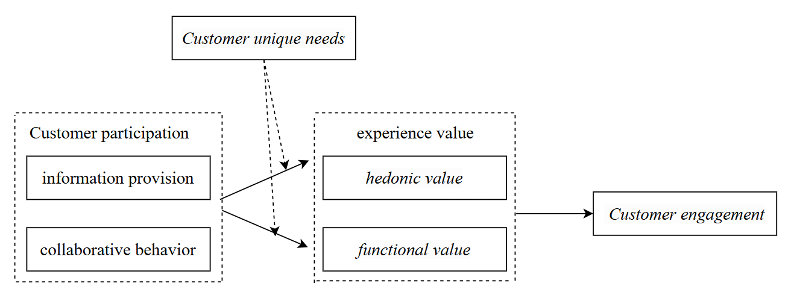

Figure 1. Conceptual Model

2.6 Summary

The current study lacks a systematic analysis of how customer engagement in customized course contexts influences customer retention through different types of course experiential value. And how this influence is moderated by individual traits such as the need for uniqueness. This study aims to fill this theoretical and empirical gap.

Overall, this study advances value co-creation theory by unpacking how customer participation translates into experiential value and long-term retention in customized course-based services, while identifying individual-level boundary conditions.

3 Methodology

This study selects respondents who had participated in customized courses as research subjects. This study choose these respondents as the research subjects to explore the interaction between customized marketing, customer engagement, customer experience value, and customer retention.

Through a literature review, this study uses mature scales developed by studies both in China and abroad to measure information provision behavior and co-creation behavior in customer engagement within customized marketing; the dimensions of hedonic and functional value in customer experience value; and variables related to customer retention and unique needs.

3.1 Data Source

This study used the Wenjuanxing online platform to survey students who had participated in customized courses. The specific implementation process is as follows: First, a pre-survey phase was conducted, selecting 30 students with customized course experience using convenience sampling. Questionnaires were distributed and collected offline. The pre-survey results showed that respondents generally felt the questionnaire design was reasonable and the completion time was appropriate, with the questionnaire's validity and reliability meeting measurement requirements. The formal survey phase then commenced, collecting 483 questionnaires online. After data cleaning and removal of invalid samples, 279 valid questionnaires were obtained, resulting in a valid response rate of 57.76%. The survey process strictly adhered to social survey ethics to ensure the authenticity and reliability of the research data.

3.2 Correlation analysis

This study uses SPSS 27.0 to examine the Pearson correlation coefficients among the variables (as shown in Table 1). The results showes that there were significant positive correlations among the variables (p < 0.01). The correlation coefficient between information provision and co-creation was 0.729, and the correlation coefficient between functional value and hedonic value was 0.878, indicating a high degree of positive correlation between these latent variables. The correlation coefficients between customer retention and information provision, co-creation, functional value, and hedonic value were 0.583, 0.562, 0.713, and 0.709, respectively, all reaching a significant level. This indicates that each influencing factor is related to customer retention to some extent. The correlation coefficients between unique needs and other variables ranged from 0.506 to 0.652, also showing a significant positive correlation, indicating that meeting customer unique needs plays a role in the overall experience and retention process.

Table 1. Pearson Correlation Analysis
Relevance | Information provision | Co-creation | Functional value | Hedonic value | Customer retention | Unique requirements
Information provision | 1
Co-creation | .729** | 1
Functional value | .632** | .758** | 1
Hedonic value | .608** | .717** | .878** | 1
Customer retention | .583** | .562** | .713** | .709** | 1
Unique | .509** | .506** | .588** | .606** | .652** | 1
**At the 0.01 level (two-tailed), the correlation is significant.

3.3 Reliability and validity analysis

3.3.1 Confirmatory Factor Analysis

This study uses AMOS 26.0 to conduct confirmatory factor analysis on each variable. Detailed results are shown in Table 2. The tests reveales that the models for each factor had good fit, meeting the evaluation criteria of c²/df < 3, CFI > 0.9, TLI > 0.9, NFI > 0.9, RMSEA < 0.08, and RMR < 0.05, indicating good model fit.

Table 2. Results of confirmatory factor analysis
Model | χ²/df | CFI | TLI | NFI | RMSEA | RMR
Single factor（TG+CZ+GN+XL+BL+DT） | 2.382 | 0.942 | 0.934 | 0.904 | 0.071 | 0.043
Two factors (TG+CZ,GN+XL+BL+DT) | 2.150 | 0.952 | 0.945 | 0.914 | 0.064 | 0.043
Three factors (TG+CZ,GN+XL,BL+DT) | 2.040 | 0.957 | 0.950 | 0.919 | 0.061 | 0.036
Four Factors (TG+CZ,GN,XL,BL+DT) | 2.034 | 0.957 | 0.950 | 0.920 | 0.061 | 0.035
Five Factors  (TG,CZ,GN,XL,BL+DT) | 1.990 | 0.960 | 0.952 | 0.922 | 0.060 | 0.032
Six Factors (TG,CZ,GN,XL,BL,DT) | 2.011 | 0.959 | 0.951 | 0.923 | 0.060 | 0.032
Note: n=279; TG represents information provision; CZ represents co-creation; GN represents functional value; XL represents hedonic value; BL represents customer retention; DT represents unique needs.

3.3.2 Reliability and Validity Testing

To ensure the reliability of the measurement tool, SPSS 27.0 and AMOS 26.0 were used to conduct reliability and validity analyses of the scales (see Table 3). Cronbach's α coefficient was used to test the internal consistency of each scale. The results showed that the Cronbach's α coefficients of each subscale exceeded 0.8, higher than the generally accepted standard of 0.7. This indicates high consistency among the items of each dimension. Convergent validity of each variable was tested using CFA analysis. The results showed that the standardized factor loadings of each item were greater than 0.7, the CR (combined reliability) were all above 0.8, and the AVE (average variance extracted) were all above 0.6, indicating that the measurement scales of each dimension have good convergent validity.

Table 3. Reliability and validity test results
Latent variables | Observed variables | Factor loadings | Cronbach’s α | AVE | CR
Information provision | TG1 | 0.727 | 0.875 | 0.640 | 0.877
Information provision | TG2 | 0.844 | 0.875 | 0.640 | 0.877
Information provision | TG3 | 0.812 | 0.875 | 0.640 | 0.877
Information provision | TG4 | 0.813 | 0.875 | 0.640 | 0.877
Co-creation | CZ1 | 0.758 | 0.807 | 0.595 | 0.815
Co-creation | CZ2 | 0.792 | 0.807 | 0.595 | 0.815
Co-creation | CZ3 | 0.763 | 0.807 | 0.595 | 0.815
Functional value | GN1 | 0.802 | 0.904 | 0.709 | 0.907
Functional value | GN2 | 0.829 | 0.904 | 0.709 | 0.907
Functional value | GN3 | 0.910 | 0.904 | 0.709 | 0.907
Functional value | GN4 | 0.823 | 0.904 | 0.709 | 0.907
Hedonic value | XL1 | 0.762 | 0.867 | 0.693 | 0.871
Hedonic value | XL2 | 0.803 | 0.867 | 0.693 | 0.871
Hedonic value | XL3 | 0.516 | 0.867 | 0.693 | 0.871
Customer retention | BL1 | 0.792 | 0.861 | 0.619 | 0.866
Customer retention | BL2 | 0.643 | 0.861 | 0.619 | 0.866
Customer retention | BL3 | 0.867 | 0.861 | 0.619 | 0.866
Customer retention | BL4 | 0.828 | 0.861 | 0.619 | 0.866
Unique needs | DT1 | 0.816 | 0.904 | 0.707 | 0.906
Unique needs | DT2 | 0.852 | 0.904 | 0.707 | 0.906
Unique needs | DT3 | 0.890 | 0.904 | 0.707 | 0.906
Unique needs | DT4 | 0.803 | 0.904 | 0.707 | 0.906

3.4 Hypothesis Testing

This study used SPSS 27.0 for hierarchical regression analysis to explore the relationships among customer engagement, functional value, hedonic value, customer retention, and unique needs (see Table 4).

3.4.1 Direct Effect Test

Regression analysis showed that customer participation had a significant positive impact on customer retention (β=0.553, P<0.001). As shown in Model 6 of Table 4, after adding customer participation, it explained 24.1% of the variation in customer retention. This indicates that the higher the level of customer participation, the stronger the customer retention intention; therefore, hypothesis H1 is valid.

3.4.2 Hierarchical Regression and Mediation Effect Test

In Models 2 and 4, customer participation has a significant positive impact on both functional value (β=0.688, P<0.001) and hedonic value (β=0.688, P<0.001). However, in Models 7 and 8, adding functional value (β=0.568, P<0.001) and hedonic value (β=0.539, P<0.001) to customer participation and customer retention respectively both show a significant positive impact on customer retention. At this point, the direct effect of customer participation significantly decreases in Models 7 (β=0.162, P<0.01) and 8 (β=0.193, P<0.01), indicating that hedonic and functional values ​​play a partial mediating role between customer participation and customer retention. Therefore, hypotheses H2a, H2b, H3a, and H3b are valid.

Table 4. Stratified Regression Analysis
Variables | Functional Value |  | Hedonic Value |  | Customer Retention
Variables | Model 1 | Model2 | Model 3 | Model 4 | Model 5 | Model 6 | Model 7 | Model 8 | Model 9
Gender | 0.079 | 0.08 | 0.04 | 0.041 | -0.015 | -0.014 | -0.06 | -0.036 | -0.005
Age | 0.322 | 0.145 | 0.32 | 0.149 | 0.265 | 0.123 | 0.041 | 0.043 | 0.035
Education Level | -0.213 | -0.047 | -0.175 | -0.014 | -0.138 | -0.004 | 0.022 | 0.003 | 0.019
Occupation | 0.029 | -0.033 | 0.009 | -0.052 | 0.095 | 0.045 | 0.064 | 0.073 | 0.036
Customer Engagement |  | 0.688*** |  | 0.667*** |  | 0.553*** | 0.162** | 0.193** | 0.359***
Functional Value |  |  |  |  |  |  | 0.568***
Hediletic Value |  |  |  |  |  |  |  | 0.539***
Customer Retention
Unique Needs |  |  |  |  |  |  |  |  | 0.426***
Customer Engagement×  Customer Unique Needs |  |  |  |  |  |  |  |  | 0.101**
R² | 0.19 | 0.568 | 0.157 | 0.511 | 0.146 | 0.388 | 0.526 | 0.528 | 0.523
ΔR² | 0.202 | 0.374 | 0.169 | 0.351 | 0.158 | 0.241 | 0.137 | 0.139 | 0.01
F | 17.325 | 74.168 | 13.933 | 59.174 | 12.85 | 36.275 | 52.373 | 52.934 | 44.587
Note: n = 279; *p < 0.05, **p value < 0.01, ***p value < 0.001.

This study uses the Process plugin in SPSS 27.0 to further explore the influence of functional value and hedonic value as mediating variables. A 95% confidence level was selected, and the Bootstrap method is used for resampling to test the mediation effect (results are detailed in Table 5). The results show that the individual mediating effects of functional value and hedonic value are 0.224 and 0.231, respectively. The confidence intervals for the two mediation paths are [0.076, 0.359] and [0.092, 0.371], respectively, and the confidence intervals do not include 0. Their respective effect proportions are 38.31% and 39.38%. Furthermore, the indirect effect accounts for 77.69% of the total effect in the model, indicating that both hedonic value and functional value have significant mediating effects. Therefore, hypotheses H4a and H4b are valid.

Table 5. Mediation effect test
Effect | Path | Effect | BootSE | T | P | BootLLCI | BootULCI | Effect Proportion
Total Effect |  | 0.581 | 0.056 | 10.469 | 0.000 | 0.472 | 0.691
Direct Effect | CY→BL | 0.127 | 0.067 | 1.905 | 0.058 | -0.004 | 0.258 | 22.29%
Indirect Effect | CY→BL | 0.454 | 0.060 |  |  | 0.329 | 0.565 | 77.69%
 | CY→GN→BL | 0.224 | 0.071 |  |  | 0.076 | 0.359 | 38.31%
 | CY→XL→BL | 0.231 | 0.071 |  |  | 0.092 | 0.371 | 39.38%
Note: CY represents customer engagement, GN represents functional value, XL represents hedonic value, and BL represents customer retention.

3.4.3 Moderated Mediation Effect Test

This study examines the moderating effect of the moderating focus on the mediation effect. Using a standardized method (±1 SD), the intensity and direction of the moderating effect on customer engagement and functional/hedonic value are investigated when the level of the moderating focus is one standard deviation below the mean (-1 SD) and one standard deviation above the mean (+1 SD). The relevant results are shown in Tables 6 and 7. Unique requirements significantly moderates the effect on the moderating focus at low (β=0.2721, CI=[0.1528,0.3821]), medium (β=0.3491, CI=[0.2483,0.445]), and high (β=0.426, CI=[0.2847,0.5556]) levels of both customer engagement and functional value. Unique demand significantly moderated the effects on customer engagement and hedonic value at low (β=0.2411, CI=[0.1232,0.3513]), medium (β=0.3037, CI=[0.2078,0.3962]), and high (β=0.3662, CI=[0.2378,0.4853]) levels. Furthermore, Figures 2 and 3 also demonstrate the significant moderating effect of unique demand on customer engagement and both functional and hedonic value. Hypotheses H5a and H5b are valid.

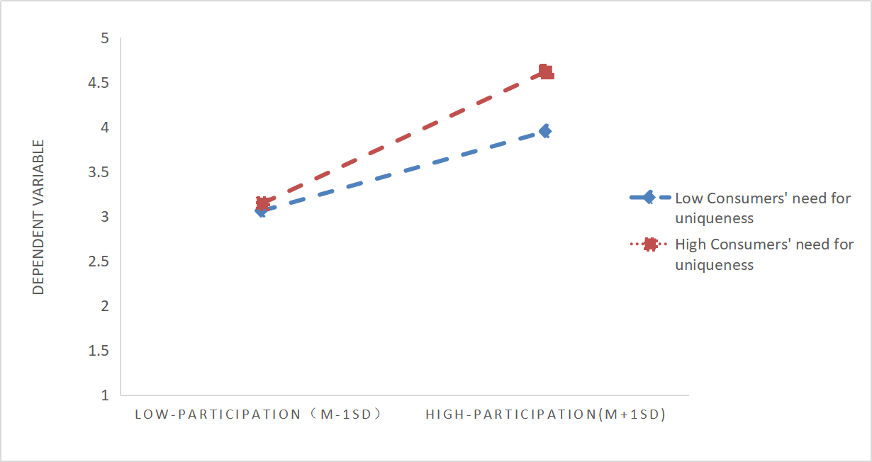
Figure 2. The moderating effect of unique requirements
on customer engagement and functional value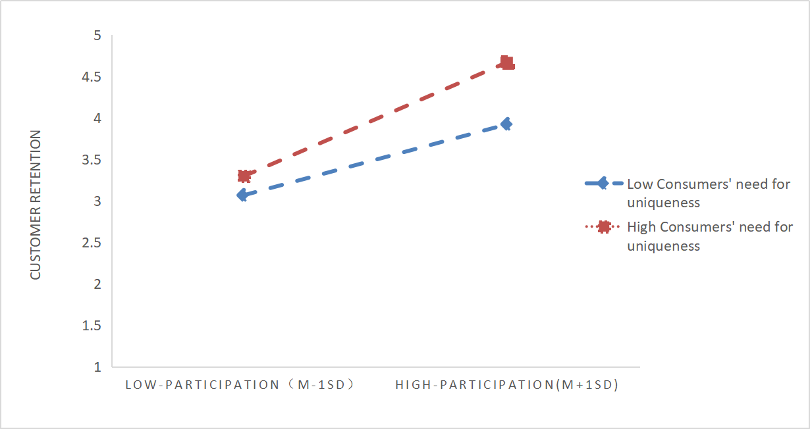
Figure 3. The moderating effect of unique requirements
on customer engagement and hedonic value

4 Conclusion

Based on research by studies both in China and abroad, this study explores the impact of customized courses on customer experience value and retention, using students and consumers who have participated in customized courses as research subjects. The study found that: 1. Customer participation has a significant positive impact on customer retention. 2. Customer participation has a significant positive impact on both hedonic and functional values ​​within customer experience value. 3. Both hedonic and functional values ​​within customer experience value have a significant positive impact on customer retention. 4. Both functional and hedonic values ​​within customer experience value play a mediating role in the relationship between customer participation and customer retention. 5. Customer unique needs have a moderating effect on the relationship between customer participation and hedonic value, and between customer participation and functional value.

4.1 Theoretical significance

This study systematically reveals the intrinsic mechanism by which customer participation influences customer retention in customized course scenarios within the framework of value co-creation theory. First, it introduces value co-creation theory into the context of customized course-based services, moving beyond the limitations of traditional teaching models or technology-oriented perspectives and expanding the boundaries of theoretical application. Second, it distinguishes and examines the mediating roles of functional and hedonic values, revealing the path by which customer participation influences retention intentions through multidimensional experiential value. Furthermore, it introduces course-related unique requirements as a moderating variable, revealing the boundary conditions of customer heterogeneity in value co-creation and addressing theoretical concerns regarding individual differences in participation effects. Overall, this paper constructs a moderated mediation model of "customer participation-experiential value-customer retention," providing a systematic theoretical explanation for understanding the dynamic mechanism of value co-creation in customized course service scenarios.

4.2 Management significance

Based on the perspective of dynamic demand, this study reveals the intrinsic mechanism by which customer participation behavior affects customer retention in customized education services through empirical testing.

Customer engagement has a direct driving force on customer retention, and educational institutions need to strengthen the design of engagement mechanisms. It is recommended to establish a dual learning system, that is, to stimulate customer demand through exploratory learning (such as innovation competitions) and to deepen existing value-driven elements through utilization learning (such as satisfaction tracking and course optimization). Some studies have also pointed out that: embedding knowledge sharing platforms into courses, actively inviting customers to share their real learning experiences or successful practice cases, and integrating these contents into teaching resources, while setting up a tiered reward mechanism, such as participating in points redemption for value-added services, linking economic benefits with knowledge contributions (Hamari et al., 2014). At the same time, the customer engagement process should be effectively controlled regularly to ensure that cooperative behavior truly enhances service value. Authorities and legislators should create affordable immersive activities and intervention programs for locals and potential virtual tourists to choose and fund, according to Abidin et al. (2025).

Secondly, institutions should focus on improving the functional and hedonistic value of customers. In terms of functional value, the practicality of courses needs to be strengthened. After understanding the basic needs of customers, modular knowledge system design can be carried out to customize courses for customers, so as to achieve precise improvement in learning efficiency. In terms of hedonistic value, institutions can design interactive gamified scenarios on the learning platform to increase the learning experience of customers. Some studies have also proposed establishing a virtual learning community achievement system, holding case competitions regularly, and publicizing the winning solutions to improve the hedonistic value of customers (Zainuddin et al., 2020). However, training institutions also need to avoid "emphasizing form over content". Over-design of entertainment projects may affect the learning efficiency of customers. At the same time, institutions also need to regularly track the practical value and experience value of customers in real time and actively respond to customer feedback.

Finally, the unique needs of customers play the role of "demand amplifier" between participation behavior and value creation. In response to the moderating effect of unique customer needs, institutions need to build a dynamic response system, implement hierarchical management of customer needs, equip high-unique groups with dedicated course consultants, and provide customized personalized learning solutions. As some studies have proposed: build a dynamic mapping model of "demand-solution", use real-time data generated during customer participation (such as classroom interaction heatmaps, etc.) to regularly update personalized learning paths, and set corresponding assessment indicators, thereby increasing the renewal willingness of customers with strong unique needs (Taylor et al., 2021). Therefore, institutions need to pay attention to the moderating effect of unique customer needs between customer participation and experience value.

4.3 Research limitations and future prospects

The limitations of this study are as follows: First, the primary research subject was university students; future studies could select different groups to increase sample diversity. Second, this study used unique needs as a moderating variable; future studies could consider other moderating factors, such as channel attractiveness, which might provide a more comprehensive explanation of the relationship between online service scenarios and customer retention intentions.

5 Reference

Abidin, N. H. Z., Fauzi, M. A., Wider, W., Daud, W. M. N. S. M., & Musa, R. (2025). Metaverse in tourism and hospitality industry: science mapping of the current and future trends. Journal of Tourism Futures. https://doi.org/10.1108/jtf-05-2024-0089
Amjad, M. Y., & Azhar, T. M. (2023). Role of Customer Participation in Technology Innovation in Higher Education Institutions (HEIs): A Qualitative Study on Value Co-Creation and Co-Destruction. Journal of Management and Research, 10(1). https://doi.org/10.29145/jmr.101.01
Dewarani, G., & Alversia, Y. (2023). The influence of customer involvement and engagement on co-creation of services, satisfaction, and loyalty: The case of Software as a Service. Innovative Marketing, 19(2), 27–37. https://doi.org/10.21511/im.19(2).2023.03
Dziewanowska, K., & Kacprzak, A. (2023). The Influence of Engagement in Value Co-Creation on E-Learning Experience and Student Satisfaction: An Empirical Study. Marketing of Scientific and Research Organizations, 48(2), 61–80. https://doi.org/10.2478/minib-2023-0010
Hamari, J., Koivisto, J., & Sarsa, H. (2014). Does Gamification Work? -- A Literature Review of Empirical Studies on Gamification. 2014 47th Hawaii International Conference on System Sciences, 3025–3034. https://doi.org/10.1109/HICSS.2014.377
Nguyen, L. T. K., Lin, T. M. Y., & Lam, H. P. (2021). The Role of Co-Creating Value and Its Outcomes in Higher Education Marketing. Sustainability, 13(12), 6724. https://doi.org/10.3390/su13126724
Nwankwo, C. A., & Kanyangale, M. I. (2023). Customer Experience Management: Analysis of Customer Retention in Restaurants in Anambra State, Nigeria. Marketing of Scientific and Research Organizations, 49(3), 1–26. https://doi.org/10.2478/minib-2023-0013
Payne, A. F., Storbacka, K., & Frow, P. (2008). Managing the co-creation of value. Journal of the Academy of Marketing Science, 36(1), 83–96. https://doi.org/10.1007/s11747-007-0070-0
Sadighha, J., Pinto, P., Guerreiro, M., & Campos, A. C. (2024). Stimulating customer participation behaviour and boosting value co-creation in hotels. International Journal of Hospitality Management, 119, 103733. https://doi.org/10.1016/j.ijhm.2024.103733
Singh, A., Ishrat, A., Barthwal, T., Rani, A., & Mishra, M. (2025). Factors of online learning engagement and their impact on value co-creation among students: A structural equation modelling approach. On the Horizon: The International Journal of Learning Futures, 33(2), 199–222. https://doi.org/10.1108/OTH-11-2024-0075
Soleymani, A., De Laat, M., & Specht, M. (2025). Exploring Personal Experience and Value Creation in Postdigital Education: Insights from a Large-Scale MOOC Survey. Postdigital Science and Education. https://doi.org/10.1007/s42438-025-00561-0
Souza, A. A. D., Damacena, C., Araújo, C. F., Carvalho, B. P., & Seibt, N. G. (2023). The influence of customer participation and convenience on customer satisfaction: A multiple mediation. Revista de Administração Da UFSM, 16(2), e5. https://doi.org/10.5902/1983465971688
Taylor, D. L., Yeung, M., & Bashet, A. Z. (2021). Personalized and Adaptive Learning. In J. Ryoo & K. Winkelmann (Eds.), Innovative Learning Environments in STEM Higher Education (pp. 17–34). Springer International Publishing. https://doi.org/10.1007/978-3-030-58948-6_2
Taylor, J., & Armes, G. (2024). Social comparison on Instagram, and its relationship with self-esteem and body-esteem. Discover Psychology, 4(1), 126. https://doi.org/10.1007/s44202-024-00241-3
Vargo, S. L., & Lusch, R. F. (2016). Institutions and axioms: An extension and update of service-dominant logic. Journal of the Academy of Marketing Science, 44(1), 5–23. https://doi.org/10.1007/s11747-015-0456-3
Wayne, K., MacNeill, L., Luke, A., Anthonisen, G., McGavin, C., Wilhelm, L., & Doucet, S. (2024). Enhancing patient-oriented research training: Participant perceptions of an online course. Research Involvement and Engagement, 10(1), 93. https://doi.org/10.1186/s40900-024-00629-4
Xu, H., Chen, Y., & Xu, P. (2024). Driving Mechanism of Customer Participation in Service-Oriented Enterprises: A Perspective of Value Co-Creation. Sustainability, 16(8), 3310. https://doi.org/10.3390/su16083310
Yin, J., Zhao, Y., Ma, Z., Chen, S., & Li, M. (2025). Customer citizenship behavior and customer perceived value in China: The mediating role of value co-creation experience. Humanities and Social Sciences Communications, 12(1), 1987. https://doi.org/10.1057/s41599-025-06223-7
Zainuddin, Z., Chu, S. K. W., Shujahat, M., & Perera, C. J. (2020). The impact of gamification on learning and instruction: A systematic review of empirical evidence. Educational Research Review, 30, 100326. https://doi.org/10.1016/j.edurev.2020.100326
Zhang, S., Che, S., Nan, D., & Kim, J. H. (2023). How does online social interaction promote students’ continuous learning intentions? Frontiers in Psychology, 14, 1098110. https://doi.org/10.3389/fpsyg.2023.1098110
Zhang, X., Singh, S., Li, J., & Shao, X. (2024). Exploring the effects of value co-creation strategies in event services on attendees’ citizenship behaviors: The roles of customer empowerment and psychological ownership. Journal of Retailing and Consumer Services, 76, 103619. https://doi.org/10.1016/j.jretconser.2023.103619

