

Nsukka Journal of the Humanities
Copyright: © 2025 by the authors. Submitted for possible open access publication under the terms and conditions of the Creative Commons Attribution (CC BY) license (https://creativecommons.org/licenses/by/4.0/).
Januari 2026, 33, (3) www.njh.com.ng/

Article
Bibliometric Analysis of Model Predictive Control (MPC) in the Sugar Industry (1997-2025)

Imam Fauzi¹, Fatmawati²*, Nenik Estuningsih³, Dieky Adzkiya⁴
1Department of Mathematics, Faculty of Science and Technology Trace, Indonesia, «Airlangga University», imamfauziku@gmail.com. https://orcid.org/ 0009-0006-1422-5771.
2Department of Mathematics, Faculty of Science and Technology Trace, Indonesia, «Airlangga University». https://orcid.org/0000-0002-0418-6629.
3Department of Mathematics, Faculty of Science and Technology Trace, Indonesia, «Airlangga University». https://orcid.org/ 0000-0002-6414-3014.
4 Department of Mathematics, Faculty of Science and Data Analytics, Indonesia, «Sepuluh November Institue of Technology». https://orcid.org/ 0000-0002-4718-2871.
Correspondence: Fatmawati, https://orcid.org/0000-0002-0418-6629.

Abstract
Model Predictive Control (MPC) is an advanced control strategy increasingly applied to complex industrial processes, including the sugar industry, which is transformed by nonlinear dynamics, operational constraints, and the need for energy efficiency and product quality. Although research related to MPC in the sugar industry has been growing for decades, comprehensive insights into the trends, intellectual structure, and research developments in this field are still limited. This study aims to systematically analyze the research landscape of MPC in the sugar industry using a bibliometric approach. Bibliographic data were collected from the Scopus database. The selection process followed the PRISMA framework and resulted in 111 relevant documents published between 1997 and 2025. Bibliometric analysis was performed using the Bibliometrix (R) and VOSviewer packages to capture annual publication trends, contributions from countries, institutions, journals, and most influential authors, as well as to capture collaboration networks, co-citations, and keyword co-occurrence. The results show that publications on MPC in the sugar industry experienced a gradual growth with a more significant increase after 2010, as the focus on energy efficiency and process optimization increased. India, Brazil, and Spain are the most productive countries, while journals such as the Journal of Food Engineering, Energy, and the Journal of Process Control are the primary sources of influential publications. Keyword analysis reveals that evaporation, crystallization, and energy control are core themes, with recent trends toward economic MPC and the integration of artificial intelligence methods. This study provides a comprehensive understanding of the evolution and future directions of MPC research in the sugar industry.
Keywords: predictive control model, sugar industry, bibliometric analysis.

Introduction
The sugar industry is one of the oldest and most complex agro-industrial sectors, playing a vital role in meeting food needs, providing biomass-based energy, and contributing to the national economy in many developing and developed countries (Solomon, 2016) . The sugar production process involves various integrated unit operations, such as palm sap extraction, heating, clarification, evaporation, and crystallization, each of which has nonlinear, multivariable process dynamics and is susceptible to disturbances (Cavalcante & De Albuquerque, 2015) . This complexity makes process control in the sugar industry a significant technical challenge.

One of the main characteristics of the sugar industry process is the presence of long dead times, strong variable interactions, and physical limitations (constraints) on actuators and process variables. Variations in the quality of sugarcane or beet raw materials, fluctuations in production loads, and demands for energy efficiency further complicate the required control strategies (Sunori et al., 2022) . In this context, Model Predictive Control (MPC) emerges as an advanced control strategy that is conceptually and practically well-suited for complex industrial systems. MPC works by utilizing process models to predict future system behavior and determine optimal control actions through iteratively solving optimization problems (Sujatha et al., 2022) . The main advantage of MPC is its ability to handle multivariable systems and operational constraints explicitly. (Afram & Janabi-Sharifi, 2014) .
Since its widespread introduction in the process industry in the early 1980s, MPC has undergone rapid development and widespread adoption in the chemical, petrochemical, energy, and food sectors (Darby & Nikolaou, 2012) . The sugar industry was one of the sectors relatively early to explore the application of predictive control, particularly in evaporator and crystallizer units, which are critical to the quality of the final product (Dahiya et al., 2019) . Early research related to MPC in the sugar industry focused largely on dynamic modeling of evaporators and crystallizers, as well as the application of generalized predictive control (GPC) to improve process stability and quality (Bordons & Camacho, 1999; Zamarreño & Vega, 1999) . These studies demonstrated that predictive approaches are able to overcome the limitations of conventional control, especially in the face of significant nonlinearity and process disturbances.
With advances in computing and control theory, MPC research in the sugar industry has evolved toward more sophisticated approaches, such as nonlinear MPC, neural predictive control, and state-space MPC (Paz Suárez et al., 2011; Zamarreño et al., 2000; Zamarreño & Vega, 1999) . These approaches represent more realistic process dynamics and are adaptive to changing operating conditions in the field. Beyond focusing on individual process units, recent research trends also show increasing attention to plant-wide control and hierarchical MPC in the sugar industry. These approaches aim to optimize the entire production system, including the integration of sugar processing, energy cogeneration, and bioethanol (Mazaeda et al., 2015, 2020; Menezes Morato et al., 2017) . This aligns with industry demands for energy efficiency and sustainability. On the other hand, the increasing global focus on decarbonization and renewable energy utilization has encouraged the integration of MPC into energy systems based on sugarcane biomass and sugar industry by-products (Pina et al., 2017) . MPC is used not only for process stability but also as a tool for energy optimization and emission reduction.
Although the literature on MPC in the sugar industry has been growing for over two decades, these studies are scattered across different journals, disciplines, and application contexts. This situation makes it difficult for both new researchers and industry practitioners to comprehensively understand the knowledge structure, key actors, and the evolution of research topics in this field (Mukherjee et al., 2022) . Most previous studies are technical and case study-based, focusing on the development of specific models or algorithms. However, very few studies attempt to systematically map the MPC literature in the sugar industry from a macro perspective, such as publication growth, collaboration networks, research, and scientific impact based on citations.

Bibliometric approaches have proven effective for analyzing the intellectual structure of a research field, identifying research trends, and mapping relationships between authors, institutions, journals, and research topics (Chusniyah et al., 2024; Irwanto, 2025) . In the context of process control and MPC, bibliometric analysis has been used in the energy, chemical, and manufacturing fields (Kozak, 2016; Lee, 2011) , but its specific application to the sugar industry remains very limited. The absence of bibliometric mapping focused on MPC in the sugar industry creates a significant research gap. Without this mapping, it is difficult to identify dominant research themes, emerging topics, or under-explored research areas with potential for further development. Based on these conditions, the novelty of this study lies in the presentation of a comprehensive bibliometric analysis focused specifically on model predictive control research in the sugar industry. This study integrates analysis of scientific productivity, citation impact, country and institutional collaboration networks, document and author co-citation, as well as keyword analysis and thematic maps.
Thus, the main objective of this study is to answer four research questions, namely:
RQ1. How has the distribution of publications on predictive control models in the sugar industry evolved over the years?
RQ2. Which countries, institutions, and journals contribute the most to research on predictive control models in the sugar industry?
RQ3. Which publications receive the highest number of citations and who are the most influential authors in the field?
RQ4. What are the most frequently explored topics, as indicated by author keywords in these publications?
The urgency of this research is increasing as the sugar industry transforms toward smart manufacturing, Industry 4.0, and digital process control. By providing a knowledge map based on bibliometric data, this research is expected to serve as a strategic reference for researchers, academics, and industry practitioners in directing further research and supporting the adoption of more effective and sustainable MPC in the sugar industry.

Methodology
This study uses a bibliometric approach to analyze research developments on Model Predictive Control (MPC) in the sugar industry. The bibliometric method was chosen because it can quantitatively and systematically map publication trends, contributions of key actors, and the structure and evolution of research themes. This approach is widely used to study developments in the multidisciplinary fields of industrial process engineering and control (Chusniyah et al., 2024; Mukherjee et al., 2022) . Data were collected from the Scopus database, which was selected for its extensive coverage of reputable journals and conference proceedings in the fields of engineering, energy, and the process industry. The data search was conducted on December 15, 2025, and the entire process was carried out on the same day to avoid differences in data volume due to database updates.
The search strategy uses the following keyword combination in the TITLE-ABS-KEY column:
( TITLE-ABS-KEY ( model predictive control ) OR TITLE-ABS-KEY ( MPC ) OR TITLE-ABS-KEY ( predictive control ) OR TITLE-ABS-KEY ( advanced process control ) AND TITLE-ABS-KEY ( sugar industry ) OR TITLE-ABS-KEY ( sugar factory ) OR TITLE-ABS-KEY ( sugar mill ) OR TITLE-ABS-KEY ( sugar production ) OR TITLE-ABS-KEY ( sugarcane processing ) OR TITLE-ABS-KEY ( cane sugar ) )
The initial search yielded 325 documents. After filtering based on English language and document type (journal articles and conference proceedings), the number of documents was reduced to 249. The article selection process was conducted using the PRISMA (Preferred Reporting Items for Systematic Reviews and Meta-Analyses) framework to ensure transparency and consistency of selection. Further selection stages were conducted through reviewing titles, abstracts, and keywords. Articles were considered inclusive if: (1) They discussed Model Predictive Control (MPC) or its derivatives, such as predictive control, generalized predictive control (GPC), receding horizon control, nonlinear MPC, or economic MPC; (2) They were directly related to sugar industry processes, such as sugar mills, sugar refineries, cane sugar, or beet sugar. Articles were excluded if they did not involve a predictive control approach or were not relevant to the sugar industry. After the final selection process, 111 articles were obtained, which were used as the main dataset.
A total of 111 selected articles were downloaded in CSV format and analyzed using Bibliometrix (R-package) and VOSviewer. Bibliometric analysis was conducted through two main approaches: (1) Performance analysis, including annual publication trends, the most productive journals, the most contributing authors, institutions, and countries, as well as documents with the highest citations; (2) Science mapping, which includes analysis of co-authorship, co-citation, keyword co-occurrence, and thematic mapping to identify the intellectual structure and development of MPC research topics in the sugar industry. This approach allows for a comprehensive mapping of research dynamics, scientific collaborations, and the direction of MPC research development in the context of the sugar industry.

Articles from the Scopus database (n = 325)
Screened articles (n = 249)
Exclusion of non-journal and non-conference papers (n=38)
Exclusion of non-English articles (n=24)
Articles deemed worthy
(n = 111)
Excluded documents:
Not related to MPC and the sugar industry (n=138)
Articles included in the bibliometric synthesis (n = 111)
Identification
Eligibility

Included
Screening

Figure 1. PRISMA Flowchart

Results and Discussion
Based on Table 1, the bibliometric analysis of Model Predictive Control (MPC) research in the sugar industry includes 111 documents published between 1997 and 2025 and derived from 74 publication sources. The annual publication growth rate of 2.51% indicates that this topic is developing moderately but consistently, although not experiencing a significant surge as in other process industry sectors. The average document age of 11.3 years indicates that most of the literature is in the scientific maturity phase, while the average citation value of 15.84 per document reflects that publications in this field have a fairly good level of relevance and academic influence in the process control and chemical engineering research community.
In terms of authorship and collaboration, 344 authors contributed to this literature corpus with a total of 385 author keywords, demonstrating a diversity of methodological approaches and application focuses. An average of 3.77 authors per document indicates that MPC research in the sugar industry is generally conducted collaboratively, although the level of international collaboration is still relatively low (15.32%). Only 8 publications were authored by a single author, confirming that the complexity of MPC topics and process systems in the sugar industry tends to encourage team-based research. These findings suggest that although the MPC research community in the sugar industry has been established, there is still significant opportunity to expand cross-national and cross-disciplinary collaboration to accelerate the development and adoption of MPC in this sector.

Table 1. Overview of Key Information
Documents and citations | Results | Authors and collaboration | Results
Timespan | 1997-2025 | Authors | 344
Sources | 74 | Author’s keywords | 385
Documents | 111 | Authors of single-authored documents | 8
Annual growth rate % | 2.51% | Co-authors per document | 3.77
Document average age | 11.3 | International co-authorsips % | 15.32
Average citations per document | 15.84
Annual Scientific Production
Based on Figure 2, scientific publications related to Model Predictive Control (MPC) in the sugar industry began to appear consistently since the late 1990s, with a gradual increase until the period 2010–2020. This initial phase coincided with the start of the application of MPC and Generalized Predictive Control (GPC) in nonlinear and multivariable processes in the process industry, including evaporators, crystallizers, and melters in sugar factories. This pattern is in line with the development of MPC in general, which began to shift from theoretical research to real industrial applications in the 1990s, particularly in the chemical and food sectors (Cadet, Touré, et al., 1999; Qin & Badgwell, 2003) .
Furthermore, the graph shows that although the number of publications per year is relatively low, the growth trend is stable and has not experienced long-term stagnation. This indicates that MPC in the sugar industry is a specific and applicable topic, not a massive research field, but remains relevant due to the complex, nonlinear nature of the sugar process and its numerous operational constraints. The need for product quality control, energy efficiency, and process stability makes MPC a viable solution in critical units such as multiple-effect evaporators and crystallization pans (Dahiya et al., 2019; Kadyan & Kumar, 2017).
Based on Figure 3, the average number of citations per year indicates a peak in citations during certain periods, although the number of publications is not consistently high. This phenomenon indicates that several key articles have had a strong academic influence, particularly early works discussing nonlinear MPC (Cadet, Toure, et al., 1999; Zheng, 1997) , neural MPC (Zamarreño & Vega, 1999) , and the application of physical model-based MPC to the sugar industry (El-Belghiti et al., 2005) . These seminal articles are frequently cited because they provide a solid methodological foundation and real-world industrial case studies, thus remaining relevant even though they were published more than a decade earlier.
Interestingly, in the period after 2020, the average annual citations tended to decline or fluctuate, although publications continued to emerge. This can be interpreted as a shift in research focus to other approaches such as machine learning (Alves et al., 2024) , soft sensing (Sujatha et al., 2022) , and hybrid control (Menezes Morato et al., 2017) , which are often not explicitly labeled MPC despite still adopting prediction and optimization principles.
Overall, the combination of a stable trend in scientific production (Figure 2) and a relatively high average citation rate over a given period (Figure 3) indicates that MPC research in the sugar industry is characterized by greater scientific depth than publication quantity. This field is supported by a number of influential studies that serve as references across time, such as studies from Eggleston & Monge (2005), El‐Belghiti et al. (2005), Higa et al. (2009), Kaya & Ibrahim Sarac (2007), Quintas et al. (2006), serta Zamarreño & Vega (1999) , indicating that MPC is still seen as a credible and effective approach to sugar process control.
Figure 2. Number of articles published annually on MPC in the sugar industry

Figure 3. Average annual citations of MPC in the sugar industry
The countries that contribute the most
Based on Table 2, India emerged as the country with the highest number of publications (NP) in Model Predictive Control (MPC) research in the sugar industry, namely 84 documents since its first publication in 2003. This dominance of India can be attributed to the size of the national sugar industry and the high demand for process optimization, especially in units such as evaporators, crystallizers, and juice heaters. However, despite its high productivity, India's total citations (TC) and average article citations (AAC) are relatively lower than those of several European and Latin American countries, indicating that some publications are applicative and oriented towards local implementation (Sujatha et al., 2022; Sunori et al., 2016) .
In contrast, Brazil and France show higher scientific impact, reflected by their high AAC scores (27.0 and 27.3, respectively), despite having fewer publications than India. Brazil, as one of the world's largest sugar and bioethanol producers, has produced many studies linking MPC to energy efficiency and process system integration. (Alves et al., 2024; Gomes et al., 2019) , so that their works receive wider citations.
Spain and France have a prominent position as early pioneers of MPC research in the sugar industry, with the first publications being published in 1997 and 1999, respectively. These countries played a major role in the development of nonlinear MPC, generalized predictive control (GPC), and neural predictive control for sugar processes, particularly in evaporators and crystallization pans. Many seminal works originating from these Western European research groups remain the main references, thus explaining their high citation counts and AAC scores (Benne et al., 2000; Cadet, Touré, et al., 1999; Cadet, Touré, et al., 1999; Zamarreño & Vega, 1999) .
Contributions from Asian countries such as China, Thailand, and Malaysia are relatively recent, with the first publications occurring after 2010. Although the number of publications and citations is still limited, this trend reflects the increasing adoption of MPC and advanced process control along with the modernization of sugar factories and the push towards Industry 4.0. Malaysia's relatively high AAC score (21.5) indicates that despite its small contribution, the publications produced are of high relevance and citation quality, especially in the hybrid approach between MPC and data-driven techniques (Areeya et al., 2020; Meng et al., 2021) .
Table 2. Top 10 most productive countries
Rank | Negara | NP | TC | AAC | FP
1 | India | 84 | 148 | 9.9 | 2003
2 | Brazil | 59 | 324 | 27.0 | 2004
3 | Spain | 48 | 189 | 17.2 | 1997
4 | France | 35 | 191 | 27.3 | 1999
5 | China | 29 | 86 | 17.2 | 2013
6 | Argentina | 15 | 24 | 8.0 | 2007
7 | Hungary | 15 | 33 | 11.0 | 2006
8 | Mexico | 14 | 15 | 7.5 | 2008
9 | Thailand | 12 | 4 | 2.0 | 2014
10 | Malaysia | 11 | 43 | 21.5 | 2019
NP=total number of publications, TC=total citations, AAC=average number of citations per article, FP=year of first publication
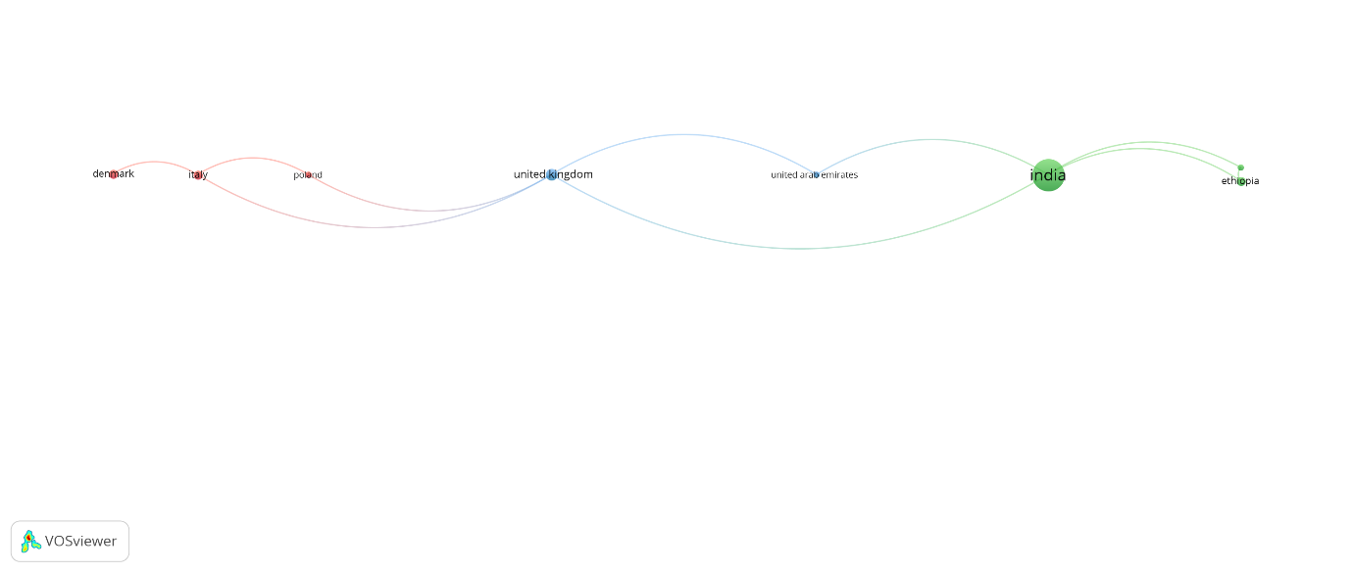
Figure 4. Co-authorship networks of countries
Based on Figure 4, the inter-country co-authorship network in Model Predictive Control (MPC) research on the sugar industry exhibits a sparse and poorly clustered structure. Only a few countries are interconnected, indicating that most publications are still conducted within the national scope. India emerges as the most dominant node, but its international connections are relatively limited, reflecting its high domestic productivity rather than global collaboration.
In Europe, separate collaboration pathways are observed between Denmark, Italy, Poland, and the United Kingdom, forming a linear, low-intensity network. This pattern indicates that MPC research collaboration in the sugar industry tends to take place within specific regional or project-based research groups, rather than within broad international networks. This is consistent with the nature of MPC research, which is often developed based on case studies of specific sugar mills and local process conditions (Qin & Badgwell, 2003; Sujatha et al., 2022) .
Overall, this visualization confirms that the level of international collaboration remains low, consistent with the 15.32% international co-authorship percentage. This finding suggests significant opportunities to expand cross-national collaboration, particularly between high-productivity and high-citation impact countries, to improve the quality, visibility, and generalizability of MPC research in the sugar industry.
The most contributing institutions
Based on Table 3, the University of Valladolid (Spain) is the most productive institution in Model Predictive Control (MPC) research in the sugar industry, with a total of 12 publications and continuous contributions since 1997. This consistency is also clearly visible in Figure 5, which shows a gradual increasing trend over time. The dominance of the University of Valladolid reflects the strength of the process control research group in Spain, especially in the development of nonlinear MPC and its application to energy- and food-based industrial processes, including the sugar industry (Mazaeda et al., 2020; Zamarreño et al., 2000; Zamarreño & Vega, 1999) .
Indian institutions, particularly Graphic Era Hill University, ranked second with 7 publications, despite only starting to contribute since 2016. The curve in Figure 5 shows relatively rapid growth in a short period, indicating an increase in interest and capacity in MPC research in India over the last decade. This phenomenon is in line with the development of advanced control and process optimization research in developing countries with large-scale sugar industries and high operational complexity (Saravanan & Valarmathi, 2012; Sunori et al., 2016) .
From other European regions, Université de La Réunion (France) is ranked third with 6 publications since 1999. The contribution of this institution appears to be stable but not very aggressive in annual growth. This is likely related to the research focus on MPC applications in tropical sugar cane mills and multi-effect evaporation systems, which are often used as industrial case studies based on specific geographical locations (Benne et al., 2000; Cadet, Touré, et al., 1999) .
Brazil has the largest number of institutions in the top 10, namely the Universidade Estadual de Campinas, Universidade Federal de Santa Catarina, Universidade Estadual de Maringá, and Universidade Federal do Rio de Janeiro. Although each institution has a moderate number of publications (2–5 papers), collectively Brazil demonstrates a strong research ecosystem. This is closely related to Brazil's position as one of the world's largest sugar and bioethanol producers, thus encouraging MPC research for energy efficiency, evaporation, and crystallization (Jorge et al., 2010; Menezes Morato et al., 2017; Pacheco & Frioni, 2004; William Herrera et al., 2016) .
Spanish institutions other than the University of Valladolid, namely the Universidad de Salamanca and the Universidad de Sevilla, also showed consistent contributions from the late 1990s to the mid-2010s. This pattern confirms that Spain was one of the early centers for the development and application of MPC in the sugar industry, particularly through model-based predictive control (MPC), generalized predictive control (GPC), and neural predictive control approaches (Mazaeda et al., 2020; Menezes Morato et al., 2017; Zamarreño & Vega, 1999).
Overall, Figure 5 shows that institutional contributions are incremental and long-term, rather than short-term. This reflects the nature of MPC research, which requires in-depth modeling, industrial validation, and collaboration with real-world factories. The distribution of institutions across Europe, Asia, and South America demonstrates that MPC research in the sugar industry is growing globally, but remains concentrated in select research groups with strong access to industrial facilities and process data.
Table 3. Top 10 most productive institutions
Rank | Institution | Location | NP | FP
1 | University of Valladolid | Spanyol | 12 | 1997
2 | Graphic Era Hill University | India | 7 | 2016
3 | Universite de la Reunion | Perancis | 6 | 1999
4 | Universidade Estadual de Campinas | Brazil | 5 | 2009
5 | Universidad Federal de Santa Catarina | Brazil | 4 | 2005
6 | Universidad de Salamanca | Spanyol | 4 | 1997
7 | Universidad de Sevilla | Spanyol | 4 | 2015
8 | Universidade Estadual de Maringa | Brazil | 3 | 2009
9 | Saveetha School of Engineering | India | 3 | 2022
10 | Universidade Federal do Rio de Janeiro | Brazil | 2 | 2017
NP=total number of publications, FP=year of first publication

Figure 5. Affiliate production from year to year
The most influential journals
Based on Table 4, the Journal of Food Engineering holds the top position as the most influential journal in Model Predictive Control (MPC) research in the sugar industry, with the highest total citations (TC = 241) despite containing only 8 publications. This indicates that MPC articles published in this journal have a significant scientific impact and are often used as primary references. This journal's dominance can be explained by its focus on modeling, process control, and the application of advanced control techniques in the food industry, including sugar evaporation and crystallization (Jorge et al., 2010; Khaire & Gogate, 2018; Quintas et al., 2006) .
The journals Energy and Applied Thermal Engineering, both ranked in the Q1 quartile, also showed significant influence despite their relatively limited number of publications. The presence of these two journals confirms that MPC research in the sugar industry is not only positioned as a process control issue, but is also closely related to energy efficiency and thermal system optimization, particularly in multi-effect evaporator units and process heating systems (Kaya & Ibrahim Sarac, 2007; Mkwananzi et al., 2019; Pina et al., 2017) . This aligns with the energy-intensive nature of the sugar industry and the need for a model-based optimization approach.
From a systems control perspective, the Journal of Process Control and Control Engineering Practice emerged as core journals with a Q1 quartile and stable citation counts. These journals played a key role in publishing methodological developments in MPC, such as generalized predictive control (GPC), nonlinear MPC, and neural predictive control, which were then applied to sugar and related bioindustrial processes (Mazaeda et al., 2020; Menezes Morato et al., 2017; Vergara-Dietrich et al., 2019; Zamarreño & Vega, 1999) . The existence of these pure control journals demonstrates a strong theoretical foundation in the field of MPC in the sugar industry.

Table 4. Top 10 most influential journals
Rank | Sources | TC | NP | Q | Publisher
1 | Journal of Food Engineering | 241 | 8 | Q1 | Elsevier
2 | Energy | 202 | 4 | Q1 | Elsevier
3 | Process Biochemistry | 112 | 2 | Q2 | Elsevier
4 | Journal of Process Control | 90 | 4 | Q1 | Elsevier
5 | Applied Thermal Engineering | 84 | 2 | Q1 | Elsevier
6 | Biofuels, Bioproducts and Biorefining | 76 | 1 | Q2 | John Wiley and Sons
7 | Engineering Applications of Artificial Intelligence | 74 | 1 | Q1 | Elsevier
8 | Journal of the Science of Food and Agriculture | 66 | 1 | Q1 | John Wiley and Sons
9 | Control Engineering Practice | 64 | 2 | Q1 | Elsevier
10 | International Sugar Journal | 61 | 11 | - | Agra Europe
TC=total citations, NP=total number of publications, Q=Quartile
Figure 6 shows the interconnected co-citation network between control journals (e.g., Automatica, Journal of Process Control) and process and energy engineering journals (Journal of Food Engineering, Energy, Applied Thermal Engineering). This pattern indicates that MPC research in the sugar industry is interdisciplinary, integrating control theory, chemical engineering, and energy management. Interestingly, the International Sugar Journal has the highest number of publications (NP = 11) but relatively lower total citations compared to other Q1 journals. This reflects the journal's role as an applied and industry-specific medium, oriented more toward practice and field case studies than broad theoretical contributions. Nevertheless, this journal remains important as a link between academic MPC research and actual implementation in sugar mills (Lavarack, 2007; Rozsa et al., 2016) .
Overall, the journal distribution in Table 4 and the network structure in Figure 6 confirm that MPC research in the sugar industry has two main axes: (1) the development of predictive control and modeling methods published in highly reputable control journals, and (2) applications to energy systems and food processes that appear frequently in process and energy engineering journals. This combination reflects the maturity of the MPC field in the sugar industry as a theoretically well-established and industrially relevant research domain.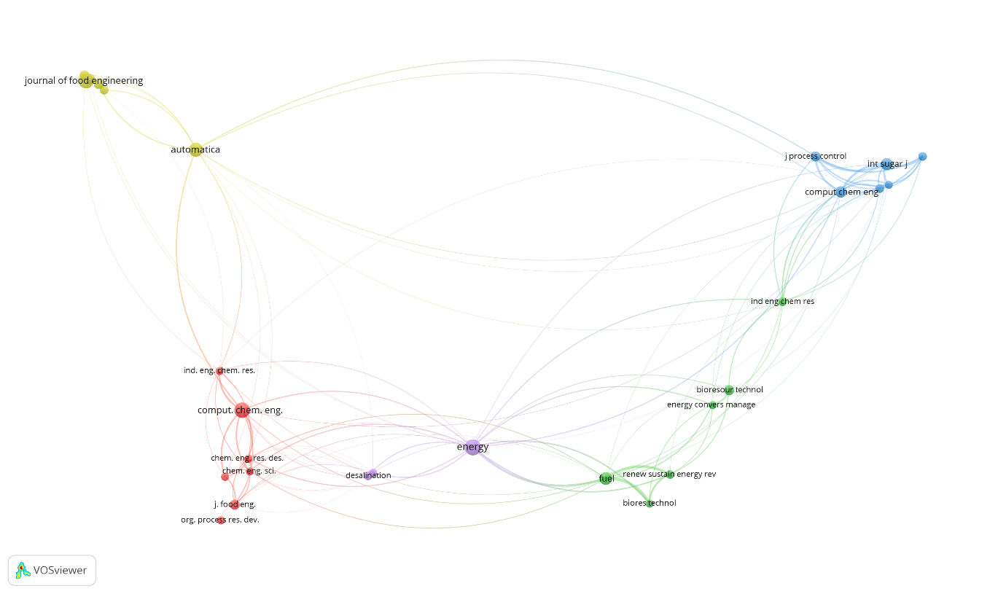
Figure 6. Co-citation networks of journals
Most cited documents
The citation analysis results in Table 5 indicate that the most influential document in the MPC research landscape in the sugar industry is the work of Eggleston and Monge (2005) published in Process Biochemistry. With the highest total citations (TC = 86), this article emphasizes the importance of understanding the kinetics and control of sugar-based biochemical processes as a foundation for the development of advanced control strategies, including MPC. The high number of citations indicates that aspects of sugar-based bioprocesses and fermentation have become cross-disciplinary references in process control and optimization (Eggleston & Monge, 2005).
The paper with the highest annual citation rate (TCY) is Mandegari et al.'s (2017) work in Biofuels, Bioproducts, and Biorefining. This indicates a shift in research focus from conventional sugar process control to bioenergy and biorefinery, where MPC plays a crucial role in managing process complexity, feedstock variability, and energy efficiency. These findings strengthen the link between the sugar industry and the development of sustainable sugarcane-based energy systems (Mandegari et al., 2017).
A fundamental contribution to the development of MPC is directly reflected in Zamarreño and Vega's (1999) article in Engineering Applications of Artificial Intelligence. This article was one of the early milestones in the application of neural predictive control to sugar industry processes and remains a primary reference, as reflected by its high citation count (TC = 74). This work serves as a bridge between nonlinear MPC theory and its actual implementation in sugar processing units, such as melters and evaporators (Zamarreño & Vega, 1999).
In addition to the control aspect, a number of highly cited documents come from the Energy and Applied Thermal Engineering journals, such as the work of Kaya and Ibrahim Sarac (2007) and Higa et al. (2009). The dominance of these articles confirms that the issues of energy efficiency, thermal integration, and optimization of multi-effect evaporators are central topics in the sugar industry. Although not always explicitly mentioning MPC, these studies often form the basis of models and objective functions in designing MPC in the sugar industry energy system (Kaya & Ibrahim Sarac, 2007; Higa et al., 2009).
More recent articles, such as Vergara-Dietrich et al. (2019) in the Journal of Process Control, demonstrate the evolution of research toward advanced MPC, including plant-wide control and hierarchical approaches. The high TCY in this article reflects the growing interest in integrated MPC across process units, in line with the complexity of modern sugar mills involving simultaneous continuous and batch processes (Vergara-Dietrich et al., 2019).
Table 5. Top 10 most cited documents
Rank | DOI | Author | Journal | TC | TCY
1 | 10.1016/j.procbio.2004.06.025 | Eggleston & Monge (2005) | Process Biochemistry | 86 | 4,10
2 | 10.1002/bbb.1801 | Mandegari et al. (2017) | Biofuels, Bioproducts and Biorefining | 76 | 8,44
3 | 10.1016/S0952-1976(98)00055-4 | Zamarreño & Vega (1999) | Engineering Applications of Artificial Intelligence | 74 | 2,74
4 | 10.1016/j.jfoodeng.2005.08.011 | Quintas et al. (2006) | Journal of Food Engineering | 74 | 3,70
5 | 10.1016/j.energy.2006.09.002 | Kaya & Ibrahim Sarac (2007) | Energy | 74 | 3,89
6 | 10.1016/j.energy.2015.06.054 | Pina et al. (2017) | Energy | 70 | 7,78
7 | 10.1002/jsfa.1944 | El‐Belghiti et al. (2005) | Journal of the Science of Food and Agriculture | 66 | 3,14
8 | 10.1016/j.applthermaleng.2008.03.009 | Higa et al. (2009) | Applied Thermal Engineering | 61 | 3,59
9 | 10.1016/j.jprocont.2017.11.003 | Vergara-Dietrich et al. (2019) | Journal of Process Control | 55 | 7,86
10 | 10.1186/s13068-016-0566-2 | Xue et al. (2016) | Biotechnology for Biofuels | 46 | 4,60
TC=total citations, TCY=total citations per year

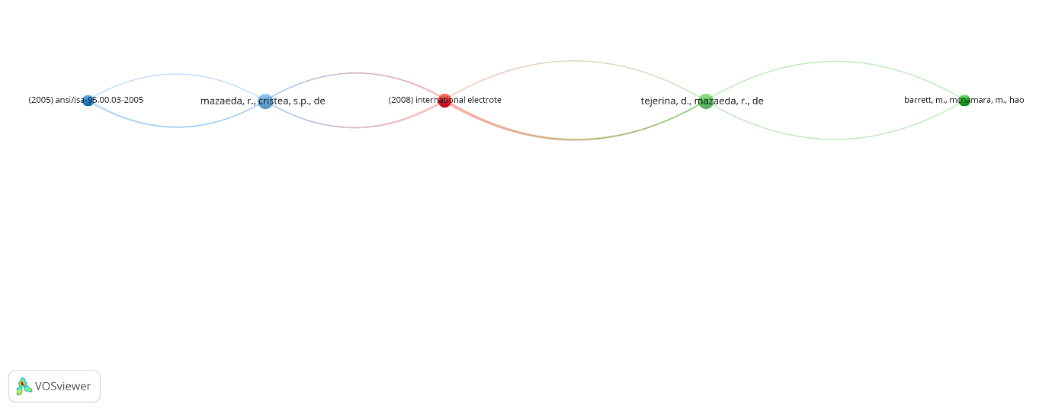
Figure 7. Co-citation networks of references
Figure 7 shows that the resulting network is relatively simple and elongated, with a limited number of nodes and sequential connections. This pattern indicates that research on MPC and optimization related to the sugar industry relies heavily on a small number of key references that are frequently cited together. References at the beginning of the network serve as foundational references, followed by subsequent works that develop or apply the concept.
The sparse interconnectedness of references indicates that this field remains quite focused and specific, with a clear path of scientific development. Each group of references tends to represent a specific stage of development, from early approaches to more sophisticated applications. Overall, this co-citation network confirms that research development in this field is incremental, with key references acting as bridges between research periods.
The most influential writer
Table 6. Top 10 most influential authors based on total citations
Rank | Author | TC | NP | Institution | FP
1 | Vega P | 127 | 3 | Universidad de Salamanca | 1997
2 | Zamarreño JM | 127 | 3 | Universidad de Valladolid | 1997
3 | Normey-Rico JE | 97 | 4 | Federal University of Santa Catarina | 2005
4 | Bordons C | 96 | 4 | Universidad de Sevilla | 2015
5 | Morato MM | 96 | 3 | Universidad de Sevilla | 2017
6 | Benne M | 94 | 4 | Université de La Réunion | 2000
7 | Chabriat J-P | 94 | 4 | Université de La Réunion | 2000
8 | Görgens JF | 92 | 2 | University of Stellenbosch | 2017
9 | Eggleston G | 86 | 1 | LSU Agricultural Center | 2005
10 | Monge A | 86 | 1 | Cora Texas Manufacturing Co | 2005
TC= Total Citations, NP=total number of publications, FP=year of first publication

Table 7. Top 10 most influential authors based on total publications
Rank | Author | NP | TC | Institution | FP
1 | De Prada C | 9 | 57 | Universidad de Valladolid | 1998
2 | Mazaeda R | 8 | 54 | Universidad de Valladolid | 2006
3 | Sunori SK | 7 | 30 | Graphic Era Hill University | 2016
4 | Benne M | 4 | 94 | Université de La Réunion | 2000
5 | Chabriat J-P | 4 | 94 | Université de La Réunion | 2000
6 | Bordons C | 4 | 96 | Universidad de Sevilla | 2015
7 | Normey-Rico Je | 4 | 97 | Federal University of Santa Catarina | 2005
8 | Juneja P | 4 | 7 | Graphic Era Hill University | 2016
9 | Cristea SP | 3 | 24 | Universidad de Valladolid | 2006
10 | Filho RM | 3 | 49 | University of Campinas | 2015
TC= Total Citations, NP=total number of publications, FP=year of first publication
Based on the total citations (TC) in Table 6, P. Vega and J.M. Zamarreño occupy the top positions as the most influential authors, each with 127 citations despite having only three publications. This indicates that their contributions are fundamental and have a long-term impact, especially through the development and application of neural predictive control and nonlinear MPC in sugar industry processes. Their initial work in the late 1990s became an important milestone in the application of artificial intelligence-based MPC in process units such as evaporators and melters in sugar mills (Zamarreño et al., 2000; Zamarreño & Vega, 1997, 1999) .
The next influential group of authors is Normey-Rico, Bordons, and Morato, who are widely recognized in the fields of advanced process control and economic MPC. Their contributions marked a shift from regulation-based MPC to hierarchical and plant-wide MPC, particularly in the context of energy optimization and process integration in sugarcane-based industries. Normey-Rico and Bordons' work has been widely cited in the development of multivariate MPC and constrained control, both in the sugar industry and in the related energy sector (Bordons & Camacho, 1999; Menezes Morato et al., 2017; Vergara-Dietrich et al., 2019).
Authors from the Université de La Réunion, namely M. Benne and J.-P. Chabriat, also showed a very high influence with a TC of 94. Their collaboration focused on nonlinear modeling and neural network-based MPC for multi-effect evaporation systems in the sugar cane industry. Their research emphasized the importance of accurate predictive models to deal with nonlinearities and large disturbances in the evaporation process, making their work a main reference in MPC of thermal processes in the sugar industry (Benne et al., 2000; Cadet, Touré, et al., 1999; Grondin-Perez et al., 2005) .
From the perspective of the number of publications (NP) in Table 7, C. de Prada and R. Mazaeda emerge as the most prolific authors. Although their total citations are not as high as those of Vega or Zamarreño, their consistent publications reflect their continued contributions to the development of plant-wide control, hierarchical MPC, and crystallization process optimization. Their role is crucial in expanding the application of MPC from the unit operation level to the entire plant system level, including in the sugar crystallization process (De Prada et al., 2008; Mazaeda et al., 2015, 2020; Sarabia et al., 2007) .
The presence of authors from South Asia, such as S.K. Sunori and P. Juneja from India, demonstrates the geographic diffusion of MPC research in the sugar industry over the past decade. Despite their relatively lower citation count, these contributions signal a growing focus on the application of MPC and predictive control in sugar mills in developing countries, which typically face challenges in energy efficiency, product quality, and control system modernization (Sunori et al., 2016, 2021, 2022) .
Based on Figure 8, the co-citation network of authors in MPC research in the sugar industry forms several main, interconnected clusters, indicating a strong and multi-layered scientific foundation. The red cluster appears to be the core of the network and is dominated by authors such as Bordons, C., Morato, MM, De Prada, C., and Cristea, SP, who are widely known for their work on MPC, economic MPC, and hierarchical control. The central position of this cluster indicates that their works are frequently referenced across topics, particularly on integrated control and process optimization in the sugar and energy industries (Bordons & Camacho, 1999; De Prada et al., 2008; Menezes Morato et al., 2017; Vergara-Dietrich et al., 2019) .
The green cluster represents strong contributions to advanced nonlinear and model-based MPC, with authors such as Georgieva, P., De Azevedo, S.F., and Grondin-Perez, B. This cluster is largely concerned with MPC applications in batch and semi-continuous processes, including crystallization and evaporation, which are key unit operations in the sugar industry. The close relationship between the green and red clusters suggests that nonlinear approaches and economic optimization are evolving as a natural extension of classical MPC (Benne et al., 2000; Grondin-Perez et al., 2005; Paz Suárez et al., 2011) .
Meanwhile, the smaller blue cluster shows authors such as Görgens, JF and Nebra, SA, who have contributed significantly to the integration of MPC with sugarcane-based energy and bioenergy systems, such as cogeneration and biomass utilization. The relationship of this cluster with the main cluster shows that MPC research in the sugar industry is not only focused on process quality, but is also increasingly directed towards energy efficiency and sustainability of production systems ( Mandegari et al., 2017; Pina et al., 2017) .
The yellow and turquoise clusters located at the edge of the network reflect more specific or relatively recent contributions, including authors such as Sunori, SK, who has extensively studied the application of MPC and predictive control to sugar mills in developing countries. While not as strongly connected as the core cluster, their presence demonstrates the geographic and thematic expansion of MPC research from European centers to Asia and Latin America in the last decade (Sunori et al., 2016, 2021, 2022) .
Overall, the network structure in Figure 8 confirms that the development of MPC in the sugar industry has been cumulative and collaborative, with early authors establishing a theoretical foundation that was later expanded to include nonlinear MPC, economic MPC, and energy-process integration. This co-citation pattern is consistent with the general evolution of MPC in the process industry, from a regulatory approach to system-wide optimization (Mazaeda et al., 2020; Sujatha et al., 2022) .
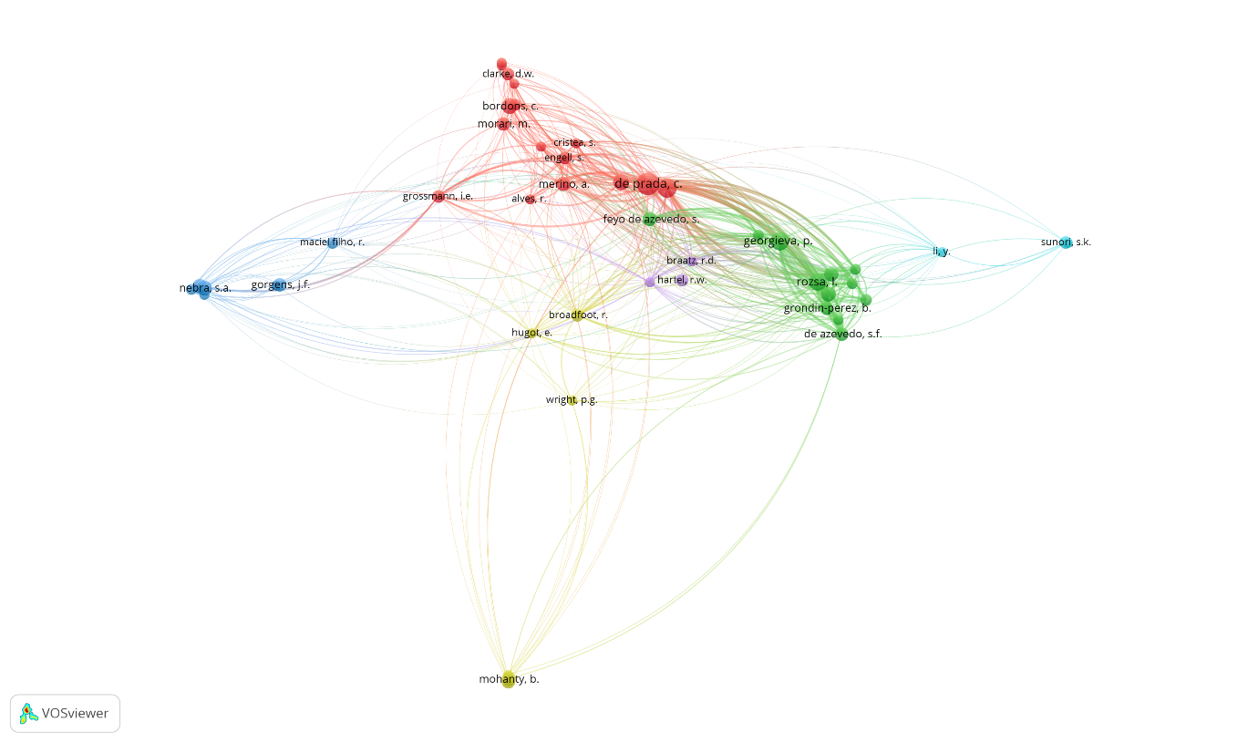
Figure 8. Co-citation networks of authors
Keyword Analysis
Based on the keyword co-occurrence map (Figure 9a), it can be seen that MPC research in the sugar industry is grouped into several main clusters. The core cluster centers on the keywords "model predictive control (MPC)," "process control," and "predictive control," indicating that MPC is the dominant approach in sugar industry process control. These keywords have a strong correlation with "robust control," "setpoint tracking," and "dead time," indicating the research focus on handling process delays, uncertainty, and control system stability (Saravanan & Valarmathi, 2012; Sujatha et al., 2022) .
Other clusters show a close relationship between MPC and specific unit operations, such as "sugar mill," "multiple-effect evaporator," "evaporation," "crystallization," and "heat exchanger." This indicates that MPC applications in the sugar industry are largely focused on thermal and separation processes, which are inherently nonlinear, multivariate, and energy-intensive. This finding aligns with the literature stating that evaporation and crystallization are the primary targets for MPC applications due to their sensitivity to disturbances and changes in operating load (Jorge et al., 2010; Mazaeda et al., 2015; Sunori et al., 2021) .
The time-overlapping network analysis (Figure 9b) shows the dynamic evolution of research topics over time. In the early period (around before 2010), the dominant keywords were “process control,” “evaporation,” and “simulation,” indicating an initial focus on modeling and basic control of sugar industry processes. In the middle period, the use of “nonlinear control,” “robust control,” and “predictive control” increased, indicating a shift toward advanced control approaches to address process complexity.
In the more recent period (after 2015), the timeline shows the emergence and strengthening of keywords such as "hierarchical control," "plant-wide control," "hybrid predictive control," and the association with "bioethanol." This reflects the current research direction, which focuses not only on a single unit process but on the integrated optimization of the entire sugar mill and its derivatives, including bioenergy. This shift confirms that MPC is evolving from a mere operational control tool to part of the sugar industry's overall energy optimization and sustainability strategy.
Overall, the keyword analysis shows that MPC research in the sugar industry has evolved from conventional control approaches to integrated, plant-wide predictive control. The consistent dominance of MPC keywords across time periods confirms its position as a key method for addressing the challenges of complexity, energy efficiency, and sustainability in the modern sugar industry.
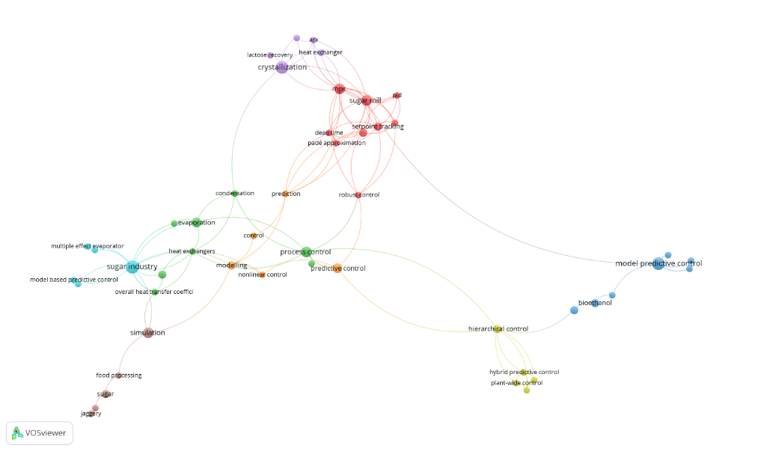
(a)
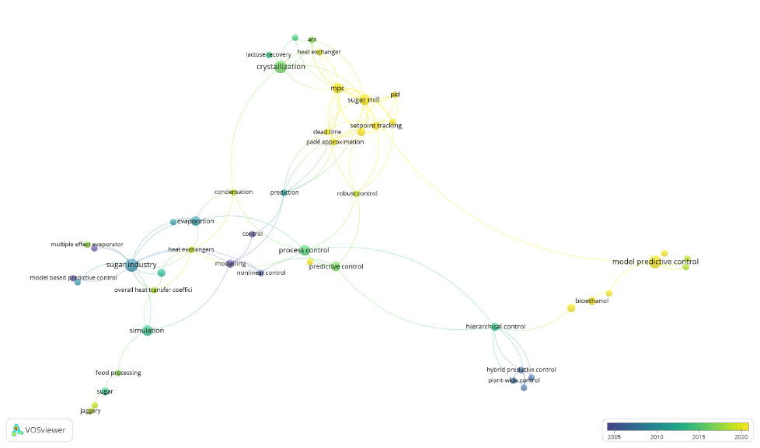
(b)
Figure 9. Co-occurrence keyword analysis: a. clustering network and b. time-overlapping network
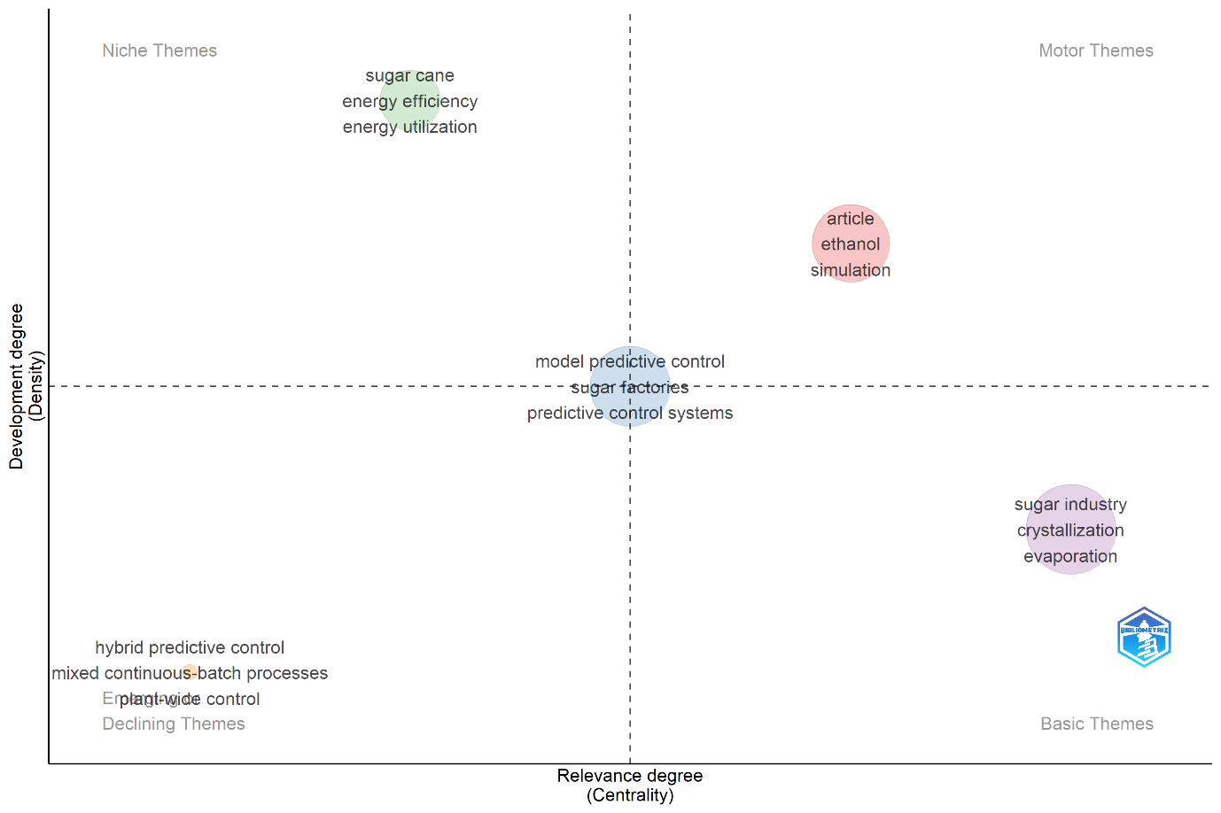
Figure 10. Thematic map
Based on Figure 10, the themes “model predictive control,” “sugar factories,” and “predictive control systems” are located in the center of the map with moderate centrality and density. This position indicates that MPC is a core theme in sugar industry research, acting as a bridge between various other topics but still developing conceptually and methodologically. This finding is consistent with the literature that mentions MPC as a primary approach in sugar industry process control due to its ability to handle multivariate systems, operational constraints, and nonlinear dynamics (Bordons & Camacho, 1999; Qin & Badgwell, 2003) .
In the Motor Themes quadrant, themes such as "ethanol" and "simulation" exhibit high centrality and density, indicating that these topics are mature and are key drivers of current research. This indicates a shift in the focus of MPC research from conventional unit process control to bioenergy process optimization, particularly for sugarcane-based bioethanol, supported by advanced simulations. This development aligns with the growing attention to energy efficiency, plant integration, and sustainability in the sugar industry (Pina et al., 2017; Vergara-Dietrich et al., 2019) .
Meanwhile, the themes “sugar industry,” “crystallization,” and “evaporation” are in the Basic Themes quadrant, indicating high relevance but a relatively lower level of development. This confirms that evaporation and crystallization remain the main foundation of MPC research in the sugar industry, but their approaches and methodological innovations tend to be more established. Conversely, themes in the Declining Themes quadrant, such as “hybrid predictive control” and “plant-wide control,” show potential as future research directions, although they are currently underdeveloped. Overall, this thematic map demonstrates the evolution of MPC research from unit process control to system integration and plant-scale energy optimization (Mazaeda et al., 2015; Menezes Morato et al., 2017) .

Conclusion
This study shows that publications on model predictive control (MPC) in the sugar industry have gradually evolved over time. Initial publications appeared in the late 1990s and were dominated by fundamental studies of MPC in key process units such as evaporators and crystallizers. After a period of relatively slow growth, the number of publications has increased more consistently since the mid-2010s, in line with the development of issues related to energy efficiency, bioethanol, and plant system integration. This indicates that MPC is increasingly seen as a relevant solution to the operational and sustainability challenges of the modern sugar industry.
In terms of geographic and institutional contributions, countries such as India, Brazil, Spain, and France emerge as major contributors, reflecting the combination of academic strength and the size of the sugar industry in the region. Institutions such as the University of Valladolid, Universidad de Salamanca, Université de La Réunion, and Universidade Estadual de Campinas play a central role in the development of MPC research, both in terms of productivity and citation impact. Furthermore, highly reputable journals such as the Journal of Food Engineering, Energy, and Journal of Process Control serve as key channels for knowledge dissemination, demonstrating the interdisciplinary nature of MPC research, bridging control engineering, process engineering, and energy.
Citation analysis reveals that a number of classical and methodological publications receive the highest number of citations, especially works integrating MPC with nonlinear modeling, energy optimization, and real-world industrial applications. Authors such as Vega, Zamarreño, Normey-Rico, Bordons, and Benne prove to be the most influential, both in terms of total citations and central position in the co-citation network. Meanwhile, keyword analysis shows that the most frequently explored topics include evaporation, crystallization, sugar industry, model predictive control, energy efficiency, and ethanol, with recent trends toward plant-wide control, hierarchical MPC, and bioenergy systems, signaling the evolution of research from unit control to comprehensive system integration.
Theoretically, the results of this study strengthen the position of MPC as a dominant and mature approach in process control in the sugar industry, while also demonstrating a shift in research focus toward issues of integration, energy efficiency, and sustainability. Mapping influential authors, institutions, and journals can serve as a strategic reference for new researchers to understand the scientific landscape, build international collaborations, and identify relevant journals for publication. From a practical and industrial perspective, these findings indicate that the application of MPC is no longer limited to the unit operation level, but is increasingly directed toward plant-wide control and energy optimization, which is highly relevant for modern sugar mills facing pressures of cost, efficiency, and environmental regulations. Furthermore, the dominance of bioethanol and energy topics opens up opportunities for integrating MPC with energy transition and green industry policies, particularly in sugarcane-producing countries.
This study has several limitations that require attention. First, the bibliometric analysis relies on a single primary database, potentially overlooking publications that are not indexed or fall outside the scope of that database. Second, the use of quantitative indicators such as the number of publications and citations does not fully represent the quality or practical impact of each study. Third, keyword analysis relies heavily on the consistency of terminology used by authors, so variations in terminology can influence the results of thematic mapping. Therefore, further studies are recommended to combine bibliometrics with systematic literature reviews or industry case studies to gain a more in-depth and contextual understanding.

References
Afram, A., & Janabi-Sharifi, F. (2014). Theory and applications of HVAC control systems – A review of model predictive control (MPC). Building and Environment, 72, 343–355. https://doi.org/10.1016/j.buildenv.2013.11.016
Alves, V., Dos Santos, J. M., Viegas, O., Pinto, E., Ferreira, I. M. P. L. V. O., Aparecido Lima, V., & Felsner, M. L. (2024). An eco-friendly approach for analysing sugars, minerals, and colour in brown sugar using digital image processing and machine learning. Food Research International, 191, 114673. https://doi.org/10.1016/j.foodres.2024.114673
Areeya, S., Tawai, A., & Sriariyanun, M. (2020). Model-Based Control for Fed-Batch Enzymatic Hydrolysis Reactor of Lignocellulosic Biomass. 2020 6th International Conference on Control, Automation and Robotics (ICCAR), 536–540. https://doi.org/10.1109/ICCAR49639.2020.9108066
Benne, M., Grondin- Perez, B., Chabriat, J.-P., & Hervé, P. (2000). Artificial neural networks for modelling and predictive control of an industrial evaporation process. Journal of Food Engineering, 46(4), 227–234. https://doi.org/10.1016/S0260-8774(00)00055-8
Bordons, C., & Camacho, E. F. (1999). Application of simple cascade GPC with robust behaviour to a sugar refinery. 1999 European Control Conference (ECC), 1405–1410. https://doi.org/10.23919/ECC.1999.7099508
Cadet, C., Touré, Y., Gilles, G., & Chabriat, J. P. (1999). Knowledge modeling and nonlinear predictive control of evaporators in cane sugar production plants. Journal of Food Engineering, 40(1–2), 59–70. https://doi.org/10.1016/S0260-8774(99)00037-0
Cadet, C., Toure, Y., Gilles, G., & Gatina, J. C. (1999). Non linear receding horizon observer and model based predictive control of evaporators in cane sugar industry. 1999 European Control Conference (ECC), 3053–3058. https://doi.org/10.23919/ECC.1999.7099794
Cavalcante, C. S., & De Albuquerque, F. M. (2015). The Sugar Production Process. In Sugarcane (pp. 285–310). Elsevier. https://doi.org/10.1016/B978-0-12-802239-9.00014-1
Chusniyah, A., Makruf, I., & Supriyanto. (2024). Two decades of sustainable development studies in higher education management: A bibliometric analysis. International Journal of Sustainability in Higher Education. https://doi.org/10.1108/IJSHE-11-2023-0546
Dahiya, O., Kumar, A., & Saini, M. (2019). Mathematical modeling and performance evaluation of A-pan crystallization system in a sugar industry. SN Applied Sciences, 1(4), 339. https://doi.org/10.1007/s42452-019-0348-0
Darby, M. L., & Nikolaou, M. (2012). MPC: Current practice and challenges. Control Engineering Practice, 20(4), 328–342. https://doi.org/10.1016/j.conengprac.2011.12.004
De Prada, C., Sarabia, D., Cristea, S., & Mazaeda, R. (2008). Plant‐wide control of a hybrid process. International Journal of Adaptive Control and Signal Processing, 22(2), 124–141. https://doi.org/10.1002/acs.983
Eggleston, G., & Monge, A. (2005). Optimization of sugarcane factory application of commercial dextranases. Process Biochemistry, 40(5), 1881–1894. https://doi.org/10.1016/j.procbio.2004.06.025
El‐Belghiti, K., Rabhi, Z., & Vorobiev, E. (2005). Kinetic model of sugar diffusion from sugar beet tissue treated by pulsed electric field. Journal of the Science of Food and Agriculture, 85(2), 213–218. https://doi.org/10.1002/jsfa.1944
Gomes, S. M., Santos, D. F. L., & Basso, L. F. C. (2019). Innovation strategies in the Brazilian sugar–energy industry. Journal of Agribusiness in Developing and Emerging Economies, 9(5), 536–551. https://doi.org/10.1108/JADEE-09-2018-0120
Grondin-Perez, B., Benne, M., Bonnecaze, C., & Chabriat, J.-P. (2005). Industrial multi-step forward predictor of mother liquor purity of the final stage of a cane sugar crystallisation plant. Journal of Food Engineering, 66(3), 361–367. https://doi.org/10.1016/j.jfoodeng.2004.04.002
Higa, M., Freitas, A. J., Bannwart, A. C., & Zemp, R. J. (2009). Thermal integration of multiple effect evaporator in sugar plant. Applied Thermal Engineering, 29(2–3), 515–522. https://doi.org/10.1016/j.applthermaleng.2008.03.009
Irwanto, I. (2025). Research trends on artificial intelligence in K-12 education in Asia: A bibliometric analysis using the Scopus database (1996–2025). Discover Artificial Intelligence, 5(1), 155. https://doi.org/10.1007/s44163-025-00389-4
Jorge, L. M. M., Righetto, A. R., Polli, P. A., Santos, O. A. A., & Filho, R. M. (2010). Simulation and analysis of a sugarcane juice evaporation system. Journal of Food Engineering, 99(3), 351–359. https://doi.org/10.1016/j.jfoodeng.2010.03.017
Kadyan, M. S., & Kumar, R. (2017). Availability based operational behavior of B-Pan crystallization system in the sugar industry. International Journal of System Assurance Engineering and Management, 8(S2), 1450–1460. https://doi.org/10.1007/s13198-017-0614-8
Kaya, D., & Ibrahim Sarac, H. (2007). Mathematical modeling of multiple-effect evaporators and energy economy. Energy, 32(8), 1536–1542. https://doi.org/10.1016/j.energy.2006.09.002
Khaire, R. A., & Gogate, P. R. (2018). Intensified recovery of lactose from whey using thermal, ultrasonic and thermosonication pretreatments. Journal of Food Engineering, 237, 240–248. https://doi.org/10.1016/j.jfoodeng.2018.04.027
Kozak, S. (2016). From PID to MPC: Control engineering methods development and applications. 2016 Cybernetics & Informatics (K&I), 1–7. https://doi.org/10.1109/CYBERI.2016.7438634
Lavarack, B. P. (2007). Application of energy integration techniques (pinch technology) to reduce process steam consumption for raw sugar factories. International Sugar Journal, 58–68.
Lee, J. H. (2011). Model predictive control: Review of the three decades of development. International Journal of Control, Automation and Systems, 9(3), 415–424. https://doi.org/10.1007/s12555-011-0300-6
Mandegari, M. A., Farzad, S., Van Rensburg, E., & Görgens, J. F. (2017). Multi‐criteria analysis of a biorefinery for co‐production of lactic acid and ethanol from sugarcane lignocellulose. Biofuels, Bioproducts and Biorefining, 11(6), 971–990. https://doi.org/10.1002/bbb.1801
Mazaeda, R., Cristea, S. P., & De Prada, C. (2015). Plant-wide hierarchical optimal control of a crystallization process. IFAC-PapersOnLine, 48(8), 1210–1215. https://doi.org/10.1016/j.ifacol.2015.09.133
Mazaeda, R., Cristea, S. P., & De Prada, C. (2020). Hierarchically coordinated economic MPC plantwide control of mixed continuous‐batch units in process industries with application to a beet sugar plant. Optimal Control Applications and Methods, 41(1), 190–214. https://doi.org/10.1002/oca.2535
Menezes Morato, M., Da Costa Mendes, P. R., Normey‐Rico, J. E., & Bordons, C. (2017). Optimal operation of hybrid power systems including renewable sources in the sugar cane industry. IET Renewable Power Generation, 11(8), 1237–1245. https://doi.org/10.1049/iet-rpg.2016.0443
Meng, Y., Yao, T., Yu, S., Qin, J., Zhang, J., & Wu, J. (2021). Data‐driven modeling for crystal size distribution parameters in cane sugar crystallization process. Journal of Food Process Engineering, 44(4), e13648. https://doi.org/10.1111/jfpe.13648
Mkwananzi, T., Mandegari, M., & Görgens, J. F. (2019). Disturbance modelling through steady-state value deviations: The determination of suitable energy indicators and parameters for energy consumption monitoring in a typical sugar mill. Energy, 176, 211–223. https://doi.org/10.1016/j.energy.2019.03.191
Mukherjee, D., Lim, W. M., Kumar, S., & Donthu, N. (2022). Guidelines for advancing theory and practice through bibliometric research. Journal of Business Research, 148, 101–115. https://doi.org/10.1016/j.jbusres.2022.04.042
Pacheco, C. R. F., & Frioni, L. S. M. (2004). Experimental results for evaporation of sucrose solution using a climbing/falling film plate evaporator. Journal of Food Engineering, 64(4), 471–480. https://doi.org/10.1016/j.jfoodeng.2003.11.014
Paz Suárez, L. A., Georgieva, P., & Feyo De Azevedo, S. (2011). Nonlinear MPC for fed-batch multiple stages sugar crystallization. Chemical Engineering Research and Design, 89(6), 753–767. https://doi.org/10.1016/j.cherd.2010.10.010
Pina, E. A., Palacios-Bereche, R., Chavez-Rodriguez, M. F., Ensinas, A. V., Modesto, M., & Nebra, S. A. (2017). Reduction of process steam demand and water-usage through heat integration in sugar and ethanol production from sugarcane – Evaluation of different plant configurations. Energy, 138, 1263–1280. https://doi.org/10.1016/j.energy.2015.06.054
Qin, S. J., & Badgwell, T. A. (2003). A survey of industrial model predictive control technology. Control Engineering Practice, 11(7), 733–764. https://doi.org/10.1016/S0967-0661(02)00186-7
Quintas, M., Brandão, T. R. S., Silva, C. L. M., & Cunha, R. L. (2006). Rheology of supersaturated sucrose solutions. Journal of Food Engineering, 77(4), 844–852. https://doi.org/10.1016/j.jfoodeng.2005.08.011
Rozsa, L., Rozsa, J., & Kilpinen, S. (2016). Crystal growth and crystallization control tactics in industrial sugar crystallizers Part 1. Crystal growth. International Sugar Journal, 118, 746–755.
Sarabia, D., De Prada, C., Cristea, S., Mazaeda, R., & Colmenares, W. (2007). Hybrid NMPC Control of a Sugar House. In R. Findeisen, F. Allgöwer, & L. T. Biegler (Eds.), Assessment and Future Directions of Nonlinear Model Predictive Control (Vol. 358, pp. 495–502). Springer Berlin Heidelberg. https://doi.org/10.1007/978-3-540-72699-9_41
Saravanan, V., & Valarmathi, K. (2012). Model based controller design for Melter process in sugar industry. 2012 Third International Conference on Computing, Communication and Networking Technologies (ICCCNT’12), 1–7. https://doi.org/10.1109/ICCCNT.2012.6395916
Solomon, S. (2016). Sugarcane Production and Development of Sugar Industry in India. Sugar Tech, 18(6), 588–602. https://doi.org/10.1007/s12355-016-0494-2
Sujatha, K., Nalinashini, G., Ganesan, B. A., Jayachitra, N., Sankari, R., Kalaivani, A., & Sendilvelan, S. (2022). Predictive Model-based Analytics to Control Drying Process in a Sugar Industry. In Y.-D. Zhang, T. Senjyu, C. So-In, & A. Joshi (Eds.), Smart Trends in Computing and Communications (Vol. 286, pp. 419–426). Springer Singapore. https://doi.org/10.1007/978-981-16-4016-2_39
Sunori, S. K., Juneja, P. K., Chaturvedi, M., & Agarwal, N. (2016). Design and Analysis of Control Systems for Heat Exchanger System of Sugar Mill. 2016 8th International Conference on Computational Intelligence and Communication Networks (CICN), 480–482. https://doi.org/10.1109/CICN.2016.99
Sunori, S. K., Singh, G., Maurya, S., Mittal, A., Arora, S., & Juneja, P. (2021). Model Identification and MPC based control of Heat Exchanger System of Sugar Crystallizer. 2021 Second International Conference on Electronics and Sustainable Communication Systems (ICESC), 312–319. https://doi.org/10.1109/ICESC51422.2021.9532703
Sunori, S. K., Singh Jethi, G., Arora, S., Mittal, A., Khan, F., & Juneja, P. (2022). Controller Design for Dead Time Approximated Model of Juice Extraction Unit of Sugar Factory. 2022 6th International Conference on Computing Methodologies and Communication (ICCMC), 464–468. https://doi.org/10.1109/ICCMC53470.2022.9753728
Vergara-Dietrich, J. D., Morato, M. M., Mendes, P. R. C., Cani, A. A., Normey-Rico, J. E., & Bordons, C. (2019). Advanced chance-constrained predictive control for the efficient energy management of renewable power systems. Journal of Process Control, 74, 120–132. https://doi.org/10.1016/j.jprocont.2017.11.003
William Herrera, Elmer Rivera, Luz A. Alvarez, Laura Plazas Tovar, Sebastian Tamayo Rojas, Celina Yamakawa, Antonio Bonomi, & Rubens Maciel Filho. (2016). Modelling and control of a continuous ethanol fermentation using a mixture of enzymatic hydrolysate and molasses from sugarcane. Chemical Engineering Transactions, 50, 169–174. https://doi.org/10.3303/CET1650029
Xue, C., Wang, Z., Wang, S., Zhang, X., Chen, L., Mu, Y., & Bai, F. (2016). The vital role of citrate buffer in acetone–butanol–ethanol (ABE) fermentation using corn stover and high-efficient product recovery by vapor stripping–vapor permeation (VSVP) process. Biotechnology for Biofuels, 9(1), 146. https://doi.org/10.1186/s13068-016-0566-2
Zamarreño, J. M., & Vega, P. (1997). Identification and predictive control of a melter unit used in the sugar industry. Artificial Intelligence in Engineering, 11(4), 365–373. https://doi.org/10.1016/S0954-1810(96)00055-6
Zamarreño, J. M., & Vega, P. (1999). Neural predictive control. Application to a highly non-linear system. Engineering Applications of Artificial Intelligence, 12(2), 149–158. https://doi.org/10.1016/S0952-1976(98)00055-4
Zamarreño, J. M., Vega, P., Garcı́a, L. D., & Francisco, M. (2000). State-space neural network for modelling, prediction and control. Control Engineering Practice, 8(9), 1063–1075. https://doi.org/10.1016/S0967-0661(00)00045-9
Zheng, A. (1997). A computationally efficient nonlinear MPC algorithm. Proceedings of the 1997 American Control Conference (Cat. No.97CH36041), 1623–1627 vol.3. https://doi.org/10.1109/ACC.1997.610858

