**Menjadi Kota: Mobilitas Penduduk Dan Transformasi Status Kota Bontang, Kalimantan Timur (1950–1999)**

***Becoming a City: Population Mobility and the Transformation of Bontang, East Kalimantan (1950–1999)***

1Naldi, 2Amrullah Amir

1Universitas Hasanuddin, Indonesia

Email; [1naldi1820p@gmail.com](mailto:1naldi1820p@gmail.com); [2amrullahamir.unhas@yahoo.com](mailto:2amrullahamir.unhas@yahoo.com)

***Abstract***

This study explores the transformation of Bontang City, East Kalimantan, driven by two key phases: timber exploitation (1967–1980) and the establishment of the LNG industry by PT Badak NGL (since 1974). Employing a historical-socioeconomic approach, it applies heuristics, source criticism, interpretation, and historiography. Data were drawn from newspaper archives, government documents, and oral histories. Findings reveal that timber exploitation spurred mass migration and reshaped the coastal community’s social landscape, setting the stage for PT Badak’s LNG plant, which employed thousands and accelerated urban growth. These processes elevated Bontang’s administrative status from sub-district to administrative city (1989), and later metropolitan city (1999). The study also highlights significant environmental consequences, particularly in Kutai National Park. Overall, Bontang’s case illustrates how natural resource exploitation and industrialization can rapidly transform social structures, demographics, and ecological systems, providing a critical example of urban-industrial development in Indonesia.

**Keywords**: City, Industry, Logging, Migration, Urban.

**Introduction**

The city of Bontang, located on the east coast of Kalimantan, is an important example of the industrial cities that grew rapidly during the New Order period. Bontang's transformation from a quiet coastal area into a natural gas industry hub cannot be separated from the dynamics of migration, the expansion of state capitalism, and the massive exploitation of natural resources from the 1960s to the 1990s. Major changes began with the enactment of Law No. 5 of 1967 on Foreign Investment, which encouraged foreign companies to open forest logging concessions in East Kalimantan. This era, known locally as banjir cup (flood of cups), opened up new job opportunities for people from outside the region. In the mid-1970s, the direction of national development shifted with the arrival of the major PT Badak LNG project. The city of Bontang underwent massive industrialisation.

The flood cup period in the late 1960s to 1970s marked the beginning of natural resource-based economic expansion in the Bontang region of East Kalimantan. The term ‘flood of logs’ refers to the short logs that flooded the coast and rivers, marking the large-scale exploitation of tropical forests through the Forest Concession Rights (HPH) system granted by the government to national and foreign companies after the 1967 Foreign Investment Law. Massive logging had several major impacts, ecologically, socially and demographically. Ecologically, the clearing of primary forests along the Santan River, Pandan Bay and the area around the Manggar Mountains caused rapid environmental degradation. Forests, which serve as water buffers and habitats for biodiversity, were lost in a short period of time. Without a serious reforestation programme, the coastal area of Bontang began to experience ecosystem disturbances such as sedimentation, mud floods during the rainy season, and a decline in water and air quality. However, timber-based economic expansion was not accompanied by an adequate social security system or urban planning. Many workers live illegally on the riverbanks or build makeshift stilt houses above the sea, as is the case in the Kutai National Park (TNK) forest.

Kutai National Park (TNK) is one of the most important wet tropical forest conservation areas in East Kalimantan, which since colonial times has been known as a habitat for rare species such as orangutans, proboscis monkeys, and various types of endemic flora. However, since the early 1970s, the area has suffered serious ecological damage as a direct result of logging, illegal settlement and the development of large industrial projects such as PT Badak LNG in Bontang.

From an economic perspective, although logging activities and PT Badak create temporary jobs, their temporary and unsustainable nature actually plunges many workers into economic dependence with no guarantee for the future. When the timber is depleted and the HPH permit is revoked or not renewed, workers lose their livelihoods and are forced to seek informal employment as fishermen, boatmen, or small traders. PT Badak also has a positive impact on employment opportunities for both the local community and migrants.

Overall, logging and the development of PT Badak not only changed the physical landscape of Bontang City, but also shaped the city's social history, from the formation of migrant communities and the emergence of coastal villages to the social inequalities whose effects are still felt today. This shows that development based on natural resource extraction, without a sustainable and participatory approach, produces more vulnerability than long-term prosperity.

This study was designed to examine in depth the changes in the administrative status of Bontang City as a result of two major economic phases, namely the timber harvesting period (banjir cup) and the development of the oil and gas industry during the New Order era. This phenomenon has made Bontang one of the fastest growing cities in East Kalimantan, while also undergoing a transformation from a sub-district to an administrative city in 1989, and subsequently becoming a municipality in 1999. Initially, Bontang was a small sub-district under the administrative jurisdiction of Kutai Kartanegara Regency since 1952. This area did not have a strategic position in terms of economy or politics. However, since the enactment of Law No. 5 of 1967 concerning Basic Forestry Provisions, the forests of Kalimantan, including those in the Bontang area, began to be widely opened up for timber exploitation by various Forest Concession Rights (HPH) companies. This policy created enormous employment opportunities in the logging sector and opened up a flow of labour migration from various regions in Indonesia.

This wave of migration then increased with the start of the liquefied natural gas (LNG) industry project by PT Badak NGL in 1974. The construction of these industrial facilities not only attracted labour, but also triggered the development of urban infrastructure, increased demand for housing, and the emergence of other supporting sectors such as trade, transportation and services. In a short period of time, Bontang transformed into a strategic industrial centre in East Kalimantan. This study will trace the history of how the two economic sectors of logging and the oil and gas industry became major factors in social structural change and population growth, as well as the basis for changes in the administrative status of the region. The focus will be on the period from 1967 to 1999, namely from the start of large-scale forest clearing and the development of the oil and gas industry to the government's decision to change Bontang's status to an administrative city and finally to a municipality.

Studies on cities, urban change, and the influence of industry can be drawn from a number of important works that discuss these themes from both global and Indonesian perspectives. Lewis Mumford, in his work *The City in History* (1961), emphasises that cities should develop organically, in harmony between people, technology, and the environment. However, modern industrialisation has triggered mechanistic urban growth, causing spatial separation and tension between human needs and industrial logic. This perspective is complemented by the analysis of Moulaert, Rodriguez, and Swyngedouw in *The Globalised City* (2005), which outlines how global economic restructuring and neoliberalism have deepened social polarisation in European cities. Industry is not only an engine of growth, but also a source of inequality in access to urban space.

A more scathing critique of the impact of industrialisation on the urban landscape comes from James Howard Kunstler in *The Geography of Nowhere* (1993). He shows how the automotive industry and suburbanisation in the United States have given rise to cities without identity, a loss of public space, and a reduction in communal life. Meanwhile, in the Indonesian context, Marko S. Herman et al., through *Industrial Estates in Indonesia: A Management Guide* (2023), highlight the role of industrial estates as a factor that has tangibly changed the face of cities. This book shows that industrial estates not only function as production centres but also influence spatial planning, infrastructure, and socio-economic dynamics around cities.

A historical approach is also important for understanding urban change in Indonesia, as presented in *Kota Lama Kota Baru: Sejarah Kota-kota di Indonesia* (Colombijn, Basundoro, & Khusairi, eds.). This collection of writings shows the transformation of Indonesian cities from the colonial period, through the revolution, to the contemporary era, influenced by political, economic and development policy dynamics. From these various studies, it can be concluded that industrialisation is one of the central factors in urban transformation, whether through economic restructuring, spatial changes, or shifts in socio-cultural identity. Thus, the study of cities in the modern era requires a synthesis between global theories of industrialisation and globalisation and the unique local realities of Indonesia in order to formulate a more inclusive and sustainable model of urban development.

In this context, research on Bontang is important because it can fill this gap. Bontang is an example of a city that changed status and developed rapidly with the arrival of the timber industry in the 1960s and 1970s and the liquefied natural gas industry through PT Badak since 1974. The presence of these two industrial sectors not only drove economic structural change but also triggered a massive migration from various regions such as Sulawesi, Java, and Bugis-Mamuju, which in turn gave rise to new social dynamics in the region. Thus, research on Bontang will enrich the literature on modern Indonesian urban history by presenting a unique case study of a post-colonial industrial city. If Balikpapan represents the model of a colonial oil city, then Bontang can be seen as a New Order gas-wood industrial city that grew within the framework of national development. Therefore, this research contributes not only to increasing understanding of the socio-economic history of Bontang, but also opens up new perspectives in Indonesian urban historiography that is more diverse and inclusive.

Through a historical and socio-economic approach, this study aims not only to map demographic dynamics and regional transformation, but also to examine how national development policies implemented in the regions have shaped the character and direction of a city's growth. The results of this study are expected to make an important contribution to the study of urban history in Indonesia, particularly in understanding the process of industrial city formation outside of Java.

**Method**

This research method uses a historical method consisting of four stages, namely, first, Heuristics (Source Collection). The heuristic stage is the initial stage in historical research that focuses on searching for and collecting relevant historical data or sources. This study relies on primary sources in the form of archives from the *Berita Yudha* and *Harian Neraca* newspapers published between the 1970s and 1990s. These two newspapers were chosen because they provide contextual information related to development policies, industrial projects such as PT Badak LNG, social changes due to migration, and the dynamics of settlement and forest encroachment around the city of Bontang. In addition to newspapers, other sources collected include local archival documents, municipal administrative records, documentary photographs, and interviews with key informants such as former industrial workers, community leaders, and historical witnesses.

Source Criticism: Once the sources have been collected, source criticism is carried out to assess the authenticity and credibility of the information. Source criticism is divided into two types: external criticism, to assess the authenticity of sources such as the date of publication, author, and publishing institution (whether official or not); and internal criticism, to assess the content of the information: whether the news presented is factual or opinion, whether there is a particular political bias (for example, the New Order narrative in state-owned newspapers), and the extent to which the news reflects the objective situation on the ground. The *Berita Yudha* newspaper is known to be close to official government policy, while the *Harian* *Neraca* tends to present economic and social issues from the perspective of industry players. Therefore, source criticism is important in distinguishing between propaganda, editorial opinion, and empirical facts. Interpretation,

The interpretation stage is carried out by interpreting the meaning of each piece of information that has undergone source criticism. At this stage, researchers establish connections between events recorded in newspapers and the social reality in Bontang City. For example, news about the development of PT Badak is not only interpreted as industrial progress, but also as a moment of social transformation that caused changes in population structure, living spaces, and the emergence of migrant villages. Interpretation is also aided by comparing newspaper reports with oral narratives and other archival data in order to develop a more complete and less partial understanding. Historiography (Writing History), The final stage is the writing of history based on the results of the previous interpretation. The writing is done narratively and analytically, using a thematic and chronological approach.

**Results and Discussion**

One of the important findings in this study is the ecological impact of residential expansion and industrialisation on tropical rainforest conservation areas, namely Kutai National Park (TNK). The TNK area, which was originally designated as a protected forest during the colonial period and later established as a national park, experienced severe degradation from the late 1970s to the 1990s due to pressure from population growth and large-scale industrial development projects in the city of Bontang. From the 1980s to the early 1990s, the TNK area experienced a very high rate of deforestation. The main factors causing this were the clearing of land for settlements for the growing number of migrants, as well as the construction and expansion of large industrial companies, namely PT Badak NGL. During this period, the area, which originally functioned as a buffer zone for the tropical forest ecosystem, was transformed into a densely populated residential area and industrial infrastructure. Data from 1990 shows that around 2,098 households, equivalent to 9,317 people, were living in the TNK area, making it a location prone to conflict between conservation and residential needs.

The presence of large populations within the national park zone indicates weak government supervision of forest encroachment and a lack of sustainable spatial planning. This situation has had a direct impact on the reduction of the TNK area. The initial area of the national park, which covered 306,000 hectares, has shrunk dramatically to only about 200,000 hectares in less than two decades. This decline has occurred alongside the opening of roads connecting settlements and industrial areas, deforestation for agricultural land, and illegal activities such as illegal logging and forest encroachment by communities who do not have legal access to land.

The reduction in the area of the TNK not only causes the loss of forest cover, but also threatens the existence of endemic species, including orangutans (Pongo pygmaeus), and accelerates the fragmentation of habitats and coastal-forest ecosystems that were previously integrated. These changes reflect a failure to manage industrial city growth in accordance with principles of ecological sustainability. From a social perspective, the proliferation of settlements within the TNK also reflects how development policies have not fully considered aspects of environmental justice. The lack of legal and affordable housing options for migrant communities has made the TNK a last resort. As a result, there is a paradox between environmental conservation efforts and people's basic need for living space.

The city of Bontang is located in East Kalimantan Province. Geographically, Bontang borders East Kutai (north), the Makassar Strait (east), and Kutai Kartanegara Regency (south and west) (Saparuddin, 2011). Bontang is a strategic area with abundant natural resources for its community. Bontang City currently has an area of approximately 49,757 hectares, with 14,780 hectares of land (approximately 29.70 per cent) and 34,977 hectares of sea area (approximately 70.30 per cent) (Saparuddin, 2011). (Sumarna, 2006) Of the land area, 5,950 hectares (11.96 per cent) is protected forest, while 5,248 hectares (10.56 per cent) is used for residential areas. (Sumarna, 2006)

The coastal area of Bontang City consists of tidal swamps, shallow waters and abundant marine resources. This has made Bontang a popular destination for migrants seeking to settle and earn a living in the city. There are many versions of the origin of the name Bontang. According to the Kutai Kartanegara kingdom, in the Saway book, it is explained that the name Bontang was first given by the king of Kutai Kartenegara in the 13th century during the reign of Adji Batara Agung Dewa Sakti (Saparuddin, Bontang, Siapa, dan Bagaimana, 2006). He ordered his envoy to inspect the eastern part of Kutai, and the envoy found a group of people wearing ‘Bolang’ headbands and reported this to the Kutai king, Adji Batara Agung Dewa Sakti. This led the king of Kutai Kartanegara to give the name Bontang to the region (Saparuddin, Bontang, Siapa, dan Bagaimana, 2006). (Makarakka, 2006) Meanwhile, according to the Bugis tribe and popular folklore, the origin of the name Bontang comes from the combination of two words, namely Bond, which means gathering, and Tang, which is an acronym for para pendatang (newcomers) (Makarakka, 2006).

In 1952, Bontang was a village inhabited by various ethnic groups who had migrated from outside the region, and the village of Bontang was led by a traditional leader or elder (Mustikawati, 2014). Further developments saw Bontang's status elevated to that of a sub-district under the leadership of an assistant district head in the Kutai Sultanate government. On 21 January 1960, through a special session of the Kutai Regional People's Representative Council, the Kutai Sultanate was officially abolished, and the Kutai Level II Regency was formed, covering several sub-districts. One of these sub-districts was Bontang Sub-district, which was initially centred in Bontang Kuala and later moved to Bontang Baru. (Bontang City Archives in Ridwan Habibon, Bontang in Development, 1986).

This subdistrict encompasses several villages, namely Bontang Baru Village, Tanjung Laut Village, Santan Ulu Village, Santan Ilir Village, Santan Tengah Village, Sangata Village, Sepaso Village, Tebangan Lembab Village, Tepian Langsat Village, Keraitan Village, and Sekerat Village (Saparuddin, Bontang, Siapa, dan Bagaimana, 2006). During these years, the natural conditions in Bontang were still very beautiful, with forests that had been minimally touched and disturbed by humans. The only crowded human settlement was in Bontang Kuala, while the Tanjung Laut area was still empty (results of an interview with H. Abdul Harris, grandson of the village head of Bontang Kuala, verified by Ridwan Habibon in Juniar Purba and verified by a direct interview with 72-year-old Pak Caman on 8 November 2024, a Mamuju native who settled in Sampoang in 1957).

The development of Bontang in the 1970s cannot be separated from the dynamics of large-scale forest exploitation in East Kalimantan. During the New Order era, the forestry sector was one of the backbones of the national economy. Government policy through Law No. 5 of 1967 on Basic Forestry Provisions provided the legal basis for the opening of production forests, while also paving the way for private investment in the forestry sector. The implementation of this policy triggered what became known as the Banjir Cap, a period of massive logging that began in the early 1970s and peaked in that decade (Purba, 2017).

In this context, Bontang and its surrounding areas play an important role as one of the suppliers of timber for export. Areas such as Bungalon, Muara Lembah, Kudung, Tepiang Langsat, Sangkulirang, and Teluk Kaba have become timber production centres that are frequently visited by loggers, both local communities and migrants from various regions. Bontang, originally known as a coastal area with fishing activities, has undergone an economic shift due to the influx of the forestry industry. This has led to a shift in the professions of the community from fishermen to timber loggers, transporters, and workers in the forest product distribution chain.

Bontang's strategic location makes it an important hub for the movement of workers and timber products. The old port of Bontang Kuala was the main entry point for migrants arriving from Sulawesi, Java and other parts of Kalimantan. From this port, migrants then spread out to the main work locations, including Loktuan and Satimpo. The area, which at that time was still covered in mangrove forests and swamps, was transformed into a centre of timber-based economic activity. In Satimpo, which has now developed into an industrial area, there were once timber logging bases that bore witness to Bontang's transformation from a traditional fishing town to a forestry labour town.

These changes have had an impact not only on the economy, but also on society. The influx of workers from outside the region has led to new demographic dynamics, with Bontang becoming a space for interaction between local residents and migrants. This social heterogeneity would later become an important foundation for Bontang's development as an industrial city. However, the intensity of uncontrolled timber exploitation has led to ecological consequences in the form of forest destruction and a reduction in mangrove areas, which in the long term will affect the sustainability of Bontang's coastal environment.

Thus, the Banjir Cap period in the 1970s can be seen as a crucial phase in the history of Bontang. On the one hand, it opened up new economic opportunities and encouraged social transformation through the influx of forestry workers. However, on the other hand, it also created structural problems in the form of economic dependence on the exploitation of natural resources and ecological vulnerability, the effects of which can still be felt today.

This logging work became an important transition in the work patterns of migrants who previously relied on the sea as their source of livelihood. However, because the income from logging was quite promising and job opportunities were abundant, they quickly adapted. Logging was carried out in groups in various locations, such as Bungalon, Muara Lembah, Kudung, Tepiang Langsat, Sangkulirang, and Teluk Kaba (Amir, 71 years old, on 2 December 2024). The logs were cut into four-metre lengths, stacked, and then floated down the river to the sea to be sent to timber storage ports. The wage system at that time was based on the cubic measurement of timber.

This logging activity not only changed the employment structure of migrants, but also had a major impact on other sectors. In agriculture, land clearing in the Satimpo and Bontang Lestari areas resulted in many farmers switching to logging work, abandoning their farmland (Caman, 72, on 2 December 2024). This activity also has an impact on the environment, including the shrinking of forest areas that are now part of Kutai National Park. One of the large Japanese logging companies operating at that time was Kayu Mas, which built two large ports in Satimpo and Loktuan. Around the 1970s, logging activities reached their peak, and these ports became the centre of Bontang's economic activity. Although it had a positive economic impact, this activity caused significant environmental damage. The Kutai National Park area shrank from 306,000 hectares to only 200,000 hectares due to industrial land clearing, factory construction and settlements. Logging activities even reached 37 kilometres from the coastline. Despite reforestation and replanting efforts by companies and the government, criticism continues to be levelled at the damage caused by the expansion of logging companies.

Forest management policies began to change in late 1979, when the government restricted log exports and encouraged the domestic wood processing industry to increase added value. Starting in 1980, exports were limited to 32%, and in 1981 only companies with processing facilities were allowed to operate (Harian Neraca, Kutai National Park Threatened by Mining and Encroachment. (29 November 1989), VIII.). This marked the end of the period of large-scale logging by ordinary people, who had been competing on an uneven footing with companies that had modern equipment. After the end of logging as their main livelihood, most migrants returned to their previous jobs or sought alternative employment. The construction of a liquefied natural gas refinery, which began in 1974, opened up new opportunities in the industrial sector and became a new economic mainstay for migrants in Bontang. Next, the focus will be on the role of this workforce in industrial development and its impact on social transformation in coastal areas.

The 1970s was a period of rapid economic growth for the New Order. From 1972 to 1980, real GDP growth increased by 7.3 per cent, driven by increased exports of oil and gas as well as non-oil and gas commodities such as timber (Zanden, 2012). This was part of the New Order's strategy under Suharto to restore Indonesia's economy from the debt inherited from the Sukarno era. Timber exploitation peaked when Indonesia's economy began to enter a more mature stage. For example, in 1980, timber exports were limited to 32 per cent. This measure was part of a plan to process logs in order to increase state revenue, and timber companies were prohibited from operating unless they had invested in processing (Zanden, 2012).

In the economic sector of oil and gas revenues, Indonesia experienced a surge in revenues from oil and gas exports in the 1980s. The Iran-Iraq War became a momentum for the rise in oil prices and was very beneficial for Indonesia (Zanden, 2012). However, this did not last long as global polemics improved and corruption in Indonesia increased. On the one hand, the presence of PT Badak NGL in Bontang and another gas company that had existed earlier in Aceh, namely PT Arun NGL, became one of the pillars of the Indonesian economy.

Juniar Purba states in his book Sejarah Perkembangan Pelabuhan Tanjung Laut Indah (History of the Development of Tanjung Laut Indah Port) that in 1974, around 7,000 workers from various regions, both domestic and foreign, were recruited to build a gas refinery in Bontang. These workers came from diverse ethnic and linguistic backgrounds. Initially, they were promised that they would be sent home after the construction of trains A and B was completed. However, this plan was cancelled because the project continued with the construction of trains C and D. Eventually, many of them decided to settle in Bontang. This period was known as the Bechtel era, when many people from outside the region came to work for the Bechtel contracting company, which employed workers at PT Badak.

**Figure 1: Graph showing the development of PT Badak's workforce**

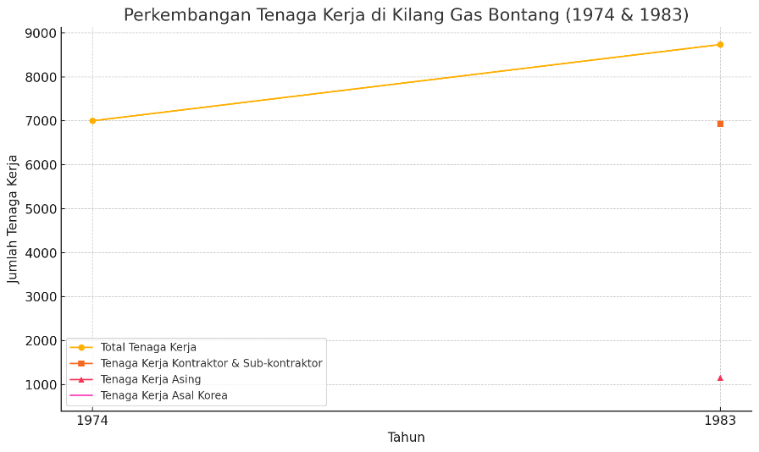

As shown in Figure 1, the total workforce in 1983 was 8,737 people, divided into 6,933 main contractors and subcontractors, including 1,152 foreign workers, 792 of whom were from South Korea. This shows that most of the workforce in Bontang in 1983 was local, but there was also a significant proportion of foreign workers, particularly from South Korea, which may have been related to large industrial projects in the area. According to the 1981 census, Bontang had a population of 35,775. Meanwhile, records from 1975 show that the population of Bontang, which only included the villages of Bontang and Berbas, was 6,000. From this comparison, it can be seen that the Bontang area, which at that time only included Bontang Kuala (Bontang Village), Bontang Baru, Tanjung Laut, Berbas and Loktuan, was affected by the development of PT Badak NGL. Various aspects improved, particularly the population, due to the attraction of job opportunities, which increased the population of the Bontang sub-district at that time. There was rapid population growth in Bontang between 1975 and 1981, followed by an increase in the workforce in 1983 (Harian Neraca, Segudang Prestasi Kilang LNG Bontang (2), Wednesday, 26 October 1988. 11).

**Figure 2: Population Growth Chart for Bontang Village (1972–1984)**

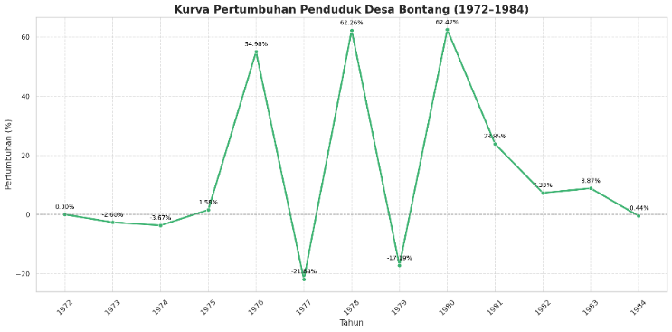

Source: Bontang City Regional Archives, owned by Ridwan Habibon

Judging from the two figures above, the population surge occurred in 1974-1975, coinciding with the opening of PT Badak, which required a large workforce. The construction of the oil refinery and several other PT Badak infrastructures became a magnet for migrants due to the abundance of job opportunities at that time. This indicates that many migrants came to Bontang to improve their economic situation.

The construction of PT Badak's oil refinery took approximately three years. This was a relatively short time frame for such a large-scale project, which undoubtedly required a large workforce. The company was officially inaugurated in 1977 by President Soeharto. The development of this company had a huge impact on the development of Bontang. PT Badak constructed infrastructure in the form of asphalt roads and other buildings. This drastic change was very noticeable to the people of Bontang at that time. From the beginning, the only land route to Bontang was a dirt road, and the only way to enter and exit Bontang was by sea, as can be seen in Figure 4 (Purba, 2017).

**Figure 3: Road conditions in the city of Bontang (Source: YouTube channel Hoby Sukses)**

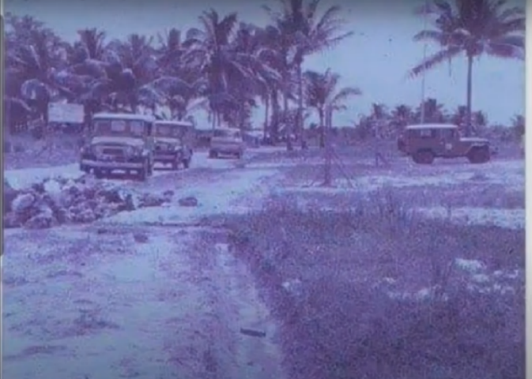

Since 1986, PT Badak has built the first 10 km asphalt road covering several villages such as Tanjung Laut, Berbas, Gunung Sari and Bontang Baru (Purba, 2017). This has had a significant impact on the mobility of the people of Bontang. This has been felt by many people living in Bontang as it has made it easier to access various places such as markets and ports. The development of Bontang continued until 1989 when Bontang changed its status from a sub-district to the administrative city of Bontang. The upgrade to administrative city status was based on the consideration that at that time, Bontang was growing significantly due to the presence of two companies, which led to a rapid increase in population. This was a result of people moving to Bontang from outside the city to work or find a new place to live.

The growth of Bontang City in East Kalimantan cannot be separated from the presence of the energy industry, especially since the establishment of PT Badak NGL in the early 1970s. This company has been the main driver of economic development and has determined the direction of urban spatial development. This phenomenon is in line with the company town theory in urban political economy studies, where the spatial and economic structure of a city is largely determined by the needs of large industries (PT Badak) and state policies that support its sustainability (PT Badak NGL, 2023). Bontang's dependence on the energy sector reflects a monostructural or rentier economy pattern, which in the long term creates vulnerability to global commodity price fluctuations and changes in national energy policy (Central Statistics Agency [BPS], 2023).

When compared to urbanisation patterns in Java, Bontang presents a different picture. Firman (2004) shows that urbanisation in Indonesia is generally driven by the expansion of metropolitan cities, the spread of industrialisation to peri-urban areas, and transmigration policies. In this context, Bontang is not the result of the expansion of a large city, but rather the product of a national strategic industrial project. Thus, Bontang is closer to the company town model than to the concept of a desakota as described by McGee (1991). The concept of desakota describes an area with mixed agricultural and urban functions, commonly found in Java. However, in Bontang, the transformation was dominated by coastal industrialisation with clear segregation between industrial areas, workers' housing, and traditional coastal communities.

Spatial and environmental aspects are important issues in the development of Bontang. The Bontang City Development Master Plan (Bontang City Government, 2012) shows that urban land is heavily geared towards industrial interests, while the availability of clean water and the quality of the coastal environment are major challenges. Research on water resources in Bontang (Rahman, 2014) confirms that there is significant ecological pressure due to industrial growth, which requires ecosystem-based planning. This is in line with urban spatial planning theory, which emphasises the integration of ecological and social aspects in the development of industrial cities. (Yunus, 2006).

Socio-economic disparities have also emerged alongside the development of Bontang. The presence of large companies has given rise to dualism: on the one hand, there are company housing complexes with complete facilities, while on the other hand, there are still informal settlements of coastal communities with limited access to basic services. PT Badak has made efforts through its corporate social responsibility (CSR) programme, but several studies show that these programmes are mostly short-term and have not fully addressed structural inequalities (Hapsari, 2018). From a political economy perspective, this condition confirms that corporate dominance not only shapes the urban space but also limits community participation in the development process.

Thus, a critical analysis of Bontang shows that although this city has been able to develop rapidly as an energy industry centre, this growth pattern has left behind issues of sustainability, social inequality, and economic vulnerability. A comparison with the concept of desakota (urbanisation) and urbanisation patterns in Indonesia confirms that Bontang is a unique type of coastal industrial city, different from urbanisation patterns in Java. Therefore, future management policies for Bontang need to be directed towards economic diversification, strengthening environmental governance, and increasing local community participation in urban spatial planning.

Bontang is known as a city for migrants, and its population is diverse. Since the 1950s, Bontang has developed with promising economic sectors for newcomers, primarily the maritime economy. The exploitation of timber and the establishment of two large companies between 1974 and 1977 created a demand for labour, which was a factor in the growth of Bontang's population. The population surge in the 1980s prompted the Kutai Regency government and even the East Kalimantan Provincial government at that time to upgrade Bontang's status from a sub-district to the Administrative City of Bontang in 1989. This change was based on Government Regulation No. 20 of 1989. This change in status left a lasting impression on the people of Bontang at that time.

**Figure 4: Changes in the Status of Bontang Source: YouTube Channel Bernand Insider**

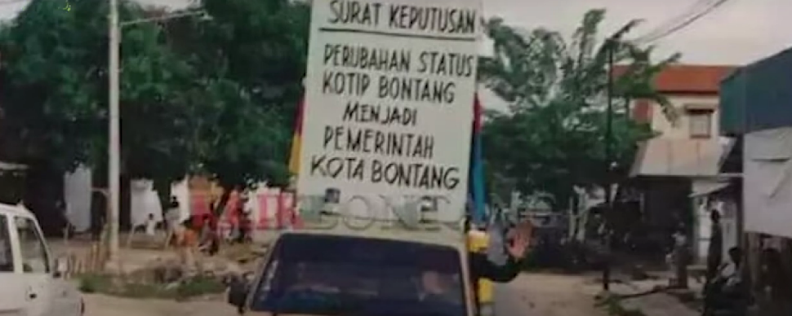

However, as administrative regulations in Indonesia developed, one of the changes was the abolition of administrative governments in various regions. This also had an impact on the administrative city of Bontang, which on 12 October 1999 underwent a change in status with the abolition of its status as an Administrative City. Bontang City was established as a Madya city in accordance with Law No. 22 of 1999 concerning regional government. The combination of timber exploitation and the development of PT Badak created an attraction that drew many people from outside Bontang to the city. Timber exploitation provided initial employment opportunities that attracted migrants, while PT Badak's large-scale projects strengthened Bontang's position as a centre for the natural gas industry. At the same time, the infrastructure built to support these industrial activities made it easier for people to settle and work, thereby accelerating population growth.

Between 1972 and 1986, the population grew by 20.9% annually (Bontang City Archives in Ridwan Habibon, Bontang in Development. (1986). Approximately 60% of the population lives in the areas of Loktuan, Tanjung Laut, Bontang Baru, and Guntung. However, population growth has also affected the location of settlements and the natural environment in Bontang.

**Conclusion**

The above discussion shows that the development of Bontang City cannot be separated from two important phases in its history, namely the timber exploitation period during the New Order era and the construction of the PT Badak liquefied natural gas industry project in the 1970s. Forest exploitation, which began with the 1967 forestry policy, triggered a large wave of migration to Bontang, particularly to areas such as Satimpo and Loktuan. This activity significantly changed the economic structure of the community from one based on the sea to one based on forestry, with ecological impacts such as the reduction of protected forest areas, including the Kutai National Park. Furthermore, the construction of the PT Badak LNG refinery since 1974 has been the main driver of economic and population growth in Bontang. This industrial project has absorbed thousands of local and foreign workers, created high social mobility, and triggered a surge in population, especially in 1974–1975.

At the same time, infrastructure began to be built on a massive scale, such as asphalt roads and other urban facilities, further cementing Bontang's position as a strategic industrial city. Bontang's change in status from a sub-district to an administrative city in 1989, and then to a municipality in 1999, was recognition of this rapid development. However, this rapid growth also brought challenges such as pressure on the environment and a reduction in residential space. Overall, the transformation of Bontang City reflects how natural resources and industrial development policies can drastically change the social, economic, and ecological landscape of a region in a relatively short period of time.

**REFERENSI**

**Archives**

Arsip Daerah Kota Bontang, Ridwan Habibon. 1986. Bontang dalam Perkembangan.

Arsip Daerah Kota Bontang. SK Pengangkatan Kepala Kampung Habibon.

Surat Kabar Berita Yhuda, 21 November 1994. Taman Nasional Kutai Terancam.

Surat Kabar Berita Yhuda, Rabu 21 Maret 1991 Halaman V.

Surat Kabar Harian Neraca, Rabu 26 Oktober 1988. Segudang prestasi Kilang LNG Bontang. Halaman 11.

Surat Kabar Harian Neraca, Sabtu 20 Oktober 1990 Halaman V.

Surat Kabar Harian Neraca. 20 Juli 1988. Industri-Pertambangan-PU/Perumahan Rakyat. Setelah 1000 Kapal Gas Alam Cair Mengalir dari Bontang

**BOOKS & JOURNALS**

Badan Pusat Statistik. *Bontang dalam Angka 2023*. BPS Kota Bontang, 2023.

Bakhtiar, A., et.al. *Dinamika Kemiliteran: Dari Kelaskaran hingga Batalyon 710 di Sulawesi Selatan*. Makassar: UPT UNHAS Press, 2019.

Baswir, R. *Mafia Berkeley dan Krisis Indonesia*. Yogyakarta: Pustaka Belajar, 2006.

Firman, T. “Major Issues in Indonesia’s Urbanization and Urban Development.” *Habitat International* 28, no. 2 (2004): 167–179. <https://doi.org/10.1016/S0197-3975(03)00040-2> (accessed September 20, 2025).

Handayani, S. A. “Bibliografi Sejarah Perkotaan: Dari Kota Tradisional sampai Modern.” *Historia: Jurnal Ilmu Sejarah* 5, no. 2 (2022): 100–110. <https://doi.org/10.19184/jh.v5i2.36314> (accessed September 20, 2025).

Hapsari, M. “CSR dan Pembangunan Komunitas: Studi Kasus pada PT Badak LNG.” *Jurnal Sosiologi Pendidikan Humanis* 3, no. 1 (2018): 45–56.

Kartodirdjo, S. *Pemikiran dan Perkembangan Historiografi Indonesia*. Yogyakarta: Ombak, 2014.

Luiten van Zanden, J., and D. Marks. *Ekonomi Indonesia 1800–2010: Antara Drama dan Keajaiban Pertumbuhan*. Jakarta: Buku Kompas, 2012.

Lukitaningsih, L., and A. R. Swandhani. “Analysis of Social Perspectives in Reconstructing the History of Urbanization in Medan City.” *Jurnal Geografi* 16, no. 2 (2024): 316–328. <https://doi.org/10.24114/jg.v16i2.59093> (accessed September 20, 2025).

Maharani, A. R., F. R. Wargadalem, and S. Safitri. “Urbanisasi dalam Tinjauan Historis: Studi Kasus Pemukiman Kumuh di Kelurahan 3–4 Ulu Kota Palembang, 2010–2020.” *Fajar Historia: Jurnal Ilmu Sejarah dan Pendidikan* 8, no. 1 (2024): 30–51. <https://doi.org/10.29408/fhs.v8i1.22524> (accessed September 20, 2025).

Makkarakka, N. *Bontang dalam Sejarah dan Perkembangannya Catatan ke-3*. n.p., 2006.

McGee, T. G. “The Emergence of Desakota Regions in Asia: Expanding a Hypothesis.” In *The Extended Metropolis: Settlement Transition in Asia*, edited by Norton Ginsburg, Bruce Koppel, and T. G. McGee, 3–25. Honolulu: University of Hawaii Press, 1991.

Muis, A. *Bontang dalam Potret dan Kata: Khazanah Literasi Sejarah Sebuah Kota di Kalimantan Timur*. Bontang: Badak LNG, 2013.

Poesponegoro, M. D. *Sejarah Nasional Indonesia VI*. 2nd ed., edisi pemutakhiran. Jakarta: Balai Pustaka, 2008.

Pradadimara, D., S. B. Husain, and T. W. M. Irsyam. *Modul Bimbingan Teknis Berbasis Kompetensi Penulis Sejarah*. Jakarta: Direktorat Pembinaan Tenaga dan Lembaga Kebudayaan, Direktorat Jenderal Kebudayaan, Kementerian Pendidikan, Kebudayaan, Riset, dan Teknologi, 2022.

PT Badak NGL. *Company Profile*. <https://www.badaklng.co.id> (accessed September 20, 2025).

Purba, J. *Masyarakat Bugis Diaspora di Bontang Abad XX*. Yogyakarta: Kepel Press, 2017.

Purba, J., and S. Murlianti. *Sejarah Perkembangan Pelabuhan Tanjung Laut di Bontang, Provinsi Kalimantan Timur*. Yogyakarta: Kepel Press, 2017.

Putri, R. C. A. “Konsep the New Urban History dalam Studi Kasus Perubahan Monumen KNIP ke Monumen Sarinah di Kota Malang.” *Chronologia: Journal of History Education* 3, no. 1 (2023): 44–54. <https://doi.org/10.22236/jhe.v3i1.6392> (accessed September 20, 2025).

Rahman, A. “Evaluasi Potensi Sumber Daya Air untuk Pengembangan Industri di Kota Bontang.” *Jurnal Air Indonesia* 10, no. 1 (2014): 45–54.

Ricklefs, M. C., dkk. *Sejarah Indonesia Modern 1200–2004*. Jakarta: Serambi Ilmu Semesta, 2005.

Safitri, F., A. I. A. Manalu, I. C. Suge Muliani, D. Zai, and R. Sinaga. “Impact of Colonialism on Urban Development in Indonesia: A Case Study of Medan.” *Warisan: Journal of History and Cultural Heritage* 5, no. 3 (2025): 144–158. <https://doi.org/10.34007/warisan.v5i3.2433> (accessed September 20, 2025).

Saparuddin. *Bontang, Apa, Siapa dan Bagaimana*. Yogyakarta: PT LeutikaPrio, 2013.

Saparuddin, dkk. *Jejak Mangrove Bontang*. Bontang: PT Badak NGL, 2011.

Septiawan, F. D. “Perkembangan Sejarah Kota Jakarta Pasca Kemerdekaan Indonesia.” *HEURISTIK: Jurnal Pendidikan Sejarah* 2, no. 2 (2022): 104–109. <https://doi.org/10.31258/hjps.2.2.104-109> (accessed September 20, 2025).

Wahyuddin, W. “Dari Jakarta ke Penajam: Membangun Kota, Mengonstruksi Makna dan Budaya.” *Jurnal Sejarah Indonesia* 6, no. 2 (2023): 121–134. <https://doi.org/10.62924/jsi.v6i2.32603> (accessed September 20, 2025).

Wibisono, B. “Pemerintahan dan Infrastruktur Kota Bitung: Kajian Sejarah Kota.” *Journal Idea of History* 8, no. 1 (2025): 13–24. <https://doi.org/10.33772/w8fvme28> (accessed September 20, 2025).

Yunus, H. S. *Dinamika Wilayah Peri-Urban: Determinan Masa Depan Kota*. Yogyakarta: Pustaka Pelajar, 2006.

**GOVERNMENT REGULATIONS AND LAWS OF THE REPUBLIC OF INDONESIA**

Peraturan Pemerintah No. 20 Tahun 1989 Tentang Pembentukan Kota Administratip Bontang. [https://peraturan.bpk.go.id/Details/63643/pp-no-20-tahun-1989](%20https://peraturan.bpk.go.id/Details/63643/pp-no-20-tahun-1989)

Undang-Undang Republik Indonesia Nomor 26 Tahun 2004 Tentang Provinsi Sulawesi Barat, diakses pada tanggal 28 Mei 2024. <https://peraturan.bpk.go.id/Details/40696>

Undang-Undang No.5 Tahun 1967 Tentang Ketentuan-Ketentuan Pokok Kehutanan.

Undang-Undang Republik Indonesia No. 22 tahun 1999 Tentang Pemerintah Daerah.

# **LIST OF INFORMANTS**

Name / Age Address

1 Nasir Laka’ da /49 years old Malahing

2 Arbaim/46 years old Tihi-Tihi

3 Maskur/58 years old Tihi-Tihi

4 Amir/71 years old Bontang Lestari

5 Caman/75 years old Sampoang

6 ABD. Rahman / 53 years old Tanjung Laut Indah

7 Muslimin/63 years old Tihi-Tihi