**Exploring EFL Learners’ Use of AI Outside the Classroom**

***Abdullah Alshayban***

***ORCID:***[*https://orcid.org/0000-0002-3620-1977*](https://orcid.org/0000-0002-3620-1977)

*Department of English Language and Literature, Qassim University, Qassim 52571, Saudi Arabia*

ashieban@qu.edu.sa

*Abstract*—This study investigates the use of ChatGPT by English as a foreign language (EFL) learners in doing English homework, especially regarding acceptance and use. Based on the technology acceptance model (TAM) and self-directed learning (SDL) theory, the proposed model investigates the impact of perceived usefulness (PU), perceived ease of use (PEOU), and learner autonomy on behavioral intention and actual use. A mixed-methods design was employed, utilizing a questionnaire modeled after previously validated, TAM-based instruments. The tool included sections for demographic information, 21 total Likert-scale items organized into three blocked sections measuring PU, PEOU, and AIU (attitude and intention to use), and four open-ended qualitative questions. Questionnaires were distributed to 157 EFL learners. Descriptive statistics, Pearson correlations, and regression analyses were applied to the quantitative data, while thematic analysis was conducted on the qualitative responses. Results identified ChatGPT as most frequently employed for grammar correction, vocabulary enhancement, and content generation, with PU significantly predisposing a positive effect on AIU. Likewise, PEOU was also high, reflecting positive views of the usability of ChatGPT. The study presents both theoretical and practical implications for integrating AI into language learning and highlighting the key role of critical evaluation skills in this context.

*Index Terms*—ChatGPT, EFL learners, technology acceptance model, self-directed learning, perceived usefulness, perceived ease of use, AI, assisted language learning

# I. Introduction

The rapid development of large language models and generative AI tools such as ChatGPT has significantly influenced educational environments, especially English as a Foreign Language (EFL) learning. ChatGPT is widely used as a writing companion to build vocabulary and facilitate practice activities (Gutai et al., 2024). EFL learners use AI systems beyond classrooms, raising concerns over language development, learner independence, and pedagogy. While early research reveals both enthusiasm and apprehension, comprehensive exploration of EFL learners’ application of such tools in academic activities is still needed.

This study investigates ChatGPT as a homework assistant for EFL learners. Grounded in the Technology Acceptance Model (TAM), it examines perceived ease of use (PEOU), perceived usefulness (PU), behavioural intentions, and self-efficacy in using ChatGPT for homework tasks. The study contributes to pedagogical and ethical debates on AI in language education.

Theoretically, the research extends TAM into informal, unsupervised AI use among EFL learners outside class. Unlike prior studies (Lubis, 2024; Othman, 2024) focusing on academic writing instruction, this study emphasizes ChatGPT as a homework tool. It highlights learners’ attitudes, motivations, and competence in predicting AI engagement in self-regulated settings (Gutai et al., 2024; Khampusaen, 2025). Thus, the study adds to literature on agency, technological dependence, and literacy practice transformations in the age of AI (Octavio et al., 2024).

Practically, findings help educators, policymakers, and institutions to implement AI in EFL settings. Learners appreciated ChatGPT's fast feedback, explanation, and availability 24/7, which reflected the findings of Barabad and Anwar (2024). This can then inform teaching methods that counterbalance the benefits and challenges. But ChatGPT also creates challenges: excessive high-level words or inappropriate output in context (Lubis, 2024; Othman, 2024). Balancing AI-enabled independence with human oversight.

Furthermore, the study supports the idea of ethical AI use with the establishment of digital literacy and critical thought. Gutai et al. (2024) and Khampusaen (2022) argue that students rely on AI for grammar checks, paraphrasing, and writing assistance and thus, teachers must learn to analyze whether AI outputs are accurate and model ethical use. Such competencies extend beyond language acquisition into academic integrity.

Qualitative insights underscore evolving teacher–student–tool dynamics. AI is no longer peripheral but central to learners’ routines (Octavio et al., 2024). Recognizing this shift is vital for designing curricula, homework guidelines, and teacher training responsive to learner realities.

Saudi Arabia provides a unique backdrop given its expanding EFL sector. This study captures how generative AI reshapes student practices in such contexts, echoing Barabad and Anwar (2024) and Gutai et al. (2024), who highlighted evolving feedback mechanisms. Findings show a transformation of guidance in EFL through ChatGPT, with implications relevant globally.

Focusing on learner experience, this study urges a re-assessment of pedagogic standards in a technologically disruptive context. It emphasizes both opportunities and challenges of integrating AI into language education, positioning ChatGPT as a valuable yet carefully managed support in contemporary EFL learning

## A. Problem Statement

Despite the increasing integration of AI in education, particularly language learning, the practical, learner-driven uses of ChatGPT remain underexplored in empirical research. Most existing literature focuses on the in-class applications, writing enhancements, or theoretical affordances of AI (Lubis, 2024; Othman, 2024). However, learners’ independent use of ChatGPT for English homework outside the classroom remains a gray area. Research by Khampusaen (2025) and Octavio et al. (2024) underscores how student engagement with ChatGPT differs from teacher-led interaction, suggesting that informal and personal use contexts deserve special attention.

Furthermore, concerns have been raised about students becoming overly dependent on AI tools, which may compromise their critical thinking and authentic writing skills (Lubis, 2024). However, learners continue to report that ChatGPT is a helpful tool for vocabulary acquisition, grammar correction, and writing ideas (Barabad & Anwar, 2024). This contradiction between perceived support and potential overreliance forms the core problem of this study: How do EFL learners strategically or habitually use ChatGPT for homework, and what are the implications for their academic autonomy and language development?

## B. Scope of the Study

This study is delimited to the investigation of university-level EFL learners’ experiences with ChatGPT in out-of-class settings. It focuses on how learners interact with the tool for completing homework assignments, particularly in grammar, vocabulary, writing, and reading tasks. The scope includes both qualitative and quantitative components: survey data measuring variables from the TAM framework and open-ended responses exploring learners’ reflections on the tool’s utility and limitations.

Rather than evaluating learning outcomes in a longitudinal sense, the study focuses on the perceptions, attitudes, and usage patterns of students at a given point in time. This strategy captures a snapshot of current trends in AI-assisted self-directed learning, especially in a post-pandemic context where blended and remote education formats have increased learners’ technological agency.

## C. Research Objectives

1. To investigate the **frequency and primary purposes** for which EFL learners use ChatGPT when completing English homework
2. To examine learners’ **perceptions of ChatGPT’s usefulness and ease of use** for grammar, vocabulary, and writing support
3. To assess learner **attitudes toward continued independent use** of ChatGPT for English learning outside formal instruction
4. To explore learners’ **personal experiences**, including perceived benefits and challenges, with the autonomous use of ChatGPT for homework

## D. Research Questions

1. How often do EFL learners use ChatGPT to support their English homework tasks?
2. For what purposes do EFL learners use ChatGPT (e.g., grammar, vocabulary, idea generation)?
3. How do EFL learners perceive the usefulness and ease of use of ChatGPT for completing English homework?
4. What are EFL learners’ attitudes toward the continued independent use of ChatGPT for English learning?
5. What personal experiences, benefits, or challenges do EFL learners report regarding their use of ChatGPT outside the classroom?

# II. Literature Review

## A. Introduction to Generative AI in Applied Linguistics

The integration of generative AI tools, such as ChatGPT, has significantly reshaped applied linguistics, especially in EFL contexts. Unlike earlier forms of computer-assisted language learning (CALL), which were static and drill-based, ChatGPT represents a shift toward interactive, generative, and learner-responsive technologies (Xiao & Zhi, 2023). As a large language model producing coherent, contextually relevant text, ChatGPT offers a conversational interface that simulates peer-to-peer engagement. This enables learners to engage in real-time written interactions that resemble human dialogue, supporting naturalistic language production and experimentation.

A key pedagogical change is the movement away from teacher authority toward learner autonomy. Yang and Li (2024) described how learners can use ChatGPT as a conversational partner to gain clarification, generate examples, and explore syntactic structures without direct teacher input. Such dynamics encourage a student-centred model of language use, where students have greater agency.

Duong et al. (2023) found that generative AI fosters lexical diversity and syntactic progression. Students are exposed to wider vocabulary, context-appropriate constructs, and idioms through interactions with AI. These tools allow for recursive writing and self-monitoring of output, one of the things that ChatGPT affords learners the ability to do is to rephrase, edit, and otherwise fine-tune their output.

## B. ChatGPT’s Linguistic Potential in Enhancing Writing Proficiency

ChatGPT has recently been identified as a great resource for the writing of EFL learners. A recent study highlights its versatility as a tool for vocabulary practice, syntax learning, and international written fluency (Han et al., 2023). Unlike static grammar checkers, ChatGPT can adapt its feedback to the context of the user, so that learners can reformulate a sentence directly in response to ChatGPT. It ensures they are grammatically correct as well as driving their language use to another level since it is the interactivity.

With students using ChatGPT on a larger scale, there has been more careful selection of lexical items and better genre awareness. Furthermore, ChatGPT-assisted academic writing improved the language use of EFL learners as compared to traditional methods in that they wrote more academically appropriately with clearer elaboration of their topics and word choice (Baskara & Mukarto, 2023). This is particularly important in non-classroom settings where learners may lack direct feedback from instructors but still need to produce high-quality assignments. ChatGPT fills this void by providing a round-the-clock assistant that reinforces the writing process with customized conversation.

The platform’s capabilities for improving fluency and structural cohesion were also mentioned in studies about collaborative self-regulated learning. One study found that students believe ChatGPT may help improve clarity, structure, and transitions between ideas (Vo & Nguyen, 2024). Some students treat ChatGPT as a co-author, enlisting it to help write introductions, flesh out ideas, and polish conclusions—thus enhancing their confidence and willingness to write independently.

## C. Learner Interaction Patterns with ChatGPT Outside the Classroom

The use of ChatGPT for language self-study is a matter of acceptance and trust for the user. Perceived usefulness and ease of use are key drivers for its adoption Based on the findings of Vo and Nguyen (2024), when learners believe that ChatGPT can enhance their linguistic skill with a user-friendly interface, they would be likely to interact with ChatGPT. This result supports more widespread research identifying that the acceptance of educational technologies is very much contingent on the expectation that the use of these technologies will assist individuals in accomplishing their goals. Second, the second big reason for this trend, is trust: Trust in ChatGPT to make the right suggestions in the choice of words to be used, the correctness of the grammar, and appropriate syntax. Gutai et al. Yeah, It even found out that when the AI explains its reasoning or provides illustrative examples for its corrections, learners are more likely to trust the AI response ( (2024)). The repeated, consistent, positive interaction with tool that acts, walks-and-talks, as a peer or tutor, strengthens this trust. Casual users think of AI more like a one-time approach to learning; users who feel empowered when using AI will more frequently use them every day (Çobanogullari 2024). We conclude that this tool can not be a very effective language learning tool due to the subjective nature of trust and the long-term perception of the benefits by the learners.

## E. Challenges and Risks in ChatGPT-Mediated Linguistic Practice

While the applied linguistics literature reveals growing interest in ChatGPT, its use remains restricted, especially regarding autonomous LD. The biggest worry is that the students will become dependent on structures that AI creates and lose the agency of being able to make language on their own, both critically and creatively. Woo et al. According to (2023), excessive exposure to artificial intelligence can produce a kind of linguistic debilitation whereby students adopt cliched or formulaic structures thoughtlessly, losing the capacity to express themselves in an authentic voice. Thus, overuse suggests the loss of creativity and the ability of expressiveness in L2 writing.

One more serious issue is that sometimes ChatGPT's linguistic output has errors. While the tool usually generates fluent text, it can sometimes create lexical vagueness, syntactic anomalies, or pragmatic errors, especially in infrequently taught languages and complicated writing genres (Han et al., 2023). If learners fail to detect such inaccuracies, these inaccuracies can not only propagate a fossil error but also lead to misconceptions. Subsequently, ChatGPT also generated L1 interference and culturally loaded expressions, but this mainly occurred when the user prompts did not provide clear contexts.

On an academic level, it has undoubtedly sparked debate regarding whether or not these edits written by AI programs should be considered as real help for schoolwork. However, the distance between genuine revision support and plagiarism blurs when ChatGPT is used as a self-editing tool and might lead to diminished cognitive effort and lack of real self-expression (Fütterer et al., 2023). Pedagogically, these concerns highlight the need for instructors to guide students in using AI tools responsibly and critically. Ultimately, although ChatGPT offers valuable linguistic support, the risks it poses to autonomy, originality, and accuracy necessitate an informed, reflective, and ethically grounded approach.

## F. Future Directions in AI-Mediated Linguistic Research and Practice

As ChatGPT and similar generative tools become widespread in applied linguistics, significant gaps remain in the empirical understanding of their outside-of-class impact on language development. Current literature primarily focuses on classroom-based use and general user attitudes (Xiao & Zhi, 2023), with limited attention to how EFL learners utilize ChatGPT for independent lexical or syntactic practice. There is a need for robust studies that explore AI-mediated interaction through corpus-based and discourse analysis methods. Such studies could examine how AI influences collocational range, code-switching behavior, or pragmatic adaptation in the learner’s language over time.

Future work should also move beyond purely textual interactions. According to Katinskaia (2025), multimodal AI tools combining text, audio, and visual aids may develop students’ phonological awareness, prosody, and discourse cohesion. Future directions include constructing linguistically grounded evaluation rubrics to assess AI responses, as existing rubrics fail to capture subtleties such as vocabulary selection, genre adherence, or syntactic innovation. Gamper and Knapp (2002) highlight the importance of autonomy and genuine production in AI scaffolding.

Advancements may further models of AI-mediated learning informed by sociolinguistics, corpus linguistics, and psycholinguistics, investigating cultural and cognitive aspects of adaptation. Given ChatGPT’s rise, the field must shift toward systematic, theory-driven, linguistically rich evaluations.

# III. Theoretical Framework

The current research utilized two well-established theories, the TAM and self-directed learning (SDL) theory, to examine EFL learners’ informal use of ChatGPT. These frameworks enabled us to examine not only the acceptance and use of AI tools by learners, but also linguistic independence related to the self-management of language development.

TAM, proposed by Davis (1989), asserts that acceptance of a specific technology depends primarily on two factors: PU and PEOU. PU is the extent to which a person believes the system will help in doing his or her task, whereas PEOU is the extent to which a person believes using the system will not require effort. In this study, these constructs are closely related to how EFL students consider ChatGPT as applicable for their English homework assignments (and for other tasks, such as grammar correction, vocabulary, and writing) and as easy to use. Results established that PU was a significant predictor of learners’ AIU, and that the ease of use of ChatGPT was generally rated as high by the learners. Numerous recent studies (e.g., Dahri et al., 2024; Liu & Ma, 2024) have successfully applied TAM to explore learners’ behavioral intentions toward ChatGPT in language learning environments, and the current findings further reinforce TAM’s validity in this context.

Complementing TAM, SDL (Knowles, 1975) emphasizes the learner’s role in initiating, managing, and evaluating their learning without direct supervision. SDL is particularly relevant to this study because learners were using ChatGPT autonomously for their homework, without teacher mediation. This preference was reflected in both the survey and qualitative responses, where students shared how they used ChatGPT to troubleshoot grammar, clarify vocabulary, or generate writing ideas—on their own terms and at their own pace. The SDL framework enables us to interpret learners’ behaviors as acts of self-regulation, where they identify linguistic challenges, seek help (through prompts), and evaluate ChatGPT’s output to enhance their language performance. The use of ChatGPT for independent learning tasks reflects an evolving model of AI-supported learner autonomy, in which the learner acts as both initiator and evaluator of language input and output.

In combination, TAM and SDL provide a robust foundation for analyzing how EFL learners interact with ChatGPT, not just as a tool, but also as a linguistic resource in their self-directed language learning journey. The patterns of high PU, PEOU, and autonomous usage evident in this analysis suggest the relevance of these frameworks, which strongly validate their application in examining modern learner engagement with AI technologies.

# IV. Research Methodology

This study used a mixed-methods design to examine how EFL learners use ChatGPT for out-of-class English homework. Combining quantitative and qualitative approaches allowed both statistical analysis and deeper insights through triangulation.

*A). Participants and Sampling*

The sample consisted of 157 undergraduate students in English Literature or Linguistics from two universities in non-English-speaking contexts. Purposive sampling was applied, focusing on learners who had previously used ChatGPT for vocabulary support, grammar checking, paraphrasing, and writing practice. The size was sufficient for both statistical testing and thematic exploration. Ethical clearance was obtained, and participants gave informed consent.

*B). Research Instrument*

Data was gathered through a structured questionnaire with two parts. The first contained 21 Likert-scale items adapted from technology adoption models and studies on AI in language learning. These measured frequency of use, perceived usefulness, ease of use, trust, and impact on linguistic development. The second included four open-ended questions inviting reflections on ChatGPT’s role in grammar editing, vocabulary selection, sentence restructuring, and writing support.

*C). Data Collection and Analysis*

The questionnaire was distributed via Google Forms. Responses were anonymous, ensuring candid feedback. Quantitative data were analyzed using SPSS v26, applying descriptive statistics and inferential tests such as t-tests and ANOVA. Reliability was checked with Cronbach’s alpha (α ≥ 0.7). Qualitative data were coded thematically using Braun and Clarke’s (2006) six-step method to identify patterns such as autonomy, trust, lexical benefits, and grammar awareness.

*D). Validity and Limitations*

Trustworthiness was enhanced through triangulation, peer debriefing, member checking, and pilot testing with ten learners. The study’s main limitations were reliance on self-reports and a nonrandom sample, which may restrict generalizability. However, the design is consistent with calls for context-specific research on AI in informal language learning. A more integrated or eloquent picture of EFL learners out-of-class use of ChatGPT in Homework for English is obtained through a mixed-methods research design questionnaire used in the present study. This methodology sought to achieve a breadth and depth of understanding and confirmation (Creswell & Plano Clark, 2018), where quantitative trends were triangulated with qualitative findings.

# V. Data Analysis

This chapter presents the analysis of data collected to address the research objectives and answers questions. It includes descriptive statistics, reliability testing, and both quantitative and qualitative analyses. The findings offer insights into learners’ perceptions, usage patterns, and behavioral intentions regarding ChatGPT in English language learning contexts.

## A. Quantitative Analysis

## (a) Descriptive Statistics

The descriptive statistics provide a general overview of the demographic characteristics and usage patterns of the 157 EFL learners who participated in the study. The descriptive spread is illustrated in Table 1. The sample consisted of 73.2% male and 26.8% female students, with the majority (59.2%) falling within the 20–29 age group. An advanced level of English proficiency was reported by 73.9% of participants. The vast majority (98.7%) reported using ChatGPT.

##### Table 1:

##### Descriptive Statistics of Respondents

| **Variable** | **Category** | **Frequency** | **Percent** |
| --- | --- | --- | --- |
| **Gender** | Male | 115 | 73.2 |
|  | Female | 42 | 26.8 |
|  |  |  |  |
| **Age Group** | Under 20 | 59 | 37.6 |
|  | 20–29 | 93 | 59.2 |
|  | 30–39 | 5 | 3.2 |
|  |  |  |  |
| **English Proficiency** | Intermediate | 41 | 26.1 |
|  | Advanced | 116 | 73.9 |
|  |  |  |  |
| **Access to ChatGPT** | Yes | 155 | 98.7 |
|  | No | 2 | 1.3 |
|  |  |  |  |

## (b). Reliability Statistics

Cronbach’s alpha was computed to check the reliability of the internal consistency of the questionnaire items used in the study. An overall reliability score (α = 0.776 across 21 items as shown in Table 2) indicates an acceptable-to-good level of reliability.

##### Table 2

##### Reliability Statistics

|  |
| --- |
| Cronbach’s Alpha: **0.776** |
| Number of Items: **21** |

## (c). Objective 1: Frequency and Purposes of ChatGPT Use

**Research Objective 1 (RO1)** aimed to investigate how frequently EFL learners use ChatGPT and for what specific English homework-related purposes. This objective relates to **Research Questions 1 and 2** as well.

#### 1. Frequency of ChatGPT Use

Table 3 summarizes the overall frequency of ChatGPT use during English homework tasks. Most respondents reported **frequent use**, only a small fraction reported using it “sometimes” “rarely” or “never”.

##### Table 3

##### Frequency of ChatGPT Use (N = 157)

| Frequency | Count (N) | Percent |
| --- | --- | --- |
| Never | 1 | 0.6% |
| Rarely | 2 | 1.3% |
| Sometimes | 9 | 5.7% |
| Often | 87 | 55.4% |
| Always | 58 | 36.9% |
|  |  |  |
|  |  |  |

These results demonstrate a **high level of engagement** with ChatGPT among EFL learners for homework support.

#### 2. Purposes of ChatGPT Use

Table 4 displays the number and percentage of participants who reported using ChatGPT for various English-related tasks. The results show that ChatGPT is used **multifunctionally** across a range of learning needs.

##### Table 4

##### Purposes for Using ChatGPT in English Homework (N = 157)

| Task | Frequency | Percentage |
| --- | --- | --- |
| Grammar correction | 157 | 100% |
| Vocabulary help | 151 | 96.2% |
| Generating ideas for writing | 148 | 94.3% |
| Sentence rephrasing | 147 | 93.6% |
| Translation | 135 | 85.9% |
| Reading explanations | 125 | 79.6% |
|  |  |  |

These findings indicate that **grammar correction** is the most common use, followed closely by **vocabulary enhancement**, **idea generation**, and **sentence rephrasing**. These findings indicate widespread and multifaceted use of ChatGPT across various linguistic functions. This usage pattern highlights the perceived utility of ChatGPT in supporting diverse aspects of English language homework among learners.

Figure 1 illustrates the widespread and multifaceted adoption of ChatGPT, with most students utilizing the tool for more than one task. This visual reinforces the descriptive findings and supports **first objective**, confirming that students used ChatGPT **frequently and diversely** to support various aspects of English language learning outside the classroom.

### Figure 1 Student Use of ChatGPT for English Homework Tasks

## (d). Objective 2: Learners’ Perceptions of ChatGPT’s Usefulness and Ease of Use

#### 1. Descriptive and Correlational Analysis

To assess **PU** and **PEOU** in relation to behavioral responses, such as **usage frequency** and **intention to use ChatGPT**, descriptive statistics and correlation and regression analyses were conducted. As depicted in Table 5, PU has a mean of 4.33, PEOU is slightly higher at 4.40, and AIU has a mean of 4.42, all on a 5-point Likert scale. The low standard deviation indicates consistent positive perceptions among participants of ChatGPT’s utility, ease, and desirability in supporting their English learning tasks.

##### Table 5

##### Descriptive Statistics of Variables

| **Variable** |  |  |  | **Mean** | **SD** |
| --- | --- | --- | --- | --- | --- |
| PU |  |  |  | 4.33 | 0.31 |
| PEOU |  |  |  | 4.41 | 0.34 |
| AIU |  |  |  | 4.43 | 0.35 |

#### 2. Correlation Between Perceived Usefulness and Intention to Use (H2b)

A **Pearson correlation** test revealed a statistically significant positive correlation between PU and AIU. This answers second RQ, demonstrating that perceptions of usefulness are positively associated with behavioral intentions. The results of correlation are shown in Table 6.

##### Table 6

##### Pearson Correlation Between PU and AIU

| Variable | 1 | 2 |
| --- | --- | --- |
| 1. PU | — | 0.271**, p < 0.001 |
| 2. AIU | .271**, p < 0.001 | — |

#### 3. Correlation Between Perceived Usefulness and Frequency of Use (H2a)

A **Spearman’s rho** correlation between PU and actual frequency of use showed a **weak and nonsignificant** correlation, shown in Table 7. This suggests that although many learners perceived ChatGPT as useful, this perception did not significantly predict how frequently they used it.

##### Table 7

##### Spearman’s rho Correlation Between Frequency of Use and Perceived Usefulness

| Variable | 1 | 2 |
| --- | --- | --- |
| 1. Frequency | — | 0.105 |
| 2. PU | 0.105 | — |

#### 4. Regression Analysis

To further explore the predictive value of **PU** and **PEOU** on **AIU**, a **multiple linear regression** was conducted with PU and PEOU as independent variables and AIU as the dependent variable.

##### Table 8a

##### Model Summary for Multiple Linear Regression Predicting AIU from PU and PEOU

| Model | R | R² | Adjusted R² | SE of the Estimate |
| --- | --- | --- | --- | --- |
| 1 | 0.281 | 0.079 | 0.067 | 0.34208 |

##### Table 8b

##### ANOVA for Multiple Linear Regression Predicting AIU from PU and PEOU

| Model | SS | Df | MS | F | P |
| --- | --- | --- | --- | --- | --- |
| Regression | 1.550 | 2 | 0.775 | 6.624 | 0.002 |
| Residual | 18.021 | 154 | 0.117 |  |  |
| Total | 19.571 | 156 |  |  |  |

##### Table 8c

##### Coefficients for Multiple Linear Regression Predicting AIU from PU and PEOU

| Predictor | B | SE B | Β | T | P |
| --- | --- | --- | --- | --- | --- |
| Constant | 2.784 | 0.487 | — | 5.711 | < 0.001 |
| PU | 0.299 | 0.091 | 0.258 | 3.294 | 0.001 |
| PEOU | 0.079 | 0.082 | .076 | 0.969 | 0.334 |
|  |  |  |  |  |  |

Tables 8a, b, and c show that **R² = 0.079**, indicating that approximately **7.9%** of the variance in students’ intention to continue using ChatGPT is explained by the model. The overall model was statistically significant, suggesting that the predictors collectively have a meaningful impact on AIU. According to Table 8c, **PU** had a **significant positive effect** on AIU, confirming that higher PU significantly predicts higher intention to continue using ChatGPT. **PEOU**, on the other hand, was not a significant predictor, suggesting that although learners may find ChatGPT easy to use, this ease alone does not strongly influence their intention to keep using it. The scatter plot, Figure 2, was created to explore the relationship between learners’ PEOU and PU of ChatGPT. The trendline equation and the low R² value suggest a weak positive linear relationship. Although the line slightly slopes upward, indicating that higher PEOU may correspond to greater PU, the data points are widely scattered. This implies that ease of use has only a minimal impact on perceived usefulness.

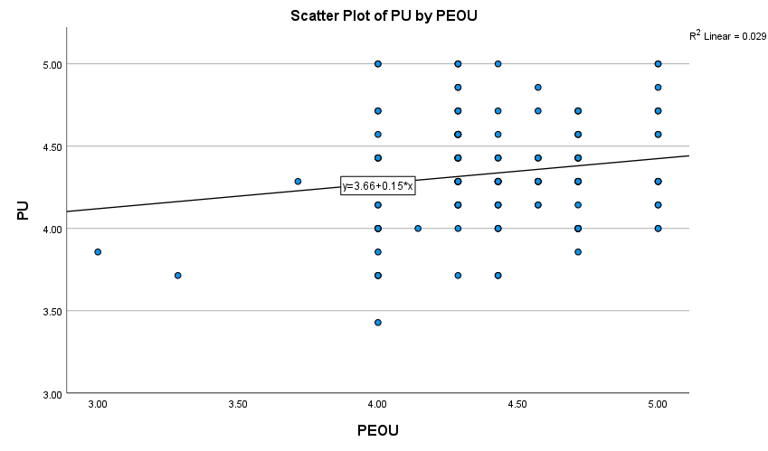

Figure 2 Scatter Plot of Perceived Usefulness (by Perceived Ease of Use)

To explore the relation between PEOU and AIU, a second scatter plot (Figure 3) was created. This scatter plot examines the relationship between PEOU and AIU. The trendline equation and a low R² value indicate a very weak positive relationship. Although the line trends upward, the wide distribution of data points shows minimal predictive strength. This suggests that although students may find ChatGPT easy to use, this perception alone has little impact on their intention to continue using it. The plot visually confirms that ease of use is not a significant driver of continued use intentions in this context.

### 

###### Figure 3 Scatter Plot of Attitude and Intention to Use by Perceived Ease of Use

## (e). Objective 3: To examine the influence of perceived usefulness on learners’ intention to continue using ChatGPT for English homework

This section addresses **Research Question 4 (RQ4)**, which posits that learners who perceive ChatGPT as useful are more likely to continue using it.

#### 1. Correlation Analysis

To explore the relationship between PU and AIU, a Pearson correlation test was conducted. The results are presented in Table 9.

##### Table 9

##### Pearson Correlation Between Perceived Usefulness and Intention to Use

| Variables | PU | AIU |
| --- | --- | --- |
| PU | 1 | 0.271** |
| AIU | 0.271** | 1 |

**p < 0.01**

The results show a **statistically significant positive correlation** between PU and AIU, suggesting that students who found ChatGPT useful were more likely to continue using it. Although the strength of the correlation is moderate, the significance indicates a meaningful association in the context of technology adoption in language learning.

#### 2. Regression Analysis

To further assess the predictive power of PU on AIU, a **simple linear regression** was conducted, treating PU as the independent variable and AIU as the dependent variable.

##### Table 10a

##### Model Summary

| Model | R | R² | Adjusted R² | Std. Error |
| --- | --- | --- | --- | --- |
| 1 | 0.271 | 0.074 | 0.068 | 0.34201 |

The model explains approximately **7.4% of the variance** in the intention to use ChatGPT. Although the explanatory power is modest, the model remains significant and relevant for understanding user behavior.

##### Table 10b

##### *ANOVA for Regression Model*

| Source | Sum of Squares | Df | Mean Square | F | Sig. |
| --- | --- | --- | --- | --- | --- |
| Regression | 1.440 | 1 | 1.440 | 12.314 | 0.001 |
| Residual | 18.131 | 155 | 0.117 |  |  |
| Total | 19.571 | 156 |  |  |  |

The ANOVA results demonstrate that the regression model is statistically significant, confirming that perceived usefulness is a significant predictor of continued use intention.

##### Table 10c

##### Coefficients of Regression Model

| Predictor | B | Std. Error | Beta | T | Sig. |
| --- | --- | --- | --- | --- | --- |
| (Constant) | 3.068 | 0.389 | – | 7.887 | 0.000 |
| PU | 0.314 | 0.090 | 0.271 | 3.509 | 0.001 |

The **unstandardized coefficient** suggests that for every unit increase in perceived usefulness, the intention to use ChatGPT increased by 0.314 units. According to Table 10c, the **standardized beta coefficient** further affirms that PU exerted a moderate, statistically significant effect on AIU. The analysis indicates that **perceived usefulness significantly influenced learners’ intention to continue using ChatGPT** for English homework tasks. The third scatter plot (Figure 4) illustrates a positive linear relationship between learners’ PU of ChatGPT and their AIU. Most data points cluster in the upper right quadrant, supporting the idea that higher PU is associated with higher AIU. The upward trendline and regression equation visually confirm this relationship, though some variability suggests other factors may be at play.

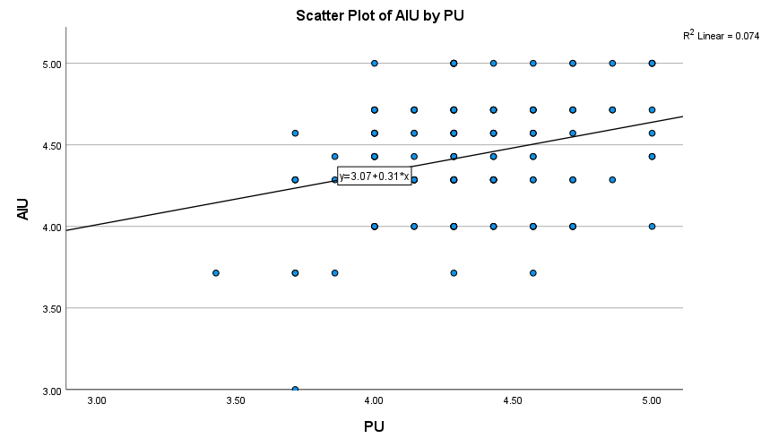

###### Figure 4 Scatter Plot Showing the Relationship Between Perceived Usefulness and Attitude and Intention to Use

## B. Qualitative Analysis

Based on the qualitative responses provided, a thematic analysis was conducted for each open-ended question to address Objective 4 and related research question.

## a. Thematic Analysis

#### 1. ChatGPT’s Impact on English Homework

Five themes were deduced from responses to Question 17 and are elaborated below. The visualization of these themes is illustrated in Figure 5.

**Theme 1: Grammar and Vocabulary Support.** A dominant theme in students’ responses was the correction and enhancement of grammar, sentence structure, and vocabulary. Learners reported using ChatGPT to identify and correct grammatical mistakes, expand their vocabulary, and improve their understanding of article usage, verb tenses, modal verbs, and cohesive devices.

**Theme 2: Writing Organization and Style.** Many learners highlighted how ChatGPT helped them structure various forms of writing—essays, letters, speeches, and reports—into clear introductions, bodies, and conclusions. It assisted with transitions, topic sentences, and paragraph development.

**Theme 3: Task-Specific and Exam Preparation Support.** Students used ChatGPT to complete specific assignments such as poem analyses, comprehension questions, summaries, vocabulary tasks, and even drama scripts. Additionally, it was seen as a tool for test preparation, helping students brainstorm ideas, simulate interview responses, and rehearse for oral exams.

**Theme 4: Concept Clarification and Learning Reinforcement**. Students turned to ChatGPT to clarify complex grammar rules and concepts, such as passive voice, phrasal verbs, and writing tone. ChatGPT’s ability to provide examples, mini-quizzes, and simplified explanations was particularly valued.

**Theme 5: Confidence and Autonomy Building**. ChatGPT encouraged self-directed learning by enabling students to work independently, often outside of school hours. Its nonjudgmental, accessible, and patient interface allowed students to engage in error correction and language learning without fear of embarrassment, contributing to increased confidence.

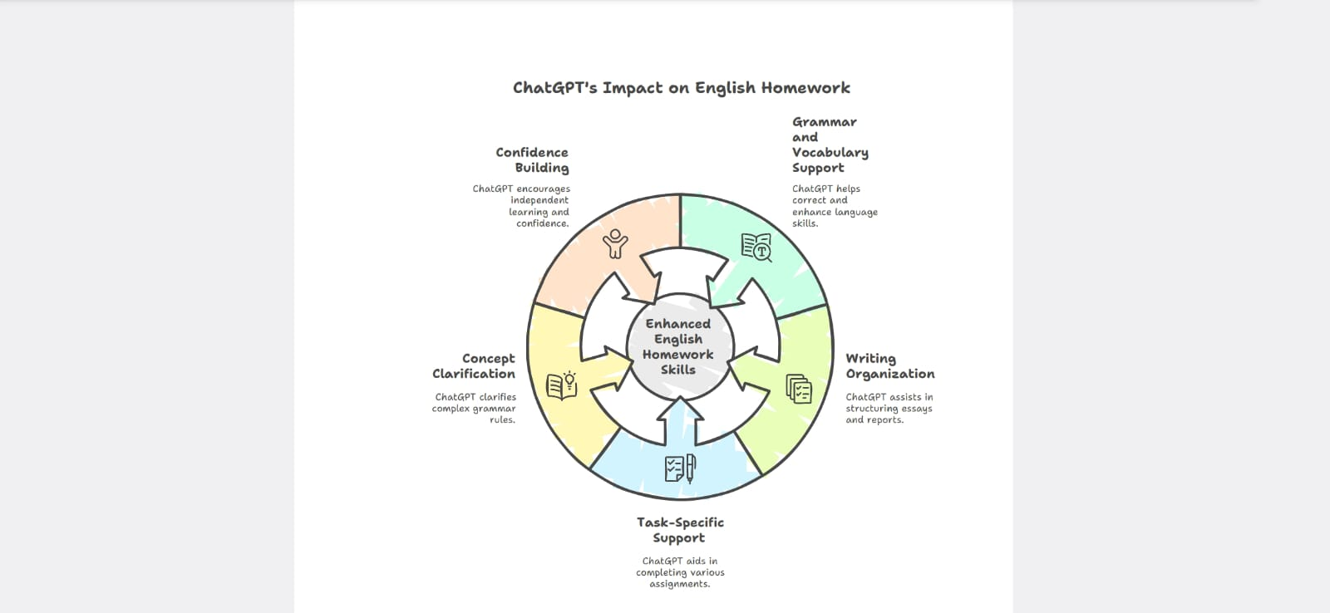

###### Figure 5 ChatGPT’s Impact on English Homework

#### 2. Benefits of ChatGPT in Learning English

Five distinct themes emerged from the responses to Question 18 and are discussed in detail below. These themes are visually represented in Figure 6.

***Theme 1: Instant Feedback and Availability.*** Having instant availability was the most highly valued feature. It was not always possible for students to have a teacher present for assistance, which is why many students appreciated being able to access ChatGPT whenever they needed it.

***Theme 2: Clarity and Simplicity.*** Students often said that ChatGPT explained approaches to grammar and vocabulary more clearly than their textbooks or classroom instruction. To personalize their understanding, users also found it helpful to be able to request a rephrase of responses on demand.

***Theme 3: Creativity and Fluency.*** ChatGPT was praised for generating ideas and assisting with creative tasks, such as storytelling, writing speeches, and improving writing fluency. Learners experienced a smoother writing flow and a more natural expression of ideas.

***Theme 4: Confidence and Independence.*** ChatGPT was a patient, anonymous listener, allowing learners to experiment at their own speed. This encouraged students to take risks with language, edit their work independently, and understand the logic behind the corrections, all of which led to self-regulated learning.

***Theme 5: Structural and Formal Support.*** Students liked the structured templates, step-by-step format, and emphasis on writing styles. This scaffolding helped them complete formal assignments and effectively learn academic tone and manners.

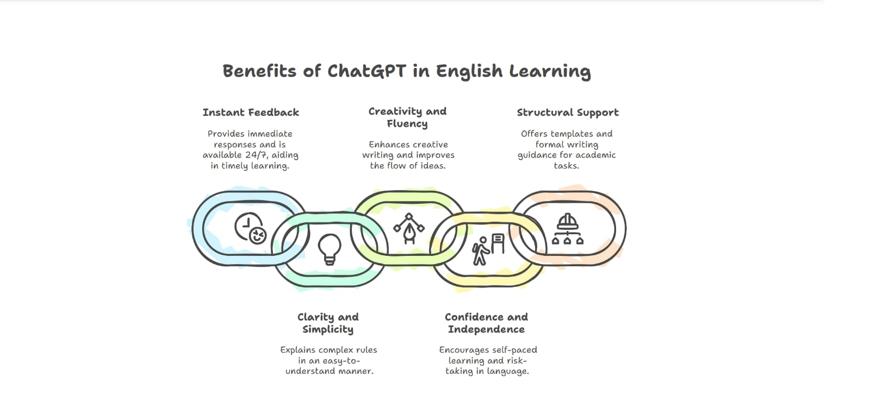

###### Figure 6 Benefits of ChatGPT in English Learning

#### 3. Limitations and Problems Associated with the Use of ChatGPT

The answers to Question 19 revealed five key themes.

***Theme 1: Overload of Information.*** One of the common concerns was that ChatGPT sometimes provides long and detailed explanations that may be beyond the students’ level of understanding. These explanations resulted in considerable confusion and had to be corrected manually.

***Theme 2: Formality and Language Appropriateness.*** In this study, ChatGPT was noted for using unnecessarily formal or technical vocabulary, misaligning it with classroom expectations or peer-level communication in informal or creative tasks**.**

***Theme 3: Lack of Contextual and Cultural Awareness.*** Some learners shared that ChatGPT was unable to comprehend their school-specific needs or cultural backgrounds. Some examples incorporated American norms that were at odds with local learning standards.

***Theme 4: Dependence and Misalignment.*** Some students feared that they would become too dependent on ChatGPT. Some said that its corrections or suggestions sometimes contradicted what their teachers had taught them, so they were unsure which standard to adopt.

***Theme 5: Nonverbal and Pronunciation Limitations.*** There was a consensus that ChatGPT could not replace teachers in helping with pronunciation, intonation, body language, and tone of voice. These are essential skills in oral communication that the tool could not address.

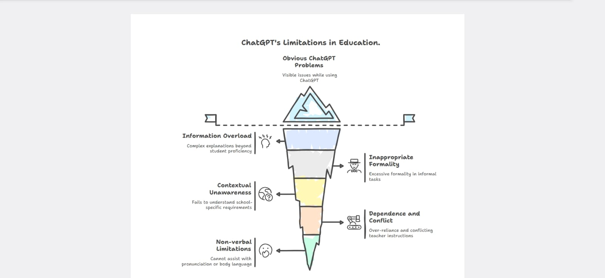

###### Figure 7 Limitations and Problems of Using ChatGPT

#### 4. Balancing AI and Human Roles in the English Language

Responses to the last question led to the identification of three main themes, detailed in the following discussion. These themes are illustrated in Figure 8.

***Theme 1: Complementary Role of ChatGPT.*** Most students acknowledged that ChatGPT was a helpful support tool, especially for grammar correction, writing structure, and vocabulary enhancement. However, they stressed that it could not fully replace human instruction.

***Theme 2: Teachers as Emotional and Contextual Guides.*** Students emphasized the irreplaceable human elements that teachers bring, such as empathy, motivation, emotional understanding, real-life examples, and personalized attention. These affective and pedagogical functions were consistently marked as absent in ChatGPT.

***Theme 3: Classroom-Specific and Oral Skills Support.*** ChatGPT was unable to provide knowledge of classroom syllabi, school-specific grading rubrics, and performance expectations. Students also highlighted that teachers are essential for face-to-face speaking practice, pronunciation feedback, and guiding group discussions, areas where ChatGPT fell short.

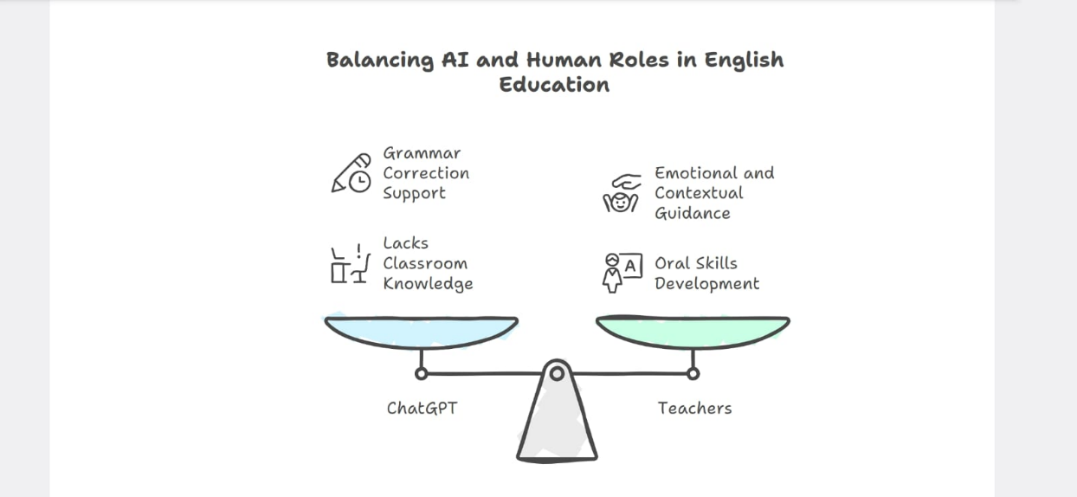

###### Figure 8 Balancing AI and Human Roles in the English Language

This thematic analysis revealed that although ChatGPT significantly enhanced students’ ability to complete English homework, especially in grammar, vocabulary, writing structure, and idea generation, it was not perceived as a substitute for a human teacher. Students valued its speed, accessibility, and clarity, but also expressed concerns about over-formality, a lack of context, and an inability to support the oral and emotional aspects of learning. Therefore, ChatGPT serves as a valuable supplementary tool, promoting self-directed learning and task completion, but it is best used in conjunction with traditional instruction for a holistic educational experience.

# VI. Discussion

This section provides an interpretation of the most important findings from the perspectives of literature, theory, and practice. It demonstrates how the results contribute to knowledge about AI use in EFL learning, with implications for future research and practice.

*A. Findings of Research*

The present study addressed four key objectives concerning the use of ChatGPT by EFL learners for English homework. First, the findings revealed that a majority of learners frequently used ChatGPT for grammar correction, vocabulary enhancement, and content generation, confirming its integration into their academic routines. Second, the quantitative analysis revealed that learners regarded ChatGPT as useful and easy to use, and the descriptive statistics results showed that PU and PEOU had high mean scores. However, the correlation results suggested a weak but nonsignificant relationship between PU and frequency of usage, compared with the stronger association PEOU had with learners’ continued use of ChatGPT. Third, regression analysis confirmed that PU and AIU were positively related and statistically significant, indicating that PU is a strong predictor of learners’ intention to continue using ChatGPT in self-directed learning. Finally, the thematic analysis of open-ended responses revealed that learners valued ChatGPT’s immediate feedback, ease of use, and assistance with vocabulary and grammar. However, the limitations included its occasional inaccuracy and learners’ overdependence on it, particularly at the vocabulary and grammar levels. These findings collectively emphasize the role of ChatGPT as an enabling assistant in EFL homework, while also indicating pathways to pedagogical support and critical AI literacy.

*B. Theoretical Implications*

This study extends the application of the TAM by validating its constructs in the context of generative AI-assisted English homework among EFL learners. The significant positive association between PU and AIU supports the predictive strength of TAM in determining learner intention, confirming that if students find a technology beneficial, they are more likely to adopt it in self-directed contexts. Interestingly, the weak link between PU and usage frequency suggests that behavioral intention in AI use may not always align with practical usage patterns, especially when shaped by task-specific needs. This nuance invites an expansion of TAM frameworks to account for context-driven usage behaviors in AI-mediated learning. Additionally, the inclusion of qualitative insights reinforces the model’s adaptability by capturing learners’ emotional and cognitive reflections, which are often absent in quantitative-only studies. Thus, this research not only confirms the relevance of TAM but also highlights the importance of integrating task-based contexts and qualitative evidence into its theoretical framework.

# VI. Conclusion

## A. Final Reflections

The current study investigated the perceptions of EFL learners regarding ChatGPT as an assistant for their homework in terms of their PU, PEOU, and continuous intentions to employ ChatGPT for self-directed English learning. The results indicated that learners commonly employ ChatGPT in their studies for grammar checking, vocabulary expansion, and writing assistance. PU was found to be significantly positively related to the intention to continue using ChatGPT in the core TAM framework. PEOU also rated highly but had less predictive power. Learners’ perspectives on the findings were further contextualized through qualitative analysis, which revealed that students valued rapid support and a tailored response but feared overreliance on the tool and incorrect answers from ChatGPT. Together, these insights suggest that although ChatGPT is a valuable tool with potential applications in language learning, its integration into education should be purposeful, critical, and pedagogically informed.

## B. Pedagogical and Practical Recommendations

Based on the results of this study, the following recommendations are proposed for stakeholders:

**For Educators:** Integrate ChatGPT as an assistant into English learning areas, specifically for grammar and writing. Educators should also nurture digital literacy and critical thinking skills in the students so that they can interact appropriately with AI-created content.

**For Students:** Use ChatGPT as a tool to support language learning in addition to (but not instead of) participation. Critically review AI output and talk to instructors and others to achieve better understanding and learning.

**For Developers:** Enhance EFL usability of ChatGPT with features such as grammar feedback, vocabulary levels, and context-aware explanations tailored to the learners' levels.

**For Policymakers**: Include AI literacy in standard language education curricula. Policymakers should encourage strategies to orient students and instructors to the ethical, efficient, and instructional methods of implementing generative AI applications into academic settings.

## C. Limitations and Future Scope

Although this study adds to the literature, it is not without limitations. The first limitation concerns the sample size, as only 157 EFL learners participated in the survey, which limits the generalizability of the findings. Second, this is a cross-sectional design that cannot inform us about how learner behavior or perceptions may change over time. Third, the research limited its focus to only three variables (PU, PEOU, and AIU) from the TAM and failed to consider other potential factors, such as self-efficacy or prior experience with digitization, which may influence the dependent variables.

In future research, longitudinal designs should be explored to determine how perceptions and patterns of use by learners may change or develop each time ChatGPT is introduced to learners. A more comprehensive view could lead to a greater understanding of variables such as motivation, learning outcomes, and ethical awareness. Furthermore, more comparative studies between various contexts and high-proficiency versus low-proficiency EFL learners would help determine best practices when incorporating AI in EFL education.

# References

Al-Ariqi, I. Y. (2024). Cognitive engagement and academic performance among EFL/ESL learners in conflict-affected zones. *Journal of Second and Multiple Language Acquisition (JSMULA), 6*(3), 539–558. Retrieved from https://science-res.com/index.php/jsmula/article/view/164

Barabad, M., & Anwar, M. (2024). Exploring ChatGPT’s role in English learning for EFL students: Insights and experiences. *International Journal of Innovative Science and Research Technology, 9*(3), 755–766. Retrieved from https://www.researchgate.net/publication/384274137_Exploring_ChatGPT's_Role_in_English_Learning_for_EFL_Students_Insights_and_Experiences

Baskara, R., & Mukarto, A. (2023). Indonesian EFL learners’ experiences with ChatGPT-assisted writing. PDF via journal repository. Retrieved from https://files.eric.ed.gov/fulltext/EJ1467949.pdf?utm_source=chatgpt.com

Braun, V., & Clarke, V. (2006). Using thematic analysis in psychology. *Qualitative Research in Psychology, 3*(2), 77–101. Retrieved from https://www.tandfonline.com/doi/abs/10.1191/1478088706qp063oa

Bryman, A. (2016). *Social research methods* (5th ed.). Oxford University Press. Retrieved from https://books.google.com.pk/books?hl=en&lr=&id=N2zQCgAAQBAJ

Çobanogullari, F. (2024). Learning and teaching with ChatGPT: Potentials and applications in foreign language education. *The EuroCALL Review, 31*(1), 4–15. Retrieved from https://files.eric.ed.gov/fulltext/EJ1452159.pdf

Cohen, L., Manion, L., & Morrison, K. (2002). *Research methods in education* (5th ed.). Routledge. Retrieved from https://www.taylorfrancis.com/books/mono/10.4324/9780203224342

Creswell, J. W., & Clark, V. L. P. (2017). *Designing and conducting mixed methods research*. Sage Publications. Retrieved from https://www.scirp.org/reference/referencespapers?referenceid=2697821

Dahri, N. A., Yahaya, N., Al-Rahmi, W. M., Aldraiweesh, A., Alturki, U., Almutairy, S., Alzahrani, A. I., & Soomro, R. B. (2024). Extended TAM-based acceptance of AI-powered ChatGPT for supporting metacognitive self-regulated learning in education: A mixed-methods study. *Heliyon, 10*(8), e31191. Retrieved from https://doi.org/10.1016/j.heliyon.2024.e31191

Davis, F. D. (1989). Perceived usefulness, perceived ease of use, and user acceptance of information technology. *MIS Quarterly, 13*(3), 319–340. Retrieved from https://doi.org/10.2307/249008

Duong, T. T. M., Van Da, C., & Van Hanh, N. (2023). The use of ChatGPT in teaching and learning: A systematic review through SWOT analysis. Frontiers in Education. Retrieved from https://www.researchgate.net/publication/378303562_The_use_of_ChatGPT_in_teaching_and_learning_a_systematic_review_through_SWOT_analysis_approach.pdf

Field, A. (2024). *Discovering statistics using IBM SPSS statistics* (6th ed.). Sage Publications. Retrieved from https://books.google.com.pk/books?hl=en&lr=&id=83L2EAAAQBAJ

Fütterer, T., Fischer, C., Alekseeva, A., Chen, X., Tate, T., Warschauer, M., & Gerjets, P. (2023). ChatGPT in education: Global reactions to AI innovations. *Scientific Reports, 13*, 15310. Retrieved from https://www.researchgate.net/publication/373929455_ChatGPT_in_Education_Global_Reactions_to_AI_Innovations

Gamper, J., & Knapp, J. (2002). A review of intelligent CALL systems. *Computer Assisted Language Learning, 15*(4), 329–347. Retrieved from https://www.tandfonline.com/doi/abs/10.1076/call.15.4.329.8270

Gutai, G., Klímová, B., & Pareja-Lora, A. (2024). A review study of the use of ChatGPT in EFL classes: Systematic review. *Journal of Language and Cultural Education, 12*(2), 1–10. Retrieved from https://ebuah.uah.es/dspace/handle/10017/64531

Han, J., Yoo, H., Myung, J., Kim, M., Lee, T. Y., Ahn, S. Y., & Oh, A. (2023). ChEDDAR: Student–ChatGPT dialogue in EFL writing education. *arXiv*. Retrieved from https://arxiv.org/abs/2309.13243

Han, J., Yoo, H., Myung, J., Kim, M., Lee, T. Y., Ahn, S. Y., Oh, A., & Answer, A. N. (2023, December). Exploring student-ChatGPT dialogue in EFL writing education. In thirty-seventh conference on neural information processing systems, Neural information processing systems foundation. Retrieved from https://gaied.org/neurips2023/files/19/19_paper.pdf

Katinskaia, A. (2025). *An overview of artificial intelligence in computer-assisted language learning*. arXiv. Retrieved from https://arxiv.org/abs/2505.02032

Khampusaen, D. (2025). The impact of ChatGPT on academic writing skills and knowledge: An investigation of its use in argumentative essays. *LEARN Journal: Language Education and Acquisition Research Network, 18*(1), 963–988. Retrieved from https://eric.ed.gov/?id=EJ1470999

Knowles, M. S. (1975). *Self-directed learning*. Association Press. Retrieved from https://www.francoangeli.it/Ricerca/Scheda_Libro.asp?ID=21863

Liu, G., & Ma, C. (2024). Measuring EFL learners’ use of ChatGPT in informal digital learning of English based on the technology acceptance model. *Innovation in Language Learning and Teaching, 18*(2), 125–138. Retrieved from https://www.tandfonline.com/doi/abs/10.1080/17501229.2023.2240316

Liu, Y., Park, J., & McMinn, S. (2024). Using generative artificial intelligence/ChatGPT for academic communication: Students’ perspectives. *International Journal of Applied Linguistics, 34*(4), 1437–1461. Retrieved from https://onlinelibrary.wiley.com/doi/abs/10.1111/ijal.12574

Lubis, A. H. (2024). Potential uses and concerns of ChatGPT in EFL academic writing classrooms: A preliminary portrait. *The Journal of AsiaTEFL, 21*(3), 698–710. Retrieved from https://www.earticle.net/Article/A456305

Mai, D. T. T., Da, C. V., & Hanh, N. V. (2024). The use of ChatGPT in teaching and learning: A systematic review through SWOT analysis approach. *Frontiers in Education, 9*, 1328769. Retrieved from https://www.frontiersin.org/articles/10.3389/feduc.2024.1328769/full

Moon, H., Chung, Y., & Randolph, A. W. (2025). Teaching and learning languages with ChatGPT: Challenges and opportunities in multilingual classrooms in higher education. *Indonesian Journal of English Language Teaching and Applied Linguistics, 10*(1), 207–223. Retrieved from https://eric.ed.gov/?id=EJ1467949

Octavio, M. M., Argüello, M. V. G., & Pujolà, J. T. (2024). ChatGPT as an AI L2 teaching support: A case study of an EFL teacher. *Technology in Language Teaching & Learning, 6*(1), 1142-1142. Retrieved from https://www.castledown.com.au/journals/tltl/article/view/1142

Othman, A. K. A. (2025). EFL students’ perceptions on using ChatGPT as an AI tool for developing academic writing skills: A case study at University College of Haql. *Journal of Educational Technology & Society, 28*(1), 85–102. Retrieved from https://www.researchgate.net/publication/393127997

Vo, A., & Nguyen, H. (2024). Generative artificial intelligence and ChatGPT in language learning: EFL students’ perceptions of technology acceptance. *Journal of University Teaching and Learning Practice, 21*(6), 199–218. Retrieved from https://search.informit.org/doi/abs/10.3316/informit.T2024092900004091943901204

Woo, D. J., Susanto, H., Yeung, C. H., Guo, K., & Fung, A. K. Y. (2023). *Exploring AI-generated text in student writing: How does AI help?* arXiv. Retrieved from https://arxiv.org/abs/2304.02478

Woo, D. J., Yu, Y., & Guo, K. (2025). *Exploring EFL secondary students’ AI-generated text editing while composition writing*. arXiv. Retrieved from https://arxiv.org/abs/2505.17041

Xiao, Y., & Zhi, Y. (2023). An exploratory study of EFL learners’ use of ChatGPT for language learning tasks: Experience and perceptions. *Languages, 8*(3), 212. Retrieved from https://www.mdpi.com/2226-471X/8/3/212

Yang, L., & Li, R. (2024). ChatGPT for L2 learning: Current status and implications. *System, 124*, 103351. Retrieved from https://www.researchgate.net/publication/381699015_ChatGPT_for_L2_learning_Current_status_and_implications

Dr. Abdullah Alshayban is an associate professor in the Department of English Language and Literature at Qassim University, Saudi Arabia. He has a Ph.D. in Applied Linguistics from the University of Memphis in Tennessee, USA. He earned his MA in TESL/TEFL from Colorado State University in Fort Collins, Colorado, USA. His areas of interest include language and vocabulary acquisition, grammar, syntax, semantics, research methodology, and Computer-Assisted Language Learning. Email: ashieban@qu.edu.sa

<https://orcid.org/0000-0002-3620-1977>

Publications:

|  |  |
| --- | --- |
| 1. Commonly Used Medical Phrasal Verbs among EFL Arabic Medical Students | |
|  | [27453-85924-3-SM.DOCX](https://www.sciedupress.com/journal/index.php/wjel/author/downloadFile/27453/85924/3)  2025-03-01 | |
| 1. Arabic-Speaking EFL Learners’ Recognition, and Use of English Phrasal Verbs in Listening and Writing | |
|  | [22488-74061-1-SM.DOCX](https://www.sciedupress.com/journal/index.php/wjel/author/downloadFile/22488/74061/1)  2022-09-12 | |