*Article*

**Branding of Community Education-Based Equality Program Learning Services**

**Abdurochman1, Ach Rasyad2, Zulkarnain3, Endang Sri Redjeki 4, Rumiari5**

*Universitas Negeri Malang, Indonesia*

*1 Department of Nonformal Education,*

*2 Department of Nonformal Education,*[*ach.rasyad.fip@um.ac.id*](mailto:ach.rasyad.fip@um.ac.id)*,*[*https://orcid.org/**0000-0001-5518-7149*](https://orcid.org/0000-0001-5518-7149)

*3 Department of Nonformal Education,**[zulkarnain.fip@um.ac.id](mailto:zulkarnain.fip@um.ac.id), https://orcid.org/**0000-0001-5208-403X*

*4 Department of Nonformal Education,**[endang.sri.fip@um.ac.id](mailto:endang.sri.fip@um.ac.id), https://orcid.org/0000-0002-0232-3685*

*5 Department of Nonformal Education,* [*rumiari79@gmail.com*](mailto:rumiari79@gmail.com)*,* [*https://orcid.org/0009-0005-8801-9711*](https://orcid.org/0009-0005-8801-9711)

Correspondence: [*abdurochman.2301419@students.um.ac.id*](mailto:abdurochman.2301419@students.um.ac.id)*,http://orcid.org/**0009-0007-3385-6592*

**Abstract**

*Non-formal education is indispensable in society, especially in the management of public education, which is indispensable in every social environment, not limited to rural communities, but also the needs of urban communities. This study aims to describe the branding of Package A equality education learning services in promoting non-formal education through effective branding strategies, as well as strengthening public perception of education services by providing the image and attractiveness of Package A equality programs. This research uses a case study approach, with a focus on branding equity education learning. This research shows that equitable education learning provides information and communication, improves the image and attractiveness of these non-formal educational institutions in the community, makes the teaching and learning process unique and interesting, and is able to create a valuable learning experience for learning residents. Branding of equality education learning services to improve the image, attractiveness of non-formal educational institutions, answer the challenges of the digital era and strengthen competitive advantage. It promotes effective learning that engages participants in the educational process and encourages long-term brand recognition of loyalty among learners.*

**Keywords***: Branding, Non-Formal Education, Equality, Package A*

**Introduction**

Currently, it is in accordance with the development and needs of people from various circles. The presence of non-formal educational institutions seeks to increase the value of the quality of institutional identity. How does non-formal education promote learning equality held by the community? Through education, people can grow to their innate potential. It is an academic institution where community involvement takes the place of government involvement outside of traditional educational frameworks to give people who have lost access to educational resources opportunities, thus improving society as a whole Mokh Thoif, 2021). Said Ahmad et al. (2023) claim that non-formal educational institutions are educational establishments created for persons who are unable to participate in or fulfil specific educational standards within the official education system. Meanwhile, Education claims that it offers educational possibilities to individuals who are left behind as a result of school dropouts Mosiara, 2023). Incorporating the community into the coaching process is intended to help offenders adjust and reintegrate into society more readily after serving their terms. It may also be a way to improve the efficiency of institutional education programs, Darwis (2020). Organising "above and outside school" learning programs through non-formal and informal education programs is limited to school-based and non-school-based educational institutions, Supriyono (2023).

Non-formal education learning institutions can be managed by the community as educational units or PKBM. Education improves people's living conditions, employment opportunities, and the calibre of human resources Ahmad et al., 2023). A community arranges non-formal education to address the needs of learning citizens who have been identified by the government as needing education, Zulkarnain et al. (2024). By implementing equitable education programs, which have been demonstrated to provide a wide range of learning opportunities, societies can meet national education goals for the expansion and equitable distribution of educational opportunities.

These educational initiatives play a significant role in expanding educational opportunities for underserved populations and those who, for a variety of reasons, are unable to participate in formal education Rosmilawati, 2020). Several distinctive conclusions have emerged from the investigation conducted at PKBM Al Madinah, which underscores the importance of contextual community empowerment. As a result, PKBM Al Madinah's contribution to Kediri City is thought to have a significant influence on creating an educational setting that promotes community skill development Rochman, et al., 2024). The structured nature of these programs ensures that learners acquire critical competencies that facilitate their reintegration into general education or the world of work.

Non-formal education is trying to overcome delays in the formal pathway. According to Pienimäki et al. (2021) stated that although non-formal learning shares structural similarities with formal education, it serves as a supplement to it. As stated by Souto Otero (2021) that "planned activities that are not explicitly classified as education (in terms of learning objectives, duration, or support) but incorporate a substantial learning component" incorporate non-formal learning. Equality Learning Package is structured learning with non-explicit activities, meaning that the equality learning program Package A is non-formal learning supported by other learning, similar to formal learning. Branding of learning services through educational programs at PKBM Al-Madinah. PKBM Al-Madinah's programs for branding educational services are an essential step in improving the reputation and appeal of educational establishments, Anang, et al. (2020). The main aspect of branding in educational services centres on the quality of the academic and non-academic services provided.Yang and Sigdel (2023) We out a study that clarified the relationship between institutional branding and higher education services, highlighting the significant influence that academic services have on student happiness, which enhances institutional reputation and brand recognition. Similarly, Pham et al. (2019) demonstrated that the quality of e-learning services, such as advocacy materials and administrative assistance, directly affects student loyalty and happiness, enhancing educational institutions' brand equity. This shows that the perception of the quality of the services provided is the basis for building a strong educational brand. Strategies to build a communication image among target groups with brand equity goals.

Meanwhile, Venessa & Arifin (2017),A brand is any symbol, sign, design, or combination of these that can be used to identify different producers or sellers and set them apart from rival companies in the market. These three things can be used as the identity of several sellers or producers to later be used as a differentiator from other competitors in the market. According to the brand equity is formed due to the consumer's view of the difference between a brand and a competitor (differentiation). The goal of quality learning services is to improve academic and non-academic services that add value and yield benefits while meeting customer expectations Rahmawati et al., 2023). The importance of branding learning in non-formal education provides an opportunity for the community to continue to acquire knowledge and skills that are currently in great demand in an effort to improve the quality of life in the community. This research can analyse the obstacles and successes of educational institutions in the community to identify opportunities to be able to continue education. The purpose of this study is to describe the success of brands or brands of non-formal educational institutions in providing educational services needed by the community. The novelty or uniqueness of this research is the promotion of non-formal education through the branding of equality education program services that affect society. The methods used can influence the community to receive experiential education and program services according to economic needs and values.

**Metodologi**

In this study, a qualitative approach was used. The ability to gather more detailed and nuanced data is the driving force behind the use of qualitative research, which facilitates the accomplishment of research objectives. Rukayat (2018), Qualitative research approaches yield comprehensive insights, Sugiyono (2021). Research is actual data, precise data, which is the value behind visible data. Therefore, qualitative research does not emphasise generalisations but rather emphasises meaning. Inductive analysis, which emphasises comprehension from the viewpoint of the persons involved, frequently uses case studies and other qualitative approaches Fadli, 2021). Effective utilisation of case studies to accomplish descriptive or explanatory objectives can be achieved by carefully planning the research and following established protocols Rustendi, 2023). This research will explain Branding, Learning, and Equality Education. A case study is a comprehensive analysis of individuals, events, and backgrounds (it might be a group, organisation, or person). To gain a thorough understanding of a case under investigation is the aim of this study. Scholars who study meaningful programs, events, processes, or activities. The researcher employs a purposive strategy while choosing informants, which entails choosing individuals who are thought to be knowledgeable about the issue under investigation.

When the researcher interviews the informant in person to gather data, the informant inquires about the previously developed guidelines' outline. In order to comprehend the contextual framework and ramifications of the gathered data, it is imperative to engage in direct interaction with the research participants. The informant is interviewed by the researcher for 120 minutes until the researcher has all the information he needs, and he can respond to the research question that the researcher has chosen. Since the researcher's role in this study is limited to observation, his presence falls under the category of passive participation in order to fully understand what is being witnessed. The following procedures are used to put observation into practice: (2) The researcher is present to gather information about the potential informant to be interviewed; (3) the researcher is present to search for documents deemed necessary as additional data; and (4) the researcher begins activities before entering the field by conducting pre-field service at PKBM, the location for the implementation of the A Brending learning equality education package, to obtain an overview.

.

**Results And Discussion**

**Results**

Based on the focus of the problem, "The branding of the learning services of the equality program package A includes: (1) the implementation of the package A equality program process at PKBM Al-Madinah, (2) the elements of the PKBM Al-Madinah learning service, (3) the function of the education unit service for the community.

1. **Branding of Learning Services for the Equality Program Package A at PKBM Al-Madinah, Kediri City.**

The branding of learning services for the A equality program at PKBM Al-Madinah Kediri City has a focus on efforts to improve the image and attractiveness of this non-formal educational institution in the community. The opinion of informant Imadhul Bilad, as a community leader, explained the process of the equality program as follows:

*Yes, sir, it is strong, especially the care system that is carried out, with visits to those in need and a network of agencies. PKBM Al-Madinah has great respect for public education, especially for those who do not go to school or drop out of school. The branding of package A services at PKBM Al-Madinah is very satisfying because this program is also aimed at residents who do not have the opportunity to receive formal education. Because in carrying out inclusive education, PKBM Al-Madinah must innovate and be creative by branding the teaching program service**.(IMA.F.SF.1)*

Furthermore, informant Syailendra Yuda Crisilla also said when interviewed that "branding equality learning services is a good promotion". This is interesting for the community to be involved in the learning process. Also conveyed by informant Nurul Handayani regarding the branding of the equality learning package A, as follows:

*In my opinion, sir, it is good and very good because it has increased online and offline. It is very good because PKBM Al-Madinah has provided word-of-mouth information, brochures and social media regarding the quality of teaching, curriculum and educational procedures. Optimising TV media owned by PKBM Al-Madinah, social media, brochures/leaflets, parent communication WAGs, and offline forums for meetings with parents and community leaders.* *Consistent and creative service branding makes PKBM Al-Madinah increasingly known to many people. The branding of the service carried out is by digitising learning activities and extra activities, participating in competition events from the Regional level to the National level, so that many achievements are achieved by the children of PKBM Al-Medina Package A.(NUR.F.SF.1)*

Strategic and integrated use of various existing communication media to attract public interest in their educational programs. Putri Rahayu said that "with social media, consistent and creative service branding makes PKBM Al-Madinah increasingly known to many people". Furthermore, informant Imadhul Bilad provided information, "The branding of the service carried out is by digitising learning activities and extra activities, participating in competition events from the Regional level to the National level, so that many achievements are achieved by the children of package A PKBM Al.-Madinah". This shows that learning branding can be carried out by educational units to increase the excellence of the Al-Madinah PKBM institution.

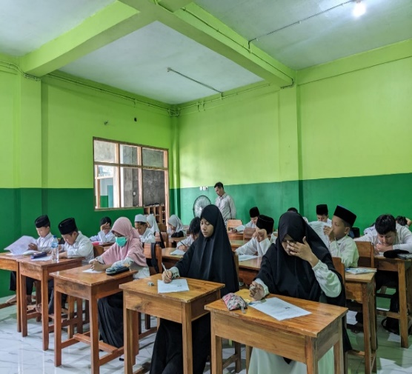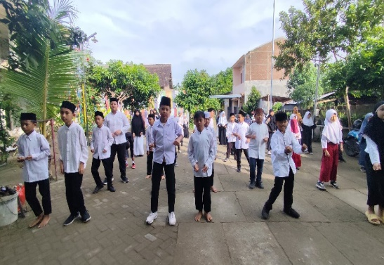

Figure 1. Equality Education Learning Process

1. **Elements of PKBM Al-Madinah Learning Services in Learning Branding**

The learning service elements of the A package A equality program at PKBM Al-Madinah Kediri City in learning branding include all aspects that make the teaching and learning process unique and interesting. According to the information of Syailendra Yuda Crisilla stated that the elements were built as a promotion for the educational unit, as follows:

*This is good, sir. The implementation of the curriculum and personal approach with various stakeholders is good. Digital promotion and community-based collaboration can be further improved. The elements of learning services in Package A PKBM Al-Madinah are very good, starting with a curriculum that suits their needs, tutors who have the ability and experience in teaching, comfortable and adequate facilities for the learning process and the latest and effective technology to improve the quality of learning. It is very good so that learning can also run well, and by the expectations of all parents/guardians of students and partners in it.(SYA.F.SF.2)*

Furthermore, informant Putri Rahayu, when interviewed, explained that the emphasis on effective, quality, and citizen learning highlights a citizen-centred approach and prioritises active participation in the teaching and learning process. This learning is carried out as follows:

*The branding of learning at PKBM Al-Madinah is very interesting because it adjusts to children's talents and interests. Innovative learning can be one of the advantages of education at the institution, and in an interesting extracurricular program, it can be an attraction in itself. These extracurricular programs not only provide learners with the opportunity to develop their special interests and talents but also build the additional skills and character necessary for life outside the classroom. (PUT. F.SF.2)*

PKBM Al-Madinah not only provides education in general, but also tries to recognise and accommodate the uniqueness of each student in terms of their talents and interests. This is what informant Imadhul Bilad explained when interviewed as follows:

*In my opinion, sir, be proactive in carrying out marketing strategies that suit the needs of PKBM Al Medina. This approach involves an in-depth analysis of educational trends, community preferences, and factors influencing the decision of parents or prospective students who want to study at PKBM Al Madinah. Improving Service Branding does need to always maintain and even increase commitment to what has been implemented for it is necessary: 1. there is evaluation and follow-up for improvement, 2. as long as efforts are made to improve the competence of existing human resources as an effort to improve the quality of services provided, 3. oriented to the interests or needs (learning citizens) of the community in providing services. 4. Conduct publications and activities that are known to the wider community. (IMA. F.SF.2)*

By continuing to pay attention to and develop the importance of branding, strategic marketing, and commitment to continuous service quality improvement, PKBM Al-Madinah has great potential to continue to move forward and make a significant contribution to the world of equality education.

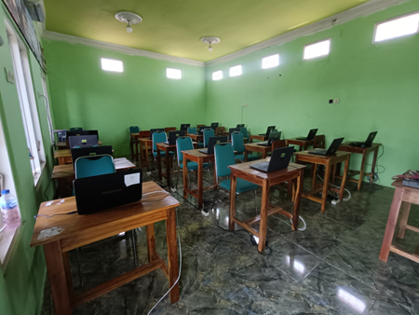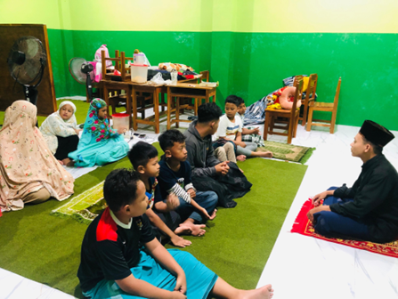

Figure 2. Educational program services

1. **Role and Function of Institutional Services to Parents or the Community**

The Package A equality program at PKBM Al-Madinah Kediri City plays an important role in increasing access to education for the community, especially for parents or people who have children who have dropped out of school or have never attended school. It was said that the informant, Syailendra Yuda Crisilla, related to the functions of services provided by the community as follows:

*This institution is very helpful for the interests of the community, both in academic and vocational education. Very helpful to the community in the field of education, a practical solution for parents in choosing a school/place for their children to study according to their children's potential and needs. The Al-Madinah Foundation is very perturbed for the community, especially for children who drop out of school, so that they can continue their education. It is also very helpful for children who are already working or want to focus on memorising the Quran, but still want to get a formal school diploma. (SYA. F.SF.3)*

Furthermore, the informant Putri Rahayu explained that providing satisfactory services and institutions providing good social welfare is done as a function and role given. Then it was emphasised that the informant stated as follows:

*In my opinion, sir, Good, the institution has provided services to the surrounding community well, and also established good relations with the parents of the students. The role and function of institutional services are very influential in improving the quality of education and community welfare, so that they can strengthen the relationship between institutions, parents, and the community. Its function is as a bridge of knowledge, service, and solution to various problems in an educational institution between tutors and the community. (PUT. F.SF.3)*

Strengthening excellent programs, improving the quality of educational services, and active communication with the community a forms of continuous efforts to improve the quality of education services, increase the competitiveness of institutions and provide added value for learning residents and the community. Informant Moh. Nizar Nasrodin Salim, when interviewed, said below:

*Yes, sir. The roles and functions of institutional services to parents are: 1) Providing education and training to parents or the community on various relevant topics. 2) Providing guidance and counselling to parents or people in need. 3) Increase awareness and knowledge of parents or the community on various relevant topics. Most parents have a positive perception of the service institutions at PKBM Al-Madinah. Their knowledge of PNF was built due to intense socialisation by the Al-Madinah PKBM institution. They assessed that PNF provides learning flexibility for their children to gain more knowledge, along with hands-on experience in the field. (MOH. F.SF.3)*

The involvement of the role of the community and parents is an important component in the school's efforts to improve the quality of school services, for example, improving the competence of all elements of the school and tutors and principals.

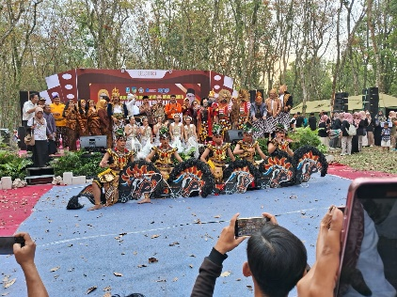

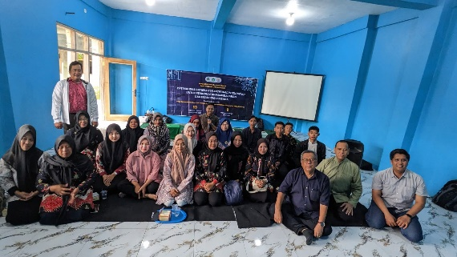

Figure 3. Parent and Community Services

**Discussion**

Branding of learning services for the equality program package A at PKBM Al-Madinah Kediri City which: (1) communication and promotion strategies through websites, social media, print media, events or activities such as socialization, parenting, etc., establish relationships with the community and alumni, conduct partnerships with related agencies, and encourage satisfied students to recommend the program to friends and family. (2) Build a positive student experience by improving the quality of learning, providing academic and non-academic support, creating a comfortable learning environment and providing efficient administrative services. (3) Conducting periodic evaluations of the effectiveness of the branding strategy that has been implemented. Prospective citizens' decisions to participate in education and community service are greatly influenced by educational institutions, and PKBM's positive reputation is fostered and maintained in large part through effective branding. Branding is the intentional creation of a brand identity that emotionally engages consumers and creates solid psychological ties that go beyond straightforward business transactions Choi & Min, 2024). An essential component in the creation of educational brands is communication. This approach is predicated on an awareness of consumers' distinct emotional responses, personalities, and brand-related experiences in order to boost brand endorsement and loyalty Malär & Nyffenegger, 2011). This emotional connection not only increases customer satisfaction but also builds trust and brand equity, both of which are essential for long-term business success Akın and Gürbüz, 2024).

In the higher education sector, where institutions must set themselves apart in a competitive market, branding has grown in importance. According to research, trainees have a big influence on training outcomes, instructors and training materials have an indirect impact, and the work environment has a big impact on training results during the training process Abdurochman et al., 2024). The idea of brand equity is crucial; studies reveal that university brands have a big impact on potential students' decisions, highlighting the necessity of efficient brand management Mourad et al., 2011). In order to draw in students and faculty, branding strategies should take into account both verbal and visual identity components, including slogans, colour schemes, and logos, which have been demonstrated to have a beneficial impact on how people perceive a brand Foroudi et al., 2017).

The elements of learning services from the A package A equality program at PKBM Al-Madinah Kediri City in learning branding include all aspects that make the teaching and learning process unique and interesting, which include curriculum quality, adaptive and participatory learning methods, supportive and inclusive learning environment, adequate learning facilities and resources, community and parent involvement. But this can lead to dialectical conflicts between these conflicting brand stories Mampaey, et al., 2019). So branding must emphasise that the Package A curriculum is in accordance with the needs of students, easy to understand, and can be applied in daily life. The learning materials must be of high quality and support independent learning. So, branding should depict a warm, inclusive, and motivating learning atmosphere. Institutions are therefore encouraged to align internal and external brand messages in order to promote coherence and boost general trust, as this method of internally branding themselves can affect external perceptions Saurombe et al., 2017). The main function of the A package A equivalency program at PKBM Al-Madinah provides opportunities for individuals to study and obtain a certificate (diploma) equivalent to education in Elementary School (SD) or Madrasah Ibtidaiyah (MI) for those who want to continue their education or improve basic literacy skills. have a role and function to parents or the community in terms of (1) providing information and understanding about Non-Formal Education (PNF), (2) facilitate access to education for those in need, (3) improve the skills and knowledge of parents or the community, (4) encourage parental involvement in children's education, (5) build networks and collaboration with communities and (6) provide guidance and counseling. The involvement of parents and the community in PKBM activities strengthens social ties and support for education. PKBM can facilitate parental involvement through various activities and effective communication.

**Conclusion**

In general, it can be inferred from the research findings and the outcomes discussion that (1) The branding of equality education learning package A at PKBM Al-Madinah has a program aimed at residents who do not have the opportunity to receive formal education in implementing inclusive education; (2) consistent and creative services make PKBM Al-Madinah increasingly known by many people by digitizing learning activities, extra activities supported by learning infrastructure facilities; (3) The emphasis on effective, qualitative, and citizen-engaged learning highlights a citizen-centered approach and prioritizes active participation in the teaching and learning process. This is evidenced by the involvement of the community, who participate in learning equality education every year. Equality education learning breeding also competes in quality with formal education, both knowledge and skills.

**References**

Abdurochman, A., Supriyono, S., Dayati, U., & Desyanty, E. S. (2024*). Memahami Transformasi Pendidikan Luar Sekolah: Analisis Empiris Dampak Program PKBM Al-Madinah Kediri melalui Pendekatan Fenomenologi*. *Jurnal Simki Pedagogia*, *7*(1), 56–67. <https://doi.org/10.29407/jsp.v7i1.519>

Akın, S. and Gürbüz, E. (2024). *The relationship of internet banking users' emotional brand experiences and consumer-based brand equity*. European Journal of Management Studies, 29(1), 85-113. <https://doi.org/10.1108/ejms-03-2023-0013>

Ahmad, et al. (2023). *Tren perkembangan pendidikan non-formal*. Jurnal Pendidikan (Teori Dan Praktik), 7(2), 76-82. <https://doi.org/10.26740/jp.v7n2.p76-82>

Ahmad, et al. (2023). *Tren perkembangan pendidikan non-formal*. Jurnal Pendidikan (Teori Dan Praktik), 7(2), 76-82. <https://doi.org/10.26740/jp.v7n2.p76-82>

Anang, A., Husein, A., & Rasyad, A. (2020). *Pendidikan agama sebagai branding di media sosial*. Jurnal Humanitas Katalisator Perubahan Dan Inovator Pendidikan, 6(2), 99-108. <https://doi.org/10.29408/jhm.v6i2.3273>

Choi, C., Xu, J., & Min, D. (2024*). Investigating the influence process on consumers’ active engagement through emotional brand attachment and brand love*. Asia Pacific Journal of Marketing and Logistics, 36(11), 3061-3080. <https://doi.org/10.1108/apjml-10-2023-1028>

Darwis, A. (2020). *Penerapan konsep community based correction dalam program pembinaan di lembaga pemasyarakatan*. Jurnal Ilmiah Ilmu Sosial, 6(1), 01. <https://doi.org/10.23887/jiis.v6i1.24081>

Fadli, M. (2021). *Memahami desain metode penelitian kualitatif*. Humanika, 21(1), 33-54. <https://doi.org/10.21831/hum.v21i1.38075>

Foroudi, P., Dinnie, K., Kitchen, P., Melewar, T., & Foroudi, M. (2017). Imc antecedents and the consequences of planned brand identity in higher education. European Journal of Marketing, 51(3), 528-550. <https://doi.org/10.1108/ejm-08-2015-0527>

Malär, L., Krohmer, H., Hoyer, W., & Nyffenegger, B. (2011). *Emotional brand attachment and brand personality: the relative importance of the actual and the ideal self*. Journal of Marketing, 75(4), 35-52. <https://doi.org/10.1509/jmkg.75.4.35>

Mokh Thoif, S. H. (2021). *Tinjauan Yuridis Pendidik Nonformal Dalam Sistem Pendidikan Nasional Di Indonesia*. Scopindo Media Pustaka.

Mosiara, S. (2023). *Menjelajahi peran pendidikan dalam mempromosikan keadilan sosial di negara-negara sub-Sahara*. IJHSS, 1(1), 1-15. <https://doi.org/10.47941/ijhss.1428>

Mourad, M., Ennew, C., & Kortam, W. (2011). *Brand equity in higher education. Marketing Intelligence & Planning*, 29(4), 403-420. <https://doi.org/10.1108/02634501111138563>.

Mampaey, J., Schtemberg, V., Schijns, J., Huisman, J., & Wæraas, A. (2019). *Internal branding in higher education: dialectical tensions underlying the discursive legitimation of a new brand of student diversity*. Higher Education Research & Development, 39(2), 230-243. <https://doi.org/10.1080/07294360.2019.1674252>

Pienimäki, M., Kinnula, M., & Iivari, N. (2021). *Finding fun in non-formal technology education*. International Journal of Child-Computer Interaction, *29*. <https://doi.org/10.1016/j.ijcci.2021.100283>

Pham, L., Limbu, Y., Bui, T., Nguyen, H., & Pham, H. (2019). *Does e-learning service quality influence e-learning student satisfaction and loyalty? Evidence from Vietnam*. International Journal of Educational Technology in Higher Education, 16(1). <https://doi.org/10.1186/s41239-019-0136-3>

Rahmawati, I., Baharudin, T., & S, H. (2023*). Kontribusi manajemen sarana prasarana terhadap mutu layanan pembelajaran di sma negeri 1 ciampe*a. Jurnal Kajian Islam Modern, 9(02), 12-22. <https://doi.org/10.56406/jkim.v9i02.247>

Rukayat. (2018). *Pendekatan Penelitian Kuantitatif: Quantitative Research Approach*. <https://webadmin-ipusnas.perpusnas.go.id/ipusnas/publications/books/157207/>

Rosmilawati, I. (2020). *Access to online education for Indonesian incarcerated students*. Digital Press Social Sciences and Humanities, 6, 00006. <https://doi.org/10.29037/digitalpress.46372>

Rochman, et al., (2024). *Strategi Pemberdayaan Masyarakat Berbasis Kontekstual Di Pkbm Al Madinah Kota Kediri*. Abidumasy Jurnal Pengabdian Kepada Masyarakat, *5*(01), 6–14. https://doi.org/10.33752/abidumasy.v5i01.5712

Rustendi, T. (2023). *Pendekatan kuantitatif dalam studi kasus pada penelitian bidang akuntansi*. Jurnal Akuntansi, 17(1), 24-37. <https://doi.org/10.37058/jak.v17i1.6736>

Saurombe, M., Barkhuizen, N., & Schutte, N. (2017*). Management perceptions of a higher educational brand for the attraction of talented academic staff*. Sa Journal of Human Resource Management, 15(0). https://doi.org/10.4102/sajhrm.v15i0.831

Supriyono, S.,(2023). *Pendidikan non formal dan Pendidikan Masyarakat*. Baskara Media, Malang

Sugiyono. (2021). *Metode penelitian kuantitatif, kualitatif, dan R&D*. Alfabeta.

Souto-Otero, M. (2021). Validation of non-formal and informal learning in formal education: Covert and overt. *European Journal of Education*, *56*(3), 365–379. <https://doi.org/10.1111/ejed.12464>

Venessa, I., & Arifin, Z. (2017). *Pengaruh Citra Merek (Brand Image) dan Harga terhadap Keputusan Pembelian Konsumen.* Survei pada Mahasiswa Program Studi Administrasi Bisnis Fakultas Ilmu Administrasi Universitas

Yang, C. and Sigdel, B. (2023). *The impact of higher education service on institutional brand in Thailand: the mediating role of Chinese students’ satisfaction*. The Eurasian Journal on Global Socio-Economic Dynamics, (6(43)), 417-429. <https://doi.org/10.35678/2539-5645.6(43).2023.417-429>

Zulkarnain, et al.,(2024). *Membangun Masyarakat Melalui Pendidikan Luar Sekolah*. Media Pendidikan Plus2, Malang